BUSINESS INTELLIGENCE ANALYSIS
Sample Superstore: Sales, Profitability and Business Performance Analysis
Power BI dashboard review, independent data validation and evidence-based recommendations
Item | Detail
Prepared by | Razeena C P
Tools | Power BI Desktop (data model, DAX measures, 7-page dashboard); Python (pandas, matplotlib) for independent validation and charts
Reporting period | Order dates 3 January 2023 to 30 December 2026
Data | 10,194 order line items | 5,111 orders | 804 customers | 1,849 products | US and Canada
Date | October 2026
Evidence labels used throughout: [Verified] = calculated from the raw data; [Interpretation] = reasoned reading of verified results; [Hypothesis] = needs further investigation.

1. Executive Summary
Business context. Sample Superstore is a US and Canada office-products retailer selling Furniture, Office Supplies and Technology to Consumer, Corporate and Home Office customers. This report reviews the Power BI dashboard built for the business and re-derives its results from the raw data to test whether growth is translating into healthy profit.
$2.33M  Total sales | $292.3K  Total profit | 12.56%  Profit margin
5,111  Orders | 804  Customers | $455.20  Average order value

Main analytical findings
- Growth is strong, margin is stable. Sales rose from $473.0K (2024) to $745.6K (2026), +58%, and profit from $62.0K to $95.9K, +55%. Margin held near 13% from 2024 to 2026 [Verified].
- Heavy discounting is the largest controllable profit leak. 1,415 line items (13.9%) were discounted 30% or more. Together they lost $136.0K, 96.8% of them were loss-making, and they account for 88.6% of all gross losses. Lines discounted 20% or less earned $428.3K at a 21.8% margin [Verified].
- Furniture grows sales but not profit. It is 32.4% of sales but 6.7% of profit (2.61% margin). Tables lose $17.8K and Bookcases $3.6K [Verified].
- Central region under-earns. Margin is 7.9% versus 15.0% in the West. Texas (-$25.7K) and Illinois (-$12.6K) drive it, both with average discounts near 37 to 39% [Verified]. Twelve of 59 states are loss-making, -$98.4K combined.
- Revenue is not the same as profit. The #1 customer by revenue (Sean Miller, $25.0K) is a net loss of $1,981 because of one 50%-discounted videoconferencing unit. 159 of 804 customers (19.8%) are unprofitable [Verified].
- Shipping mode is not a profit lever in this data. Margins across the four ship modes sit within 12.2% to 13.9%; average dispatch time is 3.96 days [Verified].
Key risks and opportunities
- Risk: 302 of 1,849 products lose money (-$77.6K combined); the ten worst lose $29.5K, equal to 10.1% of net profit. Margin dipped to 10.1% in Q4 2026 despite record sales [Verified].
- Opportunity: if discounts of 30% or more had at least broken even, profit would be up to $136K higher (an upper bound that ignores any lost volume) [Interpretation].
Highest-priority recommendations
1) Introduce a discount guardrail: manager approval above 20% and a hard review above 30%. 2) Review pricing and discount practice in the Central region, starting with Texas and Illinois. 3) Fix Furniture economics, starting with Tables, Bookcases and the loss-making 3D printers and laser printer. All benefits are potential and untested; each should be piloted and tracked against the KPIs in Section 6.

2. Business Problem and Objectives
A retailer can grow sales and still lose money on large parts of the business. The dashboard shows what happened; this analysis asks where profit is created or destroyed and what management should change.
Business questions addressed
- How are sales, profit and margin trending, and what drives them?
- Which categories, sub-categories and products create profit, and which destroy it?
- Which regions, states and cities are under-performing, and why?
- Which customers and segments are genuinely profitable, not just large?
- How do discounts relate to profitability, and is there a discount level beyond which orders lose money?
- Does shipping mode or speed matter for profit or operations?
Intended stakeholders: sales and pricing leadership (discount policy), regional managers (Central, East), category and merchandising managers (Furniture, Machines), and operations (fulfilment). The report is also written for hiring managers reviewing an analytics portfolio.

3. Dataset and Methodology
Attribute | Verified detail
Source file | samplesuperstore.csv (26 columns), loaded as one table, `samplesuperstore`, in Power BI
Grain | One row per order line item; 10,194 rows, 5,111 distinct Order IDs
Period | Order dates 3 Jan 2023 to 30 Dec 2026; latest ship date 5 Jan 2027
Geography | US and Canada; 4 regions, 59 states/provinces; 200 rows (1.96%) are Canadian
Entities | 804 Customer IDs, 1,849 product names (1,862 Product IDs), 3 categories, 17 sub-categories, 3 segments, 4 ship modes
Measures | Sales, Quantity, Discount, Profit; plus Shipping Days = DATEDIFF(Order Date, Ship Date, DAY)

Data preparation and quality checks
- No missing values in any of the 26 columns; no zero or negative sales values.
- Dashboard reconciliation: all seven KPI cards, the category margins and the regional profit figures were recomputed from the raw file and match the dashboard (Appendix B). Total Sales differs by $0.01 from rounding.
- Shipping Days was recomputed from the two date columns: 0 mismatches. Every order has a single ship date and ship mode, so row-level and order-level averages are identical (3.96 days).
- Duplicates: no duplicate Row IDs. Two line items repeat another line exactly (excluding Row ID), worth $380 of sales (0.016%); immaterial and retained.
- Customer identity: the customer name "Harry Olson" is attached to five Customer IDs, which is why there are 804 IDs but 800 names. Customer ID is used for all customer counts.
Analytical methods
Descriptive statistics; trend and year-over-year analysis; contribution (share-of-total) analysis; ranking; segmentation by discount tier; Pearson and Spearman correlation at line-item level; counterfactual upper-bound estimates. Margin is always computed as a ratio of sums (total profit divided by total sales), never as an average of row-level margins. Correlation is treated as association, not causation: the data has no pricing experiment or cost-of-goods detail.
KPI definitions (as implemented in Power BI)
KPI | DAX definition | Assessment
Total Sales / Profit | SUM(Sales) / SUM(Profit) | Correct
Profit Margin | DIVIDE([Total Profit], [Total Sales], 0) | Correct (ratio of sums)
Total Orders | DISTINCTCOUNT([Order ID]) | Correct (orders, not rows)
Unique Customers | DISTINCTCOUNT([Customer ID]) | Correct
Average Order Value | DIVIDE([Total Sales], [Total Orders], 0) | Correct; mean is skewed by large orders (median $149)
Avg Shipping Duration | AVERAGE(Shipping Days) | Valid; measures order-to-dispatch time, not delivery time

4. Key Performance Overview
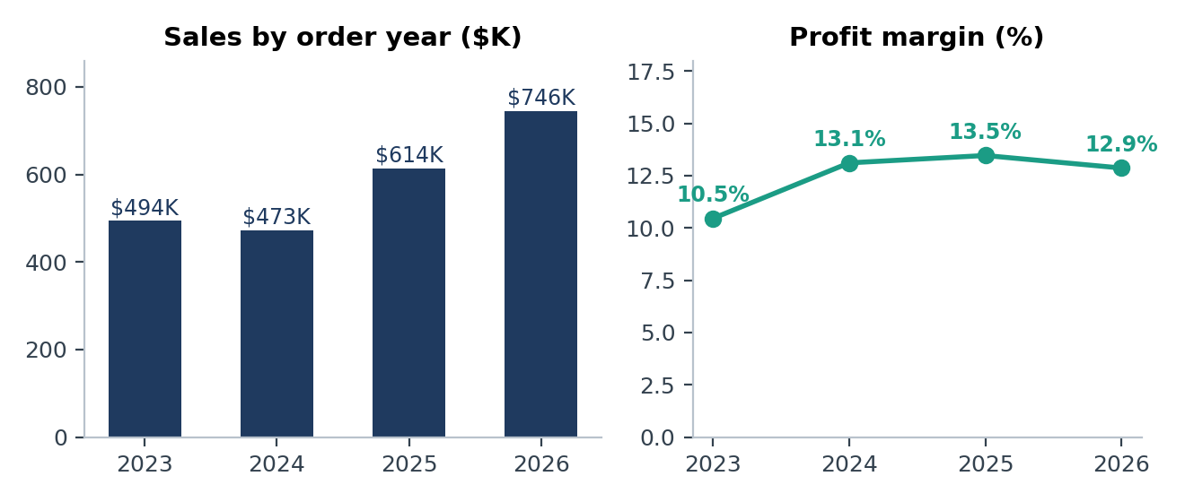
Figure 1. Sales and profit margin by order year, 2023 to 2026. Source: samplesuperstore.csv, recomputed.
Year | Sales | YoY | Profit | YoY | Margin | Orders | Customers
2023 | $494,040 | - | $51,684 | - | 10.5% | 995 | 605
2024 | $472,993 | -4.3% | $62,021 | +20.0% | 13.1% | 1,053 | 577
2025 | $613,934 | +29.8% | $82,665 | +33.3% | 13.5% | 1,340 | 653
2026 | $745,568 | +21.4% | $95,926 | +16.0% | 12.9% | 1,723 | 704

Important performance patterns
- Growth is driven by volume. Orders rose from 1,053 (2024) to 1,723 (2026), +64%, while customers rose 22%. Existing customers are ordering more often [Verified].
- Profit growth slowed relative to sales in 2026. Sales grew 21.4% but profit only 16.0%, so margin slipped from 13.5% to 12.9% [Verified].
- Strong, repeatable seasonality. Q4 delivers 37% to 39% of annual sales in every year; Q1 is the weakest quarter each year. Pooled across years, November ($352.7K) is the best month and February ($59.8K) the weakest; Nov and Dec together are 29.4% of sales [Verified].
- Best and worst quarters. Best: Q4 2026 ($287.1K sales). Weakest: Q1 2024 ($70.4K). Margin ranged from 5.4% (Q1 2023) to 19.0% (Q1 2026); Q4 2026 had the third-lowest margin of 16 quarters (10.1%) despite record sales [Verified].
- Order values are highly skewed. Mean order value is $455 but the median is only $149; 20.3% of all orders are loss-making [Verified].
Note on the time axis
The last order date in the file is 30 December 2026, which is later than the date of this report, so the dates appear to be re-based sample data rather than live transactions. Trends are interpreted within the dataset and should not be read as a real calendar forecast.

5. Detailed Analytical Findings

5.1 Product performance
Category | Sales | % of sales | Profit | % of profit | Margin
Technology | $839,893 | 36.1% | $146,543 | 50.1% | 17.45%
Office Supplies | $731,893 | 31.5% | $126,023 | 43.1% | 17.22%
Furniture | $754,748 | 32.4% | $19,730 | 6.7% | 2.61%
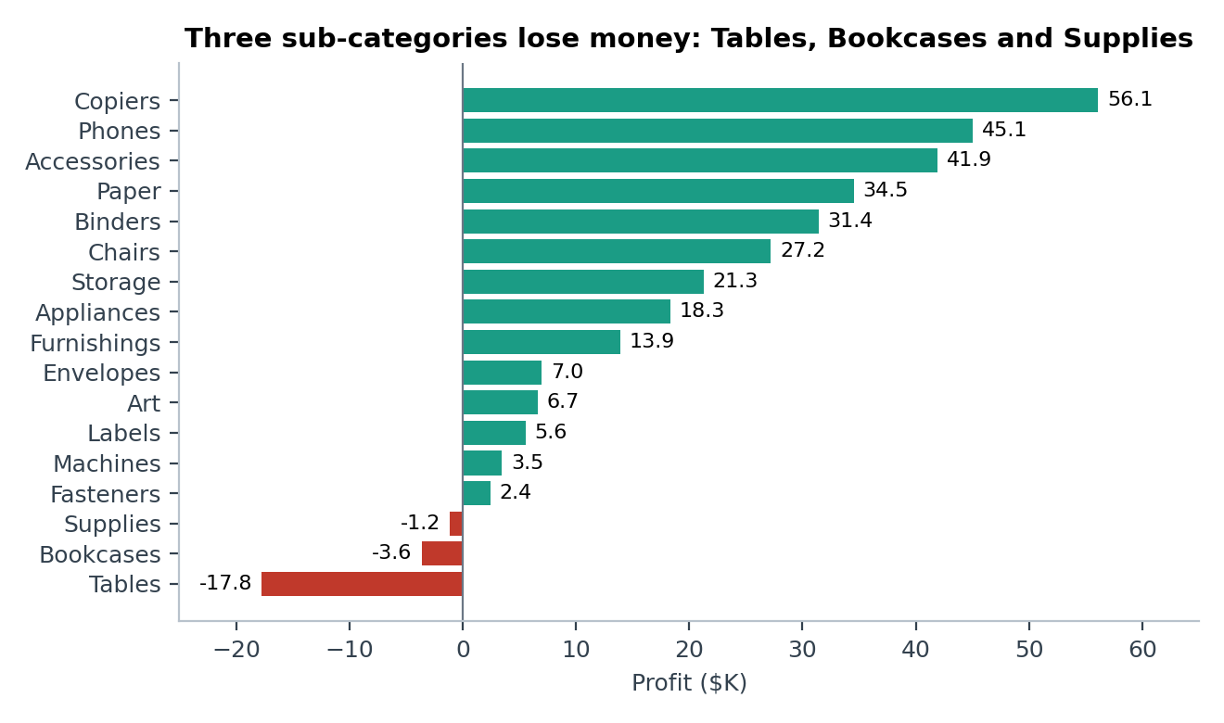
Figure 2. Profit by sub-category, all 17 shown. The dashboard's "most profitable sub-categories" chart is Top-N filtered and hides the three loss-makers.
Which categories and sub-categories create or destroy profit? [Verified]
Result Technology and Office Supplies generate 93% of profit. Furniture's margin was low in every year (3.6%, 1.9%, 3.6%, 1.5%). Tables lose $17,753 (-8.5%), Bookcases $3,632 and Supplies $1,171. Machines earns $189.9K in sales but only $3.5K profit (1.8%). Copiers are the standout: 70 orders, $56.1K profit (19.2% of total) at 37.2% margin.
Interpretation Furniture's weakness is persistent, not a one-year event, and coincides with the heaviest discounting (average 17.4%; Tables 26.0%, Machines 30.4%).
Action Review Tables, Bookcases and Machines pricing and discount rules first; protect the Copiers, Paper and Accessories lines that carry margins of 25% to 43%.
Which products sell a lot but lose money? [Verified]
Result 302 of 1,849 products are loss-making (-$77,600 combined). 19 of the 93 products in the top 5% by sales lose money. Worst: Cubify CubeX 3D Printer Double Head (-$8,880 on $11,100 sales, 50% discount), Lexmark MX611dhe laser printer (-$4,590, 40%), Cubify CubeX Triple Head (-$3,840, 50%). Canon imageCLASS 2200 copier alone earns $25,200, 8.6% of net profit. Product sales and profit are only moderately correlated (r = 0.59).
Interpretation A product's sales rank is a poor guide to its value; several top sellers are bought largely because they are heavily discounted [Hypothesis: confirm with price and demand data].
Action Set minimum price floors for the ten worst products (together -$29.5K) and decide to reprice, bundle or delist.

5.2 Geographic performance
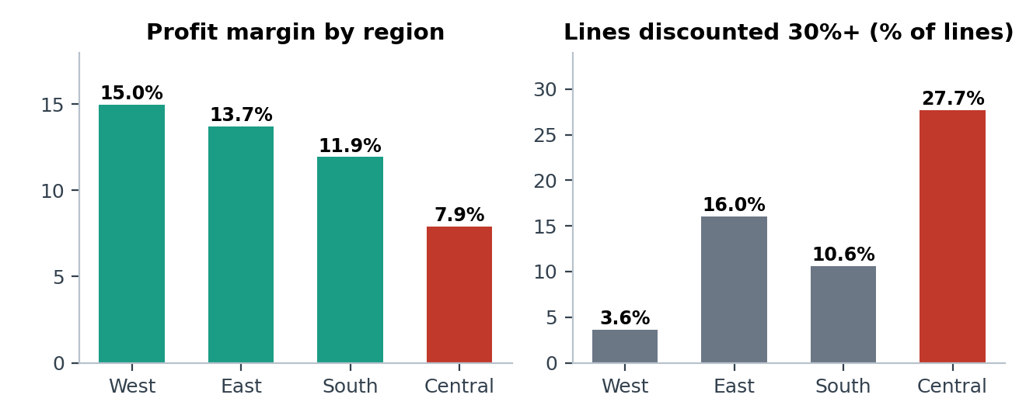
Figure 3. Profit margin and share of heavily discounted lines (30%+) by region.
Where does the business make and lose money? [Verified]
Result West leads on profit ($110.8K, 15.0% margin), then East ($94.9K), South ($46.7K) and Central ($39.9K, 7.9%). Central is 21.6% of sales but 13.6% of profit. 27.7% of Central lines are discounted 30%+ versus 3.6% in the West. Within Central, Texas (-$25.7K) and Illinois (-$12.6K) lose money while the other Central states earn 24% to 36% margins with almost no discounting. Philadelphia is the 5th-largest city by sales ($109.1K) but loses $13.8K; Houston loses $10.2K and Chicago $6.7K.
Interpretation The regional gap is largely a discount-practice gap, not a demand gap: Central lines discounted under 30% earn a 24.7% margin. Association only; local competition or product mix may also play a part [Hypothesis].
Action Run a targeted discount review in Texas, Illinois, Ohio and Pennsylvania before any broad regional strategy change. Protect California and New York ($150.4K profit combined, average discounts 5% to 7%).
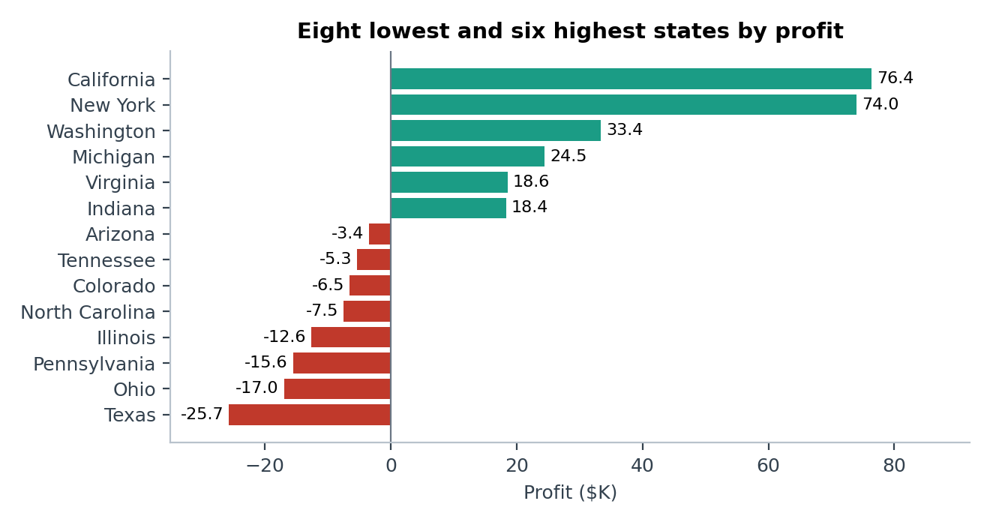
Figure 4. States with the lowest and highest profit. All 12 loss-making states are listed in Appendix D.

5.3 Customers and segments
Segment | Sales | % of sales | Profit | Margin | Avg discount
Consumer | $1,170,660 | 50.3% | $136,371 | 11.65% | 15.8%
Corporate | $715,806 | 30.8% | $94,250 | 13.17% | 15.7%
Home Office | $440,068 | 18.9% | $61,676 | 14.02% | 14.7%
Which customers and segments are really profitable? [Verified]
Result Consumer is half of sales but has the lowest margin; Home Office is the smallest segment with the best margin (2.4 points above Consumer). Customers average 6.4 orders (median 6, max 17); 12 bought once. Revenue is only moderately concentrated: the top 20% of customers produce 48.5% of sales and no customer exceeds 1.1%. Profit is more concentrated: the top 20% by profit account for 81% of net profit, because 159 customers (19.8%) are loss-making (-$71.5K). Sean Miller is #1 by revenue ($25,043) but loses $1,981: one Cisco TelePresence EX90 sold for $22,638 at 50% off lost $1,811. Cindy Stewart loses $6,626 on $5,690 of sales.
Interpretation Order frequency is a weak predictor of profit (customer-level r = 0.19 with profit versus 0.43 with sales), so "loyal" does not mean "profitable".
Action Add a profit check to large quotes (for example margin must be positive above a deal-size threshold) and review the 159 unprofitable accounts for discount behaviour.

5.4 Discounts and profitability
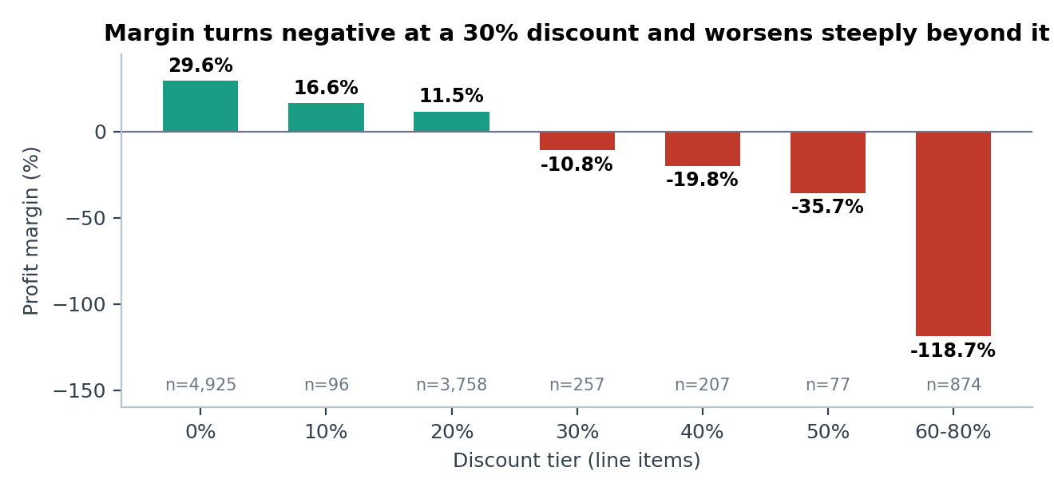
Figure 5. Profit margin by discount tier (line items). Source: samplesuperstore.csv; see data note in Appendix C on discount precision.
At what discount level do orders lose money, and does discounting pay for itself? [Verified]
Result Lines with no discount earn 29.6% margin and none lose money. At 20% the margin is 11.5%. At 30% it is -10.8% (92.6% of lines lose money), and it gets steadily worse: -35.7% at 50% and -118.7% at 60 to 80%. Lines at 30% or more (1,415; 13.9% of lines, $364.8K of sales) lost $136.0K, 96.8% were loss-making and they explain 88.6% of all gross loss dollars. Margin turns negative at 30% for Furniture and Office Supplies, and at 40% for Technology. Correlation of discount with line margin is r = -0.87. Discount shows no relationship with line sales (r = -0.03) or quantity (r = 0.01).
Interpretation The data supports a discount cap: below 20% discounting is profitable; above 30% it almost always loses money. The lack of any association with quantity suggests deep discounts are not buying extra units per line [Interpretation, association only; volume effects on order count or customer acquisition cannot be tested here].
Action Introduce tiered approval: up to 20% standard, 20 to 30% manager sign-off, above 30% executive exception. Sub-categories to watch: Binders (-$38.6K on 30%+ lines, 40% of its lines are discounted that deeply; its margin is 40.9% on all other lines), Tables (-$30.8K), Machines (-$29.6K).
How much of Furniture's weak margin is a discount problem? [Verified]
Result Excluding lines discounted 30%+, Furniture's margin is 13.4%, against 2.61% reported. Those lines lost $55.0K.
Interpretation Most of Furniture's margin gap is explained by deep discounts rather than by the category being structurally unprofitable [Hypothesis: product cost and freight data are needed to confirm].
Action Pilot a 20% discount ceiling on Tables and Bookcases for one quarter and compare margin with a control group.

5.5 Shipping and operations
Ship mode | Orders | % of orders | Sales | Margin | Avg days (range) | Avg order value
Standard Class | 3,068 | 60.0% | $1,378,841 | 12.20% | 5.00 (3 to 11) | $449
Second Class | 982 | 19.2% | $466,671 | 12.63% | 3.24 (1 to 5) | $475
First Class | 795 | 15.6% | $351,751 | 13.93% | 2.18 (1 to 4) | $442
Same Day | 266 | 5.2% | $129,272 | 12.50% | 0.04 (0 to 1) | $486
Does shipping mode or speed affect profitability or vary by region? [Verified]
Result Standard Class is 60% of orders and 59.3% of sales. Margins sit in a narrow 12.2% to 13.9% range and average discounts are similar (13.9% to 16.5%). Average days by region range only from 3.91 to 4.05 (Central slowest); by year from 4.02 to 3.91. Two line items took 11 days, the only extreme outliers.
Interpretation Customers are not paying a margin penalty for speed in this data, and fulfilment is consistent across regions. Shipping Days measures order-to-dispatch, so true customer delivery time and shipping cost cannot be assessed.
Action No profit case for changing the shipping mix. Add shipping cost and delivery date to the data before drawing operational conclusions; review the two 11-day outliers.

5.6 Additional findings
- Canada: 200 lines, $29.3K sales and $5.9K profit (20.1% margin, 1.3% of sales). Small but profitable [Verified].
- Gross profit versus gross loss: profitable lines earned $449.3K; loss-making lines (1,901, or 18.6%) lost $157.0K, erasing 35% of gross profit [Verified].
- Customer ID anomaly: one name maps to five IDs, so any customer view built on Customer Name merges separate accounts [Verified].

6. Business Recommendations
Recommendations are ranked by financial impact and strength of evidence. All benefits are expected or potential and have not been tested; no implementation or outcome data exist.
# | Problem and evidence | Proposed action | Expected benefit | KPI to monitor | Priority
1 | Lines discounted 30%+ lose $136.0K; 96.8% loss-making; 88.6% of gross loss | Tiered discount approval: <=20% standard, 20-30% manager, >30% executive exception | Up to $136K higher profit (upper bound; ignores lost volume) | % of lines at 30%+; gross loss $; margin on discounted lines | High
2 | Central margin 7.9% vs 15.0% West; Texas -$25.7K, Illinois -$12.6K; 27.7% of lines at 30%+ | Discount audit and local approval limits in TX, IL, then OH and PA | Central margin moving toward the 24.7% earned below 30% discount | Central margin; loss-making states (12 today) | High
3 | Furniture 2.61% margin; Tables -$17.8K; Machines 1.8%; 13.4% Furniture margin without 30%+ lines | Cap Tables/Bookcases discounts at 20%; reprice Machines; review supplier cost | Furniture margin recovery toward double digits (hypothesis) | Furniture and Machines margin; Tables profit | High
4 | 302 loss-making products (-$77.6K); 10 worst lose $29.5K | Price floors; reprice, bundle or delist the 10 worst (3D printers, Lexmark, conference tables) | Up to $29.5K from the top 10 if losses reach break-even | # loss-making products; profit of the worst 10 | Medium
5 | 159 unprofitable customers (-$71.5K); top-revenue customer loses money; 20.3% of orders lose money | Margin check on large quotes; account review of loss-making customers | Fewer unprofitable large deals | % loss-making orders; % loss-making customers | Medium
6 | Q4 = 37-39% of sales every year; Q4 2026 margin 10.1% | Plan stock, staffing and discount budget for Q4; set a discount budget per peak period | Protect margin in the highest-volume quarter | Q4 margin; Q4 average discount | Medium
7 | Margins and speed uniform across ship modes; no shipping cost data | Hold the shipping mix; capture shipping cost and delivery date first | Evidence base for future decisions | Avg days by mode; on-time delivery (needs new data) | Low

Limitations and implementation considerations
- No cost, freight or returns data. Profit is taken as given; product-level cost drivers cannot be separated from discounting.
- Discounts may serve goals not visible here (customer acquisition, clearance, competitive matching). Test caps through a controlled pilot, for example one region or sub-category versus a control, before a company-wide rule.
- Counterfactual figures are upper bounds. Removing deep discounts could also remove some orders.
- Association is not causation. Regional and product patterns coincide with high discounts but were not tested experimentally.
- The time axis is re-dated sample data (Section 4), so trend statements describe the dataset only.

7. Conclusion and Next Steps
Sample Superstore is growing quickly and earns a healthy overall margin, but about a seventh of its transactions are sold at discounts of 30% or more and almost all of them lose money. Fixing that single pattern, together with Furniture and Central region pricing, is the clearest route to higher profit without needing any additional sales. Technology and Office Supplies are the profit engine and should be protected.
Further analysis
- Price-elasticity or A/B test of a discount cap; discount versus order count, not only line sales.
- Customer cohorts and repeat-purchase behaviour; basket analysis for products bought together.
- Add cost of goods, shipping cost, returns and delivery dates to measure true margin and service level.
Dashboard and BI improvements
- Replace the Top-N sub-category chart with a full ranked bar showing losses; replace the profit map's categorical legend with a diverging colour scale.
- Show margin or average profit per line against discount, not totals per tier; replace the shipping-by-region funnel with a bar chart of average days.
- Add a discount-band column, a loss-making flag, YoY growth and Quantity measures; add a takeaway and recommendation text box to each page.
- Group customer visuals by Customer ID, and build a proper date table.

Appendix

A. KPI formulas (DAX)
Measure | Formula
Total Sales | SUM(samplesuperstore[Sales])
Total Profit | SUM(samplesuperstore[Profit])
Profit Margin | DIVIDE([Total Profit], [Total Sales], 0)
Total Orders | DISTINCTCOUNT([Order ID])
Unique Customers | DISTINCTCOUNT([Customer ID])
Average Order Value | DIVIDE([Total Sales], [Total Orders], 0)
Average Shipping Duration | AVERAGE(samplesuperstore[Shipping Days])
Shipping Days (calculated column) | DATEDIFF(samplesuperstore[Order Date], samplesuperstore[Ship Date], DAY)

B. Reconciliation: dashboard versus raw data
Metric | Dashboard | Recomputed from CSV | Result
Total Sales | $2,326,534.35 | $2,326,534.36 | Match (rounding)
Total Profit | 292,296.81 | 292,296.81 | Match
Profit Margin | 12.56% | 12.56% | Match
Total Orders / Customers | 5,111 / 804 | 5,111 / 804 | Match
Average Order Value | 455.20 | 455.20 | Match
Average Shipping Duration | 3.96 | 3.961 | Match
Category margin (Furn / Office / Tech) | 2.61% / 17.22% / 17.45% | 2.61% / 17.22% / 17.45% | Match
Region profit (West / East / South) | 110.80K / 94.88K / 46.75K | 110.80K / 94.88K / 46.75K | Match
Discount levels in category matrix | 12 levels incl. 0.15, 0.32, 0.45 | 9 levels (0.0 to 0.8 in steps of 0.1) | Differs, see C

C. Data limitations
- Discount precision: the CSV used for this analysis holds 9 discount values, while the dashboard matrix shows additional levels (0.15, 0.32, 0.45). Sales and profit totals match exactly, so the CSV Discount column appears to be rounded to one decimal relative to the model. Findings are therefore stated by tier and by the 30% threshold, and exact per-level margins may differ slightly from the dashboard.
- Dates: order dates run to 30 Dec 2026, later than the report date; treated as re-dated sample data.
- No cost, freight, returns or delivery-date fields; Shipping Days is order-to-dispatch time.
- Postal codes lost leading zeros (449 US rows have 4 digits); they were not used in the analysis.
- One name, five IDs (Harry Olson); two exact duplicate line items ($380 of sales). Both immaterial to totals.

D. Supporting tables
Sub-category performance (sorted by profit)
Sub-category | Category | Sales | Profit | Margin | Avg discount
Copiers | Technology | $150,745 | $56,094 | 37.2% | 15.7%
Phones | Technology | $331,843 | $45,051 | 13.6% | 15.3%
Accessories | Technology | $167,380 | $41,937 | 25.1% | 7.8%
Paper | Office Supplies | $79,541 | $34,512 | 43.4% | 7.5%
Binders | Office Supplies | $207,355 | $31,426 | 15.2% | 36.9%
Chairs | Furniture | $335,768 | $27,224 | 8.1% | 16.9%
Storage | Office Supplies | $224,645 | $21,285 | 9.5% | 7.5%
Appliances | Office Supplies | $108,213 | $18,329 | 16.9% | 16.5%
Furnishings | Furniture | $95,598 | $13,892 | 14.5% | 13.8%
Envelopes | Office Supplies | $16,528 | $6,988 | 42.3% | 8.0%
Art | Office Supplies | $27,659 | $6,653 | 24.1% | 7.5%
Labels | Office Supplies | $12,695 | $5,573 | 43.9% | 7.1%
Machines | Technology | $189,925 | $3,462 | 1.8% | 30.4%
Fasteners | Office Supplies | $8,532 | $2,429 | 28.5% | 7.9%
Supplies | Office Supplies | $46,725 | -$1,171 | -2.5% | 7.6%
Bookcases | Furniture | $115,361 | -$3,632 | -3.1% | 22.4%
Tables | Furniture | $208,020 | -$17,753 | -8.5% | 26.0%
Loss-making states and provinces (12 of 59)
State / province | Region | Sales | Profit | Margin | Avg discount
Texas | Central | $170,188 | -$25,729 | -15.1% | 37.0%
Ohio | East | $78,258 | -$16,971 | -21.7% | 32.5%
Pennsylvania | East | $116,512 | -$15,560 | -13.4% | 32.9%
Illinois | Central | $80,166 | -$12,608 | -15.7% | 39.0%
North Carolina | South | $55,603 | -$7,491 | -13.5% | 28.4%
Colorado | West | $32,108 | -$6,528 | -20.3% | 31.6%
Tennessee | South | $30,662 | -$5,342 | -17.4% | 29.1%
Arizona | West | $35,282 | -$3,428 | -9.7% | 30.4%
Florida | South | $89,474 | -$3,399 | -3.8% | 30.1%
Oregon | West | $17,431 | -$1,190 | -6.8% | 28.9%
New Brunswick | East | $226 | -$74 | -32.9% | 40.0%
Nova Scotia | East | $382 | -$53 | -13.8% | 46.7%

