**matching**

we should find a specified pattern in the image using our knowledge of image processing.

For this task use the image “text.png”.

The pattern that you should find is the letter “a” that there are six of them in this image.

[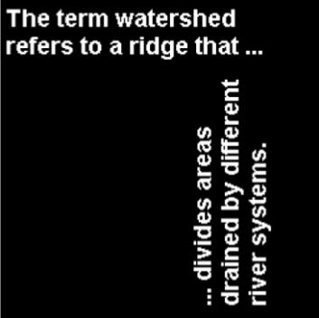](https://user-images.githubusercontent.com/60036213/266431076-f9a860a8-dec6-427c-86c3-1b7c8b606b38.png)

our result should be something like this:

[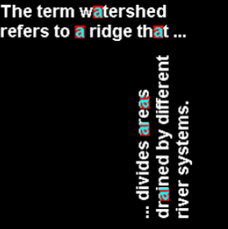](https://user-images.githubusercontent.com/60036213/266431194-0eae1cd1-c12b-44bb-adb5-0deaa197a6f1.png)

we find the patterns using spatial domain concepts and then by using frequency domain concepts.