

Safety Plan Lane Assistance

**Document Version: [Version]**

**Template Version 1.0, Released on 2017-06-21**



# Document history

|  |  |  |  |
| --- | --- | --- | --- |
| Date | Version | Editor | Description |
| 10.12.2017 | 1.0 | Raz Nissim | First draft |
|  |  |  |  |
|  |  |  |  |
|  |  |  |  |
|  |  |  |  |

# Table of Contents

Document history

Table of Contents

Introduction

Purpose of the Safety Plan

Scope of the Project

Deliverables of the Project

Item Definition

Goals and Measures

Goals

Measures

Safety Culture

Safety Lifecycle Tailoring

Roles

Development Interface Agreement

Confirmation Measures

# Introduction

## Purpose of the Safety Plan

The safety plan documents the process and the requirements for achieving functional safety in the creation of advanced driver assistance systems (ADAS). The plan defines the roles and responsibilities of team members, creating accountability for safety performance. Development interfaces are detailed in order to define responsibilities across different functions working on the project.

## Scope of the Project

For the lane assistance project, the following safety lifecycle phases are in scope:

Concept phase

Product Development at the System Level

Product Development at the Software Level

The following phases are out of scope:

Product Development at the Hardware Level

Production and Operation

## Deliverables of the Project

The deliverables of the project are:

Safety Plan

Hazard Analysis and Risk Assessment

Functional Safety Concept

Technical Safety Concept

Software Safety Requirements and Architecture

# Item Definition

The Advanced Driver Assistance System is an electromechanical system which provides two functions:

1. Lane departure warning: The system will provide haptic feedback through the vibrations in the wheel when the system detects unintentional departure from current lane.
2. Lane keeping assistance: The system will actuate vehicle controls to assist the driver in positioning the vehicle into the center of the current lane.

The system will only provide warnings and limited assistance to the driver. Limitations on the usability of the system will also be described based on the operating environment and scenarios for the vehicle.

Achieving this functionality will be done using computer vision algorithms on camera images. These images will be used to detect lane lines on the road. The camera control unit will calculate desired torque requirements and issue requests to the electronic power steering ECU. It will also issue lane departure warning requests to the electronic power steering ECU where the steering wheel should be vibrated to warn the driver. The camera control unit will communicate with the car display ECU to indicate its state (ON/OFF/FAULT) on car display.

The electronic power steering system shall receive torque requests from the camera ECU and actuate the power steering motor to achieve the desired response. The power steering motor shall also detect driver steering input and ensure that the ADAS system is only functional when the driver is in control of the vehicle.

The overall hardware system architecture is given below. The scope of the system is shown in the orange box and is made up of two sub-systems shown in blue boxes:

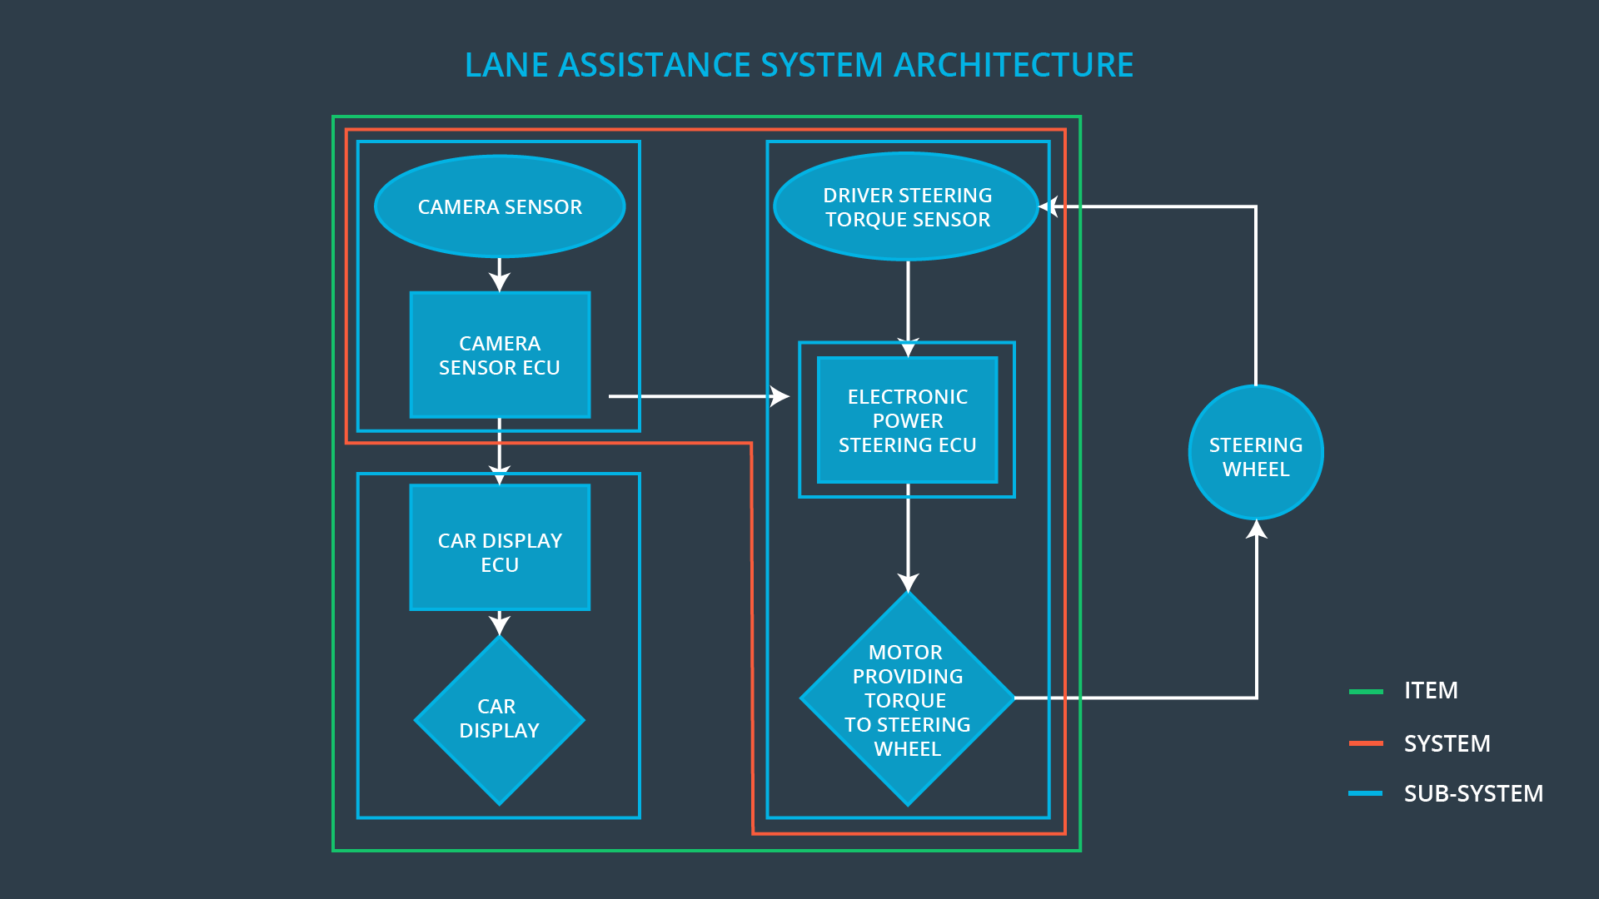

# Goals and Measures

## Goals

**The goal of this project is to understand and implement the requirements of ISO 26262 for the lane departure and lane keeping feature as a use case. This includes identifying and quantifying the risks. The system will then be engineered per the standards of ISO 26262, with the safety requirements in mind. Risk identified as unreasonable, shall be dealt with and mitigated.**

## Measures

**[Instructions:**

**Fill in who will be responsible for each measure or activity. Hint: The lesson on Safety Management Roles and Responsibilities.**

**The options are:**

**All Team Members**

**Safety Manager**

**Project Manager**

**Safety Auditor**

**Safety Assessor**

**]**

|  |  |  |
| --- | --- | --- |
| Measures and Activities | Responsibility | Timeline |
| Follow safety processes | All Team Members | Constantly |
| Create and sustain a safety culture | All Team Members | Constantly |
| Coordinate and document the planned safety activities | Safety Manager | Constantly |
| Allocate resources with adequate functional safety competency | Project Manager | Within 2 weeks of start of project |
| Tailor the safety lifecycle | Safety Manager | Within 4 weeks of start of project |
| Plan the safety activities of the safety lifecycle | Safety Manager | Within 4 weeks of start of project |
| Perform regular functional safety audits | Safety Manager | Once every 2 months |
| Perform functional safety pre-assessment prior to audit by external functional safety assessor | Safety Auditor | 3 months prior to main assessment |
| Perform functional safety assessment | Safety Assessor | Conclusion of functional safety activities |

# Safety Culture

**[Instructions:**

**Describe the characteristics of your company's safety culture. How do these characteristics help maintain your safety culture. Hint: See the lesson about Safety Culture**

**]**

# Safety Lifecycle Tailoring

**[Instructions:**

**Describe which phases of the safety lifecycle are in scope and which are out of scope for this particular project. Hint: See the** **Intro section** **of this document**

**]**

# Roles

**[Instructions:**

**This section is here for your reference. You do not need to do anything here. It is provided to help with filling out the development interface agreement section.**

**]**

|  |  |
| --- | --- |
| Role | Org |
| Functional Safety Manager- Item Level | OEM |
| Functional Safety Engineer- Item Level | OEM |
| Project Manager - Item Level | OEM |
| Functional Safety Manager- Component Level | Tier-1 |
| Functional Safety Engineer- Component Level | Tier-1 |
| Functional Safety Auditor | OEM or external |
| Functional Safety Assessor | OEM or external |

# Development Interface Agreement

**[Instructions:**

**Assume in this project that you work for the tier-1 organization as described in the above roles table. You are taking on the role of both the functional safety manager and functional safety engineer.**

**Please answer the following questions:**

1. **What is the purpose of a development interface agreement?**
2. **What will be the responsibilities of your company versus the responsibilities of the OEM? Hint: In this project, the OEM is supplying a functioning lane assistance system. Your company needs to analyze and modify the various sub-systems from a functional safety viewpoint.**

**]**

# Confirmation Measures

**[Instructions:**

**Please answer the following questions:**

1. **What is the main purpose of confirmation measures?**
2. **What is a confirmation review?**
3. **What is a functional safety audit?**
4. **What is a functional safety assessment?**

**]**

A safety plan could have other sections that we are not including here. For example, a safety plan would probably contain a complete project schedule.

There might also be a "Supporting Process Management" section that would cover "Part 8: Supporting Processes" of the ISO 26262 functional safety standard. This would include descriptions of how the company handles requirements management, change management, configuration management, documentation management, and software tool usage and confidence.

Similarly, a confirmation measures section would go into more detail about how each confirmation will be carried out.