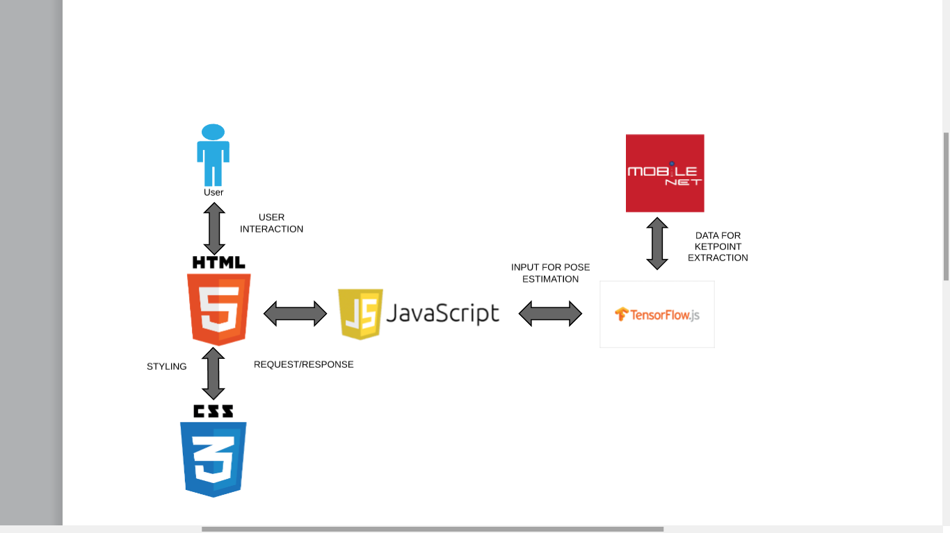

The application opens the pose corrector functionality in which the input feed of the user’s posture of a particular exercise is given as the video input.

The human body points are extracted by using the mobilenet architecture which uses a convolutional neural network built in tensorflow

It acts as dataset which classifies the human body joints to tensorflow for accurate identification of human joints.

It creates a heatmap of the user’s joints and the points with confidence value greater than threshold map as the joints, ie Points which appear darker.

The mobilenet model then creates the offset vectors of the joints in direction of a particular joint to create a body part.

This whole process results in the create of a human body skeleton joining the joints.

We then find out the angle of body parts eg. Right elbow, left elbow, etc. The angle is completely tracked for each video frame.

This angle of each frame of the user is then continuously compared in real time with the pre trained model.

The actual value ie. The value for proper posture for that particular frame is compared with the value of the angle of the pre trained model.

The user will get to the know the inconsistency in the posture by comparing the value of the angle of the particular part to that of the pretrained model.

