# Hotspot Mapper App

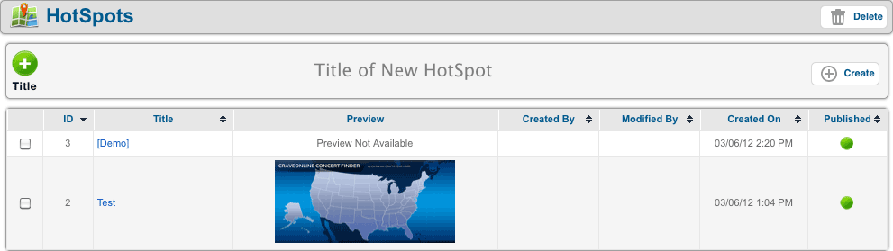

Create a new Hotspot by filling out a title. The listing contains all previously created Hotspots. Click on the **TITLE** to edit and the **PREVIEW** image to view the Hotspot.

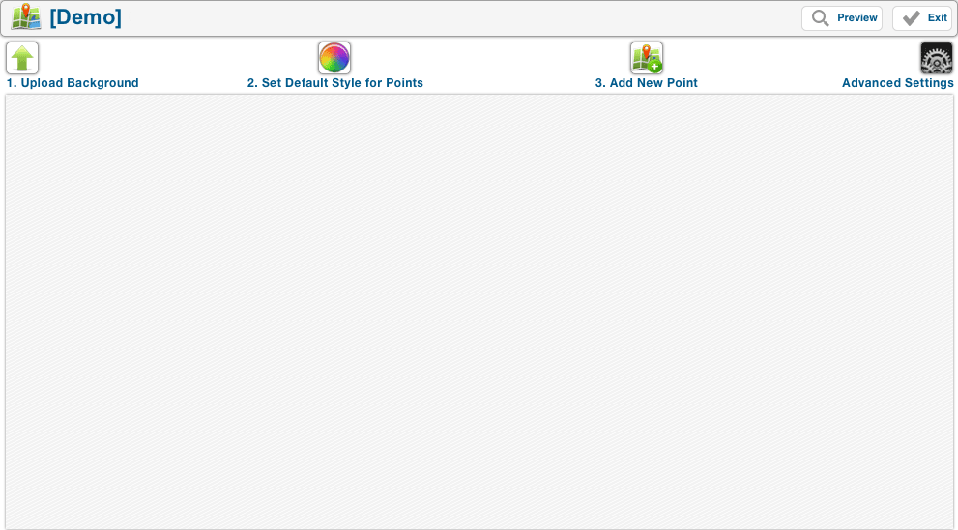

Here is the workspace. To start, **UPLOAD** a background image. The Hotspot’s **maximum width** is **1000px** with **any height.**

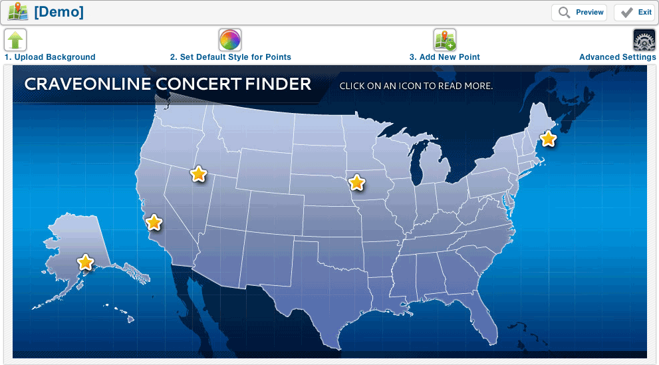

After **UPLOADING** a background, you can start adding **POINTS** and set **OPTIONS**.

1. **Upload Background** – Uploads the background image of the Hotspot
2. **Set Default Style for Points** – Customize the point’s popup’s color scheme
3. **Add New Point** – Add a new point to the map
4. **Advanced Settings** – Set the **Google Analytics tracking ID** and add **CUSTOM CSS**

**Set Default Style for Points**

* 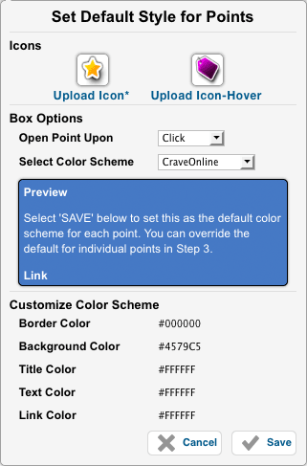**Icons –** Upload default icons for **POINTS**.

Hover icons are optional.

* **Open Point Upon** – Hotspot point’s

trigger. Can be **CLICK** or **ROLL-OVER**

* **Select Color Scheme** – Preset color styles

for AtomicOnline properties

* **Border Color** – Border color of tooltip
* **Background Color** – Background color of

tooltip

* **Title Color** – Color of tooltip’s title
* **Text Color** – Color of tooltip’s content
* **Link Color** – Color of tooltip’s links

**Add New Point**

* 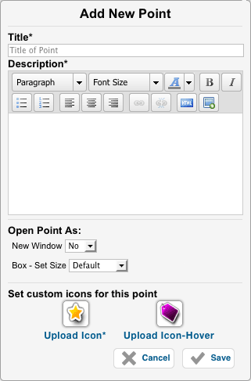**Title** – Tooltip’s title
* **Description** – Tooltip’s content. Can

contain any combination of text, images

and videos

* **New Window** – Point will open first

link in **DESCRIPTION** upon trigger

* **Box – Set Size** – Sets the tooltip’s size
  + **Default –** 50% of the dimensions

of the background image

* + **2x Default** – Full dimensions of

the background image

* + **Custom** – Specify a custom width

and height for the tooltip

* **Icons –** Override the **DEFAULT STYLES**

with specific icons

**Advanced Settings**

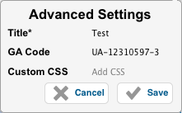

* **Title –** Hotspot’s title
* **GA Code –** Edit the Google Analytics ID
* **Custom CSS** - Customize the Hotspot

with individual custom CSS here

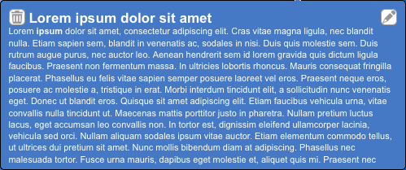

To edit a **POINT**, click/hover over the **POINT** to activate the **TOOLTIP**.

* Click the **TRASH BIN** button on the top left to delete the point
* Click the **PENCIL** button on the top right to edit the content (shown below)

