SYNDI APP

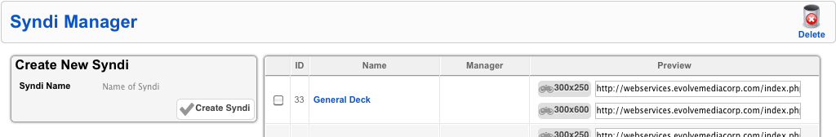

Create a new Syndi on the box to the left. The right listing contains all previously created Syndi’s. Click on the **NAME** to edit and on the **PREVIEW** icons to see it.

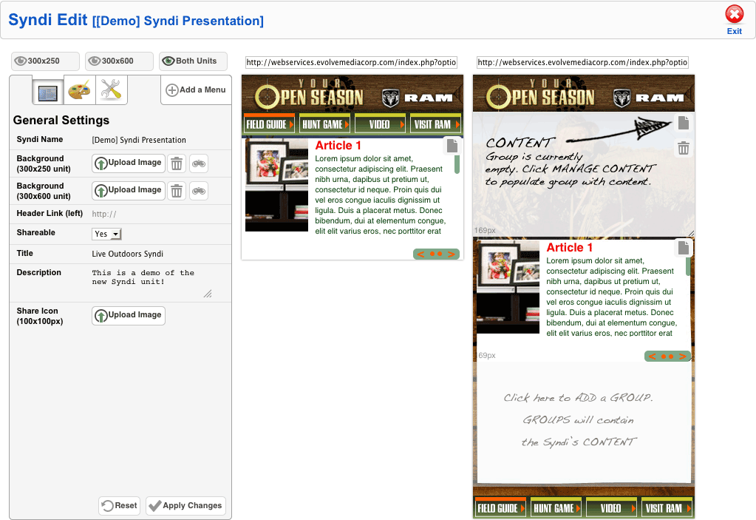

Here is the workspace, where you can add and modify both 300x250 and 300x600 versions of the Syndi.

This portion contains the **GENERAL SETTINGS** for the Syndi.

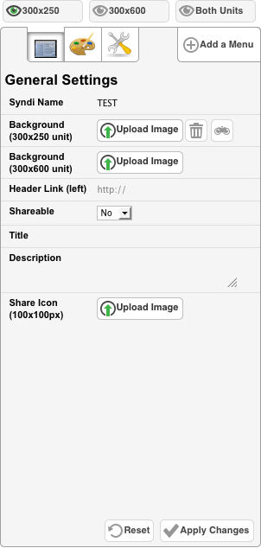

* **Syndi Name** – The **NAME** for the Syndi
* **Background** – Upload a background image
* **Header Link** – Specify a link in the header
* **Shareable** – Enable Facebook/Twitter icons
* **Title** – Facebook share title
* **Description** – Facebook/Twitter post
* **Share Icon** – Upload a Facebook Share icon

This portion contains the **COLOR SETTINGS** for the Syndi.

* 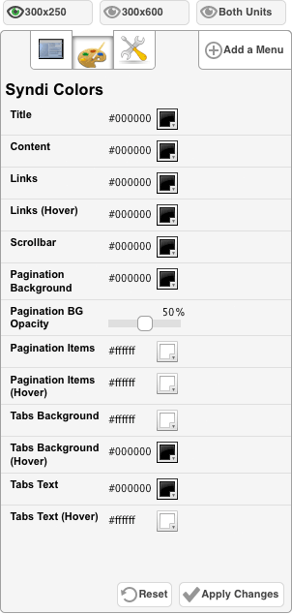**Title** – Content title’s color
* **Content** – Content’s text color
* **Links** – Link color
* **Links (Hover)** – Link hover color
* **Scrollbar** – Scrollbar’s color
* **Pagination Background** – Color for

pagination’s background

* **Pagination BG Opacity** – Adjust transparency

for **PAGINATION** area

* **Pagination Items** – Color for **PAGINATION**

Links

* **Pagination Items (Hover)** – Color for hover

state of **PAGINATION** links

* **Tabs Background** – Menu’s background color

when no image is set

* **Tabs Background (Hover)** – Menu’s hover

background color

* **Tabs Text** – Menu’s text color when no image

is set

* **Tabs Text (Hover)** – Menu’s text color on

Hover

This portion contains the **ADVANCED SETTINGS** for the Syndi.

* 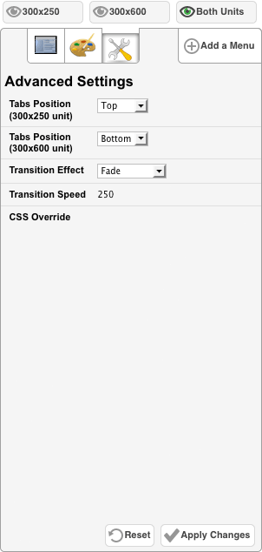**Tabs Position** – Positions the menu at the top

or bottom of the Syndi

* **Transition Effect** – The effect that occurs

when you paginate between content items

* **Transition Speed** – Time in milliseconds for

the paginate transition

* **CSS Override** – Customize the Syndi with

individual custom CSS here

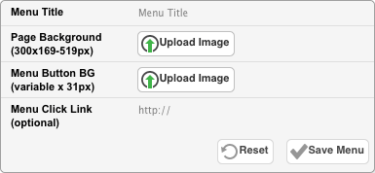

Clicking **ADD MENU** will bring up this option.

* **Menu Title** – The menu’s title
* **Page Background (optional)** – That specific menu’s background image for the content area
* **Menu Button BG (optional)** – Image for menu tab. Use an image sprite to enable hover states
* **Menu Click Link (optional)** – Set the menu tab to click out to an external link

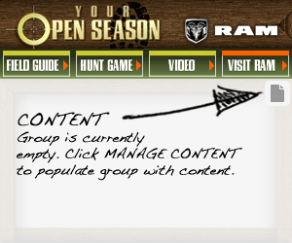

Click on the **CONTENT** button within the Syndi to add content for that group.

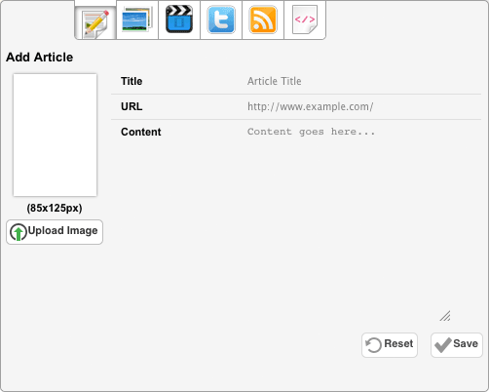

**ADD ARTICLE**

This page lets you add an article.

* **Title** – Article’s title
* **URL (optional)** – Article’s “Read More” link
* **Content** – Article text
* **Image** – Upload an article image here. Can be any dimension that fits within the available area

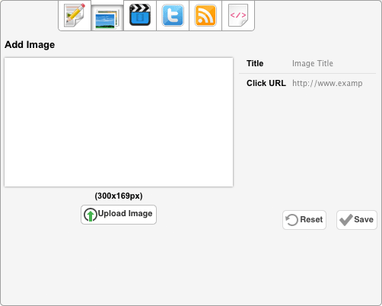

**ADD IMAGE**

Upload images here.

* **Title** – Image title (not shown in the unit)
* **Image** – Upload image
* **Click URL (optional)** – Click-through link for the image

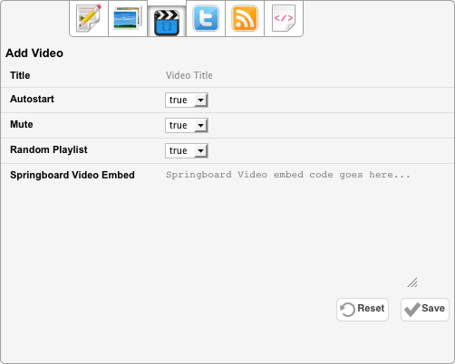

**ADD VIDEO (Springboard Video Only)**

Add a Springboard Video and/or Playlist.

* **Title –** Video’s title (not shown in the unit)
* **Autostart** – Determines if the player should auto-play the video on load
* **Mute** – Determines if the player should should be muted on load
* **Random Playlist** – Randomize a Springboard Video playlist embed code.
* **Springboard Video Embed** – Supports either a regular Springboard Video embed or a Playlist embed
  + **NOTE**: Springboard Video Playlist is limtied to 10 videos with the default embed. To enable up to 25 videos, append: **/0/0/25/0/0** to the **movie** and **src** attribute URLs in the playlist embed code.

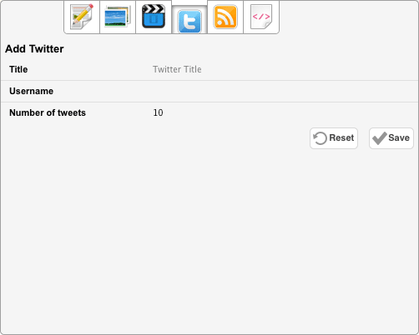

**Twitter**

Add an user’s Twitter stream here.

* **Title –** Twitter title (not shown in the unit)
* **Username** – Twitter username
* **Number of tweets** – How many Twitter posts should be shown on load

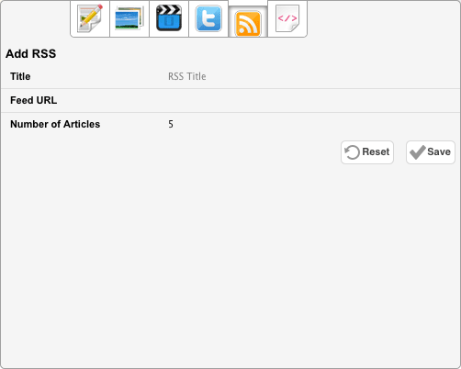

**RSS**

Add an **RSS** feed.

* **Title** – RSS title (now shown in the unit)
* **Feed URL** – URL to RSS feed
* **Number of Articles** – Number of items to load from RSS feed

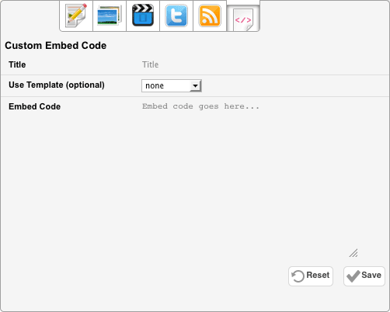

**Custom Embed Code**

Supports any embeddable units.

* **Title** – Title of Embed Code (not shown in the unit)
* **Use Template (optional)** – Use a preset **EMBED CODE** template
* **Embed Code** – Any code that is capable of running after page load (Flash widgets, iframe units, etc)