**Highest score:28?**

**trainingData[0]** is the Counter that contains all these coordinates with value 0/1(5000 images total translate into this data,5000 is the max size of this **array**)

**trainingLabel:** represents each number with true label

??? Why say this,y is a true label.

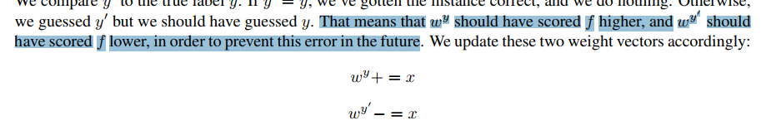

???

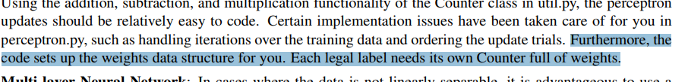???

What does full weights mean here? Set all weight vector to 1????

Most concerning question: are we going to design weight vector for each class y?

The algorithm keeps a set of weight vector w y for each class y (y is an identifier, not an exponent).