Air Travel, the most dangerous form of travel? [it’s not]

**Introduction**

Recent headlines and news stories have been shouting how air travel has become more dangerous and even has become more dangerous than travel by automobile. With the recent unfortunate airline accidents, one may think that this form of travel has become more dangerous over the last few years. We’ll look at some of the statistics comparing traveling by automobile and traveling by airline and see which one comes out on top.

**The Numbers**

Even as air travel has increased, the rate of deaths due to crashes has continued to decline year over year. From 1970 to 2020, the number of passengers carried by airlines across the world increased from approximately 310 million to 4.56 billion. That is an increase of 1370%!

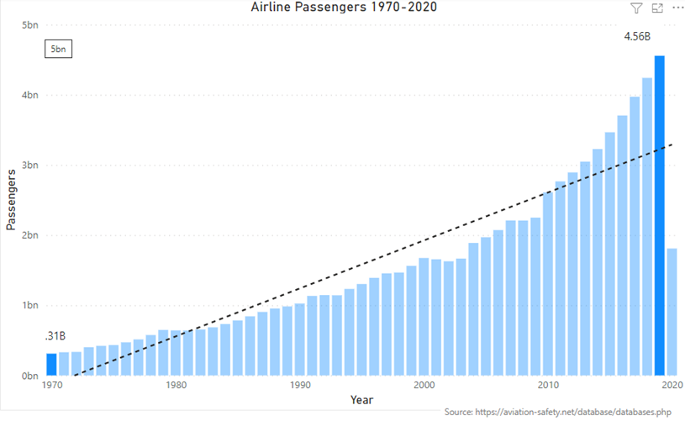

During this same time, the airline industry has worked to become safer and safer. As a result, fatalities have decreased from 2033 worldwide fatalities in 1970 to 430 in 2020. That is a 79% decrease!

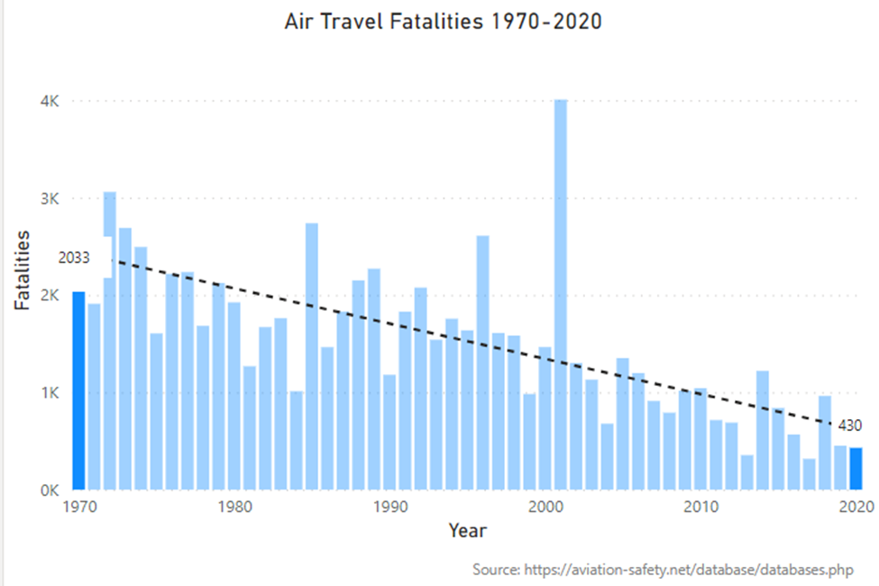

Well, what about automobile safety you say?

Let’s look at the numbers! During a similar timeframe, 1975 through 2020. I started with 1975 because that is the first year the data is available. You can see from the chart below, that over 44 thousand people lost their lives in automobile accidents in just the United States alone!

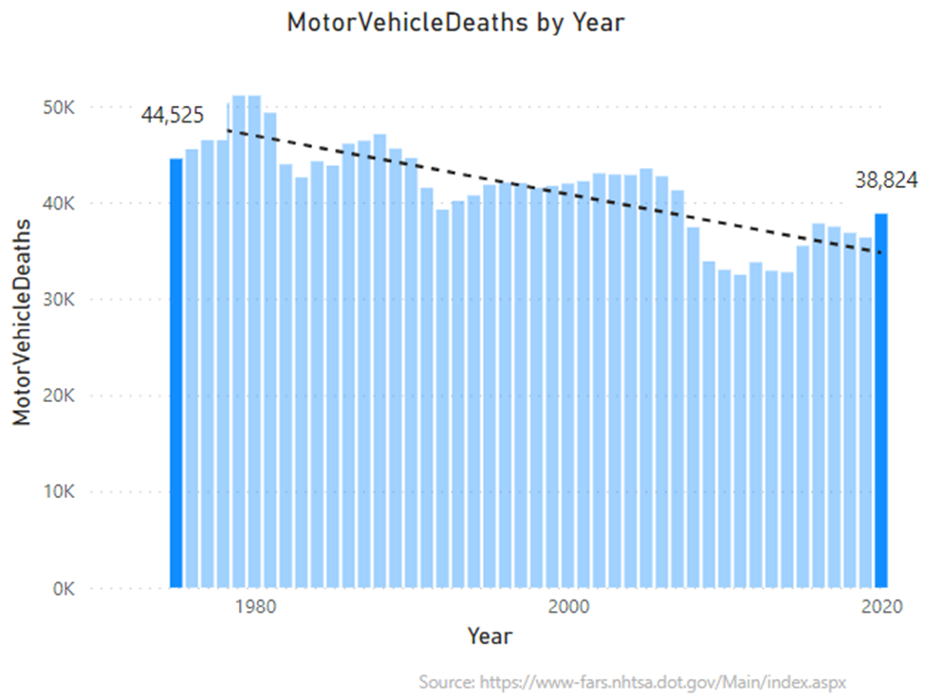

Finally, if that isn’t enough to convince you that air travel is vastly safer than traveling by automobile, let’s look at a view of the numbers together.

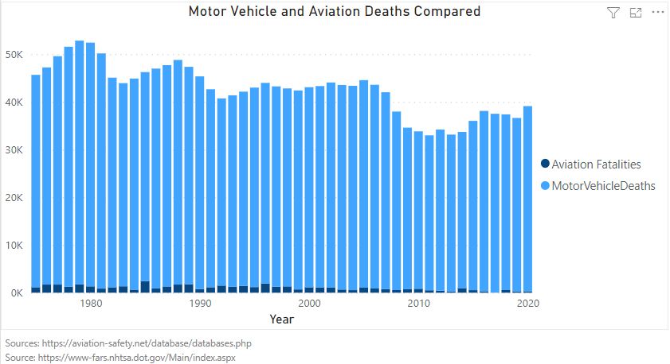

Above you can see the graph with both aviation and motor vehicle deaths compared. The small aviation fatalities compared to the light blue bars for motor vehicle deaths. You can see that the two are not even remotely close. In fact, they are so far apart, that in the later years it becomes difficult to even see the aviation bars since the motor vehicle bars as so much larger.

In conclusion, just remember the facts the next time you see a sensationalized headline or you hear a news anchor describing just how dangerous aviation travel has become, and remember that you’ve seen the numbers and you know the truth.

References

Ranter, H. (2022). Aviation Safety Network > ASN Safety Databases. Retrieved 14 July 2022, from <https://aviation-safety.net/database/databases.php>

National Highway Traffic Safety Administration. (2021, February). Fatality Analysis Reporting System (FARS) auxiliary datasets analytical user’s manual, 1982-2019 (Report No. DOT HS 813 071). Washington, DC: Author. From <https://www-fars.nhtsa.dot.gov/Main/index.aspx>