### **QSSL - User Guide**

To Run our "Proof of Concept" of quantum secured bank communication.  
a user needs the following programs to be installed on their computer:

* OpenSSL
* Cmake
* .netFrameworks 4.7.2 and above
* Visual Studio

First step is to build the program:

1. Enter the main folder named "code", and right click on folder - "open with visual studio"
2. 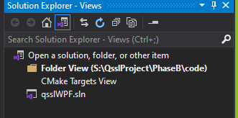At the solution explorer click on switch views
3. Click on CMake Targets View
4. Right click on CmakeLists – generate cache
5. After a successful generation right click on liboqs Project – build all.
6. Head back to qsslWPF folder to open the GUI solution
7. Build the solution.

After a successful build for the backend and frontend, we are ready to launch the project, double click on RunProject.bat will launch all the necessary executables.

**Main Screen:**

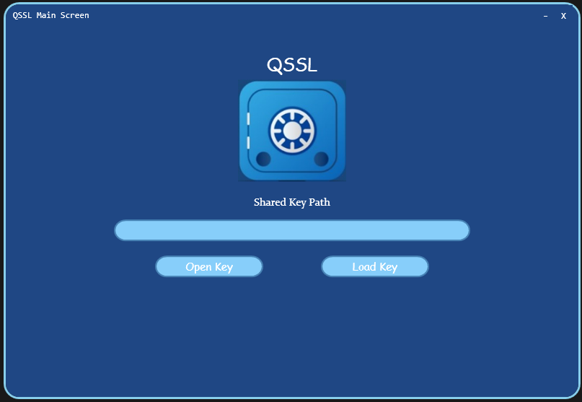

Figure 1

This screen is used to load the correct secret key achieved from the qssl protocol.

The key is saved in the folder of the executables.

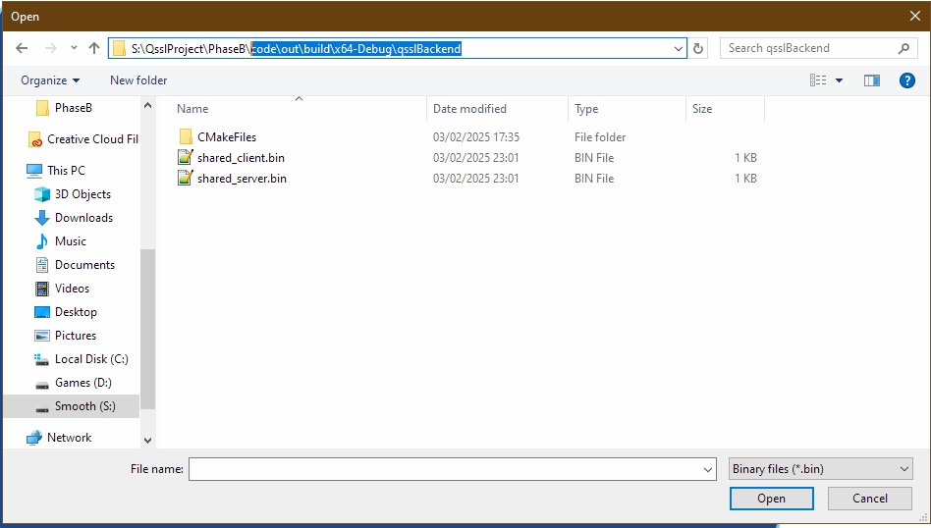

Figure 2

After selecting the correct key (both shared_client and shared_server are the same!) click on "Load Key" to move to the next screen.

**Login Screen**:

Figure 3

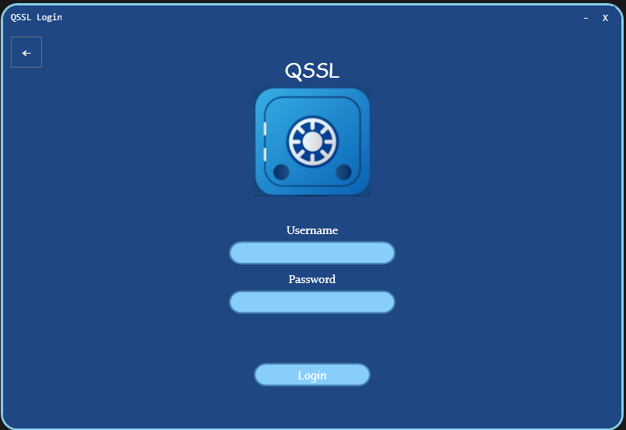

This screen is used for connecting to the bank account, the correct username and password are "admin" for username and "password" for password.

After inserting the credentials click on login button or press Enter key, to try to connect.

At the background our client and server will securely transfer messages between them. The client will send the username and password to server securely using the shared secret loaded in the previous screen, and server uses his own shared secret key that was achieved during the handshake.

while waiting for an answer the loading screen will be presented:

Figure 4

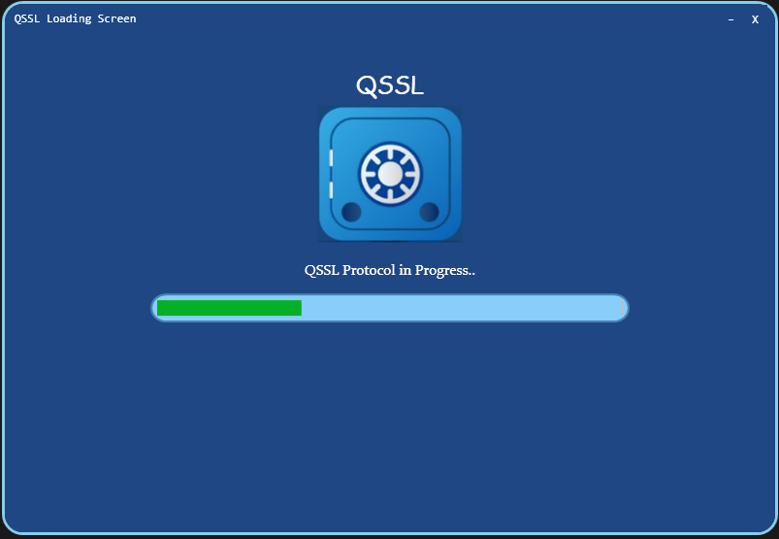

**Successful Login:**

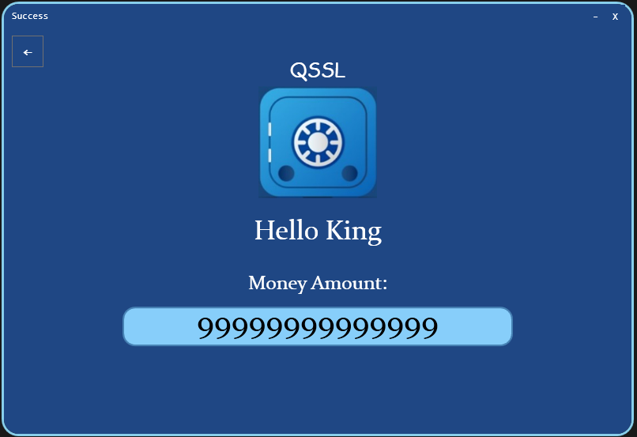

Figure 5

After a successful login this screen will be presented, to demonstrate a secure access to the user bank account.

In every screen in the program, we can return to the previous one using the back button at the left corner of the screen. We can use it to load different keys to see that only the correct one works.

**Sequence Diagram:**

Figure 6

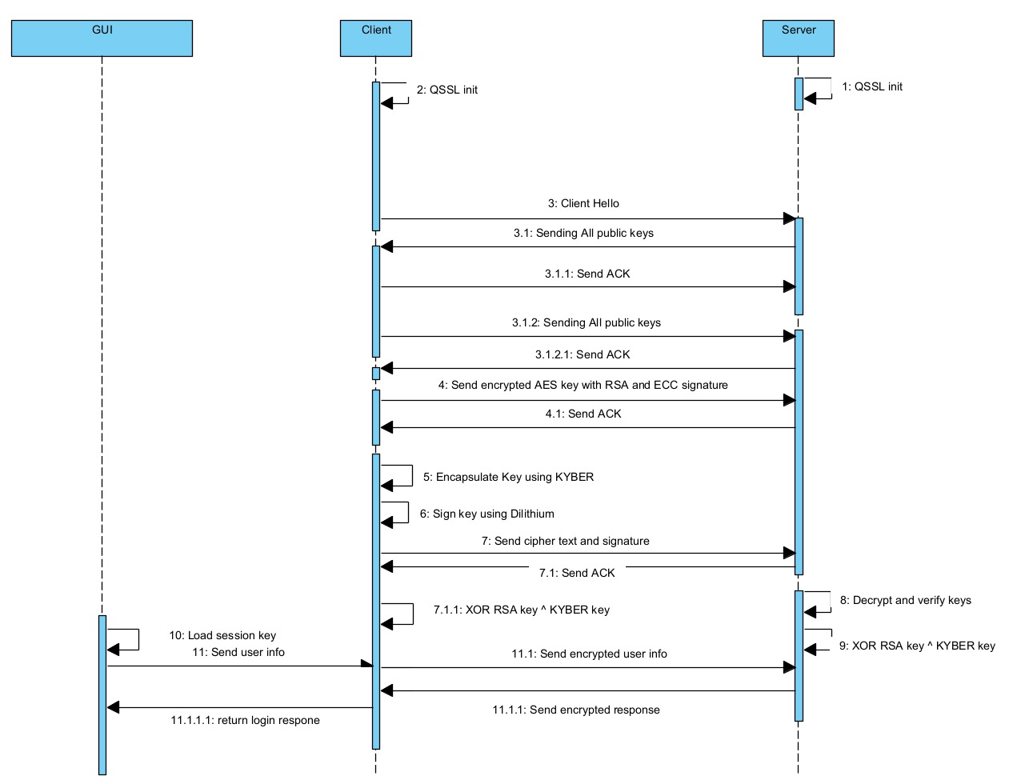

**Activity Diagram:**

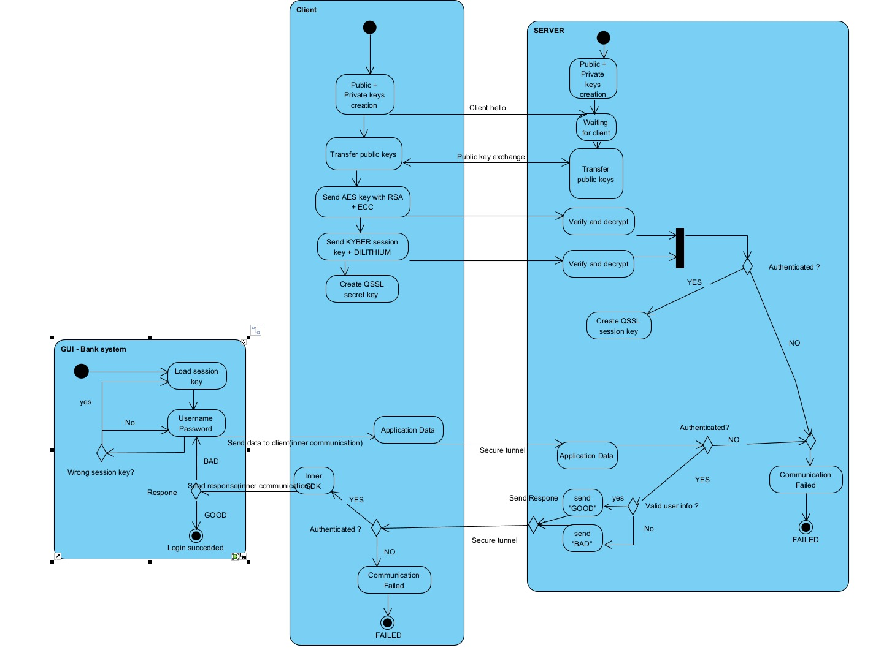

Figure 7