**Proposal Title:** Implementation and design of a multi-user remote IoT based smart home automation systems using raspberry pi

**Objective:**

1. Design a IoT based smart home system
2. Simulation smart home system using Raspberry Pi and Internet of Things (IoT) concept.
3. Data acquisition via sensors
4. Data transmission to Cloud
5. Online Web Monitor for real-time cloud monitoring

**Materials:**

**Hardware:**

1. Raspberry Pi 2 Model B
2. WiFi Dongle USB
3. Different sensors, i.e., Temperature and humidity sensors
4. Breadboard
5. LED
6. Wire and Ethernet cable
7. Electrical Motor etc.

**Software:**

**Operating Environment:** Linux based distribution, chrome (web browser) etc.

**Programming language:** C/C++, Python etc.

**Methods:**A web portal would be used to operate the whole system. Using various sensors, the proposed solution controls certain home appliances such as lights, fans, and doors. The proposed device employs the sensor to determine whether or not a human entity is present in the housework. In the form of a message, this approach also offers information about the energy used by the house owner on a daily basis.

***System design (draft)***

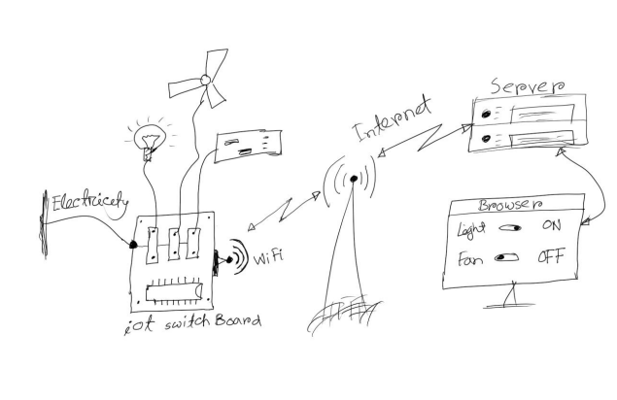

**Research questions:**1) What are the major concerns about the connectivity of home appliances?

**2)** What are theopen challengesabout the security and protection of IoT based smart home development?

3) How can saved the energy consumption of IoT communication components?