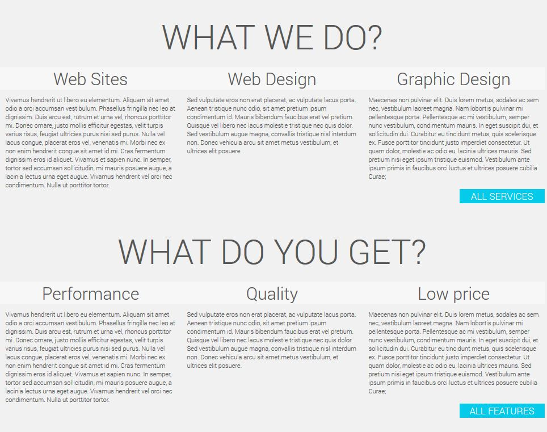

1 2 3

4 5 6

**RO:**

1. **Site-uri Web**

Comunicați simplu și eficient clienților dumneavoastră, serviciile sau produsele pe care le puneți la dispoziție printr-un site web. Un site web este probabil cel mai eficient mod de a intra în contact cu potențialii clienți, deoarece puteți pune la îndemâna lor informațiile de contact ale afacerii dumneavoastră si totodată un portofoliu de produse sau proiecte încheiate.

**EN**

1. **Websites**

Communicate simple and efficient to your customers, your services or products that you make available through a website. A website is probably the most effective way to get in touch with potential customers, because you can put within reach your business contact information and also a portfolio of products or projects completed.

**RO**

1. **Design Web**

Vă doriți un site profesionist, ușor de navigat, care îndrumă vizitatorii să vă exploreze afacerea, produsele sau serviciile? Carpatsoft vă ajută la proiectarea site-ului dorit care încântă vizual, dă dovadă de profesionalism și oferă încredere clientului în produsele sau serviciile dumneavoastră. O navigare ușoară și un design plăcut țin întotdeauna atenția clientului spre afacerea dumneavoastră, fapt care vă oferă numai câștiguri.

**EN**

1. **Web Design**

Do you want a professional website, easy to navigate, which guides visitors to explore your business product or service? Carpatsoft designers help you to design your brand and translate your business into a delightful website that demonstrates professionalism and provides confidence in your products or services. An easy navigation and a good design always keep customer’s attention to your business, which is a big plus.

**RO**

1. **Design Logo**

Orice companie sau brand care vrea să rămână în mintea clienților are nevoie de o siglă sau logo. Un logo este indispensabil pentru crearea unei identități vizuale. Un logo corect trebuie să fie pe cât de simplu pe atât de plin de înțeles

//features

A well optimized website is mandatory for the perfection that we aim. A beautiful website is nothing if it doesn’t run perfectly and doesn’t give the best experience possible. At Carpatsoft we guarantee the performance of our products with our respect. We try to find the best of solution for the every project and every problem. In fact, this is what we do: we create simple solutions to complicated problems.

Transparency is another quality of us, because we aim to keep you up to date with progress of your project and we try to make you understand all the steps that composes your project. We answer to any question related to your project friendly and patience, and we give you all the control over the decisions that are needed to take.

Keeping the price low gives us a big advantage over concurrence. We make our services affordable to small businesses, medium businesses, even for young entrepreneurs, because we know that you want to keep the costs down, or if you are on the beginning of the road, you simply don’t have much money. We will be a perfect fit you. Talk to us.

ABOUT US PAGE

Carpatsoft it's a Romanian web development company from the city of Cluj Napoca, founded in 2015. We are an enthusiastic company trying to |bring quality web services at affordable prices for small, medium and big companies.  
At Carpatsoft we offer high quality, well-established and effective web development process, flexibility, confidentiality and transparent communication.

Carpatsoft it’s a company that offers complete online services such as Web Development, Web Design, Web Applications Development, Search Engine Optimization (SEO), Consultancy for websites, Hosting, Logo Design, Graphic design, Animations, Video Editing, Photography.

We offer innovative solutions based on results of a big number of clients from Romania and from foreign countries.

Carpatsoft has its headquarters in Cluj-Napoca, one of the largest and most intercultural Romanian cities in the heart of Transylvania.

We are able to provide the best solutions even starting from incomplete and less defined specifications given to us.

TEAM

Harmony, good communication, happiness are the attributes that defines how working at Carpatsoft is. We have a team of high skilled experts working together as one. We have a passionate team, who consider their job as their passion.