Disease Knowledge Transfer across Alzheimer's Variants
R. V. Marinescu, M. Lorenzi, S. B. Blumberg, P. Planell-Morell, A. L. Young, N. P. Oxtoby, A. Eshaghi, K. X. X. Yong, S. C. Crutch, D. C. Alexander

Abstract
[Good, I would also emphasise how it beats current disease progression models e.g. works in a low-data environment and on non-multimodal data, this is a crucial result of your paper to spell out, e.g. see what I sent you last time]
We introduce Disease Knowledge Transfer (DKT), a novel technique for transferring biomarker information between Alzheimer's disease (AD) variants. DKT infers robust multimodal biomarker trajectories in rare dementias even when [emphasise] only limited, unimodal data is available, by transferring information from larger datasets of multimodal data from typical Alzheimer’s disease. DKT is a joint-disease generative model of biomarker progressions, which exploits biomarker relationships that are shared across diseases. As an example, we train DKT on combined dataset containing subjects with two distinct diseases and sizes of data available: 1) a larger, multimodal typical AD dataset (tAD) from the TADPOLE Challenge, 2) a smaller unimodal Posterior Cortical Atrophy (PCA) dataset from our local centre, for which only a limited number of MRI scans are available. We first show DKT can predict plausible population-level biomarkers for structural and molecular imaging biomarkers in PCA. We further validate DKT on synthetic data in the presence of ground truth, on 20 DTI scans from controls and PCA patients; showing that it has favourable performance compared to current approaches. [Next sentence feels out of place, it comes after the discussion on validation and before generalisability] As opposed to current deep learning approaches, DKT is interpretable, which allows us to understand underlying disease mechanisms, and can also be used to predict the future evolution of subjects instead of solving simpler control vs AD classification tasks. While we show an application to Alzheimer’s variants, we note DKT is generalisable to other forms of related dementias. We release our code publicly.

Statement of Novelty/Impact
We present DKT, a novel technique that can be used to predict, for the first time, the continuous progression of multimodal biomarkers in rare dementias for which limited, unimodal biomarker data is available, by transferring knowledge from larger datasets of related dementias.
Keywords: transfer learning, disease progression modelling, Alzheimer’s disease

Introduction
The estimation of accurate biomarker signatures in Alzheimer’s disease is crucial for understanding underlying disease mechanisms, predicting subjects’ progressions, and selecting the right subjects in clinical trials. [Next bit feels a bit too long… might be me. Get to the point of the specific problem and specific contribution] Recently, several data-driven disease progression models were proposed that reconstruct long term biomarker progressions from collections of short term individual measurements (Lorenzi et al., 2017, Oxtoby et al., 2018, Yasser et al., 2016). When applied to large datasets of typical AD, disease progression models have shown important benefits in understanding the earliest events in the Alzheimer’s disease cascade (Yasser et al., 2016, Young et al., 2014) and the heterogeneity of AD (Young et al., 2018), identifying novel genes involved in AD (Sclesi et al, 2018) and they showed improved predictions over standard approaches (Oxtoby et al., 2018). However, by necessity these models require large datasets, in addition they must be both [emphasise issues] longitudinal and multimodal, which are not available in rare dementias. Moreover, an average model of disease progression estimated from sporadic AD cases may not generalize to specific disease variants [I don’t understand ‘average model’]. For example in Posterior Cortical Atrophy, posterior regions such as the occipital lobe and superior parietal regions are affected early, instead of the hippocampus and temporal regions that are affected early in typical AD. [I think you need to spell out the benefits of your ‘12) which may not be mutlimodal’] [Maybe merge into first paragraph, to emphasise you are still talking about state of the art issues] Another approach which attempted to alleviate issue of small data sets [Is this actually true?] is [machine?] transfer learning: (Hon et al., 2017, Cheng et al., 2014, Cheng 2015) improved the accuracy of AD diagnosis, , (Cheng 2015) improved the prediction of MCI conversion . However these approaches have two key limitations Firstly, by utilising deep learning or kernel methods [abbreviation machine learning?] which lack interpretability, the user cannot understand underlying disease mechanisms that are either specific to rare dementias, or shared across related dementias. Secondly, these models cannot be used to forecast the future evolution of subjects at risk of dementia, which is important for selecting the right subjects in clinical trials.
We propose Disease Knowledge Transfer (DKT), a generative joint model that estimates continuous multimodal biomarker progressions for multiple dementias simultaneously and which inherently performs transfer learning between the modelled dementia phenotypes. This is achieved by exploiting biomarker relationships that are shared across diseases, whilst accounting for differences in the spatial distribution of brain pathology. [Maybe a bit more about details, benefits of your model here] We demonstrate DKT’s ability to predict non-MRI trajectories for PCA patients. This is done by fitting DKT to two datasets simultaneously: (1) the TADPOLE Challenge (Marinescu et al., 2018) dataset containing subjects from the Alzheimer’s, Disease Neuroimaging Initiative (ADNI) with MRI, FDG-PET, DTI, AV45 and AV1451 scans (2) MRI scans from patients with Posterior Cortical Atrophy from a small centre [local centre isn’t used in English]. We first show that DKT estimates plausible non-MRI trajectories for PCA subjects in figure-. We further validate DKT on simulated data from two synthetic diseases with known ground truth, and a set of 20 DTI scans from controls and PCA patients, showing it yields favourable performance compared to standard approaches in figure-. Compared with previous disease progression models or transfer learning methods, DKT can be applied to small unimodal datasets of rare dementias, is interpretable and can be used to forecast the future evolution of subjects at risk of dementia. [Finally we note that it can be applied to other situations not showed in the paper and release the code].

The structure of this paper is:
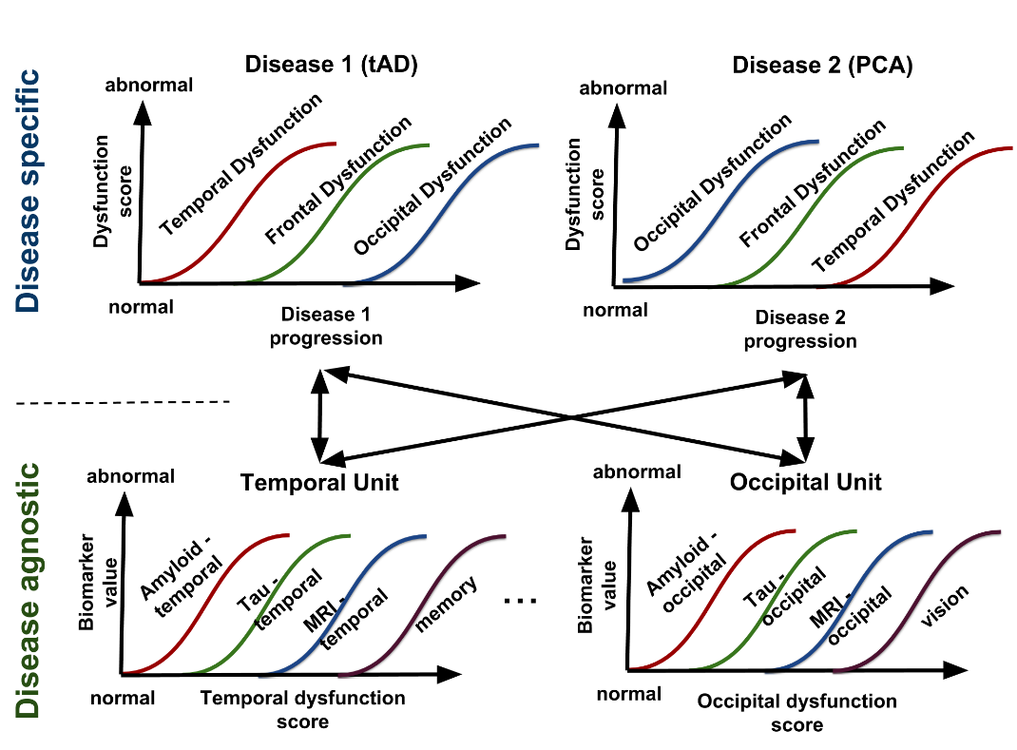
Figure 1. Diagram of the proposed DKT framework. We assume that each disease can be modelled as the evolution of abstract dysfunctionality scores (Y-axis, top row), each one related to different brain regions. Each region-specific dysfunctionality score then further models (X-axis, bottom row) the progression of several modality-specific biomarkers within that same region. The biomarker correlations within the bottom units are assumed to be disease agnostic and shared across all diseases modelled. Disease knowledge transfer can then be achieved via the disease-agnostic units.

Methods

DKT framework
Fig. 1 shows the overall diagram of our proposed framework for joint modelling of diseases. We assume that the progression of each disease (X-axis, top row) can be modelled as the evolution of abstract dysfunctionality scores, each one related to different brain regions (top row). Each dysfunctionality score is then modelled as the progression of several biomarkers within that same region, but acquired using different types of modalities (bottom row). Each group of biomarkers in the bottom row will be called a functional unit, because the correlations between biomarkers are related though common "function" in a disease agnostic way, since they are related to the same underlying brain region. Biomarker groupings into functional units are defined a-priori. We choose to model the correlations within each unit using the disease progression model (DPM) by Jedynak et al. 2012, but any other DPM can also be used. The DPM allows us to reconstruct unit-specific dysfunction progression manifolds (bottom row, X axis), which can be used for staging subjects. Finally, we use the same GP model to express the progression within each disease (Figure 1, top) in terms of the dysfunction scores estimated within each functional unit. More precisely, the X-axis dysfunction scores from the functional units become Y-axis measurements in the disease specific models.

The DKT framework has a generic mathematical formulation which uses several disease progression models as building blocks. We will first describe the generic framework, and in the following section we will present our chosen implementation of the building blocks. We assume a set of given biomarkers measurements Y = [y_{ijk} | (i,j,k) ∈ Ω] for subject i at visit j in biomarker k, where Ω is defined as the set of available biomarker measurements, since subjects can have missing biomarkers at various visits. We assume that each subject i at each visit j has an underlying disease stage s_{ij} = β_{i} + m_{ij}, where m_{ij} represents the months since baseline visit for subject i at visit j and β_{i} represents the time shift of subject i. We further denote by θ_{k} the parameters used to represent the trajectory for biomarker k ∈ K within its functional unit ψ(k), where ψ: {1, ..., K} → Λ is a function that maps each biomarker k to a unique functional unit l ∈ Λ, where Λ is the set of functional units. Moreover, we denote by λ_{d}^{l} the parameters for the trajectory of the dysfunction score corresponding to functional unit l ∈ Λ in the space of disease d. These definitions allow us to formulate the likelihood for a single measurement y_{ijk} as follows:
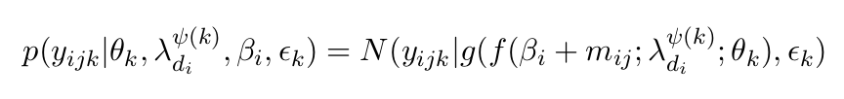
where g(. ; θ_{k}) represents the trajectory of biomarker k within functional unit ψ(k) and f( . ; λ_{di}^{ψ(k)}) represents the trajectory of the functional unit ψ(k) within the space of disease d_{i}. To be precise, d_{i} ∈ D represents the index of the disease space where subject i belongs, where D is the set of all diseases modelled. For example, MCI and tAD subjects from ADNI as well as tAD subjects from our local centre can all be assigned d_{i}=1, while PCA subjects from our local centre can be assigned d_{i} = 2. Healthy controls can be assigned to either disease space. Variable ε_{k} denotes the variance of measurements for biomarker k.
We extend the above model to multiple subjects, visits and biomarkers to get the full model likelihood:
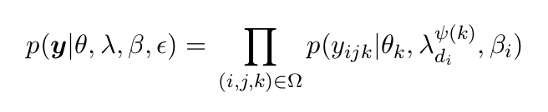
where y = [y_{ijk} | ∀ (i,j,k) ∈ Ω ] is the vector of all biomarker measurements, while θ = [θ₁, ..., θ_{k}] represent the stacked parameters for the trajectories of biomarkers in functional units, λ = [λ_{d}^{l} | l ∈ Λ, d ∈ D] are the parameters of the dysfunctionality trajectories within the disease models, β =[β₁, ..., β_{N}] are the subject-specific time shifts and ε = [ε_{k} | k ∈ K] estimate the biomarker measurement noise. Here, we assumed independence across different subjects, but the biomarker measurements and visits are linked using the latent time-shift β_{i} for each subject. The parameters of the model that need to be estimated are [θ, λ, β, ε].

Modelling biomarker trajectories
So far we defined the DKT framework using generic models g( . ; θ_{k}) and f( . ; λ_{di}^{ψ(k)}) for the biomarker trajectories within the functional units and the disease models. We choose to implement the f and g models as parametric sigmoidal curves, in order to enable fast optimisation and because these models account for floor and ceiling effects normally observed in AD biomarkers (Sabuncu et al., 2011, Caroli et al., 2010). The sigmoidal model for f is defined as:
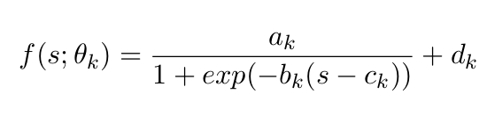
where s is the disease progression score of a subject and θ_{k} = [a_{k}, b_{k}, c_{k}, d_{k}] are parameters controlling the shape of the trajectory for biomarker k: d_{k} and d_{k} + a_{k} represent the lower and upper limits of the sigmoidal function, c_{k} represents the inflection point and a_{k} b_{k}/4 represents the slope at the inflection point. A similar model is used also for g.

Parameter estimation
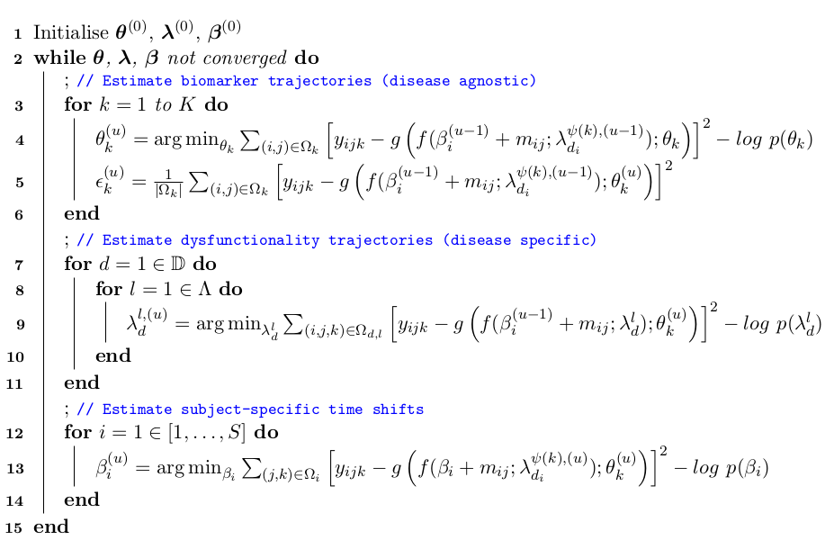
Figure 2: The algorithm for estimating the DKT parameters. The algorithm successively updates the biomarker trajectories within the functional units (disease agnostic models), dysfunctionality trajectories (disease specific) and subject-specific time shifts until convergence.
We estimate the model parameters using two-stage approach. In the first stage we aim to get an initial estimate of all the model parameters, which we do through belief propagation within each functional unit and then within each disease model. Each functional unit and disease model is assumed to be an independent disease progression model that we fit by alternatively optimising the biomarker trajectories and subject-specific time-shifts, using the approach described in Jedynak et al., 2012.
In the second stage we perform the full optimisation across all functional units and disease models using loopy belief propagation. An overview of the algorithm is given in Figure 2. Given the initial parameters estimated from the first stage (line 1), the algorithm continuously updates the biomarker trajectories within the functional units (lines 4-5), dysfunctionality trajectories (line 9) and subject-specific time shifts (line 13) until convergence. The cost function for all parameters is nearly identical, the main difference being the measurements (i, j, k) over subjects i, visits j and biomarkers k that are selected for computing the measurement error. For estimating the trajectory of biomarker k within functional unit ψ(k), measurements are taken from Ω_{k} representing all measurements of biomarker k from all subjects and visits. For estimating the dysfunctionality trajectories, Ω_{d,l} represents the measurement indices from all subjects with disease d (i.e. d_{i} = d) and all biomarkers k that belong to functional unit l (i.e. ψ(k) = l). Finally, Ω_{i} (line 13) represents all measurements from subject i, for all biomarkers and visits.

Synthetic Experiment
We first tested the DKT method on synthetic data, in order to assess the performance in the presence of ground truth. We generated synthetic data from two diseases as follows: we define two functional units l₀ and l₁ and 6 biomarkers k₀-k₆, which we allocate to functional units as follows: l₀: {k₀, k₂, k₄}, l₁: {k₁, k₃, k₅}. In a real setting, l₀ and l₁ would correspond to two brain regions, while {k₀, k₂, k₄} would correspond to biomarkers of different modalities corresponding to region l₀. Within functional units, we define the trajectories of each biomarker as sigmoidal curves with the following θ_{k} parameters: functional unit l₀: θ₀ = (1,5,0.2,0), θ₂ = (1,5,0.55,0) and θ₄ = (1,5,0.9,0) and functional unit l₁: θ₁ = (1,10,0.2,0), θ₃ = (1,10,0.55,0) and θ₅ = (1,10,0.9,0).
We next define two synthetic diseases, "synthetic AD" (d = 0) and "synthetic PCA" (d = 1). Each disease d is characterised by distinct signatures of dysfunctionality scores. Each dysfunctionality trajectory is defined as a sigmoidal curve with parameters λ_{d}^{l} as follows: "synthetic AD": λ₀⁰ = (1, 0.3, -4, 0) and λ₀¹ = (1, 0.2, 6, 0) and "synthetic PCA": λ₁⁰ = (1, 0.3, 6, 0) and λ₁¹ = (1, 0.2, -4, 0).
For the subject model, we generated time-shifts β_{i} for 100 subjects (disease d₀) and 50 subjects (disease d₁) based on a uniform distribution with ranges (-13, 10) years before/after disease onset. Within each disease, we generated the subjects' diagnosis (controls/patients) based on an exponential likelihood model with mean -4.5 (controls)/4.5 (patients) years before/after disease onset. For each subject and each biomarker, we generated data for four consecutive visits, each visit one year apart, using a noise standard deviation of 0.05.
The choice of these parameters and the smaller number of subjects in the second disease were chosen to mimic the cohorts from TADPOLE and our local centre, described further below. Before fitting DKT on the synthetic dataset, we discarded the data from biomarkers k₀, k₁, k₄ and k₅ for all subjects within the synthetic PCA cohort, to simulate the lack of multimodal data in these subjects. Remaining biomarkers k₂ and k₃, for which data was still available in the synthetic PCA cohort, are assumed to be of the same modality (e.g. MRI volume) but to represent measurements from different brain regions (e.g. temporal and occipital).

Data acquisition and Preprocessing
We chose to train DKT on ADNI data from the TADPOLE challenge (Marinescu et al., arXiv, 2018), since it contained a large number of multimodal biomarkers already pre-processed and aggregated into one table. From the TADPOLE dataset we selected a subset of 230 subjects which had at least one FDG PET, AV45, AV1451 or DTI scan. Most subjects also had MRI scans and cognitive tests. From our local centre, we used 87 controls, 76 PCA and 67 tAD subjects which only had MRI scans. For both datasets, volumetric measures for each subject have been obtained using the Freesurfer software. For FDG, AV45 and AV1451 PET, we used already extracted SUVR measures from ADNI. For DTI, we used fractional anisotropy (FA) measures from white-matter regions adjacent to each lobe. For every lobe, we averaged the biomarker values for regions of interest within each lobe and regressed out the following covariates: age, gender, total intracranial volume (TIV) and dataset (ADNI vs our local dataset). Finally, we normalised the biomarker values to lie within the [0,1] range.
For validation, we used a separate test set of DTI scans from our local controls and PCA subjects. As this validation set was acquired at a centre different from ADNI and on different scanners, we matched the FA mean and standard deviation of our local controls to be equal to the FA mean and standard deviation of the ADNI controls. No DTI data from PCA subjects was exposed to the algorithm at training time.

Results

Synthetic Results
Fig. 2 shows the true and estimated subject shifts and trajectories for each functional unit l and biomarker k. In the top-left figures we show scatter plots of the true shifts (y-axis) against estimated shifts (x-axis), for the 'synthetic AD' and 'synthetic PCA' diseases. On the top-right and middle-left figures, we show the trajectories of the functional units within disease d=0 (synthetic AD) and d=1 (synthetic PCA). In the middle-right and bottom-left figures, we show the biomarker trajectories within units l₀ and l₁. In Figure 3., we show the corresponding trajectories of PCA patients, which as opposed to Fig. 2, are plotted directly against the time-shifts, as it is normally done in a classical disease progression model. We also show the true trajectories and the data of the synthetic PCA cohort.
The results in Fig. 2. suggest that the DKT-estimated trajectories match closely with the true trajectories, for both the unit-trajectories within the disease-specific models and the biomarker trajectories within the disease-agnostic models. Moreover, the subject time-shifts are very close to the true time-shifts. When plotted directly against the disease space, the estimated PCA trajectories also match the true trajectories, even when there is a complete lack of such data (Fig. 3, biomarkers 0,1,4 and 5). There are however small errors in biomarkers 0 and 5 which are due to drifts caused by measurement noise.

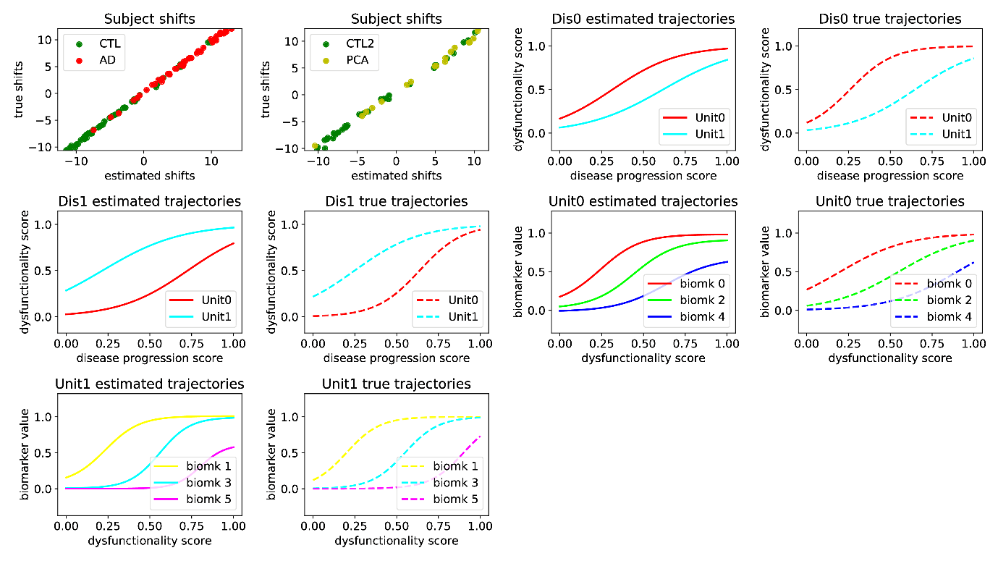
Figure 2. Comparison between true and DKT-estimated subject time-shifts and biomarker trajectories. (top-left) Scatter plots of the true shifts (y-axis) against estimated shifts (x-axis), for the 'synthetic AD' (left) and 'synthetic PCA' (right) diseases. We also show the DKT-estimated and true trajectories of the functional units within the 'synthetic AD' disease (top-right) and the 'synthetic PCA' disease (middle-left). For these figures, the x-axis measures the normalised disease progression score s_{i} while the y-axis measures the dysfunctionality scores f(s_{i} ; λ_{d}^{l}). Finally, we also show the biomarker trajectories within unit l₀ (middle-right) and unit l₁ (bottom), where the x-axis represents the dysfunctionality scores f(s_{i} ; λ_{d}^{l}) and the y-axis represents the biomarker value.

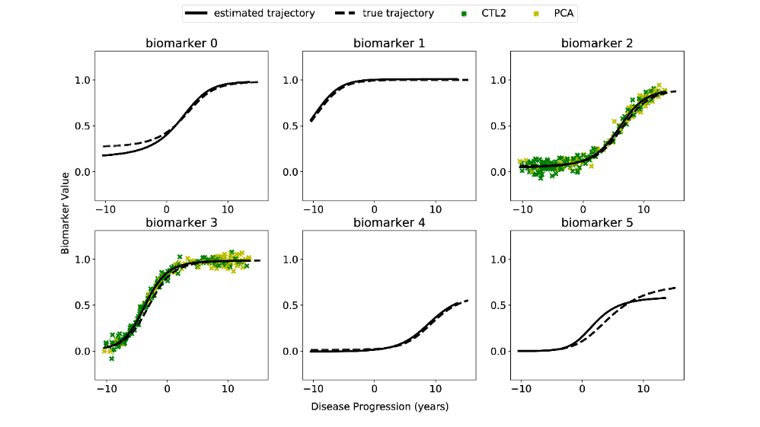
Figure 3. Estimated biomarker trajectories for the "synthetic PCA" disease, plotted alongside true trajectories. Estimation of the trajectories in biomarkers 0,1,4 and 5 has been done without any data from the "synthetic PCA" disease, only based on the disease-agnostic correlations with biomarkers 2 and 3.

Results on TADPOLE and our local datasets
Fig. 4 (top) shows the estimated biomarker trajectories within the occipital unit plotted over the dysfunction scores, along with samples from the model posterior and aligned subject data. The X-axis shows the dysfunctionality scores within the occipital unit, which represent estimated time-shifts, in months, from an arbitrary reference X=0, while the Y-axis shows biomarker values normalised to [0,1] range. The model shows a good data fit, and we can observe most PCA subjects having abnormal occipital volumes, thus leading to high occipital dysfunctionality scores, in line with the current understanding of PCA as affecting posterior regions (Crutch et al., 2012). We also show the progression of dysfunctionality scores over the disease stage for typical AD and PCA (Fig 4, bottom). In typical AD, we see that hippocampal dysfunction becomes abnormal earliest, while PCA shows early hippocampal dysfunction, which is later exceeded by the dysfunction in the occipital, temporal and parietal regions, which are known to be affected in PCA (Crutch et al., 2012, Baron et al., 2001).
In Fig. 5, we plot the inferred biomarker trajectories for PCA directly across the disease progression. We do this for five different modalities: MRI volumes, DTI, FDG, AV45 and AV1451. The results again recapitulate known patterns in PCA, where posterior regions are predominantly affected in all modalities. However, for MRI volumes and AV45, we also see early abnormalities, which we attribute to the models underestimating the biomarker measurement noise.

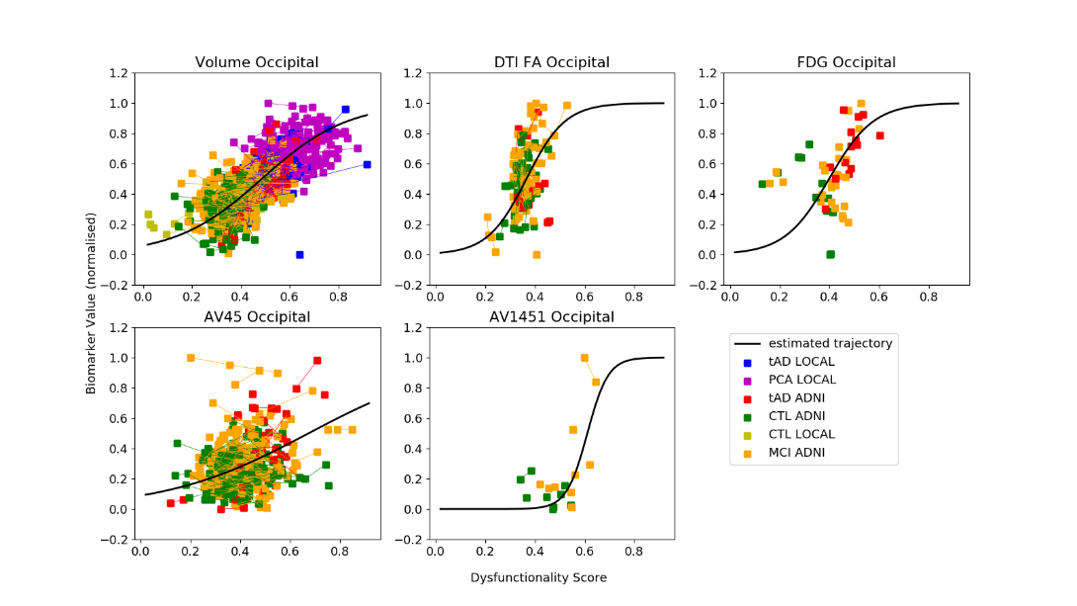
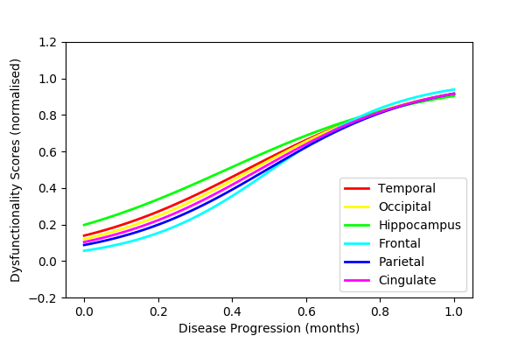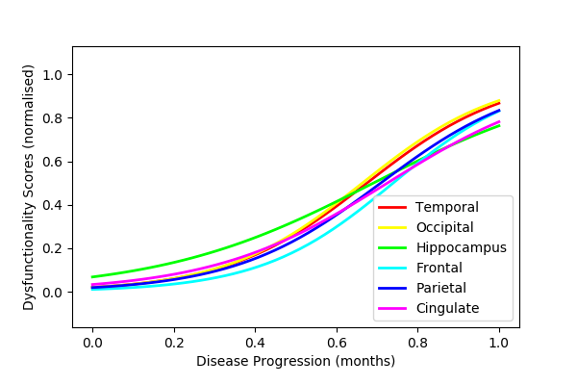
Figure 4. (top) DKT-estimated biomarker trajectories in the occipital functional unit. Subject data from ADNI and our local cohort are also shown. The X-axis, defined as the occipital dysfunctionality score, represents the time-shifts (in months) of each subject. Red lines represent samples from the trajectory posterior. The Y-axis measures biomarker values (normalised). (bottom) Progression of DKT-estimated dysfunctionality scores for (left) typical AD and (right) PCA.
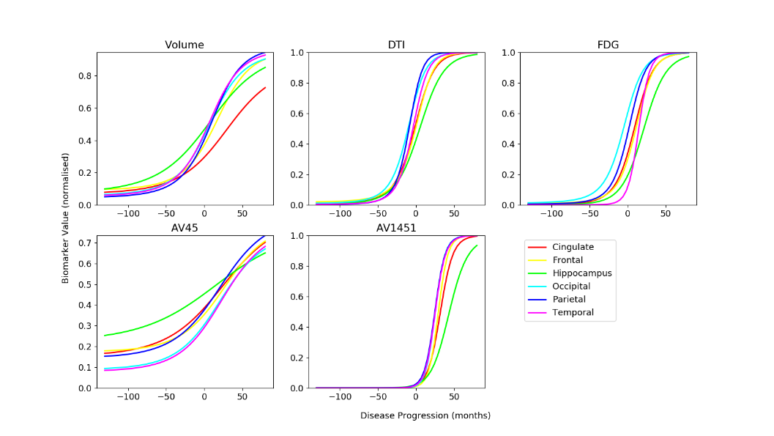
Figure 5. Estimated multi-modal trajectories for the PCA cohort. The only data that were available were the MRI volumetric data. The dynamics of the other biomarkers has been inferred by the model using data from typical AD, and taking into account the different spatial distribution of pathology in PCA as compared to typical AD.

Validation
We validated our model using a separate test set of 20 DTI scans from controls and PCA patients from our local cohort. We used DKT to predict the DTI biomarker values for the subjects within the unseen test set, using only their MRI biomarkers. Table 1. shows the prediction mean squared error (MSE) and rank correlation between the DKT predicted biomaker values and the true values. We computed the rank correlation in order to remove the effect of any systemic biases due the completely different disease and dataset that we are predicting on. We also show similar performance metrics for two simpler models: (1) a latent stage model of disease progression model, as described in Jedynak et al., 2012, which assumes all tAD and PCA subjects follow the same progression and (2) a linear univariate regression model that predicts the DTI biomarker based on the corresponding MRI biomarker, independently for each region.
The results from Table 1 indicate that the DKT predictions are relatively small for the frontal, occipital, temporal and parietal areas. Moreover, rank correlation of the DKT predicted values is also high for the cingulate lobe and the hippocampus. In terms of model comparison, DKT has better performance than the linear model (all differences are statistically significant with p < 0.002, Bonferroni corrected) and similar performance to the latent stage model. However, the fact that DKT has a similar performance to a simpler latent-stage model suggests that the patterns it estimates are meaningful. Moreover, the performance difference might become statistically significant when tested on diseases with more distinct evolutions such as Frontotemporal dementia or Huntington's and Parkinson's disease, because in this case the assumption of the latent-stage model that all patients follow the same progression breaks down.
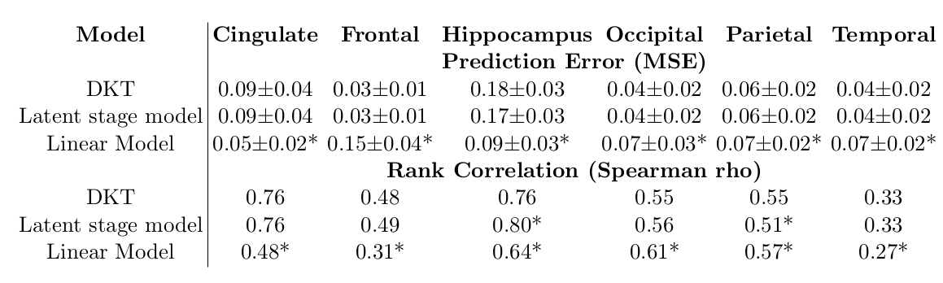
Table 1. Performance evaluation of DKT and two simpler models: a latent stage disease progression model and a linear univariate model of DTI predicted from MRI. The top table shows the prediction error (MSE) while the bottom table shows the rank correlation measured by Spearman's rho. (*) Statistically significant difference between the current model performance and DKT, based on a two-tailed t-test, Bonferroni corrected.

Discussion
We presented DKT, a framework that enables, for the first time, joint modelling of biomarker progressions in multiple dementias simultaneously. The framework allows the inference of biomarker trajectories in rare dementias, for which there is not enough data to allow estimation of such trajectories, and accounts for a different spatial distribution of pathology between distinct types of dementia. This further enables us to understand the complex mechanisms of rare dementias, as well as shared mechanisms between different types of related dementias.
Although we provided an actual implementation of DKT using specific models of the biomarker trajectories, measurement noise and link function (the disease progression score), DKT should be considered as a general framework for joint modelling of biomarker trajectories within different diseases simultaneously. The DKT framework tries to disentangle disease-specific from disease-agnostic correlations between biomarkers. The actual implementation of DKT can thus be extended to use non-parametric trajectories, or more complex link functions that estimate not only subject time-shifts but also progression speed or higher order terms.
While in this work we have focused on Alzheimer's variants such as tAD and PCA, DKT can also be applied to other progressive neurodegenerative diseases of non-Alzheimer's type such as tauopaties (e.g. Frontotemporal dementia), synucleinopathies (e.g. Parkinson's disease), other diseases such as Huntington's disease or Multiple Sclerosis, and even the normal aging process. Cognitive tests can also be included in the DKT model and even allocated in the functional units of the regions that are responsible for those tasks, based on previous voxel-based morphometry studies. However, some care needs to be exercised when selecting the biomarkers and grouping them into functional units, as in some diseases the assumption of disease agnostic dynamics might not hold for some groups of molecular biomarkers. For example, some non-Alzheimer's tauopaties such as Frontotemporal dementia might show tau abnormalities but no corresponding amyloid abnormalities within the same region. However, higher-level biomarkers such as glucose metabolism from FDG, while matter degeneration from DTI or volume from structural MRI should have more disease-agnostic dynamics over time.
The DKT methodology has several limitations that need to be addressed. First of all, the model assumes that within each region there is enough disease signal in the data to properly estimate the dysfunctionality scores. In our case with tAD and PCA, this can be a problem when estimating the dynamics of non-MRI occipital biomarkers, which might not reach a high level of abnormality in tAD. As a result, when predicting the corresponding dynamics in PCA, DKT might need to rely on trajectory extrapolation or on enough heterogeneity within the tAD population. However, whenever there is a lack in disease signal, DKT can naturally reflect such lack of knowledge through higher uncertainty in the estimated trajectories. Another limitation of our work is that we assume all subjects follow the same trajectory of disease, without taking into account the heterogeneity within the disease population. Yet another limitation of DKT is that it works on extracted brain features, discarding important information present in the brain morphometry.
There are several potential avenues for further research. During training, we can account for missing disease signal in some brain regions by adding data from other types of dementias that affect those regions. To account for heterogeneity, the DKT formulation can also be easily extended to include subject-specific effects. Another direction of future research is to extend DKT into a fully spatio-temporal model, by estimating continuous changes in volumetric brain images or cortical shapes. In this case, each voxel can have an associated dysfunctionality score that is derived from measurements of various modalities from that voxel, and perhaps from neighbouring voxels or from voxels that are connected through white-matter tracts or functional (fMRI) links. Future work can also improve the a-priori allocation of biomarkers to functional units by taking connectivity into account, or performing this allocation in a data-driven way, by finding which groups of biomarkers show the highest correlations across all diseases being modelled.

