In this project, I built a dashboard to visualize the difference between the target set for company ABC and the actual profit realized.

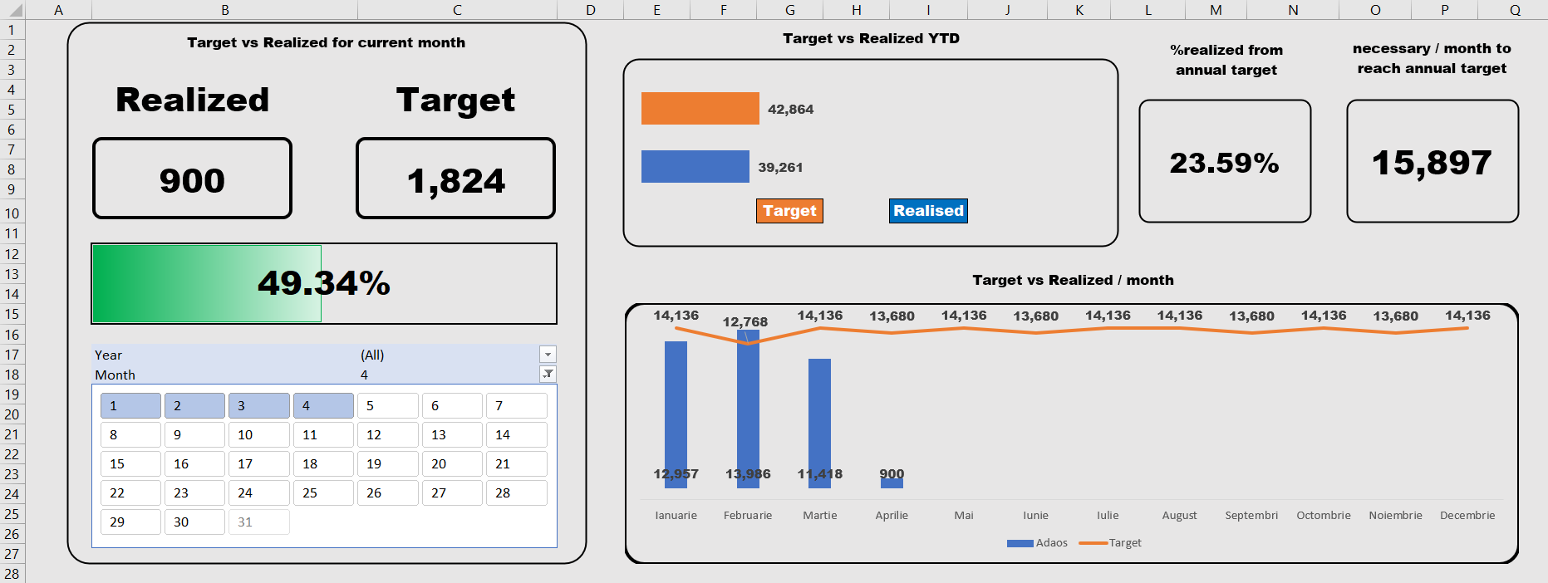

This Dashboard contains:

|  |  |
| --- | --- |
|  | A calendar which can be used to track the target vs realized, both as values and percentage realized from total target. This area of the dashboard can display data for any custom range of days, for either 1 month or multiple cumulated months. I believe its best use is to track month to date evolution. |

1. This chart displays the total target vs realized year to date.

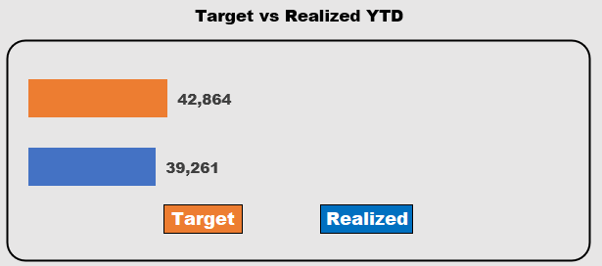

|  |  |
| --- | --- |
|  | Here we have a KPI card that displays the percentage realized from the annual total target. |

|  |  |
| --- | --- |
|  | Here we have a calculation that indicates the amount needed to be made each month, for the remaining months, which cumulated with the current Realized, is enough to hit the Target. |

1. This chart represents the target vs realized situation, per month, year to date.

The blue bars represent the Realized and the orange line represents the Target.

