CDA
Website Requirement Specification

Author | Date | Version
Shannon Greenall | 05/08/2025 | V1

CONTENTS

- Designs 6
  - Design Links 6
- Overview Of Platform, Architecture & Settings 10
  - Platform 10
  - Domain Names 10
  - Security 10
  - Cross Browser Compatibility 10
  - Responsive design 11
  - SEO 11
  - Website Performance 13
  - Cookies 13
  - WordPress General Settings 13
  - WordPress 13
  - Contact Forms 16
  - Form Field Validation 16
  - Images 16
  - Videos 16
  - Animation 17
  - Links 17
  - Content Sharing 17
  - Next JS Front End 17
- Cross Population of Content 18
  - Overview 18
- Third-party Systems 19
  - HubSpot 19
  - Emails: Brevo 22
  - Lead Forensics 22
  - Zoominfo 22
  - Spam Captcha 22
  - CleanTalk 22
- Tracking 23
  - Google Tag (Analytics) 23
  - Google Tag Manager 23
- Navigation 25
  - Admin 25
  - Header Bar 25
  - Footer 25
  - Floating CTA 26
- Content Pages 28
  - Homepage 28
  - About 28
  - Team Listing 29
  - Team Profile 29
  - Services Landing 30
  - Service Overview - eCommerce 30
  - Service Details Page 31
  - Service Overview – Outsourced CMO 32
  - Knowledge Hub 33
  - Case Study Page 33
  - News Article Page 34
  - Contact Us 35
  - Jobs Listing (Careers) 35
  - Job Details 36
  - Technologies 36
  - ROI Calculator 37
  - Policies Landing 38
  - Policies Details 38
  - 404 38
- Content Repeater Rows 39
  - Rules 39
  - Homepage header 39
  - Image & frame left, text & CTA right 39
  - Services Accordion 40
  - Technologies Slider 41
  - Values 41
  - Showreel 42
  - Stats & Image 42
  - Case Studies 43
  - Locations with image 43
  - News Carousel 44
  - Newsletter 44
  - Content Page Header 45
  - USPs 45
  - Culture Gallery slider 46
  - Approach 47
  - Full Video 47
  - Indented Image left, text right 47
  - Team Image left, text right 48
  - Join Our Team 49
  - Team Profile 49
  - Meeting Booker 50
  - Team Carousel 50
  - Services carousel with images 51
  - Services header 51
  - Services Expanded 51
  - Introduction: 2 CTAs 52
  - Service cards 52
  - List left, text right 53
  - Centred text CTA 53
  - Text Left 54
  - Client logos & image 54
  - Service Stats 55
  - Two Column text 55
  - CTA & Image on grey 55
  - Services introduction: 1 CTA 55
  - Full width text (grey background) 56
  - Video left, text right 56
  - Full width text (white background) 57
  - Text left, image & frame right 57
  - Image left, text & CTA right 58
  - 3 x Columns with icons 58
  - Contact form left, image right 58
  - Global Blocks 59
- POST Types 60
  - Services 60
  - Technologies (Platforms) 60
  - Case Studies (Projects) 60
  - News (Insights) 60
  - Jobs (Careers) 60
  - Sectors 60
  - Team 60
  - Policies 61
- cONTENT Migration 62
  - Current Content 62

DESIGNS
  - Design Links

Task | Detail
1. | Homepage:  Desktop: https://xd.adobe.com/view/9cf12dde-5df7-4ecd-829d- 0752783f401e-c9a2/  Mobile: https://xd.adobe.com/view/9cf12dde-5df7-4ecd-829d- 0752783f401e-c9a2/screen/388a27cf-5825-491e-9659-661cdb6dc317  Menu:  Desktop: https://xd.adobe.com/view/9cf12dde-5df7-4ecd-829d- 0752783f401e-c9a2/screen/15383bab-8dac-4f8a-8427-e61077b64c51 Mobile: https://xd.adobe.com/view/9cf12dde-5df7-4ecd-829d- 0752783f401e-c9a2/screen/2a159570-249f-429e-9b68-f65d5375e146  & https://xd.adobe.com/view/9cf12dde-5df7-4ecd-829d- 0752783f401e-c9a2/screen/d9cc7e1a-1d80-47b4-b028-21015bf804d6  About:  Desktop: https://xd.adobe.com/view/9cf12dde-5df7-4ecd-829d- 0752783f401e-c9a2/screen/550947c2-3791-459a-b7eb-dd584e08a4ac Mobile: https://xd.adobe.com/view/9cf12dde-5df7-4ecd-829d- 0752783f401e-c9a2/screen/7c5f65f5-7bf3-44f9-8af3-927c454417fe  Team listing:  Desktop: https://xd.adobe.com/view/9cf12dde-5df7-4ecd-829d- 0752783f401e-c9a2/screen/fc1a2a23-2da0-45b9-9787-dd08e5c27196 Mobile: https://xd.adobe.com/view/9cf12dde-5df7-4ecd-829d- 0752783f401e-c9a2/screen/2056b993-49c5-4dbd-a3f1-56205b377309  Team profile:  Desktop: https://xd.adobe.com/view/9cf12dde-5df7-4ecd-829d- 0752783f401e-c9a2/screen/d155a286-e5fd-41e3-94b8-40d849ce780e Mobile: https://xd.adobe.com/view/9cf12dde-5df7-4ecd-829d- 0752783f401e-c9a2/screen/32edea47-42e4-4f7c-b6c6-164653309622  Services Landing:  Desktop: https://xd.adobe.com/view/9cf12dde-5df7-4ecd-829d- 0752783f401e-c9a2/screen/126330cf-344a-4abc-8015-15650ee95fa3 Mobile: https://xd.adobe.com/view/9cf12dde-5df7-4ecd-829d- 0752783f401e-c9a2/screen/3be3ddd3-a716-49bf-8ba8-7548ba64ef9d

Book a time CTA pop up:
Desktop: https://xd.adobe.com/view/9cf12dde-5df7-4ecd-829d- 0752783f401e-c9a2/screen/d4575eda-5ce0-4190-b67f-4a44e4bf7ae5 Mobile: https://xd.adobe.com/view/9cf12dde-5df7-4ecd-829d- 0752783f401e-c9a2/screen/a0abb029-3472-4e49-a191- 38bdad4645e4
Service Overview (top level service category):
Desktop: https://xd.adobe.com/view/9cf12dde-5df7-4ecd-829d- 0752783f401e-c9a2/screen/b3be3cd0-18fe-470e-92cd-7f84d67cde3a Mobile: https://xd.adobe.com/view/9cf12dde-5df7-4ecd-829d- 0752783f401e-c9a2/screen/dc07badc-fe28-4732-bf2e-db2eac2224b2

Service Details pages:
eCommerce related services:
Desktop: https://xd.adobe.com/view/9cf12dde-5df7-4ecd-829d- 0752783f401e-c9a2/screen/c7a85972-6516-4d9e-9f8e-3f87d9f85837 Mobile: https://xd.adobe.com/view/9cf12dde-5df7-4ecd-829d- 0752783f401e-c9a2/screen/8d0ed72b-7f38-4bfa-ab04-48076e0f5254
Outsourced CMO:
Desktop: https://xd.adobe.com/view/9cf12dde-5df7-4ecd-829d- 0752783f401e-c9a2/screen/f4f0c68e-6e2c-493f-bc19-e610a8b58456 Mobile: https://xd.adobe.com/view/9cf12dde-5df7-4ecd-829d- 0752783f401e-c9a2/screen/6ae930ef-5a65-4ba4-88da-0c9f1ceb21f5

B2B Lead Generation:
Desktop: https://xd.adobe.com/view/9cf12dde-5df7-4ecd-829d- 0752783f401e-c9a2/screen/b2e8fcad-e032-4c74-9e07-dc129d72fd45 Mobile: https://xd.adobe.com/view/9cf12dde-5df7-4ecd-829d- 0752783f401e-c9a2/screen/ff6eb7b2-0928-4b1c-b81f-f1fb55308dce
Software Development:
Desktop: https://xd.adobe.com/view/9cf12dde-5df7-4ecd-829d- 0752783f401e-c9a2/screen/f4a974d4-68c2-4b3e-8c35-ad40c29ee2c1 Mobile: https://xd.adobe.com/view/9cf12dde-5df7-4ecd-829d- 0752783f401e-c9a2/screen/372aac62-7753-48c3-a153-bfcb2cfdc749
Booking systems:
Desktop: https://xd.adobe.com/view/9cf12dde-5df7-4ecd-829d-
0752783f401e-c9a2/screen/765a1e32-4c52-4746-918c-13aeaf9c20de

Mobile: https://xd.adobe.com/view/9cf12dde-5df7-4ecd-829d- 0752783f401e-c9a2/screen/a6a1c3a5-70f9-4e9a-983b-d72c3dc0e194

Digital Marketing:
Desktop: https://xd.adobe.com/view/9cf12dde-5df7-4ecd-829d- 0752783f401e-c9a2/screen/05a30f16-94c5-4633-87af-fe2a2187e1ac Mobile: https://xd.adobe.com/view/9cf12dde-5df7-4ecd-829d- 0752783f401e-c9a2/screen/7673cd17-9e57-44a6-beed- 5391072d8703
AI:
Desktop: https://xd.adobe.com/view/9cf12dde-5df7-4ecd-829d- 0752783f401e-c9a2/screen/1df76772-57a3-46d1-a3bf-a1cf004d07ad Mobile: https://xd.adobe.com/view/9cf12dde-5df7-4ecd-829d- 0752783f401e-c9a2/screen/b0f5244f-0e69-40cd-b68b-2fa7a85746e5

Knowledge Hub (Resources Listing):
Desktop: https://xd.adobe.com/view/9cf12dde-5df7-4ecd-829d- 0752783f401e-c9a2/screen/1b94f16f-4479-4d57-9681-d3bdf4544b33 Mobile: https://xd.adobe.com/view/9cf12dde-5df7-4ecd-829d- 0752783f401e-c9a2/screen/7ac11444-0921-4620-8613-
6b0470e46e8a
Knowledge Hub > Case Study
Desktop: https://xd.adobe.com/view/9cf12dde-5df7-4ecd-829d- 0752783f401e-c9a2/screen/ccd3eb7a-6b59-49c4-8c70-48ca63b19423 Mobile: https://xd.adobe.com/view/9cf12dde-5df7-4ecd-829d- 0752783f401e-c9a2/screen/8ee0aaf4-43d3-45b1-825e-5c7b31fc30d4

Knowledge Hub > News article
Desktop: https://xd.adobe.com/view/9cf12dde-5df7-4ecd-829d- 0752783f401e-c9a2/screen/53a5094e-b1d5-4fb4-ae88-f77047c59f20 Mobile: https://xd.adobe.com/view/9cf12dde-5df7-4ecd-829d- 0752783f401e-c9a2/screen/3a6bd8da-98b2-4221-961b- 78e9768d3de2
Contact:
Desktop: https://xd.adobe.com/view/9cf12dde-5df7-4ecd-829d- 0752783f401e-c9a2/screen/cd4cb054-cea0-447f-a267-f25ebb6769a1 Mobile: https://xd.adobe.com/view/9cf12dde-5df7-4ecd-829d- 0752783f401e-c9a2/screen/1782df86-919a-46da-a4dd-ea7f29969e78

Careers (jobs listing):
Desktop: https://xd.adobe.com/view/9cf12dde-5df7-4ecd-829d- 0752783f401e-c9a2/screen/fcde4897-5397-48f9-9742-b3c8cdb1af92 Mobile: https://xd.adobe.com/view/9cf12dde-5df7-4ecd-829d- 0752783f401e-c9a2/screen/0b5765b9-5412-4f99-aed1-cef9f68f558f
Careers > Job details
Desktop: https://xd.adobe.com/view/9cf12dde-5df7-4ecd-829d- 0752783f401e-c9a2/screen/c8146ee5-407a-4c7d-bf92-1191ad0db4cb Mobile: https://xd.adobe.com/view/9cf12dde-5df7-4ecd-829d- 0752783f401e-c9a2/screen/40b89e81-36ae-4c42-b3f9-7dae8da35315

Technologies:
Desktop: https://xd.adobe.com/view/9cf12dde-5df7-4ecd-829d- 0752783f401e-c9a2/screen/dfce0b80-ccbe-4bcc-925e-0448d68dd1a0 Mobile: https://xd.adobe.com/view/9cf12dde-5df7-4ecd-829d- 0752783f401e-c9a2/screen/c4cb033d-b93f-4159-853d-bd7f4a3383b7
ROI Calculator:
Desktop: https://xd.adobe.com/view/9cf12dde-5df7-4ecd-829d- 0752783f401e-c9a2/screen/85ad3331-e79a-444e-b899-a956460abf43 Mobile: https://xd.adobe.com/view/9cf12dde-5df7-4ecd-829d- 0752783f401e-c9a2/screen/f07219e5-b876-4ee1-8f61-734963013322
Policies Landing:
Desktop: https://xd.adobe.com/view/9cf12dde-5df7-4ecd-829d- 0752783f401e-c9a2/screen/cfd7a7bd-486a-4fcd-a0e6-6a64ee38a821 Mobile: https://xd.adobe.com/view/9cf12dde-5df7-4ecd-829d- 0752783f401e-c9a2/screen/4c18ce4d-20cf-4aa5-9516-c0794128a978

Policy Details:
Desktop: https://xd.adobe.com/view/9cf12dde-5df7-4ecd-829d- 0752783f401e-c9a2/screen/7933484f-d687-4d75-a34b- 62187e539b88
Mobile: https://xd.adobe.com/view/9cf12dde-5df7-4ecd-829d- 0752783f401e-c9a2/screen/7f7b6394-1c28-43fb-bab2-73183e4e7fa9
404:
Desktop: https://xd.adobe.com/view/9cf12dde-5df7-4ecd-829d- 0752783f401e-c9a2/screen/6b06c851-32ef-4efb-99c1-00a02c7846e8 Mobile: https://xd.adobe.com/view/9cf12dde-5df7-4ecd-829d-
0752783f401e-c9a2/screen/1dc2572b-989c-44b6-a4a8-f0622279205a

OVERVIEW OF PLATFORM, ARCHITECTURE & SETTINGS
  - Platform

Task | Detail
2. | The website will be build on WordPress with a Next JS front end
  - Domain Names

Task | Detail
3. | The website domain will be cda.group
4. | The www version should redirect to the non www version
  - Security

Task | Detail
5. | WordPress admin to be a random string of numbers and letters and  not the default /admin. For example: domainname.com/dhdh4j21mds23
6. | No admin usernames to be set to ‘admin’
7. | Disable directory listing through .htaccess file
8. | In WordPress remove the WordPress Version, script version and Site Editor under appearance menu
9. | All website Admin logins must use Two Factor Authentication.
  - Cross Browser Compatibility

Task | Detail
10. | The website application must be responsive and work on the following operating systems, browsers and devices:  - Windows PC / Laptop / Desktop:  Google Chrome | Firefox |Safari (Latest versions) | Edge  - Apple Mac Laptop / Desktop:  Last 3 years operating systems | Safari | Google Chrome | Firefox  - Apple iPhone  Released in the last 3 years Default Safari browser  - Android phones  Released in last 2 years | Samsung | Google Pixel | Sony

Default Chrome browser
- Apple iPads
Released in the last 3 years Default Safari browser
- Android tablets
Released in last 2 years | Samsung | Google Pixel | Sony Default Chrome browser
  - Responsive design

Task | Detail
11. | Responsive design should work for the following screen resolutions:  - Desktop: 1366x768 | 1920x1080 | 1440x900 | 1536x864 | 1600x900 | 1280x720 | 1280x800 | 1280x1024 | 1024x768 |  1680x1050 | 2560x1440 | 1360x768 | 1920x1200  - Tablet: 768x1024 | 1280x800 | 1024x1366 | 800x1280 | 834x1112 | 600x1024 | 1024x768 | 962x601 | 1024x600  - Mobile: 360x640 | 375x667 | 360x720 | 414x736 | 412x846 | 360x760 | 375x812 | 360x740 | 412x732
  - SEO

Task | Detail
12. | Ensure Yoast is installed and reads all the page content (description  and repeater fields).
13. | Data will be structured using www.schema.com as the best format to use) to increase the number of ways Google can display the content,  thus increasing opportunities for users to engage with the website and specific content.
14. | Automated XML Sitemap generator with url  domainname.com/sitemap.xml
15. | Site must be submitted to webmaster tools and all URLs must pass.
16. | Favicon must be added.
17. | Site title must be our brand name spelt correctly with grammar and  spacing: CDA
18. | URL Structure  - No underscores (_) in URL’s – use hyphen’s (-)

- All URLs to be friendly (for example www.domainname.com/category/page-name)
- No file extensions such as .html / .htm /.etc
- When filtering search results / categories / blog listings the URL must build up and be unique
- Services should not include category in URL. They should be domainname.com/service-name. Not domainname.com/category name/service-name
19. | Duplicate Content and pages  - Having any form of duplicate content can confuse Google as to which page to rank, potentially affecting your rankings and in turn your traffic and conversions/sales.  - Page URLs; from multiple site versions - “www.” / “non-www  - Site will use non www and the www version will redirect to it  - Homepage: Specifically checking variations of your homepage  such as “/home”, “/index.php”, “/index/html” etc.
20. | Robots TXT file  - A robots.txt file tells Google which pages not to crawl. This must be included. By default, it should allow all pages to be crawled.
21. | JavaScript rendering –  - JavaScript takes twice as long to crawl and render by Google, this is why it’s pertinent to check whether all of pages are able to be crawled and indexed in a timely manner. Please keep rendering to a minimum.  - Page content must use header hierarchy H1, H2, H3, H4, H5, H6  - All pages in the eCommerce flow must have configurable meta titles, keywords etc. This includes all category pages, products pages, basket, checkout etc.  - 301 Redirects should be controlled through htaccess file and  will be supplied in Excel format as part of the go live procedure.
22. | For all pages on the website we need:  - Ability to write and amend SEO Tags in CMS  - Ability to write and amend Meta Descriptions in CMS  - Ability to write and amend Meta Tags in CMS  - Ability to write and amend Alt tags in CMS  - Ability to write and amend URL Slug in CMS
23. | Ability to stop search engines indexing pages by adding no follow tags.
24. | Ability to add alt texts to all images.

25. | Website needs to optimise images for web automatically. So, if a website admin uploads a large file the website compresses and saves for web.
26. | Programming of website to include all SEO best practices.
  - Website Performance

Task | Detail
27. | Using Google Page Speed Insights website must score about 80 for  mobile and desktop - https://developers.google.com/speed/pagespeed/insights/
28. | Using GT Metrix, the site must score a A for Page Speed Score andA for  Y-Slow Score - https://gtmetrix.com/
  - Cookies

Task | Detail
29. | On site load (no matter what page) the user must be presented with a cookie acceptance widget where we ask the user to either agree or disagree to using the cookies.  Based on decision by the user the website should disable the cookies  accordingly or use them.
30. | No cookies will be placed until accepted by the website user.
  - WordPress General Settings

Task | Detail
31. | - Site Title = CDA – Digital Agency  - Tagline = Digital With a Human Touch  - Administration Email Address = info@cda.group  - Site Language = English (UK)  - Timezone = London  - Date Format = written in full e.g. 11th March 2023  - Time Format = hh:mm  - Week starts on = Monday
  - WordPress

Task | Detail
32. | Guttenburg / Elemantor editor to be removed in WordPress as this will  be replaced with CDA flexible repeater row.
33. | No plugins should be used for content, such as Divi in WordPress.
34. | All repeater rows will have a WYSIWYG editor so admin can add  formatting, bullet points etc.
35. | Bullet point formatting should match the site design and style of the  website, including spacing between lines and indentation.

36. | WordPress Posts (Blogs etc):  - Posts must be set up with featured image for the listing page and a second featured image for the article page itself. If no article page image is added, then the default featured image is shown.  - There must be a desktop and mobile image upload field for both listing featured, and article featured images  - Filters must be dynamic and only show the filter options that have been tagged to the content shown. After the user selects a filter option to filter the articles shown, the other filter options should then reflect what has been tagged for the remaining content only, until the user clears the filters.  - On post listing pages where there is a filter, the filter should not be selected or filtered in any way on page load, until the user selects an option.  - There must always be a ‘clear filters’ option and page should  use ajax and not refresh when narrowing choices on filters.  - Where we have a ‘latest post’ widget on a page, by default the latest articles are shown, with the most recent on the left. If admin requires, they can override this per page and choose which articles show based on either tags or by selecting the articles themselves.  - The other default functionality of WordPress posts should remain. Such as published date, authors, title, categories  - For authors, the admin will be able to create a list of authors and then assign one to an article. For each Author we will require name and image. This is not mandatory, or neither are the fields.  - The table must use flexible row content and is not mandatory.
37. | Custom Post Type  - The website is designed with pages such as case studies, team members, FAQ’s, jobs and testimonials specification will be provided for that project. However, all these custom post types must utilise WordPress best practise and allow website admin multiple tags.  - Unless stated per project the custom post should not be viewable out of a page URL. For example, if we had FAQ post type then they would only be viewable on a team page that uses custom post type rather than the raw data contained in the post on its own URL.

- All data filed should be based on repeater content blocks so that the website admin only has to enter the data via fields and the general editor.
- If a featured image is set for a post type, both mobile and desktop options should be presented. If the mobile image is not uploaded, then it will default to the desktop.
- Where we have a ‘latest XXX’ widget on a page, by default the latest posts are shown, with the most recent on the left. If admin requires, they can override this per page and choose which posts show based on either tags or by selecting the articles themselves.
- Unless the design dictates, comments should be disabled.
38. | Pages  - All pages will have a designed template as per the design assets provided  - All content templates to be correctly named in the WordPress admin  - Default text editor and flexible content rows should be available  - If a featured image is set for a post type both mobile and  desktop options should be presented. If the mobile image is not uploaded, then it will default to the desktop.
39. | Flexible Content Rows  - The Flexible Content field provides a simple, structured, block- based editor. All posts and pages should allow users to create content using these rows  - The website admin will be able to drag and drop the row order  - In each row the website admin will be able to control all content  - In each row the admin will be able to set the background  colour of the block – either white or grey. By default they should be set up as per the designs.
40. | Content Scrollers / Image Banners  - Admin can choose auto scroll on/off  - If admin sets auto scroll, they can choose time delay between slides  - All content will have image fields and text fields to construct the content  - There will be image fields for mobile and desktop imagery
41. | Keeping The CMS Tidy

- No fields should be shown in the CMS which are not used on the website.
  - Contact Forms

Task | Detail
42. | All contact forms to have a Google Captcha
43. | All contact form data entry to be saved in WordPress
44. | All contact forms to use Brevo to send emails
45. | On submission of a contact form the sender (website user) will receive a confirmation email that their enquiry has been sent with details of the enquiry. This should be styled as per the website brand and be in HTML5/CSS3 format, so it responds to the user’s device.
46. | On submission of a contact for the receiving email address (website admin or otherwise specified per form) the email should contain all form information in a clear table. When they click reply from their email client it should prepopulate the email address of the sender in the “to field”. These emails should be in HTML5/CSS3 format, so it responds to the admin device.
  - Form Field Validation

Task | Detail
47. | If a form is incorrectly submitted the user must be shown what fields  are incorrect and a message so they can correct.
48. | All mandatory fields should be shown with an * after the label.
49. | If field validation is not met each field is highlighted with an error  description that matches the website design.
  - Images

Task | Detail
50. | All images uploaded via the website admin to be compressed and  made web safe on upload.
51. | In the admin, where we ask the user to add an image to a field, such as a ‘featured image’ on a blog page on a blog page, the field in the CMS must indicate in the description the optimal width and height  dimensions so the user knows what size to upload for both desktop and mobile.
52. | The media library functionality in WordPress as per WordPress default
53. | All images will have an alt tag.
  - Videos
Task
Detail

54. | Videos will either be file uploads or external URLS from Vimeo or YouTube. Admin can choose either option for any video
55. | Admin can set whether they want the video to auto play on page load  or not
56. | Videos will have a field for mobile and desktop thumbnail.
  - Animation

Task | Detail
57. | A full animation spec has been provided separately.
  - Links

Task | Detail
58. | All internal links should open in same tab
59. | External links should open in a new tab
60. | Admin can overrule these options if required
61. | If a content block is a link such as an image or an image with a title under it all the content will be clickable (mouse cursor should be hand tool)
62. | Links should be styled as per design
63. | Links should be relative and not hard coded
  - Content Sharing

Task | Detail
64. | The site will incorporate social sharing of products and content  through the sharing widget.
  - Next JS Front End

Task | Detail
65. | The front of the website will be built in Next JS.

CROSS POPULATION OF CONTENT
  - Overview

Task | Detail
1. | The site will be built with post types for: News, Case Studies  (Knowledge Hub), Services (Main and Services details), Sectors, Careers (Jobs) & Technologies
2. | The databases will be used for tagging and cross-population of content  across the website, as well as filtering on listing pages.
3. | Admin can overwrite the automation of content population and manually select the content to display on all pages should they require.

THIRD-PARTY SYSTEMS
  - HubSpot

Task | Detail
66. | HubSpot will be integrated for various functions:  - Marketing newsletter sign up  - Contact forms will be embedded using HubSpot code with our custom design on top
67. | Contact Us form:  <script charset="utf-8" type="text/javascript" src="//js- eu1.hsforms.net/forms/embed/v2.js"></script>  <script> hbspt.forms.create({ portalId: "143891025",  formId: "a96b433a-ff5a-4a4b-8a94-5ad81115476e", region: "eu1"  });  </script>
68. | Newsletter form:  <script charset="utf-8" type="text/javascript" src="//js- eu1.hsforms.net/forms/embed/v2.js"></script>  <script> hbspt.forms.create({ portalId: "143891025",  formId: "d91d6a70-edc5-4879-a79c-16b6d4e5bb00", region: "eu1"  });  </script>
69. | Job Application Form – must auto fill the job role page that the user was on when they completed the form:  <script charset="utf-8" type="text/javascript" src="//js- eu1.hsforms.net/forms/embed/v2.js"></script>  <script> hbspt.forms.create({ portalId: "143891025",  formId: "6bbbcee8-3bee-4e8c-ac56-d2f2dd3bfac8", region: "eu1"  });  </script>

70. | eCommerce Services form:  <script charset="utf-8" type="text/javascript" src="//js- eu1.hsforms.net/forms/embed/v2.js"></script>  <script> hbspt.forms.create({ portalId: "143891025",  formId: "80e897f8-198d-42e2-81b8-41f6732d4218",  region: "eu1"  });  </script>
71. | B2B Lead Generation Services form:  <script charset="utf-8" type="text/javascript" src="//js- eu1.hsforms.net/forms/embed/v2.js"></script>  <script> hbspt.forms.create({ portalId: "143891025",  formId: "80e897f8-198d-42e2-81b8-41f6732d4218",  region: "eu1"  });  </script>
72. | Software Development Services form:  <script charset="utf-8" type="text/javascript" src="//js- eu1.hsforms.net/forms/embed/v2.js"></script>  <script> hbspt.forms.create({ portalId: "143891025",  formId: "074aaebe-afd8-4cd4-aed3-9121b4a6cc8f", region: "eu1"  });  </script>
73. | Booking Systems Service form:  <script charset="utf-8" type="text/javascript" src="//js- eu1.hsforms.net/forms/embed/v2.js"></script>  <script> hbspt.forms.create({ portalId: "143891025",  formId: "49fddd49-7309-4c02-9cd9-af6ac456a12e",  region: "eu1"

});
</script>
74. | Outsourced CMO service form:  <script charset="utf-8" type="text/javascript" src="//js- eu1.hsforms.net/forms/embed/v2.js"></script>  <script> hbspt.forms.create({ portalId: "143891025",  formId: "2a38348b-7333-42c2-bc42-24d0cf303487",  region: "eu1"  });  </script>
75. | Digital Marketing services form:  <script charset="utf-8" type="text/javascript" src="//js- eu1.hsforms.net/forms/embed/v2.js"></script>  <script> hbspt.forms.create({ portalId: "143891025",  formId: "8a22cbe4-8abf-4e1f-8bac-7f40a4f1f866", region: "eu1"  });  </script>
76. | AI Service form:  <script charset="utf-8" type="text/javascript" src="//js- eu1.hsforms.net/forms/embed/v2.js"></script>  <script> hbspt.forms.create({ portalId: "143891025",  formId: "58c24def-6c60-45b4-be8c-bf699201624c", region: "eu1"  });  </script>
77. | Social media audits form:  <script charset="utf-8" type="text/javascript" src="//js- eu1.hsforms.net/forms/embed/v2.js"></script>  <script>

hbspt.forms.create({ portalId: "143891025",
formId: "d954bee7-02d3-46f1-8a85-a822fc6f1932", region: "eu1"
});
</script>
  - Emails: Brevo

Task | Detail
78. | Emails sending should be with https://www.brevo.com/
  - Lead Forensics

Task | Detail
79. | Tracking code to be implemented. Login details to be provided separately.
  - Zoominfo

Task | Detail
80. | Tracking to be implemented. Login details to be provided separately.
  - Spam Captcha

Task | Detail
81. | Install Google captcha on website
  - CleanTalk

Task | Detail
82. | We will use Clean talk to provide additional protection for spam entries.

TRACKING
  - Google Tag (Analytics)

Task | Detail
83. | Google Tag ID –  G-FSEQW6CRLN
84. | Installation code :  <!-- Google tag (gtag.js) --> <script async src="https://www.googletagmanager.com/gtag/js?id=G- FSEQW6CRLN"></script> <script> window.dataLayer = window.dataLayer || []; function gtag(){dataLayer.push(arguments);} gtag('js', new Date()); gtag('config', 'G-FSEQW6CRLN'); </script>
85. | In Google Analytics this is for the property: CDA - GA4, Stream ID:  5711838712
  - Google Tag Manager

Tas  k | Detail
86. | Copy the code below and paste it onto every page of your website. Paste this code as high in the <head> of the page as possible:  <!-- Google Tag Manager -->  <script>(function(w,d,s,l,i){w[l]=w[l]||[];w[l].push({'gtm.start':  new Date().getTime(),event:'gtm.js'});var f=d.getElementsByTagName(s)[0], j=d.createElement(s),dl=l!='dataLayer'?'&l='+l:'';j.async=true;j.src= 'https://www.googletagmanager.com/gtm.js?id='+i+dl;f.parentNode.insert Before(j,f);  })(window,document,'script','dataLayer','GTM-MVQM4K5');</script>  <!-- End Google Tag Manager -->
87. | Paste this code immediately after the opening <body> tag:  <!-- Google Tag Manager (noscript) -->  <noscript><iframe src="https://www.googletagmanager.com/ns.html?id=GTM-MVQM4K5" height="0" width="0" style="display:none;visibility:hidden"></iframe></noscript>

 | <!-- End Google Tag Manager (noscript) -->
88. | In Google Tag Manager this is for the Account: CDA Group:  GTM-MVQM4K5

NAVIGATION
  - Admin

Task | Detail
89. | Controlled in Appearance Menu in WordPress Admin.
90. | Slide out design - https://xd.adobe.com/view/9cf12dde-5df7-4ecd-  829d-0752783f401e-c9a2/screen/15383bab-8dac-4f8a-8427- e61077b64c51
91. | Mobile will have an ‘Our services’ option: https://xd.adobe.com/view/9cf12dde-5df7-4ecd-829d-0752783f401e- c9a2/screen/2a159570-249f-429e-9b68-f65d5375e146  This will produce another menu for the top level services (which sit across the top of the page on desktop): https://xd.adobe.com/view/9cf12dde-5df7-4ecd-829d-0752783f401e- c9a2/screen/d9cc7e1a-1d80-47b4-b028-21015bf804d6
  - Header Bar

Task | Detail
92. | - CDA Logo: Image  - eCommerce: Link to content page (Service Overview)  - B2B Lead Generation: Link to content page (Service Overview)  - Software Development: Link to content page (Service Overview)  - Booking Systems: Link to content page (Service Overview)  - Digital Marketing: Link to content page (Service Overview)  - Outsourced CMO: Link to content page (Service – Outsourced CMO)  - AI: Link to content page (Service Details - AI)
  - Footer

Task | Detail
93. | - Call to action text & button: Opens ‘Book a meeting’ pop up: https://xd.adobe.com/view/9cf12dde-5df7-4ecd-829d- 0752783f401e-c9a2/screen/d4575eda-5ce0-4190-b67f- 4a44e4bf7ae5/  - Have a browse:  - Work: Link to Knowledge Hub (resource center in design) filtered by Type: Case Study:  https://xd.adobe.com/view/9cf12dde-5df7-4ecd-829d-

0752783f401e-c9a2/screen/1b94f16f-4479-4d57-9681- d3bdf4544b33
- Services: Link to Service landing page: https://xd.adobe.com/view/9cf12dde-5df7-4ecd-829d- 0752783f401e-c9a2/screen/126330cf-344a-4abc-8015- 15650ee95fa3
- Careers: Link to jobs listing: https://xd.adobe.com/view/9cf12dde-5df7-4ecd-829d- 0752783f401e-c9a2/screen/fcde4897-5397-48f9-9742- b3c8cdb1af92
- Policies: Link to Policies landing: https://xd.adobe.com/view/9cf12dde-5df7-4ecd-829d- 0752783f401e-c9a2/screen/cfd7a7bd-486a-4fcd-a0e6- 6a64ee38a821
- Let’s Connect
  - Facebook: https://www.facebook.com/cdagroupUK/
  - TikTok: https://www.tiktok.com/@cdagroupuk
  - Instagram: https://www.instagram.com/cdagroupUK/
  - LinkedIn: https://www.linkedin.com/company/cdagroup/
  - YouTube: https://www.youtube.com/@CDAGroupUK
  - Floating CTA

Tas  k | Detail
94. | Will be on every page and will open the same pop up as the footer CTA: https://xd.adobe.com/view/9cf12dde-5df7-4ecd-829d-0752783f401e-  c9a2/screen/d4575eda-5ce0-4190-b67f-4a44e4bf7ae5
95. | When clicked, the user will be asked to select their preferred meeting method. Based on this, the calendar availability will change – this is  powered by HubSpot.
96. | Teams button meeting scheduler: https://meetings- eu1.hubspot.com/stuart-alldis  Embed code:  <!-- Start of Meetings Embed Script -->  <div class="meetings-iframe-container" data-src="https://meetings- eu1.hubspot.com/stuart-alldis?embed=true"></div>  <script type="text/javascript" src="https://static.hsappstatic.net/MeetingsEmbed/ex/MeetingsEmbedCo  de.js"></script>

 | <!-- End of Meetings Embed Script -->
97. | Zoom button meeting scheduler: https://meetings- eu1.hubspot.com/stuart-alldis/general-zoom  Embed code:  <!-- Start of Meetings Embed Script -->  <div class="meetings-iframe-container" data-src="https://meetings- eu1.hubspot.com/stuart-alldis/general-zoom?embed=true"></div>  <script type="text/javascript" src="https://static.hsappstatic.net/MeetingsEmbed/ex/MeetingsEmbedCo de.js"></script>  <!-- End of Meetings Embed Script -->

CONTENT PAGES
  - Homepage

Task | Detail
98. | Desktop: https://xd.adobe.com/view/9cf12dde-5df7-4ecd-829d- 0752783f401e-c9a2/  Mobile: https://xd.adobe.com/view/9cf12dde-5df7-4ecd-829d- 0752783f401e-c9a2/screen/388a27cf-5825-491e-9659-661cdb6dc317
99. | Set up as content repeater row allowing admin to control all content.
100. | Top section – Introduction  Repeater row content block: Homepage header
101. | Who we are – Your digital partner  Repeater row content block: Image & frame left, text & CTA right
102. | Services  Repeater row content block: Services Accordion
103. | Platforms  Repeater row content block: Technologies slider
104. | Our Values  Repeater row content block: Values
105. | Our Work Video & Logos  Repeater row content block: Showreel
106. | Stats  Repeater row content block: Stats & image
107. | Projects  Repeater row content block: Case Studies
108. | Where you can find us  Repeater row content block: Locations with image
109. | Insights  Repeater row content block: News carousel
110. | Newsletter sign up  Repeater row content block: Newsletter
  - About

Task | Detail
111. | Desktop: https://xd.adobe.com/view/9cf12dde-5df7-4ecd-829d- 0752783f401e-c9a2/screen/550947c2-3791-459a-b7eb-dd584e08a4ac Mobile: https://xd.adobe.com/view/9cf12dde-5df7-4ecd-829d- 0752783f401e-c9a2/screen/7c5f65f5-7bf3-44f9-8af3-927c454417fe
112. | Set up as content repeater row allowing admin to control all content.
113. | Top section – Introduction

 | Repeater row content block: Content page header
114. | Who we are – Your digital partner  Repeater row content block: Image with frame left, text right
115. | Why CDA  Repeater row content block: USPs
116. | Services  Repeater row content block: Services Accordion
117. | Culture  Repeater row content block: Culture Gallery slider
118. | Our approach / how we work  Repeater row content block: Approach
119. | Stats  Repeater row content block: Stats & image
120. | Video  Repeater row content block: Full video
121. | Leadership team  Repeater row content block: Indented Image left, text right
122. | Our Work Video & Logos  Repeater row content block: Showreel
  - Team Listing

Task | Detail
123. | Desktop: https://xd.adobe.com/view/9cf12dde-5df7-4ecd-829d- 0752783f401e-c9a2/screen/fc1a2a23-2da0-45b9-9787-dd08e5c27196 Mobile: https://xd.adobe.com/view/9cf12dde-5df7-4ecd-829d- 0752783f401e-c9a2/screen/2056b993-49c5-4dbd-a3f1-56205b377309
124. | Set up as content repeater row allowing admin to control all content.
125. | Top section – Introduction  Repeater row content block: Content page header
126. | Meet the founder  Repeater row content block: Team Image left, text right
127. | Meet the team  Will populate based on profiles added in ‘Team’ post time
128. | Join our team  Repeater row content block: Join our Team
129. | Video  Repeater row content block: Full video
  - Team Profile

Task | Detail

130. | Desktop: https://xd.adobe.com/view/9cf12dde-5df7-4ecd-829d- 0752783f401e-c9a2/screen/d155a286-e5fd-41e3-94b8-40d849ce780e Mobile: https://xd.adobe.com/view/9cf12dde-5df7-4ecd-829d- 0752783f401e-c9a2/screen/32edea47-42e4-4f7c-b6c6-164653309622
131. | Set up as content repeater row allowing admin to control all content.
132. | Team Bio  Repeater row content block: Team profile
133. | Book a time  Repeater row content block: Meeting booker
134. | Other team members  Repeater row content block: Team carousel
135. | Services with images  Repeater row content block: Services carousel with images
  - Services Landing

Task | Detail
136. | Desktop: https://xd.adobe.com/view/9cf12dde-5df7-4ecd-829d- 0752783f401e-c9a2/screen/126330cf-344a-4abc-8015-15650ee95fa3 Mobile: https://xd.adobe.com/view/9cf12dde-5df7-4ecd-829d- 0752783f401e-c9a2/screen/3be3ddd3-a716-49bf-8ba8-7548ba64ef9d
137. | Set up as content repeater row allowing admin to control all content.
138. | Top section – Introduction  Repeater row content block: Services header
139. | Shortcuts  Not a repeater row – this will generate based on the services listed below and will scroll the user down to the correct section below
140. | Services Listing  Repeater row content block: Services Expanded
141. | Our approach / how we work  Repeater row content block: Approach
142. | Our Work Video & Logos  Repeater row content block: Showreel
  - Service Overview - eCommerce

Task | Detail
143. | Desktop: https://xd.adobe.com/view/9cf12dde-5df7-4ecd-829d- 0752783f401e-c9a2/screen/b3be3cd0-18fe-470e-92cd-7f84d67cde3a Mobile: https://xd.adobe.com/view/9cf12dde-5df7-4ecd-829d- 0752783f401e-c9a2/screen/dc07badc-fe28-4732-bf2e-db2eac2224b2

144. | Set up as content repeater row allowing admin to control all content.
145. | Top section – Introduction  Repeater row content block: Introduction: 2 CTAs
146. | Children Services  Repeater row content block: Service cards
147. | List & Content  Repeater row content block: List left, text right
148. | Centred text  Repeater row content block: Centred text CTA
149. | Clients  Repeater row content block: Client logos & image
150. | Seamless, scalable  Repeater row content block: Image left, text & CTA right
151. | Platform-agnostic  Repeater row content block: Text left
152. | Services stats  Repeater row content block: Service stats
153. | Two Column text  Repeater row content block: Two Column text
154. | CTA  Repeater row content block: CTA & Image on grey
155. | Our approach / how we work  Repeater row content block: Approach
156. | Projects  Repeater row content block: Case Studies
157. | Insights  Repeater row content block: News carousel
158. | Services with images  Repeater row content block: Services carousel with images
  - Service Details Page

Task | Detail
159. | Desktop: https://xd.adobe.com/view/9cf12dde-5df7-4ecd-829d- 0752783f401e-c9a2/screen/c7a85972-6516-4d9e-9f8e-3f87d9f85837 Mobile: https://xd.adobe.com/view/9cf12dde-5df7-4ecd-829d- 0752783f401e-c9a2/screen/8d0ed72b-7f38-4bfa-ab04-48076e0f5254
160. | Set up as content repeater row allowing admin to control all content.
161. | Top section – Introduction  Repeater row content block: Services introduction: 1 CTA
162. | Full width content  Repeater row content block: Full width text (grey background)

163. | Services stats  Repeater row content block: Service stats
164. | Video & Text  Repeater row content block: Video left, text right
165. | Full width content  Repeater row content block: Full width text (white background)
166. | Text & Image with frame  Repeater row content block: Text left, image & frame right
167. | Our approach / how we work Repeater row content block: Approach
168. | CTA  Repeater row content block: CTA & Image on grey
169. | Projects  Repeater row content block: Case Studies
170. | Insights  Repeater row content block: News carousel
171. | Services with images  Repeater row content block: Services carousel with images
  - Service Overview – Outsourced CMO

Task | Detail
172. | Desktop: https://xd.adobe.com/view/9cf12dde-5df7-4ecd-829d- 0752783f401e-c9a2/screen/f4f0c68e-6e2c-493f-bc19-e610a8b58456 Mobile: https://xd.adobe.com/view/9cf12dde-5df7-4ecd-829d- 0752783f401e-c9a2/screen/6ae930ef-5a65-4ba4-88da-0c9f1ceb21f5
173. | Set up as content repeater row allowing admin to control all content.
174. | Top section – Introduction  Repeater row content block: Services introduction: 1 CTA
175. | Centred text  Repeater row content block: Centred text CTA
176. | Clients  Repeater row content block: Client logos & image
177. | Experts in  Repeater row content block: Image left, text & CTA right
178. | Full-funnel  Repeater row content block: Text left
179. | Services stats  Repeater row content block: Service stats
180. | Flexible, scalable  Repeater row content block: Image & frame left, text right
181. | CTA

 | Repeater row content block: CTA & Image on grey
182. | Our approach / how we work  Repeater row content block: Approach
183. | Projects  Repeater row content block: Case Studies
184. | Insights  Repeater row content block: News carousel
185. | Services with images  Repeater row content block: Services carousel with images
  - Knowledge Hub

Task | Detail
186. | Desktop: https://xd.adobe.com/view/9cf12dde-5df7-4ecd-829d- 0752783f401e-c9a2/screen/1b94f16f-4479-4d57-9681-d3bdf4544b33 Mobile: https://xd.adobe.com/view/9cf12dde-5df7-4ecd-829d- 0752783f401e-c9a2/screen/7ac11444-0921-4620-8613-  6b0470e46e8a
187. | Set up as content repeater row allowing admin to control all content.
188. | Top section – Introduction  Repeater row content block: Introduction: 2 CTAs
189. | Filters – will populate based on the categories and article types added Categories will be the main Service categories  Type will be: Case Study or News
190. | Articles will automatically load based on content added
191. | Our Work Video & Logos  Repeater row content block: Showreel
192. | Newsletter sign up  Repeater row content block: Newsletter
  - Case Study Page

Task | Detail
193. | Desktop: https://xd.adobe.com/view/9cf12dde-5df7-4ecd-829d- 0752783f401e-c9a2/screen/ccd3eb7a-6b59-49c4-8c70-48ca63b19423 Mobile: https://xd.adobe.com/view/9cf12dde-5df7-4ecd-829d- 0752783f401e-c9a2/screen/8ee0aaf4-43d3-45b1-825e-5c7b31fc30d4
194. | The main bulk of the case study page will be set up as a template – admin will fill out all the blocks as individual sections in WordPress. These sections are:  - Case study title  - Intro

- Services used – Select from services post type
- Visit site URL
- Image
- 2 columns
- The challenge, image & text in grey box
- Technologies – select from Technologies post type
- Our Solution – 2 x rows of images with text. Multiple images can be added per row
- The results
- Testimonial
195. | If a block is not filled out in admin, it will be hidden from front end and  content shifted up accordingly.
196. | Underneath the share widget bar will be a series of repeater rows  (admin can add or remove),
197. | Similar Projects  Repeater row content block: Case Studies
198. | Who we are – Your digital partner  Repeater row content block: Image & frame left, text right & CTA
199. | Insights  Repeater row content block: News carousel
  - News Article Page

Task | Detail
200. | Desktop: https://xd.adobe.com/view/9cf12dde-5df7-4ecd-829d- 0752783f401e-c9a2/screen/53a5094e-b1d5-4fb4-ae88-f77047c59f20 Mobile: https://xd.adobe.com/view/9cf12dde-5df7-4ecd-829d- 0752783f401e-c9a2/screen/3a6bd8da-98b2-4221-961b- 78e9768d3de2
201. | The main bulk of the article page will be set up as a template – admin will fill out all the blocks as individual sections in WordPress. These sections are:  - Title & featured image  - Published (will be the date the article was published in WP)  - Relevant services  - Read time  - Author  - What Will you learn, who and why (2 x column)  - Article content (text & images)
202. | If a block is not filled out in admin, it will be hidden from front end and  content shifted up accordingly.

203. | There will also be an option to add repeater rows underneath the main article content, above the share widget bar.
204. | Underneath the share widget bar will be a series of repeater rows  (admin can add or remove)
205. | Insights  Repeater row content block: News carousel
206. | Who we are – Your digital partner  Repeater row content block: Image with frame left, text right
207. | 3 Columns  Repeater row content block: 3 x Columns with icons
  - Contact Us

Task | Detail
208. | Desktop: https://xd.adobe.com/view/9cf12dde-5df7-4ecd-829d- 0752783f401e-c9a2/screen/cd4cb054-cea0-447f-a267-f25ebb6769a1 Mobile: https://xd.adobe.com/view/9cf12dde-5df7-4ecd-829d- 0752783f401e-c9a2/screen/1782df86-919a-46da-a4dd-ea7f29969e78
209. | Set up as content repeater row allowing admin to control all content.
210. | Contact form with image  Repeater row content block: Contact form left, image right
211. | Where you can find us  Repeater row content block: Locations with image
212. | Newsletter sign up  Repeater row content block: Newsletter
  - Jobs Listing (Careers)

Task | Detail
213. | Desktop: https://xd.adobe.com/view/9cf12dde-5df7-4ecd-829d- 0752783f401e-c9a2/screen/fcde4897-5397-48f9-9742-b3c8cdb1af92 Mobile: https://xd.adobe.com/view/9cf12dde-5df7-4ecd-829d- 0752783f401e-c9a2/screen/0b5765b9-5412-4f99-aed1-cef9f68f558f
214. | Set up as content repeater row allowing admin to control all content.
215. | Top section – Introduction  Repeater row content block: Content page header
216. | Job Listings  Will automatically pull in based on jobs that have been listed. Admin needs control over the image / illustration
217. | Looking for another role?  Will open a pop up with the job application form (code listed above)
218. | Culture

 | Repeater row content block: Culture Gallery slider
219. | Newsletter sign up  Repeater row content block: Newsletter
  - Job Details

Task | Detail
220. | Desktop: https://xd.adobe.com/view/9cf12dde-5df7-4ecd-829d- 0752783f401e-c9a2/screen/c8146ee5-407a-4c7d-bf92-1191ad0db4cb Mobile: https://xd.adobe.com/view/9cf12dde-5df7-4ecd-829d- 0752783f401e-c9a2/screen/40b89e81-36ae-4c42-b3f9-7dae8da35315
221. | The main bulk of the job details page will be set up as a template – admin will fill out all the blocks as individual sections in WordPress. These sections are:  - Job title  - Published (will be the date the job was published in WP), Location, Working, Hours, Salary  - About the position (admin can control heading, image and text)  - Our Dream Candidate (admin can control heading, image and text)  - 2 x column block  - Benefits – 6 x blocks  - Apply – Will use the job application form as listed above – but must prepopulate with the Job title from the page the user is on.  - Thank you message will only appear once the user has  completed the form
222. | If a block is not filled out in admin, it will be hidden from front end and  content shifted up accordingly.
223. | There will also be an option to add repeater rows underneath the main article content, above the application form.
224. | Underneath the application form will be a series of repeater rows  (admin can add or remove)
225. | Culture  Repeater row content block: Culture Gallery slider
226. | Newsletter sign up  Repeater row content block: Newsletter
  - Technologies

Task | Detail
227. | Desktop: https://xd.adobe.com/view/9cf12dde-5df7-4ecd-829d-  0752783f401e-c9a2/screen/dfce0b80-ccbe-4bcc-925e-0448d68dd1a0

 | Mobile: https://xd.adobe.com/view/9cf12dde-5df7-4ecd-829d- 0752783f401e-c9a2/screen/c4cb033d-b93f-4159-853d-bd7f4a3383b7
228. | Set up as content repeater row allowing admin to control all content.
229. | Top section – Introduction  Repeater row content block: Content page header
230. | Technologies listing – will pull in all technologies added in this post type (Logo, intro text, link to the full details page – which will be a  content page)
231. | Our approach / how we work  Repeater row content block: Approach
232. | Projects  Repeater row content block: Case Studies
233. | Services with images  Repeater row content block: Services carousel with images
  - ROI Calculator

Task | Detail
234. | Desktop: https://xd.adobe.com/view/9cf12dde-5df7-4ecd-829d- 0752783f401e-c9a2/screen/85ad3331-e79a-444e-b899-a956460abf43 Mobile: https://xd.adobe.com/view/9cf12dde-5df7-4ecd-829d- 0752783f401e-c9a2/screen/f07219e5-b876-4ee1-8f61-734963013322
235. | Will have a mix of dynamic content and repeater rows
236. | Main section –  ROI Calculator, admin will enter the page title, image and intro text
237. | This page will ask the user to enter specific data and then at the end, their contact details. Once submitted, it will send an email to stuart@Cda.group and will show the user a confirmation page –  content should be configurable.
238. | The questions it will ask:  - What is the value of your current monthly web sales? –  Numbers input  - How many orders do you get on average per month?- Numbers input  - What is your average monthly website traffic? – Numbers input  - What is your average monthly engagement rate? – Numbers input  - What industry are you in?  - Name – Text input  - Email address – Text input

239. | Underneath the questions will be a series of repeater rows, which admin will have full control over.
240. | Projects  Repeater row content block: Case Studies
241. | Our Work Video & Logos  Repeater row content block: Showreel
  - Policies Landing

Task | Detail
242. | Desktop: https://xd.adobe.com/view/9cf12dde-5df7-4ecd-829d- 0752783f401e-c9a2/screen/cfd7a7bd-486a-4fcd-a0e6-6a64ee38a821 Mobile: https://xd.adobe.com/view/9cf12dde-5df7-4ecd-829d- 0752783f401e-c9a2/screen/4c18ce4d-20cf-4aa5-9516-c0794128a978
243. | Will have a mix of dynamic content and repeater rows
244. | Top section – Introduction  Repeater row content block: Content page header
245. | Policies will populate based on the policies added as a post type, with  links to their policy pages
  - Policies Details

Task | Detail
246. | Desktop: https://xd.adobe.com/view/9cf12dde-5df7-4ecd-829d- 0752783f401e-c9a2/screen/7933484f-d687-4d75-a34b- 62187e539b88  Mobile: https://xd.adobe.com/view/9cf12dde-5df7-4ecd-829d- 0752783f401e-c9a2/screen/7f7b6394-1c28-43fb-bab2-73183e4e7fa9
247. | A simple full width content page – Admin needs full control over the  content on the page, including the button.
  - 404

Task | Detail
248. | Desktop: https://xd.adobe.com/view/9cf12dde-5df7-4ecd-829d- 0752783f401e-c9a2/screen/6b06c851-32ef-4efb-99c1-00a02c7846e8 Mobile: https://xd.adobe.com/view/9cf12dde-5df7-4ecd-829d- 0752783f401e-c9a2/screen/1dc2572b-989c-44b6-a4a8-f0622279205a
249. | No need for repeater rows on this template, admin will control:  - Heading  - Text  - Links

CONTENT REPEATER ROWS
  - Rules

Task | Detail
250. | Pages  Flexible repeater rows can be added to any page.
251. | Posts  Flexible repeater rows can be added to any page.
  - Homepage header

Task | Detail
252. | 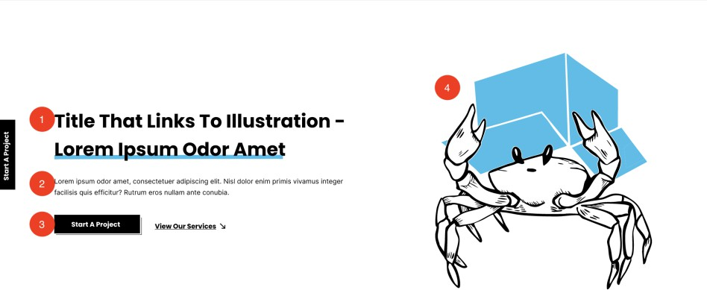
253. | This will be an individual repeater row block, not a global block.
254. | 1 = Title (admin can set which text is underlined and in which colour)  2 = Text - block must expand to show all text entered in admin and must NOT cut off text.  3 = 2 x buttons - admin has full control over title, URL and if it opens in the current or new tab  4 = Illustration image / video / GIF – will be a file that’s uploaded and  will play when the user gets to that section
  - Image & frame left, text & CTA right

Task | Detail

255. | 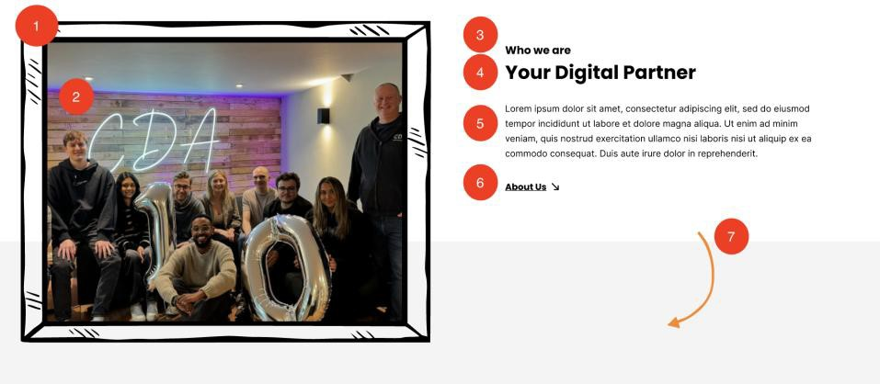
256. | This block will be managed as a Global Block in a general settings area, then when added to a page admin can choose to use the global  content or overwrite it.
257. | 1 = Frame – admin will upload frame image  2 = Image – admin will upload image or GIF which will sit in between frame  3 = Subtitle  4 = Title  5 = Text – block must expand to show all text entered in admin and must NOT cut off text.  6 = Button – admin can control title, link and whether it opens in current or new tab  7 = Arrow illustration image / video / GIF – admin will upload as a file  in WP
  - Services Accordion

Task | Detail
258. | 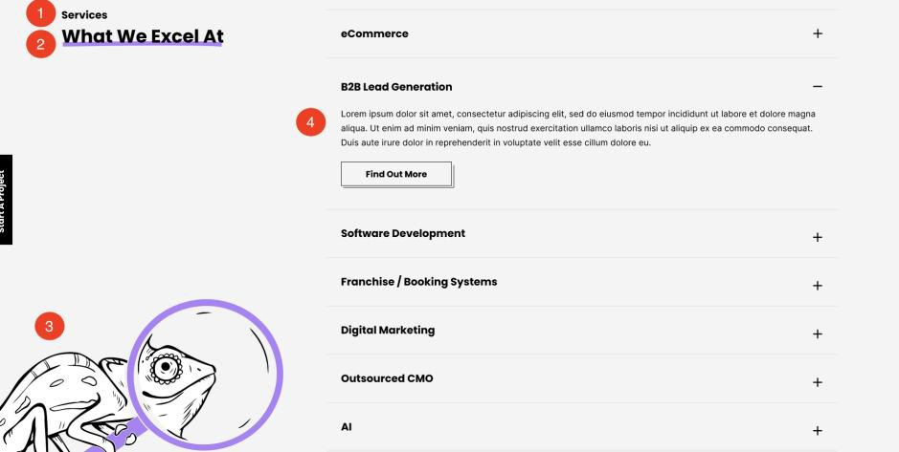

259. | This block will be managed as a Global Block in a general settings area, then when added to a page admin can choose to use the global content or overwrite it.
260. | 1 = Subtitle  2 = Title  3 = Illustration image / video / GIF  4 = Services accordion – admin will select from the list of services (post  type) which will populate the title and page that’s linked from the  button. Admin will enter the intro text manually.
  - Technologies Slider

Task | Detail
261. | 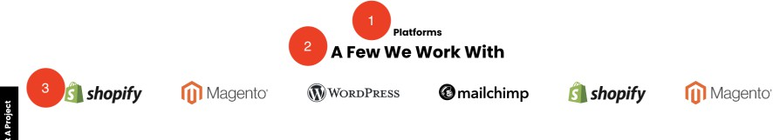
262. | This block will be managed as a Global Block in a general settings area, then when added to a page admin can choose to use the global  content or overwrite it.
263. | 1 = Subtitle  2 = Title  3 = Logos – admin can select from the logos uploaded to the technologies post type
  - Values

Task | Detail
264. | 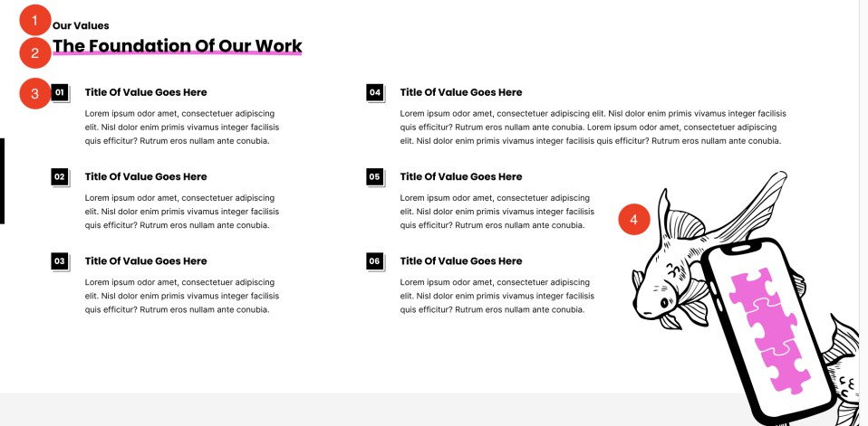
265. | This block will be managed as a Global Block in a general settings area, then when added to a page admin can choose to use the global content or overwrite it.
266. | 1 = Subtitle

2 = Title
3 = Values – for each block admin will upload title & text
4 = Illustration image / video / GIF
  - Showreel

Task | Detail
267. | 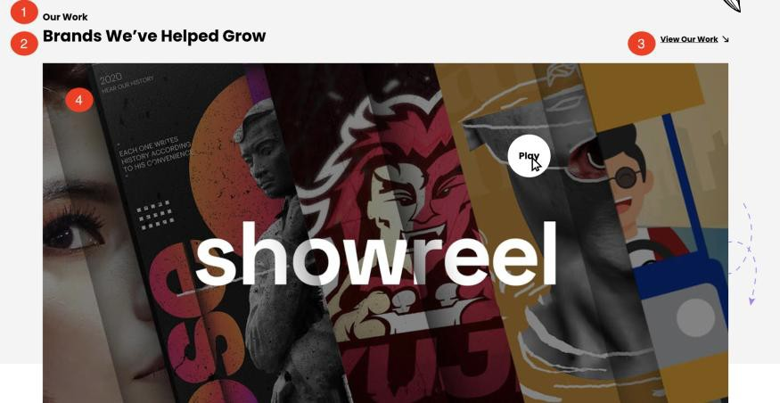
268. | This block will be managed as a Global Block in a general settings area,  then when added to a page admin can choose to use the global content or overwrite it.
269. | 1 = Subtitle  2 = Title  3 = Button & page to link to 5 = Logos
  - Stats & Image

Task | Detail
270. | 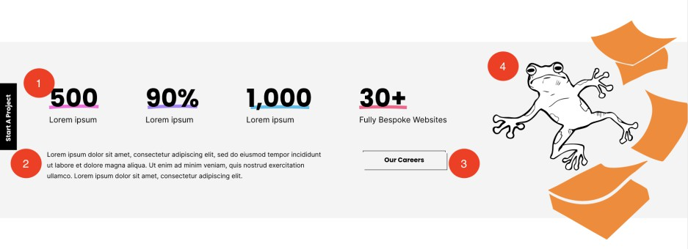
271. | This block will be managed as a Global Block in a general settings area, then when added to a page admin can choose to use the global  content or overwrite it.
272. | 1 = 4 x stats and text – colour underline will be coded

2 = Text – block will expand to show all text added in admin – it must not be cut off
3 = Button title & page to link to
4 = Illustration image / video / GIF
  - Case Studies

Task | Detail
273. | 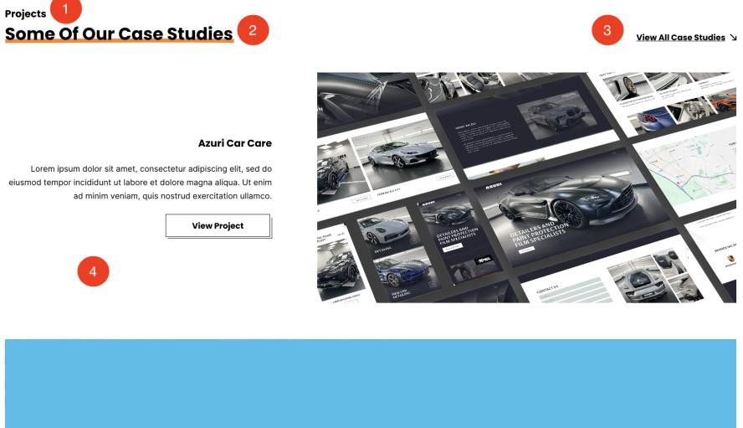
274. | This will be an individual repeater row block, not a global block.
275. | 1 = Subtitle  2 = Title  3 = Link to the Knowledge hub filtered by Case Studies type  4 = Case studies – admin will select 2 to show (intro text must be a field in the case study)
  - Locations with image

Task | Detail
276. | 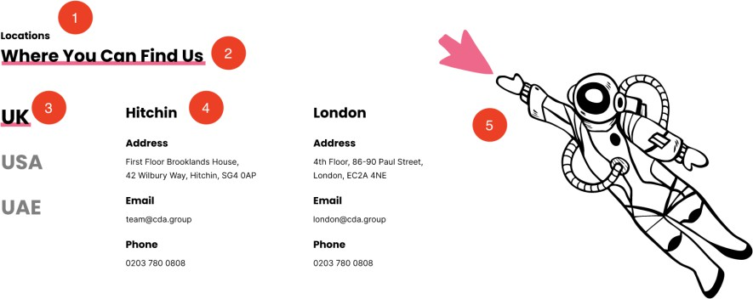
277. | This block will be managed as a Global Block in a general settings area,  then when added to a page admin can choose to use the global content or overwrite it.
278. | 1 = Subtitle

2 = Title
3 = Countries – for each, admin will upload office and contact details:
4 = Offices & contact details: Name
Address Email Phone
If any fields are not added this row will hide. Admin can upload 1 or 2 offices per country
5 = Illustration image / video / GIF
  - News Carousel

Task | Detail
279. | 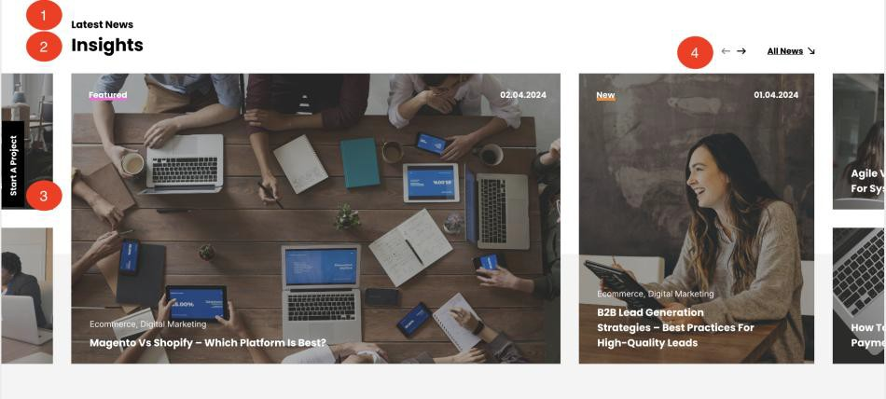
280. | This block will be managed as a Global Block in a general settings area, then when added to a page admin can choose to use the global  content or overwrite it.
281. | Admin can control:  1 = Subtitle  2 = Title  3 = Articles
282. | Admin can choose whether this block will show the most recent news articles, or articles in a certain category, or they can manually select which articles show.
283. | On the front end the block will allow the user to scroll through news articles (using the arrows shown by point 4). It will pull in 8 articles – so 2 of the stacked article layout and 2 of the side by side article layout. The ‘All news’ at the top will navigate to the Knowledge Hub page filtered by news articles.
  - Newsletter

Task | Detail

284. | 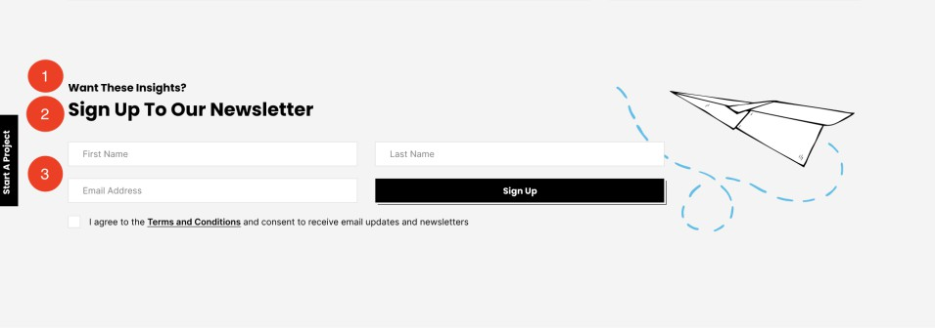
285. | This block will be managed as a Global Block in a general settings area, then when added to a page admin can choose to use the global  content or overwrite it.
286. | 1 = Subtitle  2 = Title  3 = Form – code provided in HubSpot section of this specification
  - Content Page Header

Task | Detail
287. | 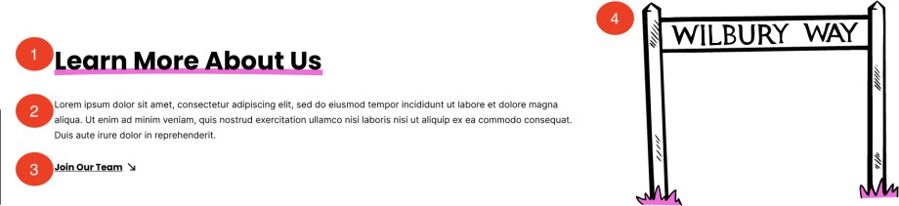
288. | This will be an individual repeater row block, not a global block.
289. | 1 = Title – admin can set the colour of the underline  2 = Paragraph text – the section must expand based on content added  – it must not be cut off  3 = Button title & page to link to – admin can set if it opens in current or new tab
  - USPS

Task | Detail

290. | 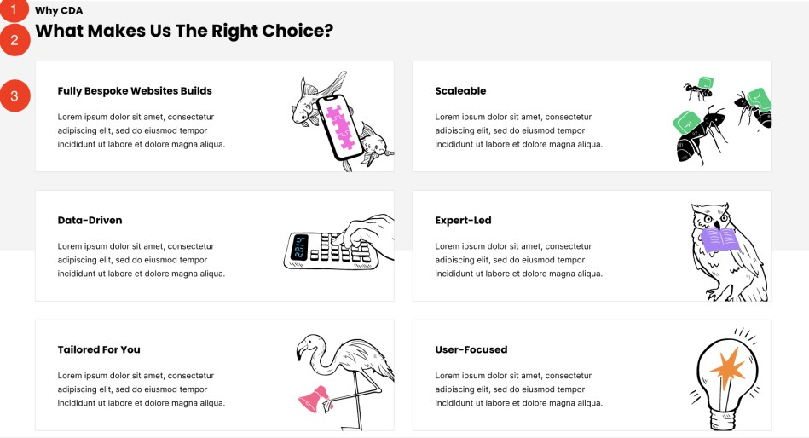
291. | This block will be managed as a Global Block in a general settings area,  then when added to a page admin can choose to use the global content or overwrite it.
292. | 1 = Subtitle  2 = Title  3 = USPs – admin will enter titles, text, image for each
  - Culture Gallery slider

Task | Detail
293. | 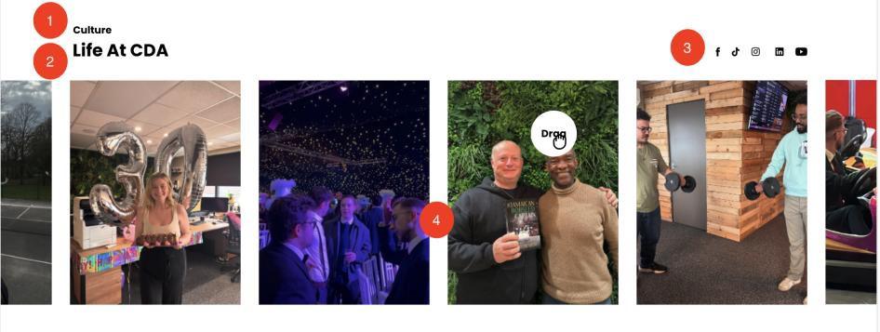
294. | This block will be managed as a Global Block in a general settings area, then when added to a page admin can choose to use the global content or overwrite it.
295. | 1 = Subtitle  2 = Title  3 = Social media links (should pull from global social media links section)  4 = Images – admin can upload as many images as they like, which will display on an infinate round carousel. On page load, pictures must be cut off at either end to show that there are more images for the user  to scroll through

  - Approach

Task | Detail
296. | 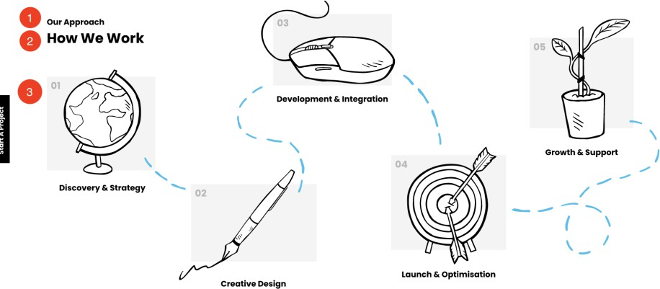
297. | This block will be managed as a Global Block in a general settings area,  then when added to a page admin can choose to use the global content or overwrite it.
298. | 1 = Subtitle  2 = Title  3 = 5 x steps – admin will upload image & title
  - Full Video

Task | Detail
299. | 
300. | This block will be managed as a Global Block in a general settings area, then when added to a page admin can choose to use the global  content or overwrite it.
301. | Admin can upload either a video file or YouTube / Vimeo link. If a link  has been added, the video must appear without the YT/Vimeo casing.
  - Indented Image left, text right

Task | Detail
302. | 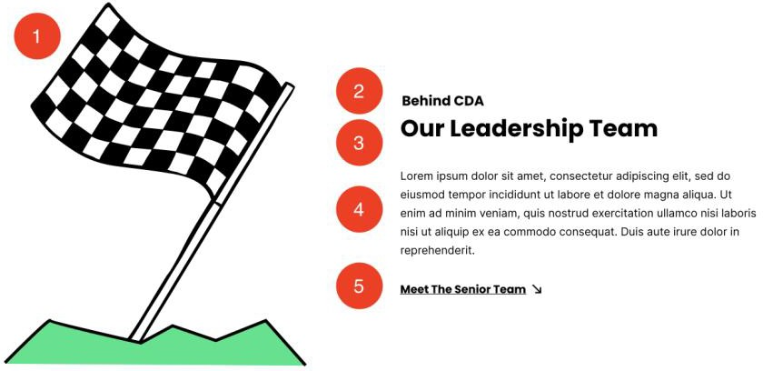
303. | This will be an individual repeater row block, not a global block.
304. | 1 = Image / video / GIF  2 = Subtitle  3 = Title  4 = Text – the block should adjust to fit the length of text entered in admin, it should not cut text off  5 = Button – admin will control the title, page linked and whether it opens in the current or a new tab
  - Team Image left, text right

Task | Detail
305. | 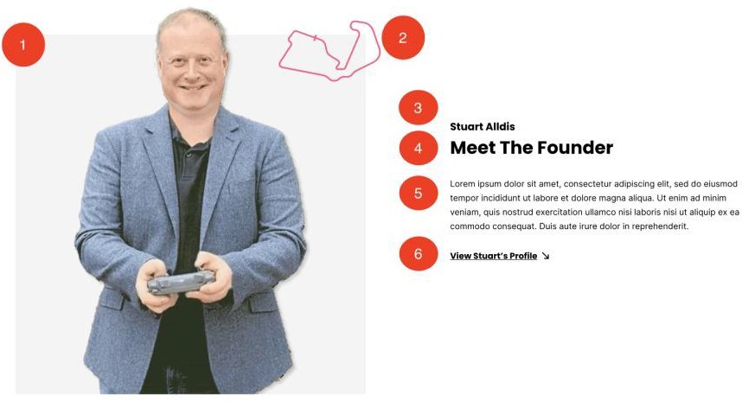
306. | This will be an individual repeater row block, not a global block.
307. | 1 = Image  2 = Illustration  3 = Subtitle  4 = Title

5 = Text – block must expand based on the text added in admin. Content must not be cut off
6 = Button title and page to link to
  - Join Our Team

Task | Detail
308. | 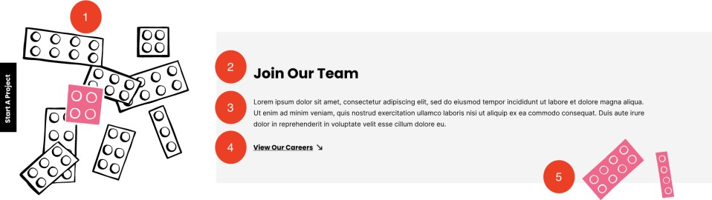
309. | This block will be managed as a Global Block in a general settings area, then when added to a page admin can choose to use the global  content or overwrite it.
310. | 1 = Image / video / GIF  2 = Title  3 = Text - block must expand based on the text added in admin. Content must not be cut off  4 = Button title and page to link to  5 = Image / video / GIF
  - Team Profile

Task | Detail
311. | 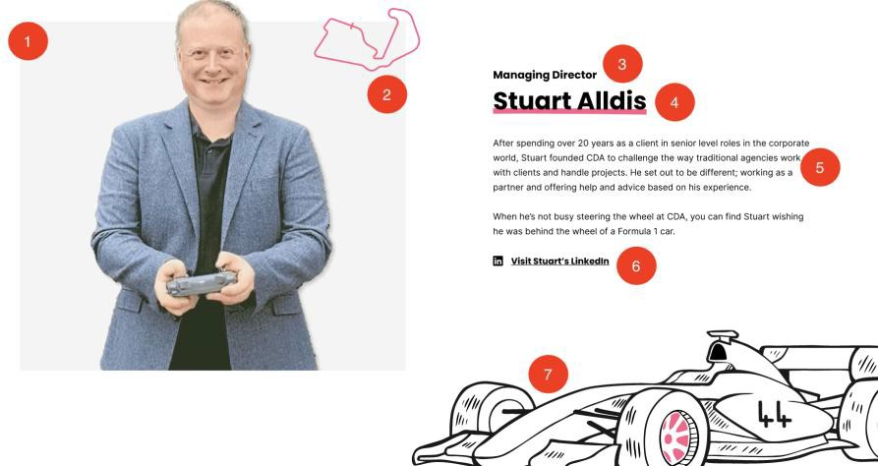
312. | This will be an individual repeater row block, not a global block.
313. | All content will be populated within the Team profile section in the  team post type.

314. | 1 = Image / video / GIF  2 = Illustration  3 = Job Title  4 = Name  5 = Bio  6 = LinkedIn URL  7 = Image / video / GIF
  - Meeting Booker

Task | Detail
315. | 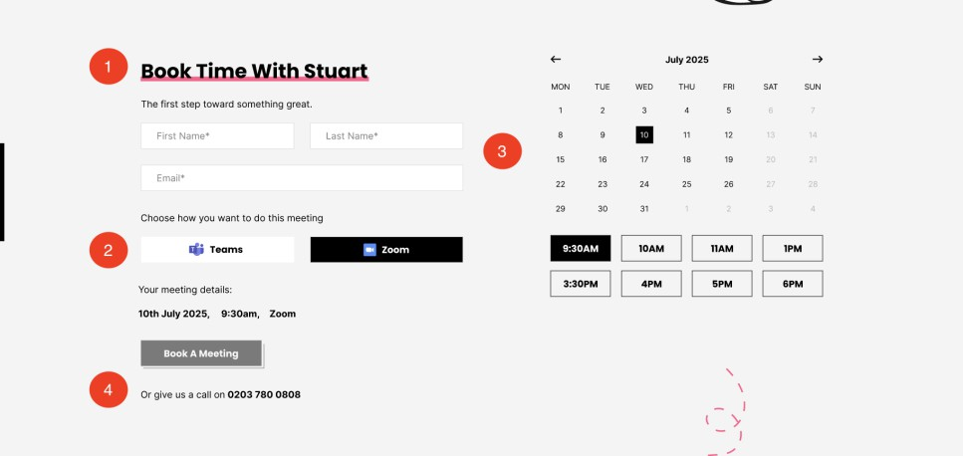
316. | This will be an individual repeater row block, not a global block.
317. | 1 = Title  2 = Meeting options – There are different meeting links based on the method. Admin will add the method title, logo and code for each method  3 = The meeting booker will populate based on the code from HubSpot  – must be styled to CDA design 4 = Text & number
  - Team Carousel

Task | Detail
318. | 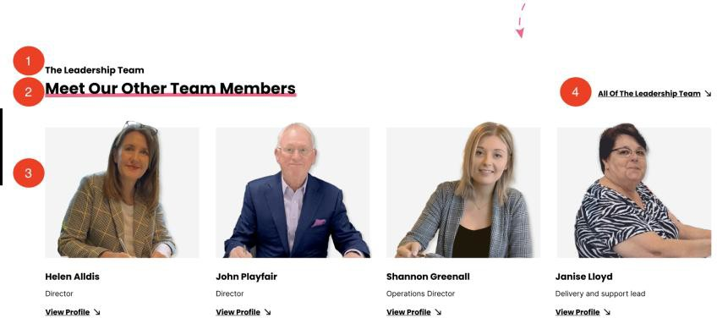

319. | This will be an individual repeater row block, not a global block.
320. | 1 = Subtitle  2 = Title  3 = Team listings – admin will select who to show here from a list of the team members added in the post type  4 = Link to the Team listing page
  - Services carousel with images

Task | Detail
321. | 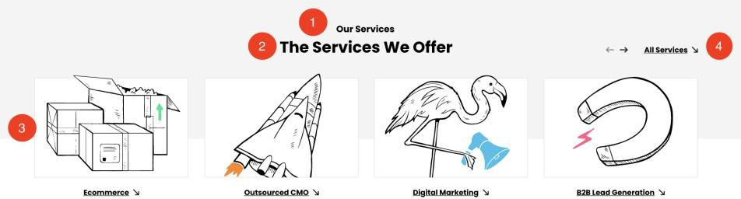
322. | This will be an individual repeater row block, not a global block.
323. | 1 = Subtitle  2 = Title  3 = Services – admin will select from a list of services added in the Post Type. Admin can select as many as they like and they’ll display in a carousel which the user can scroll through  4 = Link will be to the Services landing page
  - Services header

Task | Detail
324. | 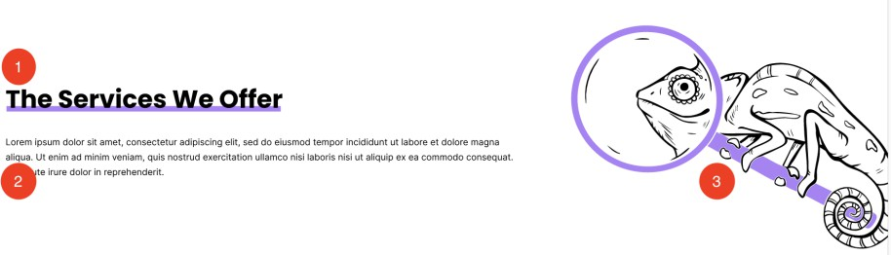
325. | This will be an individual repeater row block, not a global block
326. | 1 = Heading  2 = Intro text – block must expand based on the text added in admin. Content must not be cut off  3 = Image / video / GIF
  - Services Expanded

Task | Detail

327. | 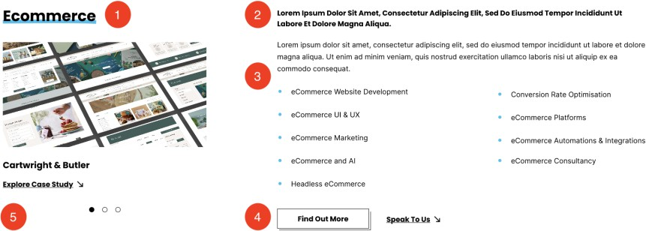
328. | This will be an individual repeater row block, not a global block
329. | Content will pull from the Services post type
330. | 1 = Service title  2 = Introduction – for every main Service, admin will enter the intro text which will show here.  3 = Sub-services – Will be free text field in the Service page so admin can enter the sub-services they want to display here.  4 = Links to Service page & contact form pop up  5 = Case studies – will pull in case studies that are tagged to this service
  - Introduction: 2 CTAs

Task | Detail
331. | 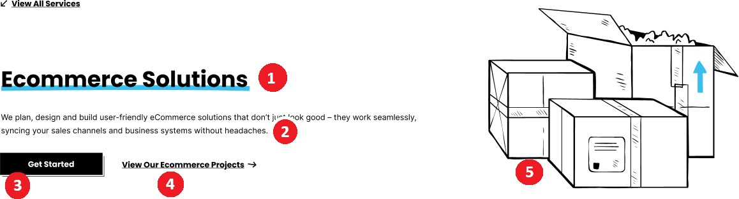
332. | This will be an individual repeater row block, not a global block
333. | 1 = Title – admin can set the colour of the underline  2 = Paragraph text – the section must expand based on content added  – it must not be cut off  3 = Get started CTA – Will open the ‘book meetig’ pop up  4 = Projects – will link to the Knowledge Hub page filtered by Case Studies that are tagged to this service  5 = Image / Video / GIF
334. | View All services at the top will link back to the Services landing page.
  - Service cards

Task | Detail

335. | 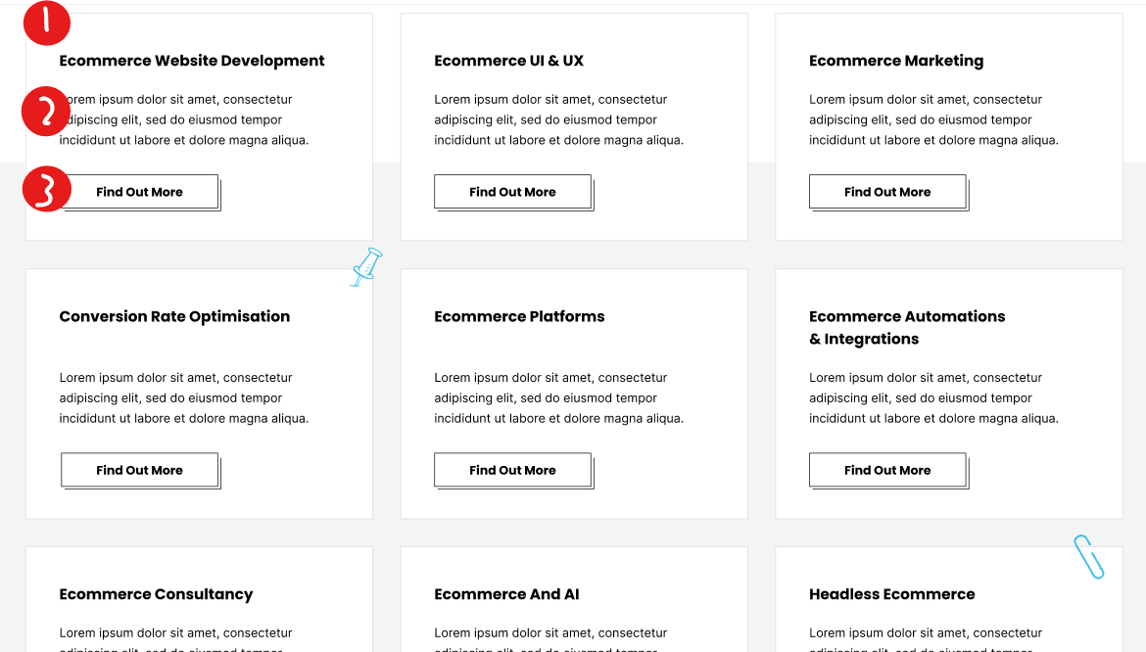
336. | This will be an individual repeater row block, not a global block
337. | This will populate from the sub-services added in the Services post type. From the parent service, admin can choose the order in which  the sub-services will display.
338. | 1 = Service title  2 = For every sub service, admin will enter the listing text which will display on the parent service page  3 = Will link to the service details page
  - List left, text right

Task | Detail
339. | 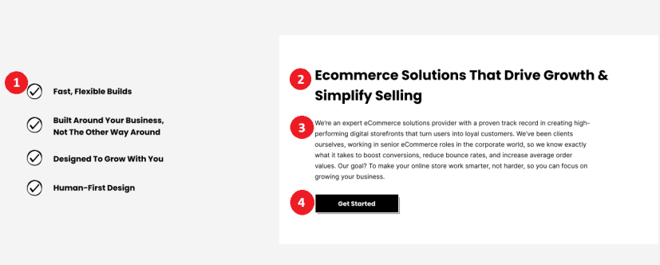
340. | This will be an individual repeater row block, not a global block
341. | 1 = List – admin can enter up to 5 points (non-mandatory). If one is not added then that line will hide  2 = Title  3 = Paragraph text – the section must expand based on content added  – it must not be cut off  4 = CTA button title & page to link to – admin can set if it should open in current or new tab
  - Centred text CTA

Task | Detail
342. | 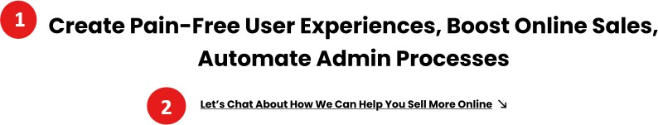
343. | This will be an individual repeater row block, not a global block
344. | 1 = Text – the section must expand based on content added – it must not be cut off  2 = CTA – button title & page to link to – admin can set if it should  open in current or new tab
  - Text Left

Task | Detail
345. | 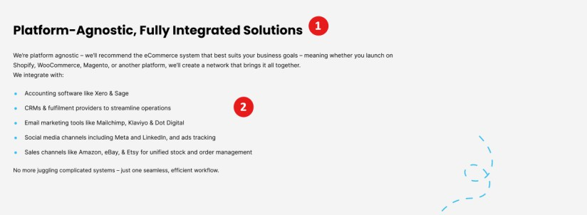
346. | This will be an individual repeater row block, not a global block
347. | 1 = Title  2 = Text
  - Client logos & image

Task | Detail
348. | 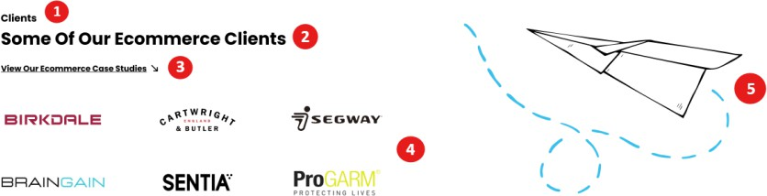
349. | This will be an individual repeater row block, not a global block
350. | 1 = Subtitle  2 = Title  3 = CTA - button title & page to link to – admin can set if it should open in current or new tab  4 = Logos – image

5 = Image / Video / GIF
  - Service Stats

Task | Detail
351. | 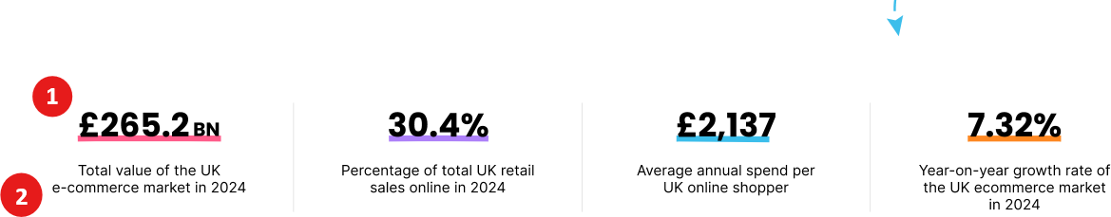
352. | This will be an individual repeater row block, not a global block
353. | 1 = 4 x stats – colour underline will be coded  2 = 4 x text
  - Two Column text

Task | Detail
354. | 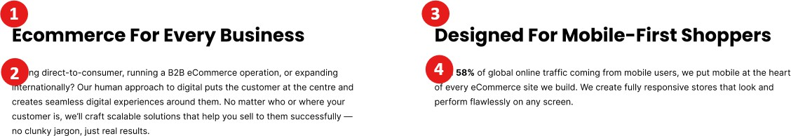
355. | This will be an individual repeater row block, not a global block
356. | 1 = Column 1 heading  2 = Column 1 text - the section must expand based on content added –  it must not be cut off  3 = Column 2 heading  4 = Column 2 text - the section must expand based on content added –  it must not be cut off
  - CTA & Image on grey

Task | Detail
357. | 
358. | This will be an individual repeater row block, not a global block
359. | 1 = Headline  2 = CTA – will open the book a meeting pop up  3 = Image / video / GIF
  - Services introduction: 1 CTA

Task | Detail
360. | 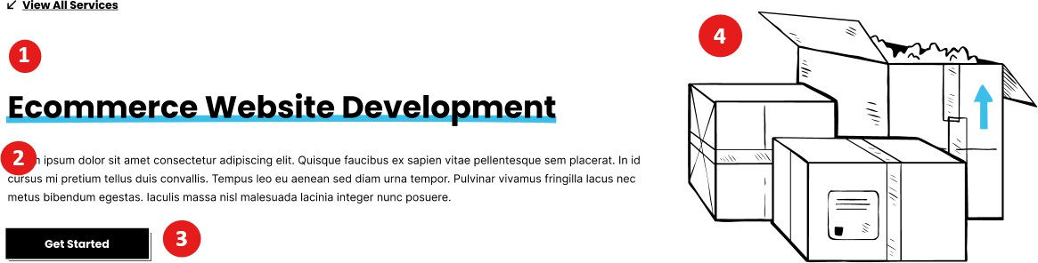
361. | This will be an individual repeater row block, not a global block
362. | 1 = Title – admin can set the colour of the underline  2 = Paragraph text – the section must expand based on content added  – it must not be cut off  3 = Get started CTA – Will open the ‘book meeting’ pop up  4 = Image / Video / GIF
363. | View All services at the top will link back to the Services landing page.
  - Full width text (grey background)

Task | Detail
364. | 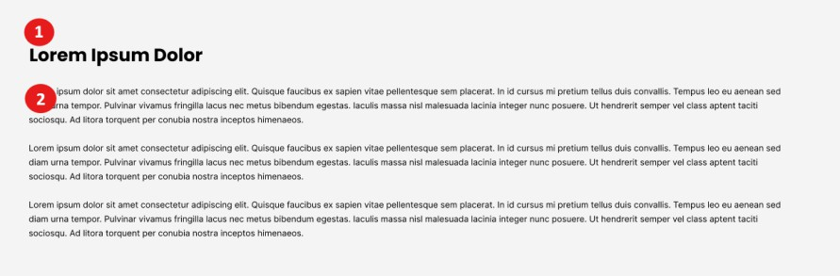
365. | This will be an individual repeater row block, not a global block
366. | 1 = Heading  2 = Text – admin can enter as much text, media, formatting here as they link and the block will adjust to fit
  - Video left, text right

Task | Detail
367. | 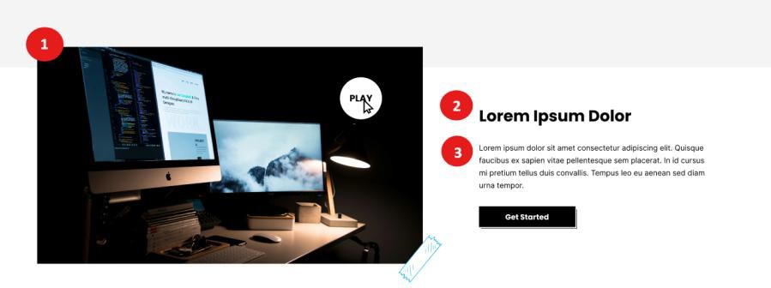
368. | This will be an individual repeater row block, not a global block

369. | 1 = Video – can be a video file or YouTube / Vimeo link. If a link has been added, the video must appear without the YT/Vimeo casing.  2 = Title  3 = Text – the section must expand based on content added – it must not be cut off  4 = CTA – will open the book a meeting pop up
  - Full width text (white background)

Task | Detail
370. | 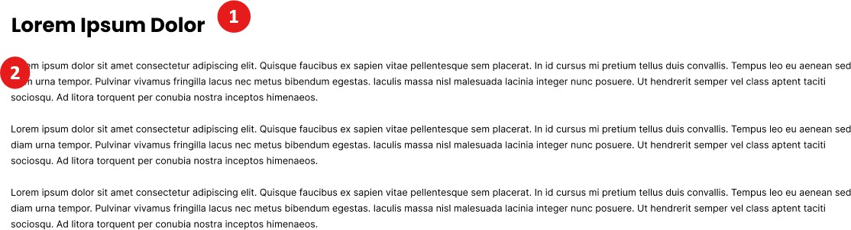
371. | This will be an individual repeater row block, not a global block
372. | 1 = Heading  2 = Text – admin can enter as much text, media, formatting here as they link and the block will adjust to fit
  - Text left, image & frame right

Task | Detail
373. | 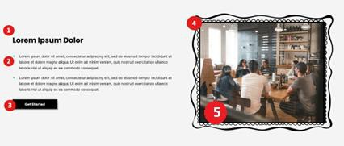
374. | This will be an individual repeater row block, not a global block
375. | 1 = Title  2 = Text – block must expand to show all text entered in admin and must NOT cut off text.  3 = Button – admin can control title, link and whether it opens in current or new tab  4 = Frame – admin will upload frame image  5 = Image – admin will upload image or GIF which will sit in between  frame

  - Image left, text & CTA right

Task | Detail
376. | 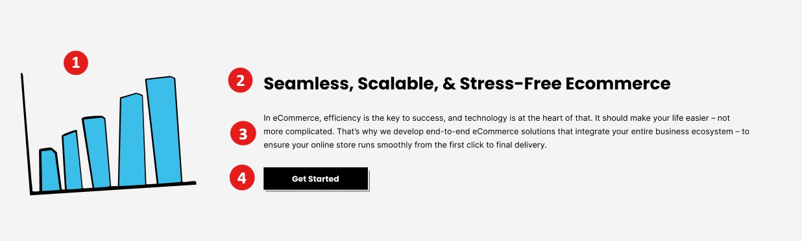
377. | This will be an individual repeater row block, not a global block
378. | 1 = Image / video / GIF  2 = Title  3 = Text – the section must expand based on content added – it must not be cut off  4 = CTA - button title & page to link to – admin can set if it should open  in current or new tab
  - 3 x Columns with icons

Task | Detail
379. | 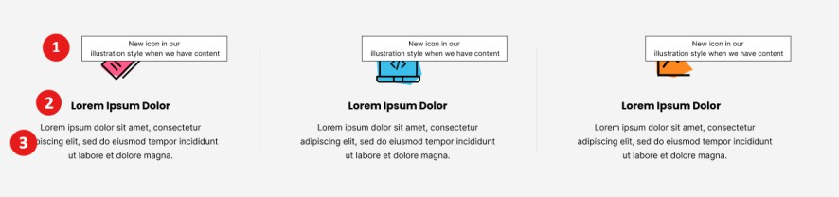
380. | This block will be managed as a Global Block in a general settings area,  then when added to a page admin can choose to use the global content or overwrite it.
381. | 1 = Image / Icon (x3)  2 = Title  3 = Text – the section must expand based on content added – it must not be cut off
  - Contact form left, image right

Task | Detail

382. | 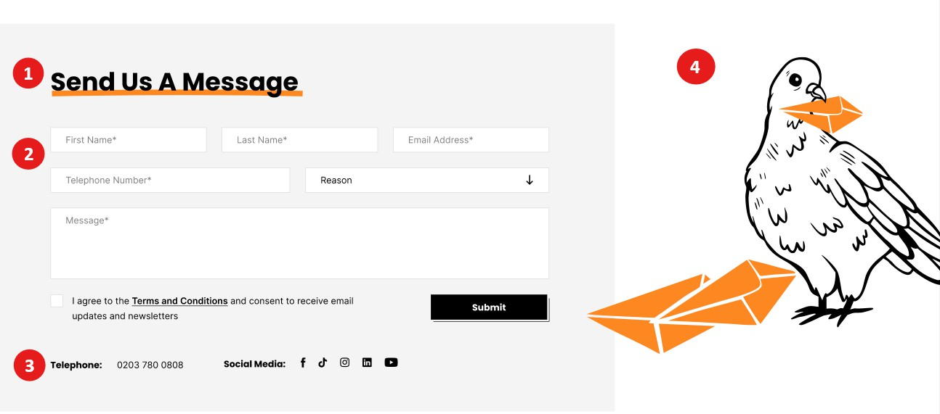
383. | This block will be managed as a Global Block in a general settings area, then when added to a page admin can choose to use the global content  or overwrite it.
384. | 1 = Title  2 = Form – will be the Contact Us form code from HubSpot but admin can overwrite and add a different code  3 = Contact details – will pull from the global settings / footer  4 = Image / Video / GIF
  - Global Blocks

Task | Detail
385. | To confirm, the list of blocks which should be set up a widgets in global settings, with the option to overwrite at page repeater row level are:  - Image & frame left, text & cta right  - Services Accordion  - Technologies Slider  - Values  - Showreel  - Stats & Image  - Locations with image  - News Carousel  - Newsletter  - USPS  - Culture Gallery Slider  - Approach  - Full Video  - Join Our Team  - 3 x columns with icons  - Contact form left, image right

POST TYPES
  - Services

Task | Detail
386. | Services will have categories which will have their own pages with  links to sub-service pages.
387. | Service and sub-service pages will be available to link in the repeater rows across the website. They will also be used for tagging and  filtering of news articles and case studies.
388. | Service and sub-service pages can be indexed and found individually in Google.
  - Technologies (Platforms)

Task | Detail
389. | Technologies will be linked from the Technologies page, and from the  repeater row block on various pages
390. | Technologies pages can be found individually in Google
  - Case Studies (Projects)

Task | Detail
391. | Case Studies will be linked from the Knowledge Hub, and cross populated onto other pages throughout the website.
392. | Case Studies can be found individually in Google.
  - News (Insights)

Task | Detail
393. | News articles will be linked from the Knowledge Hub, and cross  populated onto other pages throughout the website.
394. | News articles can be found individually in Google.
  - Jobs (Careers)

Task | Detail
395. | Job details pages will be linked from the Careers page.
396. | Job details pages can be found individually from Google.
  - Sectors

Task | Detail
397. | Sector pages will be linked from the Sectors landing page, which will  use the same template as the Services landing page.
398. | Sector pages can be found individually from Google.
  - Team

Task | Detail

399. | Team profiles will be linked to the main team listing page.
400. | Individual team profiles can be found individually from Google.
  - Policies

Task | Detail
401. | Policy pages will be linked from the Policies landing page.
402. | Policies pages can be found individually from Google.

CONTENT MIGRATION
  - Current Content

Task | Detail
403. | Content that needs to be migrated across from our existing website:  - Main Service pages (x 7)  - All News Articles  - Cookie Policy  - Privacy Policy  - Terms & Conditions

