
Data Models | Chapter 1

A Database Management System (DBMS) is software used to store and manage data. A DBMS stores data in databases and uses data models to show the various ways of managing data.
A Relational Database Management System (RDBMS) is an advanced version of a DBMS that also defines the relationship between the various data values. This feature helps in managing and using data more efficiently than DBMS.
This chapter introduces DBMS and describes the various types of data models. It explains the most widely used entity relationship model and discusses the various types of relationships among the entities. In addition, the chapter describes the various ways of accessing data by using relational operators and joins.
Objectives
In this chapter, you will learn to:
- Define a database management system
- Describe the types of data models
- Define a relational database management system
- Describe the operators that work on relations

Database Management System
A database is a collection of logically related data. Data means known facts, which are meaningful and can be recorded. For example, names, telephone numbers, and addresses. You can record this data in an indexed address book or on a hard disk, by using software such as Microsoft Access or Microsoft Excel. Using a database for storing and accessing data provides lots of benefits over the traditional approach of storing data in the flat text files.
Database Management is the task of maintaining databases so that the information is easily available. The software required to perform the task of database management is called a DBMS. DBMSs are designed to maintain large volumes of data.
Management of data involves:
- Defining structures for data storage.
- Providing methods for data manipulation, such as adding, editing, and deleting data.
- Providing data security against unauthorized access.
DBMSs are now available on a wide range of computers, from desktops to mainframes. The size and power of a computer determine the system facilities, such as security and storage. DBMS also allows the abstraction of data at different levels.
The main advantages of using DBMS are:
- It provides an efficient and easy way to store, update, and retrieve data from a database.
- It manages information about the users who interact with DBMS and the tasks that these users can perform on the data.

Introducing the Characteristics of the Database Approach
The file-based approach is a primitive approach of storing and accessing data. In this approach, data is stored in the flat text files. This method uses a collection of multiple application programs, and each program defines and maintains its own individual set of data files. The files used by one application program are not used by the other. For example, in a file processing system, the data used by the Billing program is stored in the Customer and Accounts receivable files. The data used by the Purchasing program is stored in the Buyer, Inventory, and Vendor files. The files used by the Billing program are not used by the Purchasing program and vice versa, as the file formats are different.

The process of handling data in the traditional file processing approach is shown in the following figure.
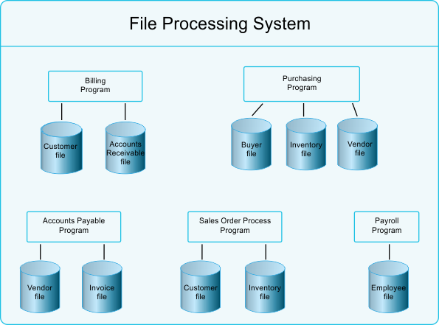
The Traditional Approach of Handling Data
As shown in the preceding figure, the Customer file is defined twice to store the data for two separate programs named Billing and Sales Order Process. Same is the case in the Vendor file that is used by the Purchasing program and the Accounts Payable program. Therefore, the same data is stored multiple times. This decentralized approach of data storage has many drawbacks associated with it. The following points discuss the loopholes in the file processing system:
- Data duplication: The redundancy in data is responsible for the wastage of storage space. It also results in the loss of data integrity. To update a single piece of information, multiple files need to be updated, which takes excess effort.
- Data dependence: The physical structure of the data file is defined in the application program that uses it. This is termed as program-data dependence. If you need to redefine the structure of the data files, changes are needed in the application program as well. This is a time-consuming process and can result in errors.
The database approach is an alternative to the traditional file-based approach of storing data. It has evolved over the years to overcome all the drawbacks associated with the
file processing system. In case of the database approach, the complete data is stored in a centralized repository called database. Data is defined and stored only once and is used by all the application programs. This controls the redundancy of data, ensures data consistency, and avoids the wastage of storage space.
The following figure shows the handling of data in the database approach.
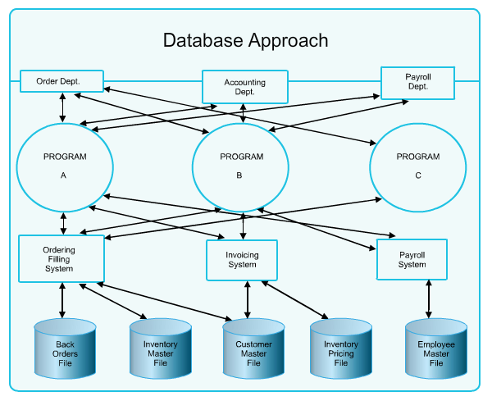
The Database Approach of Handling Data
The main characteristics of the database approach are:
- Self-describing nature of a database system
- Insulation between programs and data, and data abstraction
- Support of multiple views of data
- Sharing of data and multiuser transaction processing
Self-describing Nature of a Database System
A single character is at the lowest level within the database organization. Multiple-related characters, when taken together, make a field or an attribute. Further, multiple-related attributes together make a record or a row. Multiple records are placed in a file or in a table. Multiple-related tables, which store the data relevant for an organization and its associated processes, when taken together, constitute a database.
One of the most important characteristics of a database system is that it not only stores data but also stores the complete characteristics of the data items stored in the database. It stores the complete definition of all its structural components, such as tables, constraints, and relationship between tables. This information is stored in the system catalog and is also known as metadata. The catalog also stores the storage format of each data item.
The information stored in the catalog is used by the DBMS software to know the structure of the database before facilitating any kind of operation on it.
On the contrary, in case of the traditional file system, the description of data is stored in the program code itself. For example, in a C/C++ program, the description of data is stored inside a class or inside a structure.
Insulation Between Programs and Data, and Data Abstraction
The self-describing nature of the database contributes to a feature called program-data independence. Data is kept insulated from the programs that access it. In the traditional file system, the structure of data is stored with the program itself. So, if you change the structure of the data file, all the programs accessing that file need to be changed. However, in the database approach, the structure of data is stored in the database catalog. So, if you change the structure of any data, you do not need to make changes in the programs that access that data. For example, if you want to add some additional information, such as customer type, with each record of the customer stored in a file in the file processing system, the program accessing that file needs to be modified as well. However, with the database approach, you just need to modify the information stored in the catalog to add one more column in the table and there is no need to make modifications in any program accessing that data. This property of insulation between the program and the data in the database approach is called program-data independence. The characteristics that allow the program-data independence is called data abstraction.
Support of Multiple Views of Data
Sometimes we need to display the data stored in the database, in a format that differs from its actual form of storage. For example, we need to display the computed data or columns from multiple tables as if it is stored in a single table. In addition, at times, we need to display only the customized data to the database users, and not the complete data. The database approach of handling data provides us the flexibility to display data in any form, view, and structure, regardless of the actual storage of data in the database.
Sharing of Data and Multiuser Transaction Processing
The database approach of handling data allows multiple users to access data from the database at the same time without any updation problem. When multiple users access the same data, DBMS uses the concurrency control mechanism to ensure data integrity. For example, when several users are trying to book the movie tickets of the same show, DBMS ensures that a single seat is assigned to only one user.

Describing the Advantages of Using a DBMS
The DBMS software provides centralized management and control over the data stored in a database. In addition, the DBMS software provides the following advantages:
- Controlling redundancy: In DBMS, data is stored at a centralized location, instead of multiple independent files. This avoids the same data to get stored multiple times. This reduces the amount of storage and eliminates the effort of updating the same data in multiple files.
- Minimized data inconsistency: In traditional approach of handling data, the same data is stored in multiple files. So, the changes made in one file must also be updated in other files that store the same data. If the changes are not updated properly, data can become inconsistent. However, in DBMS, data changes in one table are automatically updated in all the related tables.
- Data integrity: It ensures that the data stored in the database is accurate and consistent. DBMS provides various types of checks and integrity constraints to ensure data integrity.
- Data security: Data stored in a database must be secured from unauthorized access. DBMS provides both, authentication mechanism and authorization mechanism, for securing data from unauthorized access.
- Sharing data: Data stored in a database can be accessed simultaneously by any number of applications and users. Sharing of data among multiple applications and users is controlled by DBMS.
- Data independence: It ensures that the changes made at one level of data will not affect the other level of data. Data independence is broadly classified as physical data independence and logical data independence.
- Provide backup and recovery: The hardware and software system can fail at any point of time. DBMS provides the backup and recovery system to recover the data in any such situation.
Identifying the Database Architecture
The architecture of a database describes the way data is stored and accessed by different applications. It also describes the organization of various database objects and the way they work together.
The following figure shows the architecture of a database.
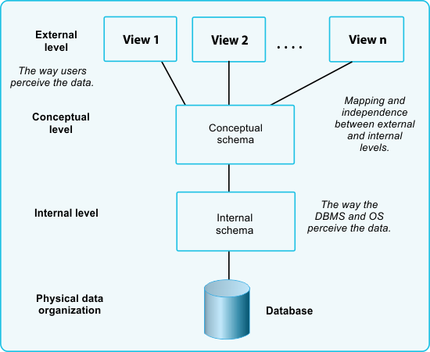
The Architecture of a Database
As shown in the preceding figure, the architecture of a database can be described as
three-level architecture. These three levels are:
- External level: It is the highest level of database abstraction. This level defines the multiple views of the same database. It describes only those parts of the database that a particular group of users requires and hides the remaining parts of database.
- Conceptual level: This level of database abstraction describes the complete logical structure of any database. In this level, the database entities and the relationship among them are defined. However, this level hides the physical storage of any database.
- Internal level: This level of database architecture describes the physical storage structure of any database. It describes the way data is stored in the physical medium or storage.
Data Models
A data model is a description of the data in a database. In addition, the data model describes the relationship among data, and any constraints that have to be defined on the data. Data models can broadly be classified into the following categories:
- Object-based logical model: Focuses on describing the data, the relationship among the data, and any constraints defined.
- Record-based logical model: Focuses on specifying the logical structuring of the database in the form of tables.

Object-Based Logical Model
There are various object-based logical models, such as Entity-Relationship (ER) model, object-oriented model, and binary model. The most widely used is the ER model. It is accepted as an ideal data model for the database design. Peter Chen introduced this model in 1976, and since then several people have added value to it.
The ER Model
The ER model views the real world as a collection of objects or entities and the relationship among them. Chen introduced not only the ER model, but also a corresponding diagramming technique. The following diagram shows various components and depicts the relationship between them.
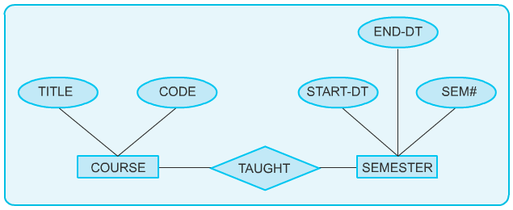
Sample ER Diagram
In the preceding diagram, COURSE and SEMESTER are two entities. The Course entity contains two attributes, TITLE and CODE. The SEMESTER entity contains three attributes: START-DT, END-DT, and SEM#. The course and semester entities are related through a relationship, TAUGHT.
Entities
Chen defined an entity as “a thing, which can be easily identified”. An entity is any object, place, person, or activity about which data is recorded. An entity can be categorized as entity type and entity instance. An entity type is a set of things that share common properties. For example, STUDENT, COURSE, and GRADE. An entity instance is an individual occurrence of an entity type. For example, John is an instance of the STUDENT entity type, Java is an instance of the COURSE entity type, and A is an instance of the GRADE entity type.
In the ER Model diagramming technique, entities are named and represented inside a rectangular box. An entity type is usually represented in uppercase in the ER model. The following diagram consists of three entities types: STUDENT, COURSE, and GRADE, which are represented inside a box.
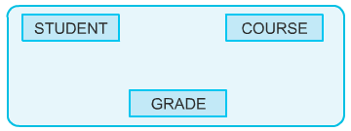
Entities
There are two types of entities, dependent and independent. An entity, which depends on another entity for existence, is called a dependent entity. An independent entity does not depend on any other entity for existence. Dependent entities are also called weak entities, and independent entities are called regular entities.
Consider an entity type, OFFERING, which refers to the various combinations of subjects offered in a course. A course with the same code can be offered in different semesters at different universities. The existence of OFFERING depends on the existence of the entity type, COURSE.
The existence of entity B is dependent on entity A when:
- Some instance of A must exist before B can exist.
- B will not exist, if A does not exist.
For example, the university offers a course in database design in the second semester. Therefore, the “database design” is an instance of the COURSE entity. The university can offer this course only if the entity instance “database design” already exists. If the university decides to drop the entity instance “database design” from the curriculum, the offering of the course must also be dropped. A dependent entity is represented by a double-lined box and is connected by a line to the entity it depends on.
The following diagram consists of an entity, OFFERING, which is dependent on entity, COURSE.
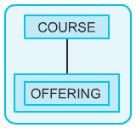
Dependent Entity
In the preceding diagram, COURSE is an independent entity.
Relationships
Chen defined a relationship as “an association among entities”. For example, there is a relationship between students and teachers. This relationship represents the fact that a teacher teaches several students and a student is taught by several teachers. This relationship could be named TEACH. As with entities, it is necessary to understand the difference between relationship types and instances.
A relationship type is an association of entity types. For example, in the association between a student and a teacher, the entity types are STUDENT and TEACHER. A relationship instance is an association of entity instances, for example, the association between a student called J. Reins and the teacher called Dr. Jack.
A relationship is depicted as a diamond with the name of the relationship type. The following diagram consists of two entities, TEACHER and STUDENT, which are associated with a relationship, TEACH.
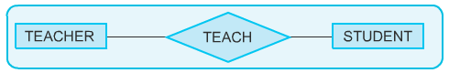
Relationships
A relationship can associate an entity with itself. For example, one teacher in a university may marry another teacher.
The following diagram represents the association of an entity with itself.
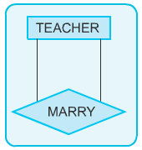
Relating an Entity with Itself
Another example of an entity associating with itself can be a student giving a seminar presentation to other students. The following diagram represents the relationship of an entity, STUDENT with itself.
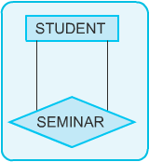
Relating an Entity with Itself

Multiple relationships can also exist between the same entities. The following diagram represents the multiple relationships between the entities, TEACHER and STUDENT.
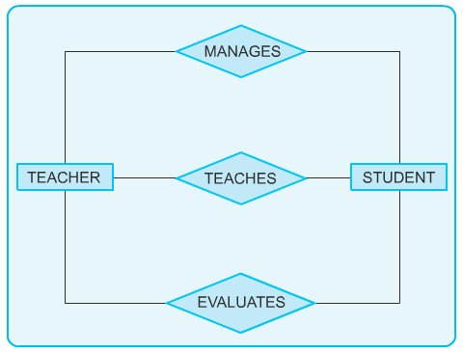
Multiple Relationships Between the Same Entities
In the preceding diagram, TEACHER entity shares many relationships with the STUDENT entity. A teacher of an institute can manage, teach, and evaluate his or her students.

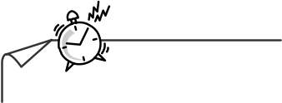
<print>
Just a minute:
Consider the following statement:
“A supplier ships certain parts.”
Identify the entities and the relationship which exists between them.
- Entities: SUPPLIER and PARTS
Relationship: SHIPS
- Entities: SUPPLIER and SHIPS
Relationship: PARTS
- Entities: PARTS and SHIPS
Relationship: SUPPLIER
- Entities: SUPPLIER, PARTS, and SHIPS
Relationship: SUPPLIES

Answer:
- Entities: SUPPLIER and PARTS
Relationship: SHIPS
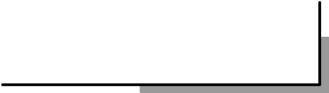

</print>
<epub>
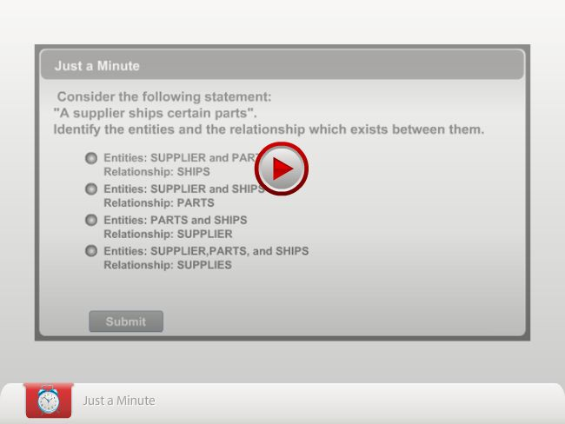
</epub>
Types of Relationships
There are the following types of relationships:
- One-to-One
- One-to-Many (or Many-to-One)
- Many-to-Many
Consider an example of a university. For a particular DEPARTMENT, such as electronics, there can be only one DEPARTMENT HEAD. This is an example of a one-to-one relationship.

The following diagram represents the one-to-one relationship between DEPARTMENT and DEPARTMENT HEAD.
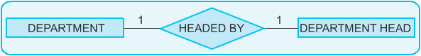
One-to-One Relationship

A STUDENT can MAJOR in only one course, but many STUDENTs can register for a given MAJOR course. This is an example of many-to-one relationship. The following diagram represents the many-to-one relationship between STUDENT and MAJOR.
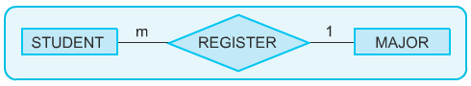
Many-to-One Relationship
A STUDENT can take many COURSEs and many STUDENTs can register for a given COURSE. This is an example of many-to-many relationship. The following diagram represents the many-to-many relationship between STUDENT and COURSE.
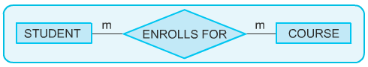
Many-to-Many Relationship
The types of relationships between two entities are represented in ER diagrams by certain symbols. An entity may be associated with one, none, or many occurrences of another entity.
Attributes
An attribute is a property of a given entity, for example, ROLL_NO is a property of an entity, STUDENT. Similar to entities, attributes can also have instances. An attribute instance is an individual occurrence of an attribute. For example, roll number 101 is the instance of the attribute, ROLL_NO.
An attribute instance is also a particular property of an individual entity instance. For example, Peter is an instance of the STUDENT entity and the roll number 101 is an instance of the ROLL_NO attribute. Therefore, roll number 101 can be considered as the property of the entity instance, Peter.
Attributes are depicted as ellipses, labeled with the name of the property. The key properties are underlined. A key property uniquely identifies an entity instance. For example, a particular student can be uniquely identified from the roll number rather than the name. It is possible for more than one student to have the same name, but a roll number is never duplicated.

The following figure shows the various attributes of the entity, STUDENT.
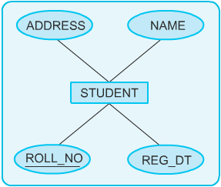

Attributes
<print>
Just a minute:
An attribute is a property of a given entity, which is depicted as ___________, labeled with the name of the property.
Answer:
Ellipses

</print>

<epub>
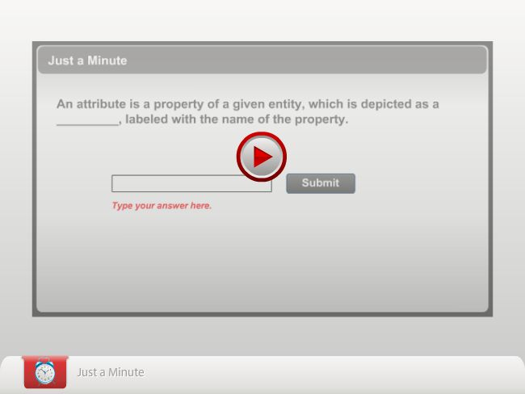
</epub>

<print>
Just a minute:
Consider the following statement:
“A supplier ships certain parts. A particular part is not necessarily supplied by only one supplier. No supplier supplies only a single part.”
What type of relationship is possible between the two entities?
- One-to-one relationship
- One-to-many relationship
- Many-to-many relationship
- Many-to-one relationship
Answer:
- Many-to-many relationship

</print>
<epub>

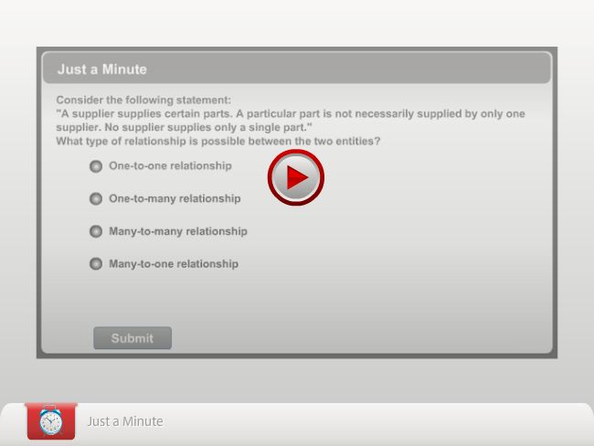

</epub>

Subtypes and Supertypes
A subtype is a subset of another entity. For example, consider the entity COURSE. There are two types of COURSEs, semester and standalone. The entity, COURSE is the supertype, and SEMESTER and STANDALONE are the subtypes.
There are some attributes that are common to both the subtypes, for example: “course code”, “name”, and “content”. STANDALONE courses have some attributes such as “duration” that do not belong to the subtype, SEMESTER. The SEMESTER subtype has some attributes such as “semester_no” that do not belong to the STANDALONE subtype.

The following diagram shows the relationship between supertype (COURSE) and subtypes (STANDLONE and SEMESTER).
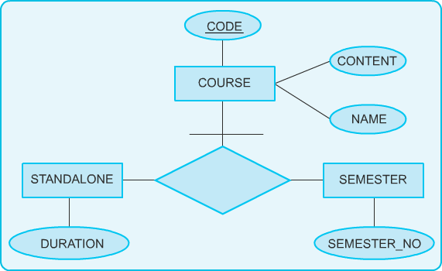s
Subtypes and Supertypes
A subentity or subtype is always dependent on the supertype for its existence. The attributes of a supertype apply to all of its subtypes. The converse is not true.
Subtypes are connected to the supertype by an unnamed relationship. The supertype is connected to the relationship with a line containing a crossbar, as indicated in the preceding diagram. The attributes, which describe supertype will also belong to all subtypes. The subtype is described by the attributes that are unique to it.
<print>
Just a minute:
There are two types of suppliers. One type of supplier allows credit, while the other type insists on payment in cash before delivery. The manufacturer wishes to maintain separate information on these two types of suppliers. For the credit supplier, “credit period” and “credit limit” have to be recorded. For the cash supplier, “date of payment” has to be stored. Identify the subtype and supertype entities.
- Subtypes: Suppliers and Cash
Supertype: Credit
- Subtype: Credit
Supertypes: Cash and Suppliers
- Subtypes: Cash and Credit
Supertype: Suppliers
- Subtype: Suppliers
Supertypes: Cash and Credit

Answer:

3. Subtypes: Cash and Credit
Supertype: Suppliers

</print>
<epub>
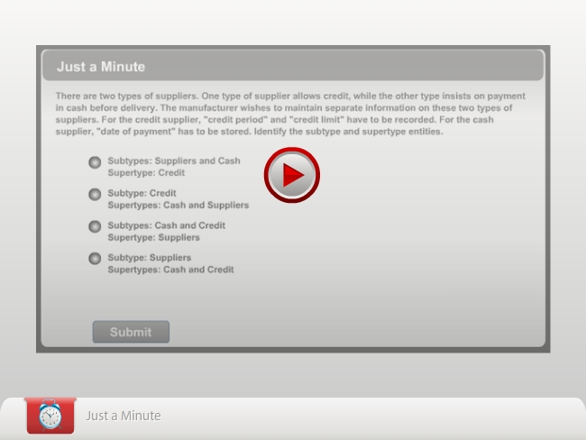
</epub>

Record-Based Logical Model
Now that you are familiar with the ER model, which is an example of an object-based logical model, we will look at other data models.
The three types of record-based logical models are:
- Hierarchical model: In this model, data is represented in the form of a tree, and relationships between the data are represented by links.
- Network model: In this model, the data and relationships among them are represented in the form of records and links. It is similar to a hierarchical model. However, records in a database are represented graphically.
- Relational model: In this model, the table in a database has a fixed length record with fixed number of attributes or fields. Of these three models, the relational model is the most popular.


Note
In this course, focus is only on the relational model as it is the most popular model.
Relational Model
Dr. E. F. Codd first described the relational model in 1970. The relational model is an attempt to simplify the database structure. It represents all data in the database as simple tables in the row-column format. The following table describes the details of a teacher.
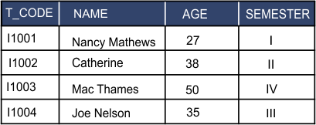

Teacher Table
An RDBMS can be defined as a database management system where all the data visible to the user is organized strictly as tables of data values, and all the database operations work on these tables.
Some typical applications of an RDBMS are:
- Airline and railway reservations
- Banking applications
- Manufacturing industry
- Order processing
- Hospital management systems
- Library management systems
- Hotel industry
Several RDBMS products are available today. Some popular products are:
- Sybase
- Oracle
- Microsoft SQL Server
- Ingres
- DB2
Relational Data Structure
The basic principle in a relational database is a tabular arrangement of data values. Each table in a database has a unique table name that identifies its contents.
The row (or record) in the table is called a tuple, and the column (or field) is called an attribute. Every column in a table must have a unique name. The number of tuples is called the cardinality of the table, and the number of attributes is called the degree of the table.
One important property of a relation is that its rows are unordered. A row cannot be identified by its position in the table. Every table must have some column or combination of columns that uniquely identifies each row in the table. At any given time, no two rows of the table contain the same values in that column or column combination. This column (or columns) is called the primary key of the table. For example, in the Student table, ROLL_NO is the primary key as it uniquely identifies each student. A table where every row is different from all other rows is called a relation. The term relational database comes from this term.
Each attribute of a table has an associated domain. A domain is a collection of values from which one or more attributes (columns) draw their actual values. The domain lists the possible values for an attribute. For example, the domain for the CODE attribute would be the set of all legal supplier codes. A set of values appearing in that column, at any given time, would be a subset of that domain.
The following diagram describes the data structure of an RDBMS.

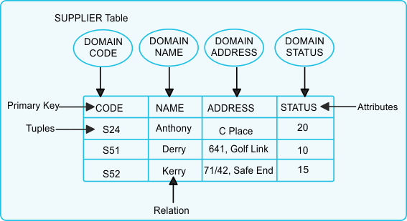
Data Structure of an RDBMS
In the preceding figure, the cardinality of the table will be three and the degree of the table will be four as there are three tuples and four attributes in the table.
Representing Missing Information
Attributes
The problem of missing or unknown information is common in the real world. For example, a person does not know the date of a seminar that is yet to be announced. In RDBMS, missing or unknown information is represented as a NULL value in a table. If a row has the NULL value in a column, it means that a particular attribute for that row is unknown. NULL is not the same as space or zero.
Representing Relationships in an RDBMS
Relationships in an RDBMS are represented by common data values stored in two or more tables.
A column in one table whose value matches the primary key in some other table is called a foreign key. Together, a primary key and a foreign key create a parent-child relationship between the tables that connect them.
The following diagram represents the parent-child relationship in a relational model.
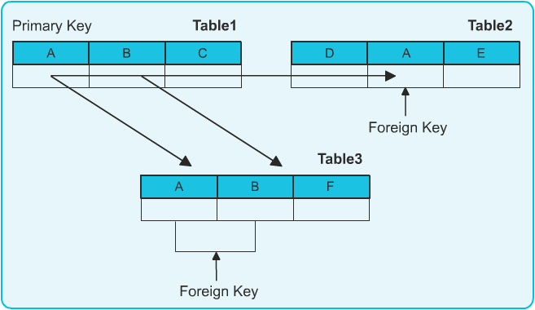
Parent-Child Relationship in a Relational Model
In the preceding diagram, Table1 consists of columns, A, B, and C. Table2 consists of columns, D, A, and E. Column A is a primary key of Table1, which is also present in Table2. Therefore, it will act as a foreign key in Table2.
Just as a combination of columns can serve as the primary key of the table, a foreign key can also be a combination of columns. Therefore in the preceding diagram, Table3, which consists of columns, A, B, and F can have a combination of columns (A and B) as a foreign key. The number of columns and the data types of the key must be identical to one another. A table can contain more than one foreign key if it is connected to more than one table.
The following TEACHER and BATCH tables show the parent-child relationship in a relational model.

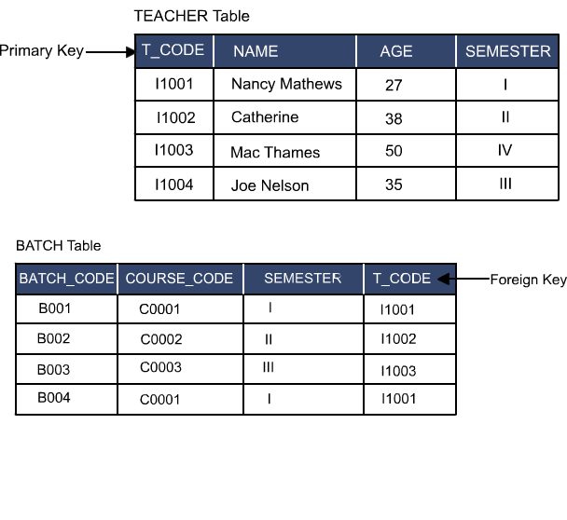
Parent-Child Relationship in a Relational Model
In the preceding TEACHER table, the teacher code (T_CODE) is the primary key, and in the Batch table, T-CODE is the foreign key. Only the teacher codes that are present in the TEACHER table can be entered in the Batch table.

<print>
Just a minute:
Which one of the following is NOT a record-based logical model?
- Hierarchical model
- Network model
- ER model
- Relational model
Answer:

3. ER model
</print>
<epub>
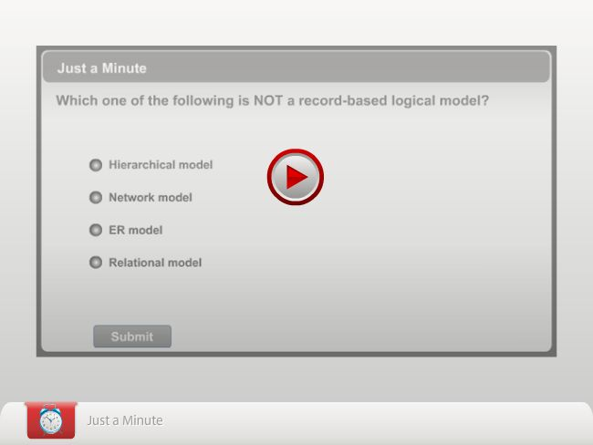
</epub>

Steps for Creating an ER Diagram
Once you have identified the entities and relationships, you need to create the
ER diagram of the database. The following steps should be followed while creating an ER diagram:
- Identify the entities: Identify the entities that are capable of an independent existence.
- Find the relationships: Find the type of relationships among selected entities.
- Identify the key attribute: Find the key attribute that can identify an instance of entity uniquely.
- Identify other important attributes: Identify other important attributes, which can be used to store the information in the database.
- Draw a complete ER diagram: Draw a complete ER diagram with all attributes including the primary key.
- Review of ER diagram: Do a final review of your ER diagram.
Consider the following scenario in a university. A university has many departments. Each department has multiple teachers and one among them is the head of the department. Each department offers multiple courses, each being taught by a single teacher. Therefore, one teacher belongs to only one department. Further, a student may enroll for many courses offered by different departments. A particular course can be offered by only one department. To create an ER diagram for this scenario, you need to first identify the entities.
Identifying the Entities
For the preceding scenario, you can have the following entities:
- DEPARTMENT
- COURSE
- TEACHER
- STUDENT
Finding the Relationships
For the preceding scenario, you can have the following relationships:
- The department offers multiple courses and each course belongs to only one department. Hence, the relationship between the department and course entities is one-to-many, as shown in the following diagram.
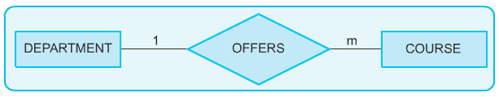
One-to-Many Relationship
- Multiple students can enroll for multiple courses. Hence, the relationship between the course and the student is many-to-many, as shown in the following diagram.
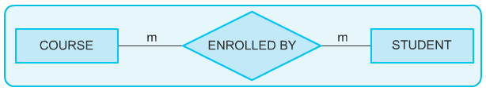
Many-to-Many Relationship
- One department has multiple teachers, and one teacher belongs to only one department. Hence, the relationship between the department and the teacher is one-to-many, as shown in the following diagram.
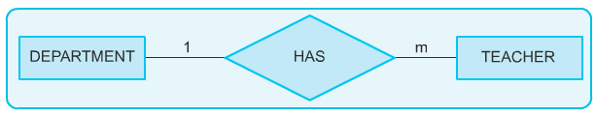
One-to-Many Relationship
- Each department has one head of the department and only one teacher is the head of for one department. Hence, the relationship between the department and the teacher is one-to-one, as shown in the following diagram.
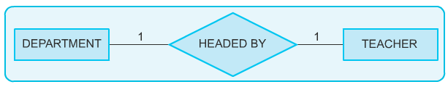
One-to-One Relationship
- One course is taught by only one teacher but one teacher teaches many courses. Hence, the relationship between the course and the teacher is many-to-one, as shown in the following diagram.
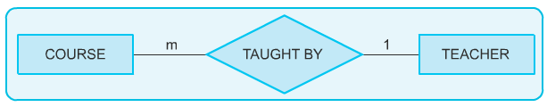
Many-to-One Relationship
Identifying the Key Attributes
After identifying entities and relationships, you need to identify the key attribute. The following list describes the key attribute for each entity:
- Dept_Code is a key attribute for the DEPARTMENT entity.
- Course_Code is a key attribute for the COURSE entity
- Roll_No is a key attribute for the STUDENT entity.
- T_Code is a key attribute for the TEACHER entity.

Identifying Other Important Attributes
The other relevant attribute of the DEPARTMENT entity is department name (Dept_Name).
The other relevant attributes of the COURSE entity are:
- Course name (Course_Name)
- Duration (Duration)
- Prerequisite (Pre_Req)
The other relevant attributes of the STUDENT entity are:
- Student name (Name)
- Date of birth (DOB)
The other relevant attributes of the TEACHER entity are:
- Teacher name (T_Name)
- Telephone number (Tele_No)
- Room number (Room_No)

Drawing a Complete ER Diagram
After considering all the preceding guidelines, you can generate an ER Diagram for the university database model, as shown in the following diagram.
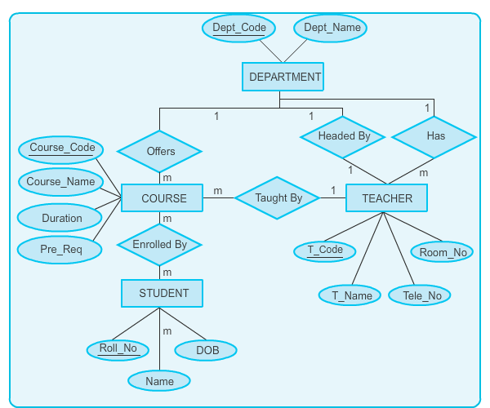
ER Diagram for the University Database Model
Reviewing an ER Diagram
After completing the ER Diagram, review your diagram so that there is no redundant data. Check if the ER diagram is representing all the preceding relationships and key attributes.
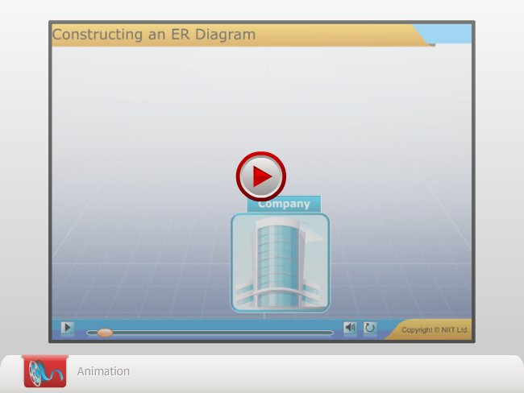

<Instruction: embed RDBMS_01_Constructing_ERdiagrams.swf>
Relational Operators
The relational model is based on the principle of relational algebra. Relational algebra is a collection of operators that operate on relations. Each operator takes one or two relations as its input and produces a new relation as its output.
The following operators have been defined as relational operators:
- RESTRICT
- PROJECT
- PRODUCT
- UNION
- INTERSECT
- DIFFERENCE
- JOIN
- DIVIDE

RESTRICT
The restrict operator extracts specified tuples or rows from a given relation based on a condition. The following diagram represents how restrict operator can extract specified tuples or rows from a given relation.
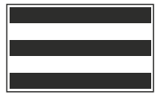
Restrict Extracts Tuples or Rows
In the preceding diagram, the black colored rows represent the extracted rows from the given relation by using the restrict operator.
For example, a STUDENT table has the attributes, ROLLNO (roll number), STUDNAME (student name), AGE, and GENDER.
The following table describes the columns of the STUDENT table.

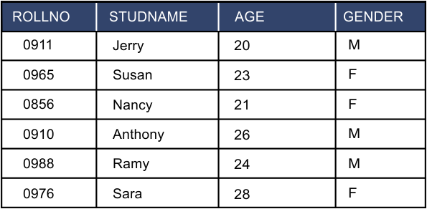
The Student Table
The condition is to extract the tuples from the STUDENT table of only those students whose age is more than 25. The following table describes the resultant relation.

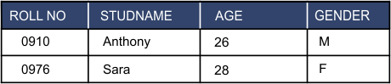
Example of the Restrict Operator

PROJECT
The project operator extracts specified attributes or columns from a given relation. The following diagram represents how project operator can extract specified attributes or columns from a given relation.
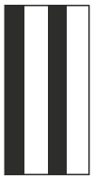
Project Extracts Attributes or Columns
In the preceding diagram, the black colored columns represent the extracted columns by using the project operator.
You can use the project operator, if you want to extract only the name and age of all the students.
The following table represents the resultant relation by using the STUDENT table.

STUDNAME | AGE
Jerry | 20
Susan | 23
Nancy | 21
Anthony | 26
Ramy | 24
Sara | 28
Example of the Project Operator
PRODUCT
The product operator joins two relations such that every tuple of the first relation is matched with every tuple of the second relation. To be product compatible, the two tables must have common attributes. The following diagram shows an example of the product operator.
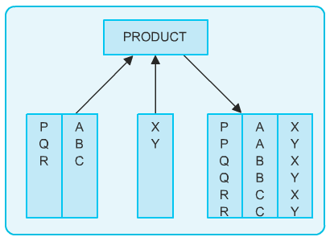
Example of the Product Operator
The product operator creates the Cartesian product between the two tables. For example, T_CODE column is a common attribute in the following TEACHER and BATCH tables.

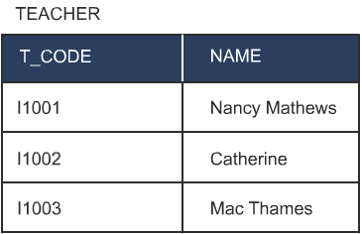
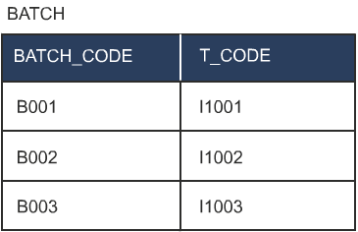
Teacher and Batch Tables
The following table lists the Cartesian product of the TEACHER and BATCH tables with all the possible combinations of their tuples.
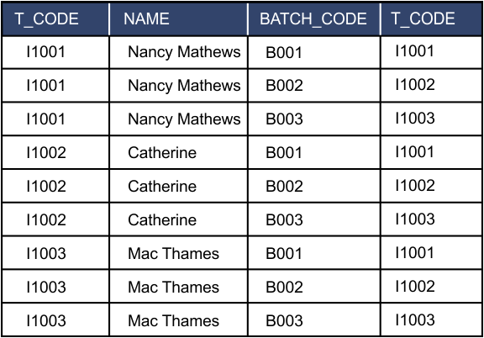
Cartesian Product of the Teacher and Batch Tables

UNION
The union operator builds a relation from tuples appearing in either or both of the specified relations. The following diagram represents the mathematical representation of the union operator.
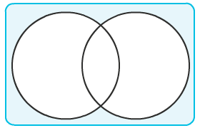
Union Operator
To be union compatible, the two tables should have the same types of attributes (sets of columns having the same data types).
Consider the following tables, A and B.

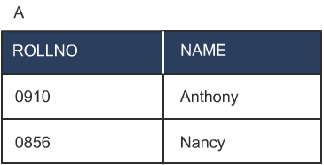
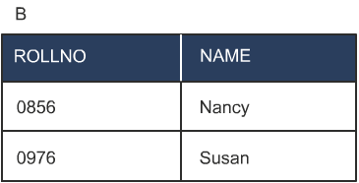
Table A and Table B
Table A contains the roll numbers and names of all the students whose major discipline is computer science. Table B contains the roll numbers and names of all the students whose major discipline is mathematics. These tables are union compatible because they have the same types of attributes. The following table illustrates the union operation on tables, A and B.

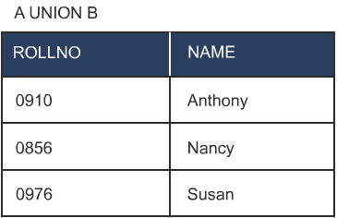
Example of the Union Operator

INTERSECT
The intersect operator builds a relation consisting of tuples that appear in both the relations. The following diagram represents the mathematical representation of the intersect operator.
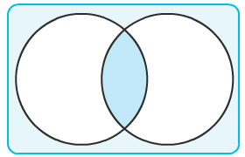
Intersect Operator
Consider the following tables, A and B.

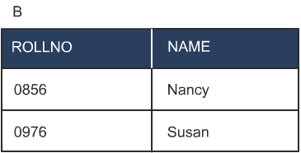
Table A and Table B
Nancy is doing a double major; therefore, her name appears in both the tables. An intersect operation on tables A and B extracts the rows common to both the relations. The intersect operation works on union compatible tables.
The following table illustrates the intersect operation on tables, A and B.

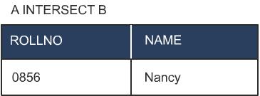
Example of the Intersect Operator

DIFFERENCE
The difference operator builds a relation of tuples appearing in the first but not in the second of the two specified relations. The following diagram represents the mathematical representation of the difference operator.
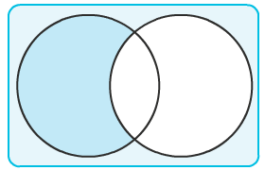
Difference Operator
The difference operation also works on union compatible tables. For tables A and B, the operation “A-B” extracts all rows that belong to A but not to B.
The following set of tables illustrates the difference operation on tables, A and B.

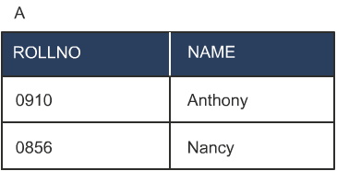
Table A and Table B

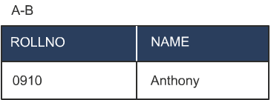
Example of the Difference Operator

JOIN
The join operator builds a relation from two specified relations. This relation consists of all the possible combinations of tuples, one from each relation that satisfies the specified condition. The join operation requires a common attribute. The following diagram shows how the join operator works.
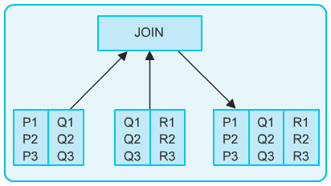
Join Operator
For example, consider the two tables, X and Y. Table X contains the roll numbers of the students, and the codes of the courses they have taken. Table Y contains the ID numbers of the teachers and the codes of the courses they teach. If you need the combination of students who take a course in physics and teachers who teach the course, you need to perform a join operation.
The following set of tables illustrates the join operation on tables, X and Y.

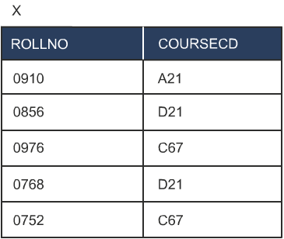

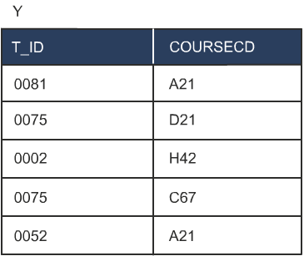
Table X and Table Y

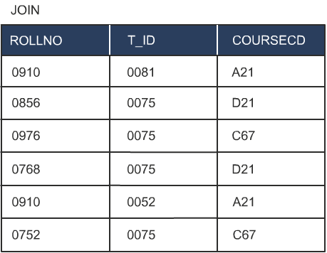
Example of the Join Operator
DIVIDE
The divide operator takes two relations and builds another relation consisting of values of an attribute of one relation that match all the values in the other relation. The divide operation is the opposite of the product operation. The following diagram shows how the divide operator works.
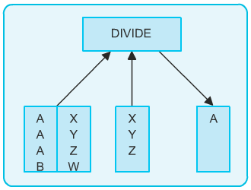
Divide Operator
For example, consider a table named STUDENT. It contains the name of the students and the course they have opted for. There is another table, COURSE, which shares a common attribute, COURSECD with the STUDENT table. You want to display the names of those students who have enrolled for all the courses. Applying the divide operator on the STUDENT and the COURSE tables will result in a value that matches all the values of relation, COURSE.
The following set of tables illustrates the divide operation on the STUDENT table.

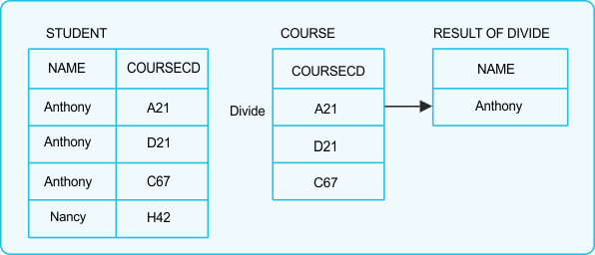
Divide Operation on the STUDENT Table

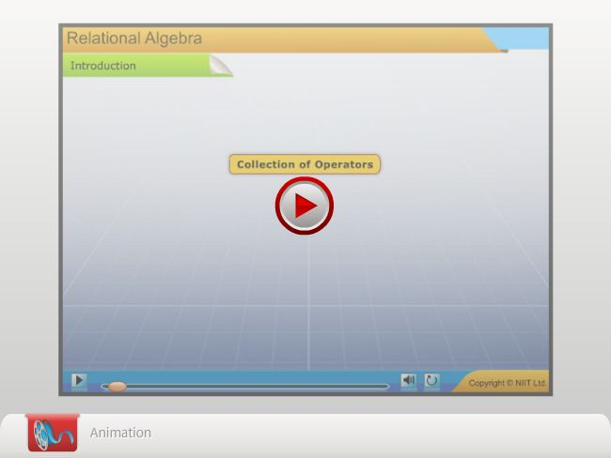
<Instruction: embed RDBMS_01_RelationalAlgebra>

<print>
Just a minute:
Which operator is used to extract specified tuples or rows from a given relation based on a condition in a relational algebra?
- Project
- Join
- Restrict
- Product
Answer:
3.Restrict

</print>
<epub>
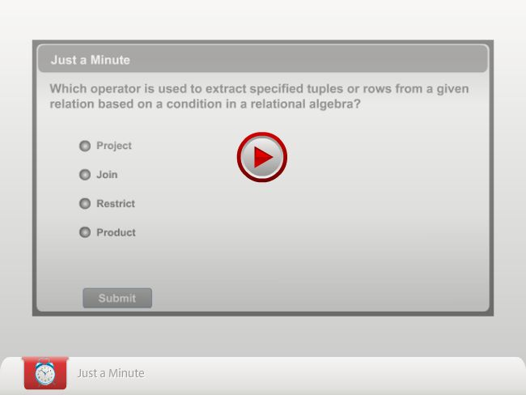
</epub>
Practice Questions
Q1. Which one of following operators is used to extract specified attributes or columns from a given relation?
  - Project
  - Divide
  - Join
  - Restrict
Q2. The number of rows in a table is called its _________ .
  - Degree
  - Attribute
  - Cardinality
  - Tuple
Q3. Which one of the following terms correctly defines an association between different entity types?
- Entity
- Relationship
- Attribute
- Regular entity
Q4. Which one of the following operators is used to build a relation consisting of tuples that appear in both the relations?
- PRODUCT
- UNION
- INTERSECT
- DIFFERENCE
Q5. Which one of the following models is used to represent the data in the form of a tree and the relationships between the data are represented by links?
- Hierarchical model
- Network model
- Relational model
- Object-based logical model
Summary
In this chapter, you learned that:
- Data models can be classified as:
- Object-based logical model
- Record-based logical model
- In the ER diagramming technique:
- Entities are represented as rectangles.
- Relationships are represented as diamonds.
- Attributes are represented as ellipses.
- Relationships, whether many-to-many, one-to-many, or one-to-one are represented symbolically.
- Weak entities are represented by double-lined boxes.
- Subtypes are connected to the supertype by an unnamed relationship, marked with a crossbar on top.
- In the relational model, data is represented in tables (relations) of rows (tuples) and columns (attributes).
- The number of tuples is called the cardinality of the table, and the number of attributes is called the degree of the table.
- An attribute (or set of attributes) that is unique in every tuple is called the primary key.
- Unknown or missing information is represented as NULL in a table.
- The foreign key is a column in one table that matches the primary key of another table.
- The following steps should be followed while creating an ER diagram:
- Identify the entities.
- Find the relationships.
- Identify the key attribute.
- Identify other important attributes.
- Draw a complete ER diagram.
- Review of ER diagram.
- The relational model is based on the principle of relational algebra.
- The eight operators that operate on relations are restrict, project, product, union, intersect, difference, join, and divide.
- The union operator builds a relation from tuples appearing in either or both of the specified relations whereas intersect operator builds a relation consisting of tuples that appear in both the relations.
- The difference operator builds a relation of tuples appearing in the first but not in the second of the two specified relations.
- The join operator builds a relation from two specified relations. This relation consists of all the possible combinations of tuples, one from each relation that satisfies the specified condition.
- The divide operator takes two relations and builds another relation consisting of values of an attribute of one relation that match all the values in the other relation.

Exercises
Exercise 1
Lee Wong is the newly appointed database administrator at Standard bank. The management of this bank wants to computerize the process of banking. According to the bank’s policy, one customer can have many accounts but one account cannot be shared by many customers. The following ER diagram represents the relationship between a customer and the accounts owned by a particular customer.
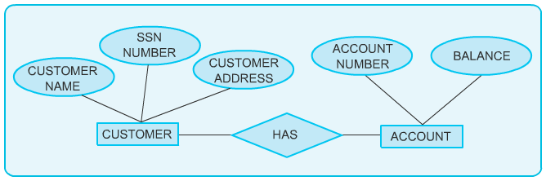
The ER Diagram Representing Relationship Between Customer and Account Entities
In the preceding diagram, you have to identify entities, their attributes, and type of relationship between the entities.

Exercise 2
You have been hired by a regional hospital to create a database that will be used to store the information of the patients. Implementing the database will make the data easily accessible. The following ER diagram represents the relationship between the patient and the doctor.

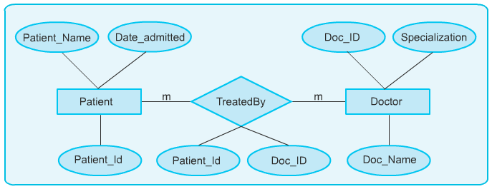
The ER Diagram Representing Relationship Between Patient and Doctor Entities
In the preceding diagram, you have to identify the entities, their attributes, and the type of relationship between the entities.
Exercise 3
Consider the following scenario:
An author can write multiple books and a book can be written by more than one author. Identify the relationship between the author entity and the book entity and represent it with an ER Diagram.
Exercise 4
Tom is working in an organization as a database administrator. Based on the hierarchy, the organization has multiple departments and each department has multiple employees. The following ER diagram represents the relationship between the departments and the employees.
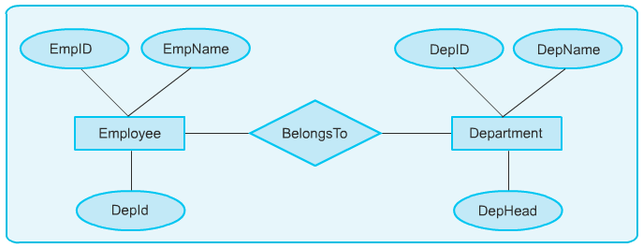

The ER Diagram Representing Relationship Between Employee and Department Entities
In the preceding diagram, you have to identify entities, their attributes, and type of relationship between the entities.
Exercise 5
Consider the following scenario:
In a college, there are multiple departments. Each department has various faculty members. Only one of these faculty members holds the position of the Head of the Department. Identify the relationship between the faculty and the department and represent it with an ER Diagram.
Exercise 6
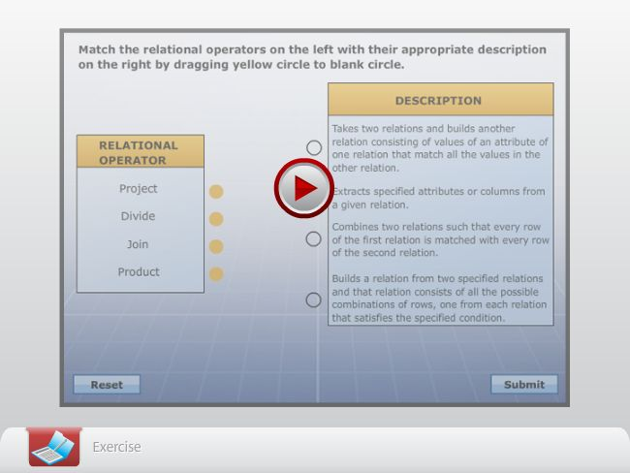
<Instruction: Embed RDBMS_01_Ex01>

Exercise 7
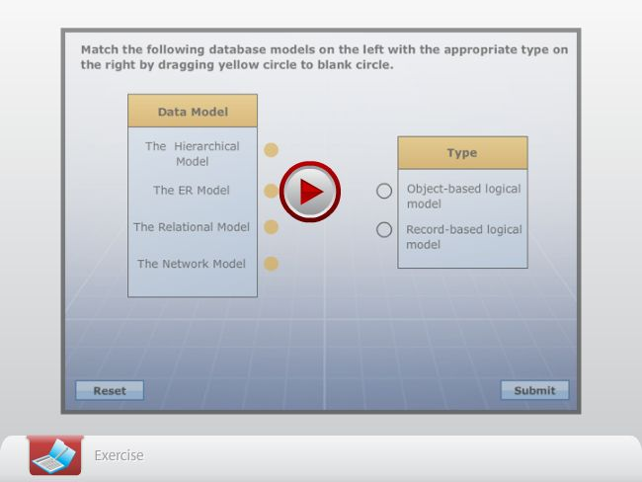

<Instruction: Embed RDBMS_01_Ex02>

Exercise 8

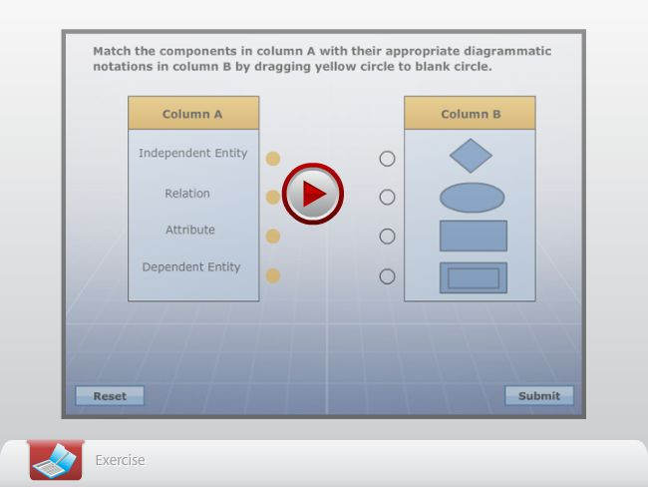

<Instruction: Embed RDBMS_01_Ex03>

