
Database Design | Chapter 2

All the data in an organization is related to entities. Designing a database involves identifying the various entities and the relationships that bind the entities. After the entities and relationships are identified, an ER diagram is drawn to logically model the data.
This chapter explains how to map entities and relationships in an ER diagram. It provides tips on creating a logical database design. In addition, it discusses how to transform entities into tables.
Objectives
In this chapter, you will learn to:
- Map an ER diagram to a table
- Identify tips of logical database design

Conceptual Model
To develop a database that satisfies the information needs of the present as well as the future, you must design a conceptual model of the database. The conceptual model reflects entities and their relationships based on the data-processing needs of an organization. The conceptual model can be mapped to a relational, hierarchical, or network model. It is independent of individual applications, database management systems, hardware, and physical storage of data.
Data analysis is the first step in designing a conceptual model and begins with collecting information about data. This involves using a questionnaire or any similar method to obtain a list of data that an organization needs. Data analysis involves identifying entities, their attributes, and relationships between entities based on the data collected.
After you complete data analysis, you draw the entity-relationship diagram. This diagram gives a detailed overview of the design, and is particularly good for communicating ideas to users. The mapping of real objects to the symbols of the entity-relationship diagram is subjective. Often, something that was originally defined as an attribute may become an entity after design review. There are no defined rules to identify an object as an entity, or an attribute, or a relationship.

Mapping ER Diagrams to Tables
A database that conforms to an ER diagram can be represented by a collection of tables in the relational system. The following components play an important part while mapping an ER diagram to table:
- Regular entities
- Attributes
- Relationships
- Weak entities
- Subtypes and supertypes
The most important principle is to create tables where information from the real world is stored and retrieved in an optimal way; that is, a minimum number of tables with a minimum number of attributes.
Regular Entities
You will recall that regular entities are not dependent. They can exist alone, independent of any other entity. They are the “building blocks” of the database. Each regular entity maps to a table.
For example, STUDENT and BOOKS are two separate entities in the following ER diagram.
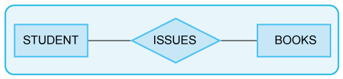
The Regular Entities
In the preceding diagram, the two regular entities, STUDENT and BOOKS, map to two separate tables.
Attributes
Each property or attribute shown in the ER diagram maps to an attribute in the appropriate table. In the following ER diagram, STUDENT and BOOKS individually have different attributes.
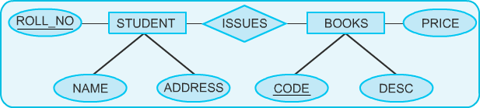s
The Attributes
If you map the preceding diagram to the tables, you will find that the entity becomes the table and the attributes of the entity become columns of the table. Therefore, the STUDENT entity becomes the STUDENT table and the BOOKS entity becomes the BOOKS table, as shown in the following tables.

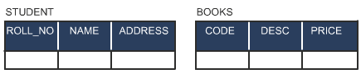
The STUDENT and BOOKS Tables
The ROLL_NO and CODE attributes are identified as primary keys in the preceding tables. Remember that the primary key must be able to uniquely identify each row in the table.

Relationships
The mapping of relationships depends on the type of relationship. There are the following types of relationships:
- One-to-One relationship
- One-to-Many relationship
- Many-to-Many relationship
Each type of relationship maps to tables in a different manner in the relational database management system. You represent the type of relationship between two entities in an ER diagram by certain symbols. An entity may be associated with one, none, or many occurrences of another entity.
One-to-One Relationship
In one-to-one relationships, one instance of an entity can relate to only one instance of the related entity.
For example, a student can do only one project in a semester and no other student can do the same project in the same semester. Therefore, there is a one-to-one relationship between student and project.
The following ER diagram represents a one-to-one relationship between the two entities, STUDENT and PROJECT.
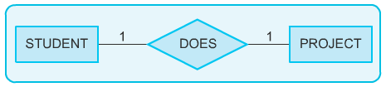
A One-to-One Relationship
In the preceding diagram, the DOES relationship associates STUDENT to PROJECT. This type of relationship can be handled in several ways. One way to handle it is by storing a foreign key in either table. Another way is to merge the two tables into one for faster access. For example, if frequent queries required data from the two tables, then it is better to merge the two tables to improve query performance.
The following STUDENT table is created after merging the STUDENT and PROJECT tables.

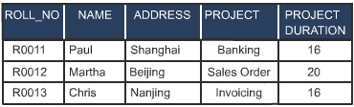
The STUDENT Table
One-to-Many Relationship
In a one-to-many relationship, one instance of an entity can relate to more than one instance of the related entity. For example, a department of an organization can have more than one employee.
The following ER diagram represents the one-to-many relationship between an employee and a department.

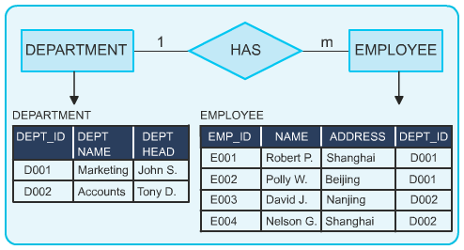
The One-to-Many Relationship Between Employee and Department
In the preceding diagram, the DEPT_ID of an employee is stored in the EMPLOYEE table. Therefore, Dept_ID is a foreign key in the Employee table.
Many-to-Many Relationship
In a many-to-many relationship, many instances of an entity can relate to more than one instance of the related entity. For example, a student can issue many books and one book can be issued to many students. The following ER diagram represents a
many-to-many relationship between STUDENT and BOOKS.
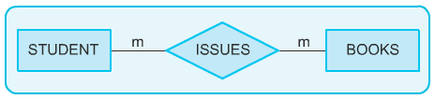
The Many-to-Many Relationship Between STUDENT and BOOKS
In the preceding diagram, the relationship, ISSUES associates students to books. ISSUES may have some attributes that are unique to it, for example, the date on which the book was issued and the date on which the book has to be returned. Therefore, you must understand that attributes do not belong only to entities. They can also belong to relationships. The ISSUES relationship is a many-to-many relationship. Such a relationship maps to a table.
The following diagram represents the mapping of many-to-many relationship between STUDENT and BOOKS with three different tables.
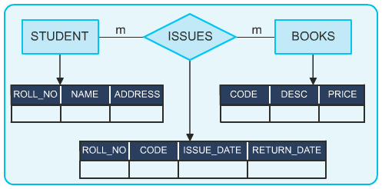
Mapping Relationships
In the preceding diagram, the new table, ISSUES includes the primary keys (ROLL_NO and CODE) of both the tables, STUDENT and BOOKS. The primary keys of both the tables will act as the foreign keys in the ISSUES table. This will help in joining the two tables, STUDENT and BOOKS.
For example, a user wants to know which book was issued to a particular student and on which date. You can use the foreign keys in the ISSUES table to make a join between all the three tables. The following table lists the complete description of the issued transaction.


Joining Tables
What is the primary key of the ISSUES table? There are two possibilities. One possibility is to take a combination of the two foreign keys (ROLL_NO and CODE) if the combination uniquely identifies every row in the table. The resulting key is known as a composite key, that is, a key made up of more than one attribute. Another possibility is to create a new attribute for the primary key, for example ISSUENUM. The following tables depict the composite and primary keys.

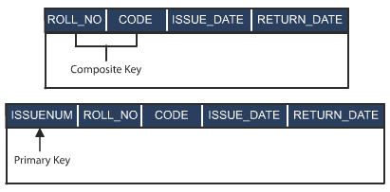
Selecting Composite and Primary Keys of the ISSUES Table
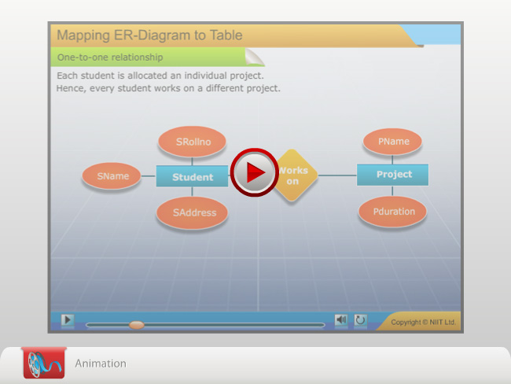
<Instruction: embed RDBMS_02_Relationship>
Weak Entities
A weak entity is an entity whose existence depends on some other entity. The weak entities have the composite key, part of which consists of the primary key of the entity they depend on. For example, address of an employee is dependent on employee.
The following ER diagram shows how you can represent a weak entity.
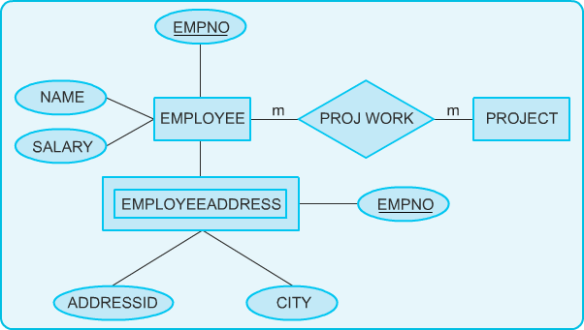
Weak Entity
In the preceding diagram, EMPLOYEEADDRESS is a weak entity. It depends on the EMPLOYEE entity as it specifies the address of an employee.
The EMPLOYEEADDRESS entity can be mapped to a separate table. The following table has been mapped with the weak entity, EMPLOYEEADDRESS.

ADDRESSID | EMPNO | CITY
Weak Entity Mapping to a Table
Subtypes and Supertypes
A subtype is a subset of another entity. A subtype is always dependent on supertype for its existence. For example, in an organization, an employee can be categorized as an hourly employee and a salaried employee. Therefore, HOURLY EMPLOYEE and SALARIED EMPLOYEE are the subtypes, which are dependent on supertype, EMPLOYEE.
The following ER diagram shows how you can represent subtypes and supertypes.
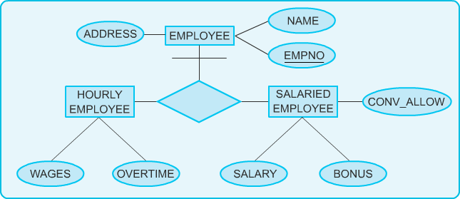
Subtypes and Supertypes
The following tables show how each entity type (subtype or supertype) maps to a separate table.

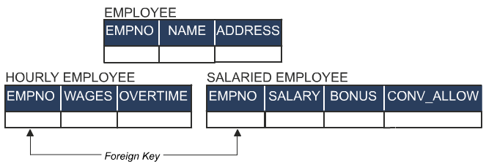

Mapping Subtypes and Supertypes
In the preceding tables, the primary key (EMPNO) of the supertype (EMPLOYEE) is the foreign key of the subtypes (HOURLY EMPLOYEE and SALARIED EMPLOYEE). It creates a link between the supertype (EMPLOYEE) and subtypes (HOURLY EMPLOYEE and SALARIED EMPLOYEE). The foreign keys of the subtypes are also their primary keys.
The following tables describe the structure of the subtypes, HOURLY EMPLOYEE and SALARIED EMPLOYEE.

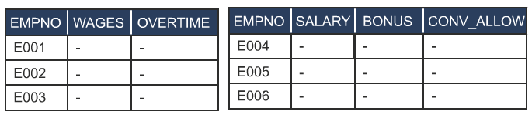Table Structure of the Two Subtypes

Tips on Logical Database Design
Here are some tips and guidelines on database design.

Attributes
Do not introduce unnecessary attributes. An attribute serves the following purposes:
- It identifies its owner entity.
- It refers to another entity.
- It simplifies the description of an entity.

If there are any entities with common attributes, merge the entities. For example, there could be different categories of books, such as storybooks and textbooks. Every category of book will have NAME, CODE, and PRICE as its attributes. Therefore, instead of making STORY BOOKS and TEXT BOOKS as different entities, you can create one entity, BOOKS. The BOOKS entity will have the common attribute of both the categories of books. Remember that the main objective is to come up with a database that has the minimum number of tables with the minimum number of attributes.
The following diagram shows how you can merge two entities that contain common attributes.
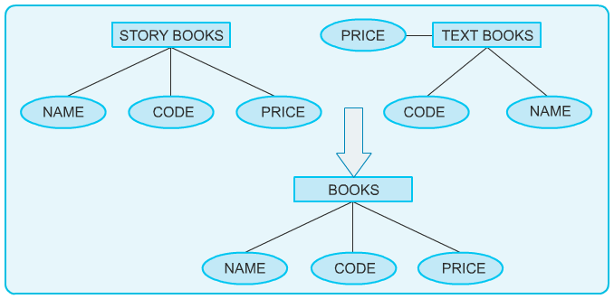
Merging Entities with Common Attributes

Keys
An RDBMS uses associative addressing; that is, it identifies and locates rows by value. The physical address is transparent to the user. Therefore, relational systems require keys that can uniquely identify the rows of a table.
There are various types of keys used in an RDBMS. These keys are:
- Primary
- Foreign
- Candidate
- Alternate
- Composite
Any attribute (or set of attributes) that uniquely identifies a row in a table is a candidate for the primary key. Such an attribute is called a candidate key. One of the candidate keys is chosen to be the primary key, based on the familiarity and greater usage. Any attribute that is a candidate for the primary key but is not the primary key is called the alternate key. When the key that uniquely identifies the rows of the table is made up of more than one attribute, it is called a composite key.
It is important to understand that the primary key is the only guaranteed way to identify rows of a table. Therefore, NULL values are not permitted in a primary key. If a primary key is allowed NULL values, it becomes difficult to identify the rows uniquely.
Consider the following STUDENT table.

STUDENT# | REGN# | DESCRIPTION
135268 | 2362 | Sem-1
833647 | 7389 | Sem-1
784799 | 8399 | Sem-2
347889 | 9077 | Sem-3
The STUDENT Table
In the preceding table, STUDENT# and REGN# are both individually unique in every row. Therefore, they are both candidate keys. If STUDENT# is chosen as the primary key, then REGN# is the alternate key.
Keys can be simple or composite. A simple key is composed of a single attribute. A composite key, on the other hand, comprises two or more attributes.
Consider the following ACCOUNTS table.

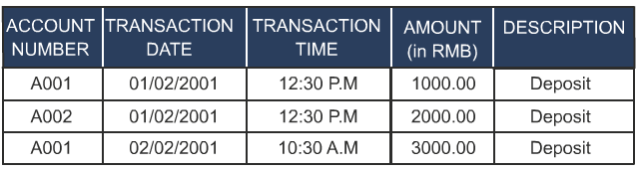
The ACCOUNTS Table
In the preceding table, assume that only one transaction can take place for a given account number at a time. We can select ACCOUNT NUMBER, TRANSACTION DATE, and TRANSACTION TIME as the composite key.
Consider the following WORKING HOURS table.

EMPID | PROJECTID | WOKING HOURS
E309 | P675 | 18
E453 | P908 | 5
E334 | P876 | 20
E453 | P675 | 20
The WORKING HOURS Table
The preceding table specifies the working hours of each employee in a company. Each row of the WORKING HOURS table can be uniquely identified by a composite key composed of EMPID and PROJECTID.
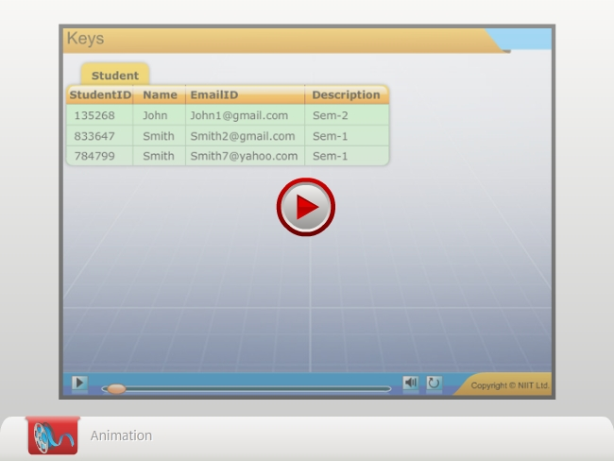
<Instruction: embed RDBMS_02_keys.swf>

<print>

Just a minute:
Which one of the following keys could be a candidate for the primary key but is not the primary key?
- Candidate
- Alternate
- Composite
- Foreign
Answer:

- Alternate

</print>

<epub>
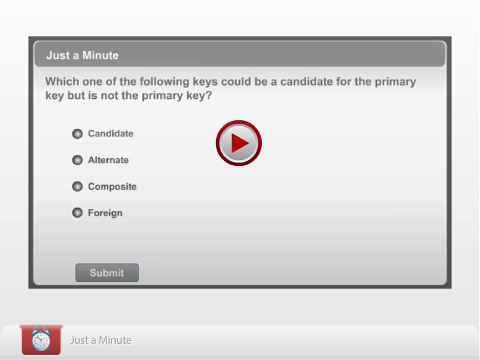
</epub>

<print>
Just a minute:
Which one of the following keys is made up of more than one attribute and uniquely identifies the rows of the table?
- Candidate
- Alternate
- Composite
- Primary
Answer:
- Composite

</print>

<epub>
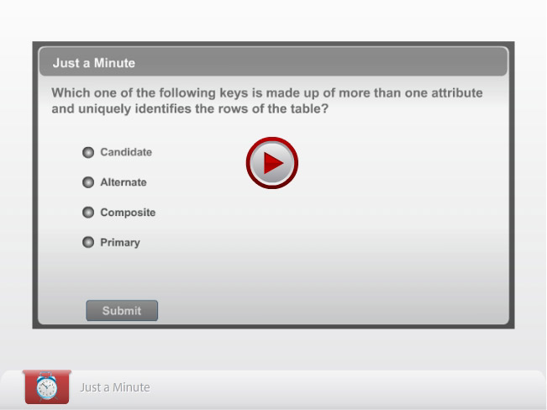
</epub>

Entities
Some attributes may acquire further attributes to qualify themselves during database design and become entities. You can create a new entity to represent important recurring groups of attributes. For example, the attribute “address” may acquire further attributes, such as BLOCK, STREET, CITY, STATE, and PIN. In this case, the attribute ADDRESS becomes an entity, as shown in the following diagram.
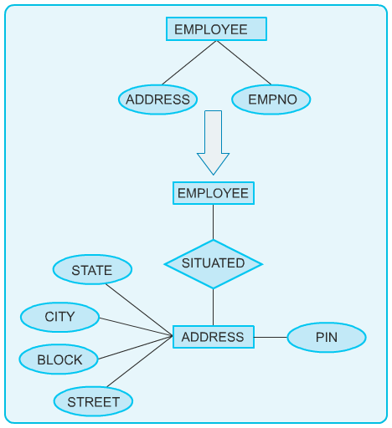
Attributes may Become Entities

Subentities
Consider the following example. The EMPLOYEE entity has the attributes, such as name, employee ID, subject, programming language, and field.
However, some of the attributes do not apply to all the employees. For example, the SUBJECT attribute applies only to teachers. In this case, all employees who are not working as teachers have the value NULL stored in the SUBJECT column. A good practice is to replace optional attributes with subentities. This is called specialization.
Specialization is the result of taking a subset of a higher-level entity set to form a lower-level entity set. In this example, EMPLOYEE is the higher-level entity set, while PROGRAMMER, TEACHER, and ENGINEER are lower-level entity sets.
The following diagram represents the concept of specialization.
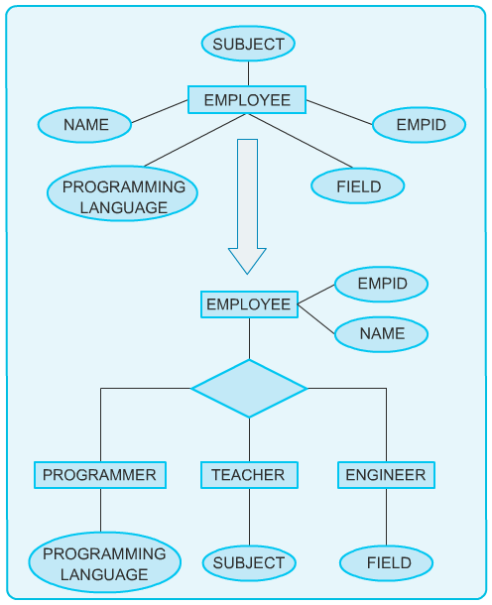
Specialization
Now, consider the opposite of the preceding example. The two entities, SAVING ACCOUNT and CURRENT ACCOUNT, have some common attributes. In this case, a better option is to create a new super entity to simplify multiple references. This is called generalization.
Generalization is the result of taking the union of two or more lower-level entity sets to produce a higher-level entity set. It is the opposite of specialization. In generalization, every higher-level entity must also be a lower-level entity. Specialization does not have this constraint. For example, an account is a higher-level entity, which has saving and current account as lower-level entities. Therefore, you can take the union of lower-level entity sets (SAVING ACCOUNT and CURRENT ACCOUNT) to produce a higher-level entity set (ACCOUNT). The following diagram represents the concept of generalization.
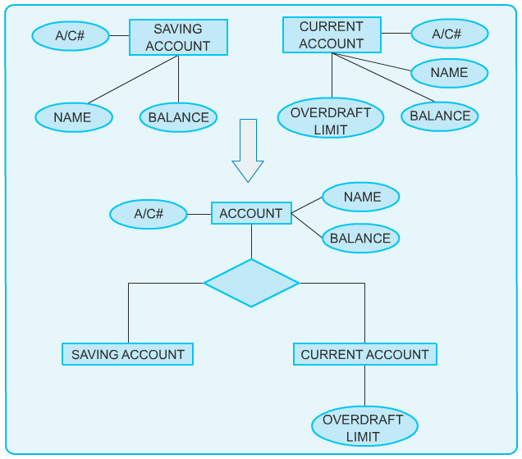
Generalization

Activity: Mapping the ER Diagram to Tables
Problem Statement
Map the following ER diagram to its corresponding tables.
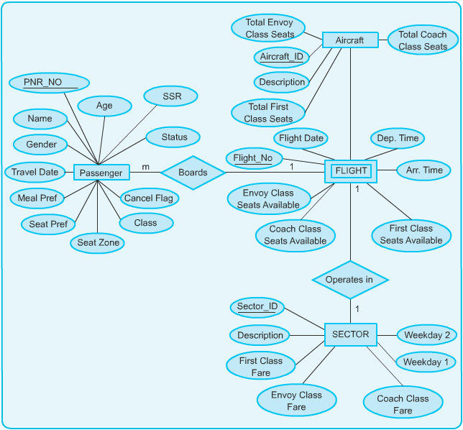
The ER Diagram

Solution

The ER diagram is mapped with the following tables.
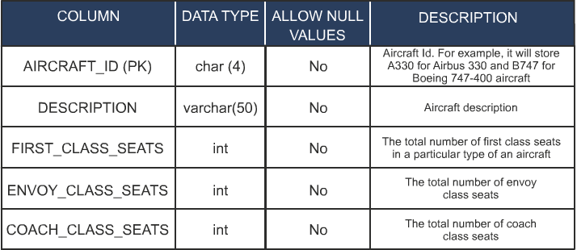
The Aircraft Table
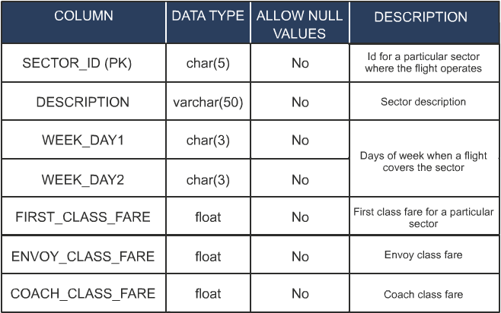
The Sector Table

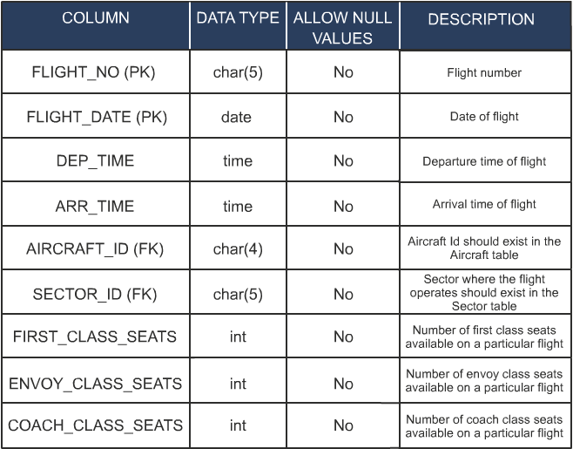
The Flight Table


Note
The number of seats in each class for a particular flight will be initialized based on the Aircraft ID. Every time a reservation takes place, the number of seats in this table will be decremented based on the class of travel chosen by the passenger. Similarly, in case of a cancellation, the number of available seats will be incremented. Though this is redundant data, it is still maintained in this table for ease of use in queries.

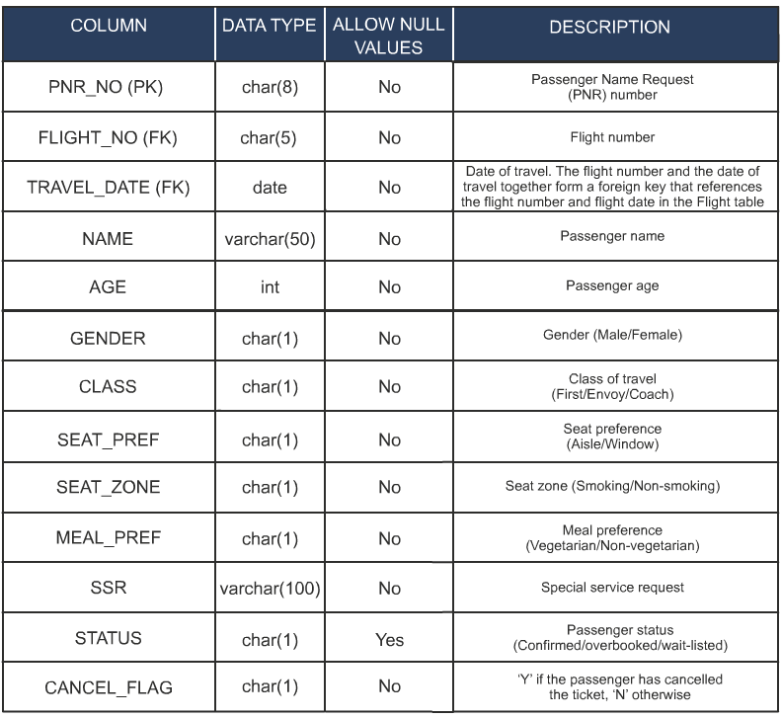
The Passenger Table

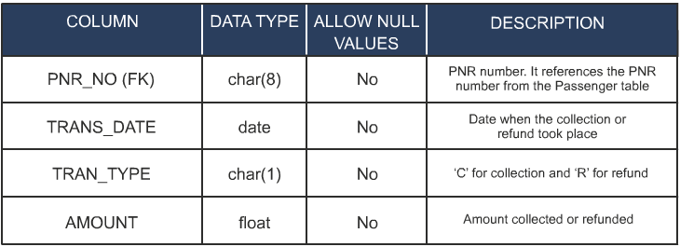
The DailyCollection Table

Note
The DailyCollection table is updated whenever a transaction, such as a reservation, cancellation, or modification, takes place. This table is created for the purpose of generation of reports. Although this table is not shown in the ER diagram, it is used to maintain a record of daily transactions.

Practice Questions
- Which type of relationship is established when multiple students can enroll for one course?
  - One-to-one
  - One-to-many
  - Many-to-one
  - Many-to-many
- Which of the following types of relationship enables you to merge two tables for faster access?
  - One-to-one
  - Many-to-one
  - One-to-many
  - Many-to-many
- Which of the following options specifies a key that is made up of more than one attribute?
  - Primary key
  - Foreign key
  - Alternate key
  - Composite key
- Which of the following keys is an attribute that is a candidate for the primary key but is not the primary key?
  - Alternate key
  - Foreign key
  - Candidate key
  - Composite key
- Which of the following options is the result of taking the union of two or more lower-level entity sets to produce a higher-level entity set?
  - Relationship
  - Specialization
  - Supertype
  - Generalization
Summary
In this chapter, you learned that:
- The conceptual model reflects entities and their relationships. Data analysis helps determine entities and relationships. The conceptual model is independent of the system where it is to be implemented.
- Regular entities are not dependent. They can exist in isolation, independent of any other entity.
- Each entity maps to a table. Each attribute in an ER diagram maps to a column in a table.
- Entities with common attributes should be merged. Attributes may acquire further attributes and become entities.
- The mapping of relationships depends on the type of relationship. Each type of relationship maps to tables in a different manner in the relational database management system.
- In one-to-one relationship, one instance of an entity can relate to only one instance of the related entity.
- In one-to-many relationship, one instance of an entity can relate to more than one instance of the related entity.
- Many-to-many relationships map to tables. One-to-one relationships are not very common and may map to foreign keys in tables.
- A weak entity is an entity whose existence depends on some other entity.
- A subtype is a subset of another entity. A subtype is always dependent on supertype for its existence.
- The primary key of the supertype is the foreign key of the subtype. It creates a link between the two.
- A candidate key is a candidate for the primary key. An alternate key is a candidate key that is not a primary key.
- Optional attributes should be replaced with subentities. This is called specialization.
- To simplify multiple references, a new super entity should be introduced. This is called generalization.

Exercises
Exercise 1
Design an ER diagram for the following situation:
An organization has two types of employees, salaried and wage earning. Both the types of employees have some common properties, such as employee code, employee name, and employee address. However, the salaried employees have other additional properties: basic, allowance, and House Rent Allowance (HRA). The wage earning employees have distinct properties that are daily wage and overtime.
Exercise 2
Shopping Spree is a leading departmental store in Shanghai. The store has a number of regular customers who purchase bulk items. The store also conducts regular feedback sessions to analyze customer satisfaction levels. Chen, the Customer Analyst of Shopping Spree, has to make the ER diagram to represent the preceding situation, and then to map the ER diagram to the corresponding tables. Help Chen to do the same.
Exercise 3
<epub>
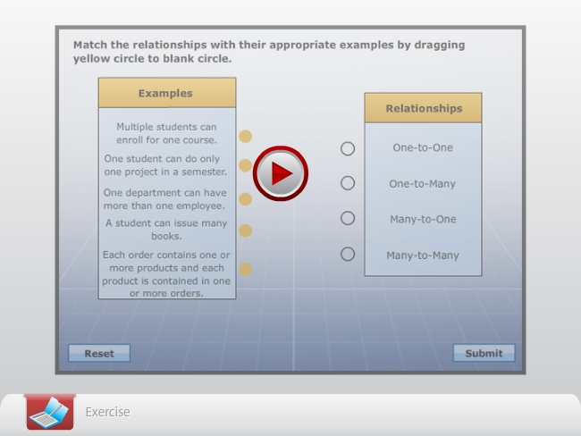

</epub>
<Instruction: Embed Ch02_Ex01.swf here>
Exercise 4
<epub>

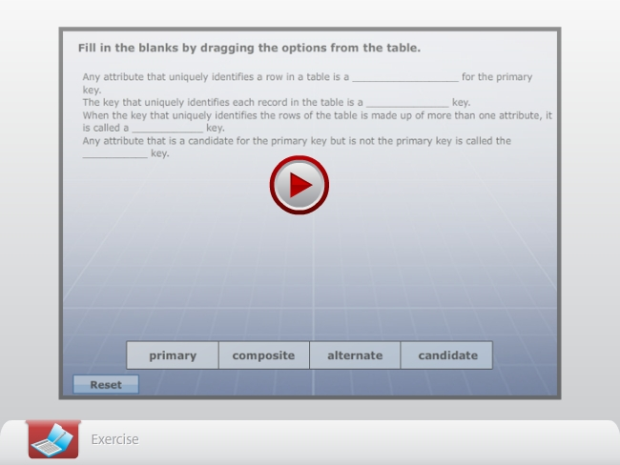

</epub>
<Instruction: Embed Ch02_Ex02.swf here>
Q5. Consider the following DoctorDetails table.
DoctorID | ShiftID | Qualification
137 | 36 | MBBS
647 | 38 | MBBS
747 | 39 | MD
347 | 07 | MBBS
The DoctorDetails Table
In the preceding table, you have to identify primary key, candidate key, and alternate key and give the reason.

