CSCE 5218-DEEP LEARNING

Group 5

Afnan Abdul Razzack

11860393

nanoGPT- Final Report

1. Introduction
For this assignment I worked with nanoGPT, a small and readable version of GPT-2 written by Andrej Karpathy (github.com/karpathy/nanoGPT, commit 3adf61e). Its whole job is simple to describe and read some text and guess the next character.
model.py defines the model, train.py trains it, and sample.py uses a trained model to write new text.
The model itself works in four steps:
- Turn characters into numbers. Each character is turned into a list of numbers (an embedding), and a second list that says where the character sits in the text is added on top.
- Pass it through a stack of transformer blocks. Each block lets the characters "look back" at earlier characters (attention) and then process what they found (a small neural network called an MLP).
- Normalize once more at the end.
- Make a guess. A final layer turns the result into a score for every possible next character.
I trained it on Tiny Shakespeare: about 1.1 million characters of Shakespeare's plays, using 65 different characters. The goal of this report is to understand how the code works and then to see, through 128 experiments, how seven settings change the model's quality, its tendency to overfit, its speed, and the text it writes.

2. Code Analysis
MODEL.PY
1. How is the causal self-attention mask implemented?
The model is not allowed to look at future characters, because its job is to guess the next one. To stop it from "cheating", nanoGPT hides all the future positions. It does this with is_causal=True (or a triangle-shaped mask made with torch.tril), which turns the scores for future positions into zero.
2. What is the purpose of LayerNorm and where is it positioned?
The purpose of LayerNorm is to keep the number inside the model at a size which is steady, so that they don’t shrink as they pass through many layers. By doing this, the training remains stable. It Is positioned before every main step: before attention(ln_1), before MLP(ln_2) and before the very end(ln_f).
3. Explain the forward pass through one transformer block?
Each block does two steps:
1.Attention: each character looks at the earlier characters and collects useful information from them.
2.MLP: each character then processes what it collected, on its own.
After each step, the result is added back to the input (x = x + ...). This allows the block to only add small improvements instead of staring again from the beginning.
4. How are positional embeddings handled?
Since, attention doesn’t know the order of the characters. NanoGPT usually keep a learned list of vectors, for each position(wpe) and then adds the matching one to every character. Then, the model gets to recognize that “a” in position 1 is different from “a” in position 10. The model cannot read longer inputs than that, because it has block_size entries.
5. What is the role of the n embd, n head, and n layer parameters?
• n_embd = width: how many numbers describe each character.
• n_layer = depth: how many blocks are stacked.
• n_head = number of attention heads.
The bigger n_embd or n_layer, the bigger is the model.
6. How does dropout regularization work in the architecture?
Dropout during training deactivates a random number of neurons in a small proportion such as 10%. This helps the neural network from getting dependent on certain neurons and thus avoids memorization, making it possible to work well even with unseen data. In nanoGPT, dropout is applied after the embedding layer, in the attention layers, and the MLP.
TRAIN.PY
1. How is the learning rate schedule implemented?
The learning rate (how big each update step is) changes during training, in the function get_lr():
1. Warm-up: In the early stages, it starts off very low and then slowly rises in order to avoid sudden changes in the model when training begins.
2. Cool down: It then slowly decreases to reach its minimum level.
2. Explain the gradient accumulation strategy
Sometimes a big batch doesn't fit in GPU memory. Instead, the code runs several small batches one after another and adds up their gradients. Only then does it update the model once. The result is the same as using one big batch. In the Shakespeare settings this is set to 1, so it is not really used.
3. How are training and validation splits created?
This is divided once by the prepare.py file: the first 90% is for training and the latter 10% is for validation. This is always the case as the model never sees the validation set during training. The files are read using np.memmap where only the portions that are required to be accessed are loaded onto the memory from the disk.
4. What loss function is used and why?
Cross-entropy. For every position, the model gives a probability for each possible next character. The loss is low when it gives a high probability to the correct character, and high when it doesn't. This is the standard loss for "guess the next token" problems. With 65 characters, pure guessing gives a loss of about 4.17, which is where training starts.
5. How does block_size affect batch construction?
Block size refers to the number of characters the model can perceive at a time. Every training instance consists of block_size characters (x) and its target is block_size characters shifted by one (y). So one chunk actually gives block_size small "guess the next character" questions. A bigger block_size means more context, but it uses more memory.
6. What is the purpose of max_iters and lr_decay_iters?
max_iters is how many training steps we run in total. lr_decay_iters is the step where the learning rate finishes going down. We usually set them equal, so the learning rate reaches its lowest value exactly when training ends.
SAMPLE.PY
1. How does temperature affect the sampling distribution?
Temperature controls how "risky" the model is when picking the next character:
• Low (below 1): it plays safe and picks the most likely characters. Text is cleaner but can be repetitive.
• High (above 1): it takes more chances. Text is more varied but has more mistakes.
nanoGPT uses 0.8 by default, which is slightly on the safe side.
2. What is top-k sampling and how does it work?
The use of top-k means that the algorithm can only choose from the top k predictions that are the most probable. For example, if k=10, it will be restricted to picking only from the top ten. This stops it from picking very unlikely, weird characters. (The default k = 200 is bigger than our 65 characters, so here it doesn't change anything.)
3. How is the context window managed during generation?
The algorithm writes one character at a time to the text. However, the algorithm has access to only the last block_size number of characters, hence, once the text becomes larger than that, the old characters get deleted from the algorithm's memory.
4. Why might you want to use different sampling strategies?
Because there is a trade-off between "safe and boring" and "creative but messy". Always picking the top choice often makes the text repeat itself. More randomness makes it more interesting but adds mistakes. Settings like temperature and top-k let you choose the balance you want.
5. How does the model handle the start of generation?
The model needs some starting text. By default it starts from a new line ("\n"), or you can give your own prompt like "ROMEO:". Since a new line in Shakespeare usually comes before a character's name, the model often begins by writing a name. To turn numbers back into letters, it uses the character list saved in meta.pkl.

3. Experimental Setup

3.1 Dataset
I used the character-level Tiny Shakespeare dataset that comes with nanoGPT. prepare.py turns each of the 65 characters into a number and splits the text into two parts:
- Training set: the first 90% of the text (1,003,854 characters)
- Validation set: the last 10% (111,540 characters), which the model never trains on

3.2 Methodology
The assignment gives seven settings to study, each with two values. I am the only member of my group, so I ran every combination myself: 2⁷ = 128 training runs. Each run trains a brand-new model from scratch, and only these seven settings change between runs.
Setting | Values | What it controls
block_size | 64, 128 | How many characters the model can see at once
n_layer | 4, 6 | How many blocks are stacked (depth)
n_head | 4, 8 | How many attention heads each block has
n_embd | 128, 256 | How many numbers describe each character (width)
batch_size | 8, 16 | How many text chunks are used per training step
max_iters | 1000, 2000 | How many training steps
dropout | 0.1, 0.2 | How strongly the model is regularized
To keep the comparison fair, everything else was kept the same in every run:
- Same starting config, Karpathy's config/train_shakespeare_char.py
- Same learning rate schedule: peak 0.001, minimum 0.0001, 100 warm-up steps, and the cool-down ending exactly at max_iters
- Same random seed (1337), so differences come from the settings and not from luck
- Same hardware: a free Google Colab T4 GPU
- Same measuring routine: loss checked every 100 steps on 50 random batches
For each run I recorded the training loss, validation loss, the gap between them (a sign of overfitting), the number of parameters, peak GPU memory, total time, and a 500-character text sample. Every sample used the same settings: a new line as the prompt, temperature 0.8, top-k 200 and seed 1337.
I ran everything from one Colab notebook that loops through all 128 combinations and saves the results to Google Drive. I made three small additions to Karpathy's code:
- The checkpoint-saving code from the course extended to also save the dataset name, so sample.py uses the right alphabet.
- One line that prints peak GPU memory.
- A one-word fix so sample.py can load checkpoints on newer PyTorch.
All code, configuration files and logs are in my GitHub repository Github.

3.3 Baseline
My reference point is the trained model the instructor provided (ckpt-1.pt). It is a small model: block size 64, 4 layers, 4 heads, width 128 and no dropout, with about 0.8 million parameters. Inside my own grid, the matching starting point is the smallest setup: block 64, 4 layers, 4 heads, width 128, batch 8, 1000 steps, dropout 0.1, which reached a validation loss of 2.27. Every other run can be read as "how much better or worse than this smallest model?"

4. Results
All 128 runs finished without errors, using about 107 minutes of GPU time in total (between 26 and 115 seconds per run). The validation loss ranged from 1.658 for the best run to 2.329 for the worst. For comparison, random guessing scores 4.17, so every model learned a lot.
runs like this: bs128_L4_H8_E256_B16_it2000_do0.1 means block size 128, 4 layers, 8 heads, width 256, batch 16, 2000 steps, dropout 0.1.

4.1 Best and worst runs
Rank | Run | Params (M) | Train loss | Val loss | Gap | Time (s) | Memory (MB)
1 | bs128_L4_H8_E256_B16_it2000_do0.1 | 3.16 | 1.469 | 1.658 | 0.190 | 79.8 | 232
2 | bs128_L4_H4_E256_B16_it2000_do0.1 | 3.16 | 1.478 | 1.662 | 0.184 | 72.9 | 196
3 | bs128_L6_H8_E256_B16_it2000_do0.1 | 4.74 | 1.461 | 1.662 | 0.201 | 114.9 | 334
4 | bs128_L6_H4_E256_B16_it2000_do0.1 | 4.74 | 1.471 | 1.668 | 0.197 | 104.9 | 281
5 | bs128_L4_H8_E256_B16_it2000_do0.2 | 3.16 | 1.563 | 1.726 | 0.164 | 79.4 | 232
124 | bs128_L6_H4_E128_B8_it1000_do0.2 | 1.19 | 2.289 | 2.311 | 0.022 | 34.4 | 95
125 | bs64_L4_H8_E128_B8_it1000_do0.2 | 0.80 | 2.330 | 2.319 | -0.011 | 30.9 | 48
126 | bs128_L4_H4_E128_B8_it1000_do0.2 | 0.80 | 2.318 | 2.325 | 0.007 | 28.5 | 70
127 | bs128_L4_H8_E128_B8_it1000_do0.2 | 0.80 | 2.319 | 2.326 | 0.007 | 26.5 | 90
128 | bs64_L4_H4_E128_B8_it1000_do0.2 | 0.80 | 2.338 | 2.329 | -0.009 | 30.0 | 44
A clear pattern jumps out. All of the top 10 runs used width 256, batch 16 and 2000 steps. All of the bottom 5 used width 128, batch 8, 1000 steps and dropout 0.2. The full table of all 128 runs is in summary.csv in my repository.

4.2 Effect of each setting
Because I ran every combination, I can compare each setting fairly. For example, I average the 64 runs with width 128 and the 64 runs with width 256; everything else is balanced between the two groups. A negative change in loss means the model got better.
Change | Avg val loss (before → after) | Change in loss | Change in gap | Time
Width 128 → 256 | 2.135 → 1.913 | −0.222 | +0.074 | 1.16×
Steps 1000 → 2000 | 2.119 → 1.929 | −0.191 | +0.064 | 1.83×
Batch 8 → 16 | 2.088 → 1.961 | −0.127 | +0.044 | 1.15×
Block size 64 → 128 | 2.041 → 2.007 | −0.034 | +0.019 | 1.08×
Layers 4 → 6 | 2.031 → 2.017 | −0.015 | +0.004 | 1.32×
Heads 4 → 8 | 2.023 → 2.025 | +0.002 | 0.000 | 1.01×
Dropout 0.1 → 0.2 | 1.984 → 2.065 | +0.081 | −0.024 | 1.00×

4.3 Model size and context length
The number of parameters depends only on the number of layers and the width. Here is the average validation loss for each size, split by block size:
Layers | Width | Params (M) | Avg val, block 64 | Avg val, block 128
4 | 128 | 0.80 | 2.154 | 2.151
6 | 128 | 1.19 | 2.132 | 2.103
4 | 256 | 3.16 | 1.939 | 1.882
6 | 256 | 4.74 | 1.939 | 1.892

4.4 How much text the model saw
The total number of characters a model trains is batch size × block size × steps. Across my runs this went from 0.5 million to 4.1 million, and the loss went down steadily as it grew:
Characters seen | Runs | Avg val loss | Best val loss
0.5M | 16 | 2.181 | 2.020
1.0M | 48 | 2.089 | 1.871
2.0M | 48 | 1.972 | 1.759
4.1M | 16 | 1.829 | 1.658

4.5 Generated samples
Here is text from three models, all started from a new line with the same settings.
Best run (val loss 1.658):
LEONTES:
But the answer'd the gate
My Lord hath heart to be deter's fear.
HENRY BOLINGBROKE:
What what to that I can it now
Which your may hail latest in the speak;
Middle run (bs64_L6_H4_E256_B8_it1000_do0.1, val loss 2.026):
HARENY:
Gorome
You, Lith tis heart my well in, es is ensen cin latiser,
Wor the and the now on that thell in you his hus wor him sprape ands
Worst run (val loss 2.329):
Whe the Rorid owind thar ferth
baise myobe tonganth ther thalatanss ar bthar us he he.
MONUSIRGBES:
Ye ave whomy y wod methake o Windo whe Cericks the m douris ange

4.6 Loss curves and figures
The figures below come straight from my notebook.
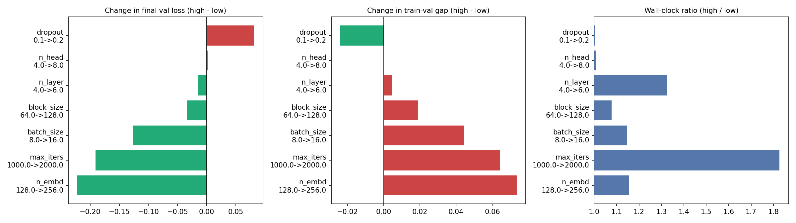
Figure 1. Main effects

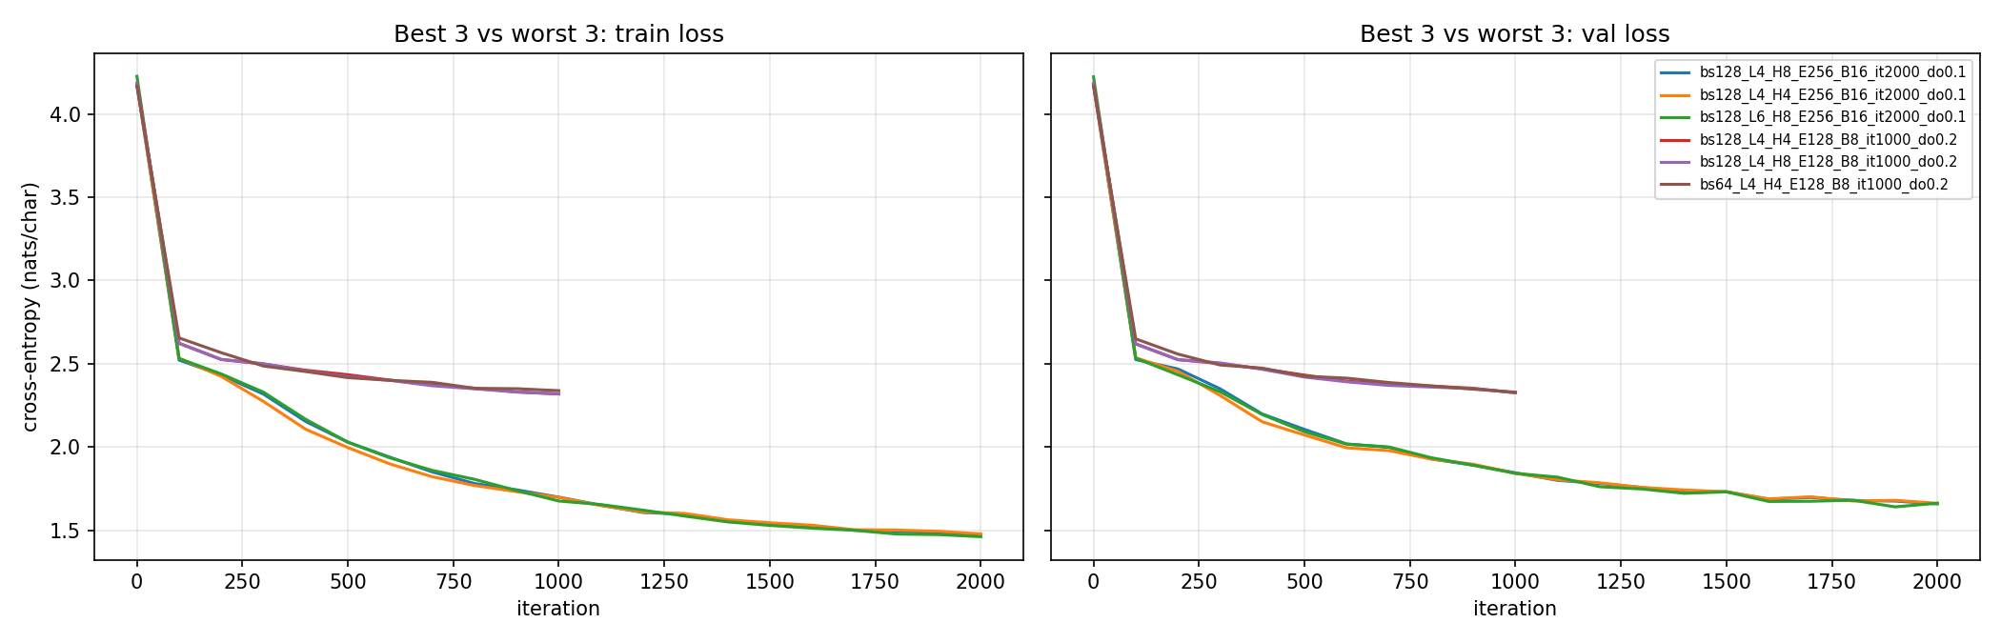
Figure 2. Train and validation loss curves for the 3 best and 3 worst runs.

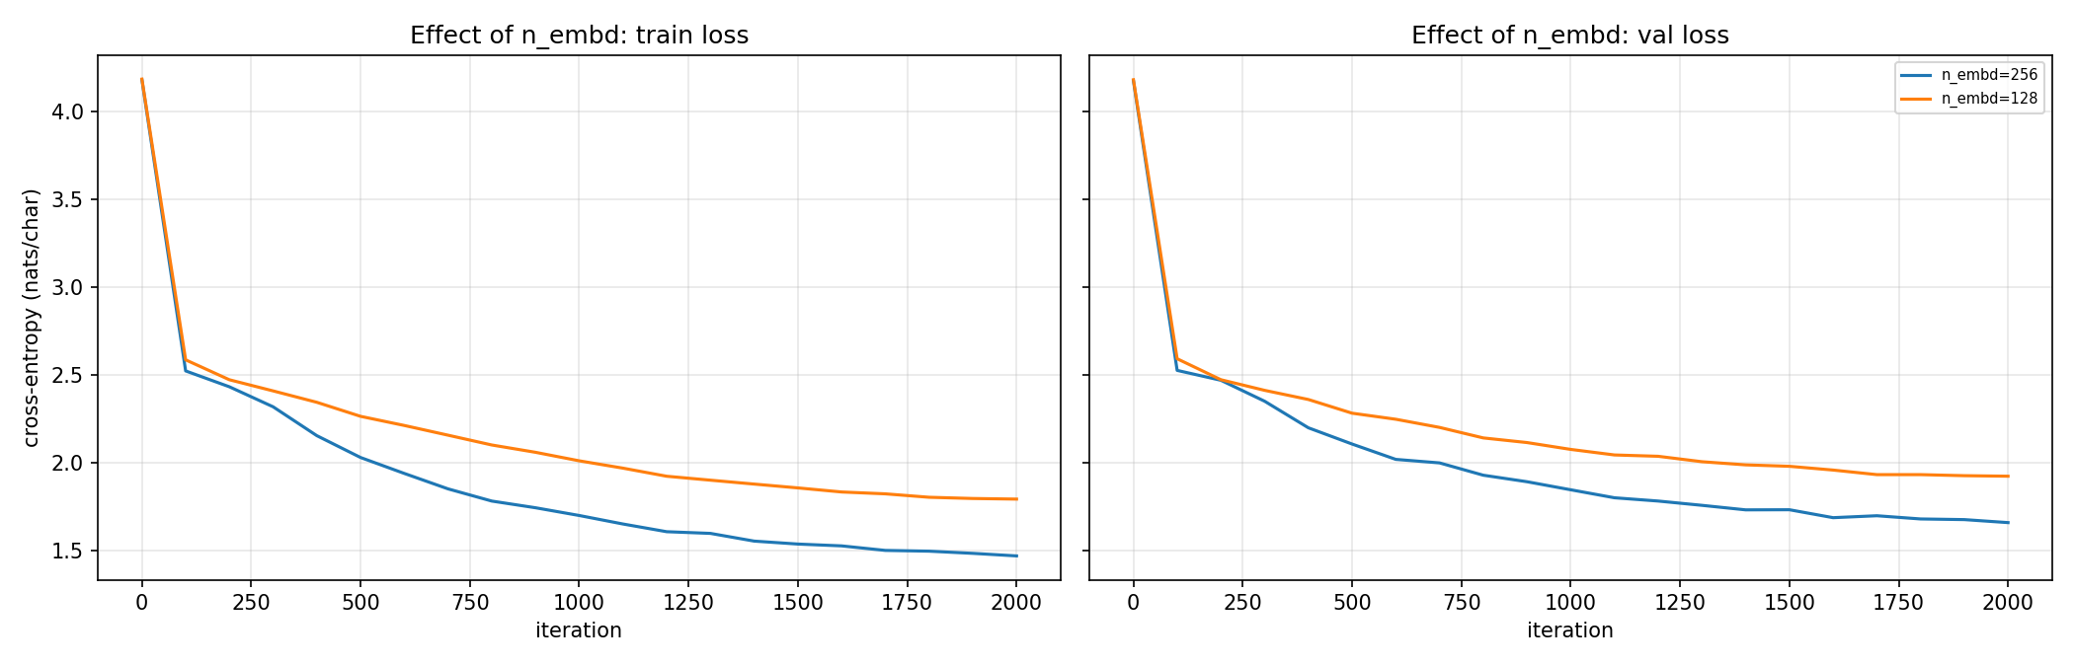
Figure 3. Effect of width: the best run (n_embd 256) against the same configuration with n_embd 128.
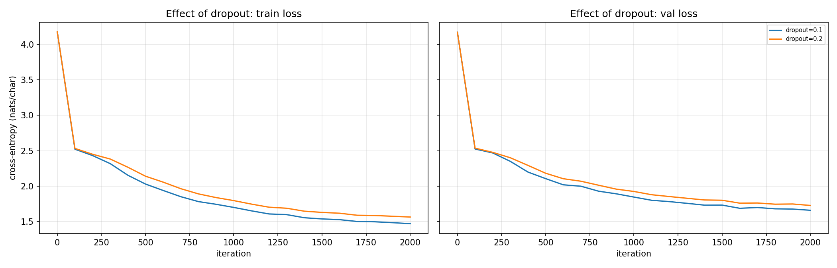
Figure 4. Effect of dropout: the best run (0.1) against the same configuration with 0.2. Dropout 0.2 lowers the gap but raises both losses.

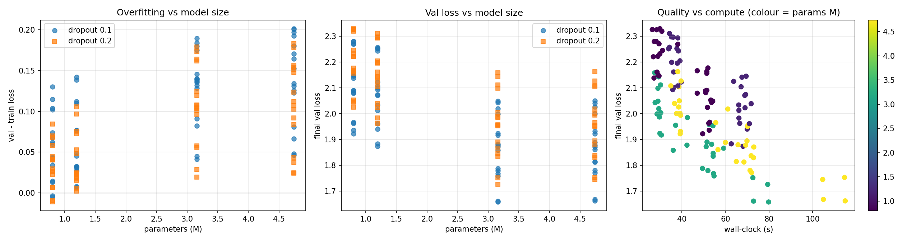
Figure 5. Left: train-val gap against parameter count. Middle: validation loss against parameter count. Right: validation loss against wall-clock time, coloured by parameter count.
Per-hyperparameter curves for block_size, n_layer, n_head, batch_size and max_iters are in the repository's figures/ folder.

5. Analysis
The biggest lesson from these experiments is that none of my models had finished learning. With at most 2,000 steps, they were all still improving when training stopped. Because of that, the settings that helped most were the ones that let the model learn faster or see more text: a wider model, more steps and bigger batches. Settings that make a model deeper or more careful helped very little or even hurt.
A quick note of noise before the details. Each loss is measured in 50 random batches, and I used one seed per setup. A few tiny models even show a slightly negative gap (validation better than training), which can only happen by chance. So, I treat any difference smaller than about 0.02 as "no real effect".

5.1 Width matters much more than depth
Making the model wider (width 128 → 256) gave the biggest improvement of all: the loss dropped by 0.22. It also made the model about four times bigger, yet it was only 16% slower. These models are small enough that the GPU handles wider layers almost for free.
Making the model deeper (4 → 6 layers) was a disappointment. It added 50% more parameters and took 32% longer, but improved the loss by only 0.015, which is within the noise. With 256, the 6-layer models were slightly worse on average than the 4-layer ones (1.916 vs 1.910).
I think there are two reasons. First, deeper models need more training steps before the extra layers pay off, and 2,000 steps isn't enough. Second, extra layers run one after another, so they always cost time, while extra width is computed in parallel.

5.2 The number of heads didn't matter
Going from 4 to 8 heads changed the loss by just +0.002, and the speed by 1%. This makes sense: more heads don’t add parameters, it only splits the same width into smaller pieces. The only real cost was memory, up 18%, because each head keeps its own attention table. For Shakespeare at the character level, 4 heads already seem to be enough.

5.3 Longer context helps, but only for bigger models
A block size of 128 instead of 64 lowered the loss by 0.034 on average, but this depends a lot on the width:
- For narrow models (width 128) the gain was tiny: 0.003 to 0.029.
- For wide models (width 256) it was about twice as large: 0.047 to 0.057.
My reading is that only the bigger models have enough capacity to use the extra characters, like a speaker's name a few lines back. Longer context mostly cost memory (+77%) rather than time (+8%).

5.4 The amount of text seen matters most
Bigger batches and more steps both mean the model reads more text, and both helped a lot (−0.127 and −0.191). Every time the amount of text seen doubled, the average loss dropped by roughly 0.1. All four of my best runs saw the maximum 4.1 million characters.
What surprised me was the cost difference. Doubling the batch made training only 15% slower, but doubling the steps made it 83% slower. Small batches leave the GPU mostly idle, so a bigger batch is almost free. If I had a fixed time budget, I would increase the batch size first.
For context, Karpathy's own Shakespeare model reaches a validation loss of about 1.47 (nanoGPT README). It is a bigger model trained on roughly 20 times more text than my largest run. My best result of 1.658 fits the idea that my models were limited by training time, not by size.

5.5 Dropout and overfitting
The gap between training and validation loss shows how much a model is overfitting. It grew with everything that made the model learn the training text better: wider models (gap 0.047 → 0.121), more steps (0.052 → 0.116) and bigger batches (0.062 → 0.106). The biggest gaps, around 0.20, belong to the largest, longest-trained models. Still, the overfitting was mild: validation loss was still going down at the end of almost every run.
Raising dropout from 0.1 to 0.2 did exactly what it should for overfitting: the gap got smaller. But it made the validation loss worse in all 64 matching pairs, by at least 0.044 each time. Dropout makes training harder on purpose to prevent memorizing, but my models hadn't started memorizing yet, so they only paid the cost. I expect dropout 0.2 would help with much longer training, which is why Karpathy's 5,000-step config uses it.

5.6 Comparing at the same training time
If I compare runs that took about the same amount of time, the winner is always a 4-layer, wide model with batch 16:
Time budget | Best run in that budget | Val loss
Under 40 s | bs128_L4_H4_E256_B16_it1000_do0.1 | 1.858
40 to 60 s | bs64_L4_H8_E256_B16_it2000_do0.1 | 1.759
60 to 80 s | bs128_L4_H8_E256_B16_it2000_do0.1 | 1.658
80 to 120 s | bs128_L6_H8_E256_B16_it2000_do0.1 | 1.662
The 6-layer version of my best model took 44% longer (115 s vs 80 s) and ended up no better. With limited compute, spending it on width, batch size and training steps beats spending it on depth.

5.7 What the generated text shows
Reading the samples, you can see the model improves in clear stages as the loss falls:
- Around 2.3 (worst runs): the model has learned the format of a play: names in capital letters followed by a colon, line breaks and punctuation. But most words are made up, like "thalatanss" or "methake".
- Around 2.0 (middle runs): short, common words are spelled correctly ("the", "heart", "you", "my"), and speaker turns look right, but longer words are still invented.
- Around 1.66 (best run): almost every word is real English. The speaker names are real Shakespeare characters (LEONTES, HENRY BOLINGBROKE), lines have a verse-like rhythm, and short phrases sound right ("My Lord hath heart to be..."). It still doesn't make sense across several lines, which is expected for a small model trained for about 80 seconds.
So, grammar and style clearly get better as the validation loss goes down, but real long-range meaning is beyond all of these models.

6. Conclusion
After 128 runs, my best nanoGPT model reached a validation loss of 1.658. It used block size 128, 4 layers, 8 heads, width 256, batch 16, 2000 steps and dropout 0.1, and it writes text that really does look like Shakespeare at first glance.
My key takeaways:
- With short training, more data beats a deeper model. The amount of text the model saw was the best predictor of quality, and all four of the best runs saw the most text.
- Width is the efficient way to make a model bigger. Going from width 128 to 256 gave the biggest gain (−0.22) for only 16% more time, while two extra layers gave almost nothing for 32% more time.
- The number of heads didn't matter at this scale. It changed memory use, but not quality or speed.
- Longer context only helps once the model is big enough to use it.
- Regularization has to fit the situation. Dropout 0.2 reduced overfitting but made every one of the 64 matching setups worse, because my models were still underfitting.
The bigger lesson for me is that building a model is a balancing act between size, data and compute. The "best" setting depends on which of those is holding you back, and here it was clearly training time.
Limitations. I used one random seed per setup, and losses measured on 50 batches are a little noisy. Training was short (at most 4.1 million characters) on a single small dataset, and I didn't tune the learning rate for each model.

