1. Count the number of times a pattern appears in a given string as a subsequence

Google Translate Icon

Given a string, count the number of times a given pattern appears in it as a subsequence.

Please note that the problem specifically targets subsequences that need not be contiguous, i.e., subsequences are not required to occupy consecutive positions within the original sequences.

For example,

Input:

string = “subsequence”

pattern = “sue”

Output: 7

subsequence  
subsequence  
subsequence  
subsequence  
subsequence  
subsequence  
subsequence

string = “subsequence”

pattern = “su”

Output: 3

2. Word Break Problem – Dynamic Programming

Word Break Problem: Given a string and a dictionary of words, determine if the string can be segmented into a space-separated sequence of one or more dictionary words.

For example,

Input:

dict[] = { this, th, is, famous, Word, break, b, r, e, a, k, br, bre, brea, ak, problem };

word = Wordbreakproblem

Output:

Word b r e a k problem,Word b r e ak problem,Word br e a k problem,Word br e ak problem

Word bre a k problem,Word bre ak problem,Word brea k problem,Word break problem

3. **Spiral order traversal of a binary tree**

Given a binary tree, print its nodes level by level in spiral order, i.e., all nodes present at level 1 should be printed first from left to right, followed by nodes of level 2 from right to left, followed by nodes of level 3 from left to right and so on… In other words, odd levels should be printed from left to right, and even levels should be printed from right to left or vice versa.

For example, the spiral [**level order traversal**](https://www.techiedelight.com/level-order-traversal-binary-tree/) for the following tree is

(1, 3, 2, 4, 5, 6, 7) or (1, 2, 3, 7, 6, 5, 4)

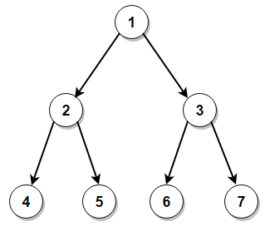

4. Decode a given sequence to construct a minimum number without repeated digits

Google Translate Icon

Given a sequence of length <= 8 consisting of I and D, where I denotes the increasing sequence and D denotes the decreasing sequence, decode the sequence to construct a minimum number without repeated digits.

For example,

sequence output

IIDDIDID ——> 125437698

IDIDII ——> 1325467

DDDD ——> 54321

IIII ——> 12345

5. The Maze II

You are given a maze represented by a binary matrix, where 0 represents a wall and 1 represents an empty space. You start at the top-left corner and your goal is to reach the bottom-right corner. Find the shortest path length from the start to the destination

Example:

{0, 0, 1, 0, 0},

{0, 0, 0, 0, 0},

{0, 0, 0, 1, 0},

{1, 1, 0, 1, 1},

{0, 0, 0, 0, 0}

Start=[0,4]

Destination=[4,4]

Output: 12