Breast Cancer Research Analysis Dashboard
Professional Portfolio Case Study
Author: Razaq Idris
Tool: Microsoft Power BI
Domain: Healthcare Analytics

1. Executive Summary
This case study demonstrates the end-to-end development of an interactive Power BI dashboard for breast cancer research. The dashboard transforms raw clinical data into actionable insights using KPIs, charts, slicers, and tables.

2. Business Problem
Healthcare professionals need an efficient way to compare benign and malignant diagnoses and understand tumor characteristics.

3. Project Objectives
• Build an interactive dashboard
• Track diagnosis distribution
• Compare tumor metrics
• Support evidence-based decisions

4. Dataset Description
The dataset contains diagnosis labels (Benign/Malignant) and tumor measurements including radius, texture, area, perimeter, compactness, concavity, symmetry and related features.

5. Data Preparation
Removed duplicates, handled missing values, validated data types, standardized diagnosis labels, created calculated measures in DAX, and optimized the data model.

6. Dashboard Design
The dashboard combines KPI cards, slicers, bar charts, scatter plot, pie chart and a matrix to present summary and comparative analysis.
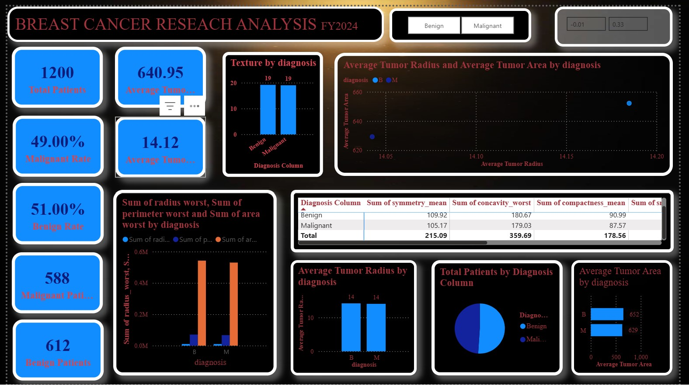

7. KPI Analysis
KPI | Interpretation
Total Patients | 1200 records analysed
Benign | 612 (51%)
Malignant | 588 (49%)
Average Tumor Radius | 14.12
Average Tumor Area | 640.95

8. Insights
- Insight 1: The dashboard enables quick comparison of benign and malignant cases, highlights tumor characteristics, and supports clinical decision-making.
- Insight 2: The dashboard enables quick comparison of benign and malignant cases, highlights tumor characteristics, and supports clinical decision-making.
- Insight 3: The dashboard enables quick comparison of benign and malignant cases, highlights tumor characteristics, and supports clinical decision-making.
- Insight 4: The dashboard enables quick comparison of benign and malignant cases, highlights tumor characteristics, and supports clinical decision-making.
- Insight 5: The dashboard enables quick comparison of benign and malignant cases, highlights tumor characteristics, and supports clinical decision-making.
- Insight 6: The dashboard enables quick comparison of benign and malignant cases, highlights tumor characteristics, and supports clinical decision-making.
- Insight 7: The dashboard enables quick comparison of benign and malignant cases, highlights tumor characteristics, and supports clinical decision-making.
- Insight 8: The dashboard enables quick comparison of benign and malignant cases, highlights tumor characteristics, and supports clinical decision-making.
- Insight 9: The dashboard enables quick comparison of benign and malignant cases, highlights tumor characteristics, and supports clinical decision-making.
- Insight 10: The dashboard enables quick comparison of benign and malignant cases, highlights tumor characteristics, and supports clinical decision-making.

9. Recommendations
- Integrate patient demographics.
- Track outcomes over time.
- Add predictive models.
- Create drill-through pages.
- Automate refresh.

10. Skills Demonstrated
Power BI, Power Query, DAX, Data Cleaning, Data Modeling, KPI Design, Dashboard Design, Data Visualization, Healthcare Analytics, Business Intelligence, Storytelling.

11. GitHub README
# Breast Cancer Research Dashboard
## Overview
Interactive Power BI dashboard analysing breast cancer diagnosis and tumor characteristics.
## Tools
- Power BI
- Power Query
- DAX
## Features
- KPI Cards
- Interactive Slicers
- Scatter, Bar and Pie Charts
- Matrix Visual
## Key Results
51% Benign, 49% Malignant, 1,200 patient records analysed.

