aula12

library(readxl)  
library(tidyverse)  
#delineamento em blocos casualisados  
#efeito fixo (bloco): trat + bloco  
fungicidas <- read_excel("dados-diversos.xlsx", "fungicida_campo")

## Modelo ANOVA com bloco

#sev (resposta)  
#diferença do dic é o rep  
aov_fung <- aov(sev ~ trat + rep, data = fungicidas)  
summary(aov_fung)

Df Sum Sq Mean Sq F value Pr(>F)   
trat 7 7135 1019.3 287.661 <2e-16 ***  
rep 1 19 18.6 5.239 0.0316 *   
Residuals 23 81 3.5   
---  
Signif. codes: 0 '***' 0.001 '**' 0.01 '*' 0.05 '.' 0.1 ' ' 1

#se não der significativo, deixa o bloco, pq o delineamento foi em bloco

#verificar as premissas  
library(performance)  
#ou  
library(DHARMa)  
check_normality(aov_fung)

OK: residuals appear as normally distributed (p = 0.230).

check_heteroscedasticity(aov_fung)

OK: Error variance appears to be homoscedastic (p = 0.484).

#plot do DHARMA  
plot(simulateResiduals(aov_fung))

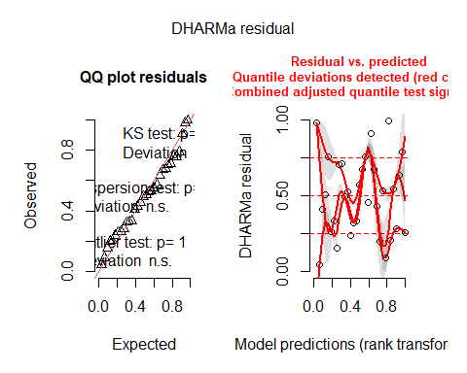

library(emmeans)  
  
#rodar a média (aov_fung em função de trat)  
means_fung <- emmeans(aov_fung, ~ trat)  
library(multcomp)  
library(multcompView)  
  
cld(means_fung)

trat emmean SE df lower.CL upper.CL .group  
 G 29.2 0.941 23 27.3 31.2 1   
 B 29.5 0.941 23 27.6 31.4 1   
 E 30.1 0.941 23 28.2 32.1 1   
 C 30.4 0.941 23 28.4 32.3 1   
 A 30.4 0.941 23 28.4 32.3 1   
 D 31.5 0.941 23 29.6 33.4 12   
 F 35.5 0.941 23 33.6 37.4 2   
 testemunha 75.8 0.941 23 73.8 77.7 3   
  
Confidence level used: 0.95   
P value adjustment: tukey method for comparing a family of 8 estimates   
significance level used: alpha = 0.05   
NOTE: If two or more means share the same grouping symbol,  
 then we cannot show them to be different.  
 But we also did not show them to be the same.

plot(means_fung)+  
coord_flip()+  
theme_minimal()

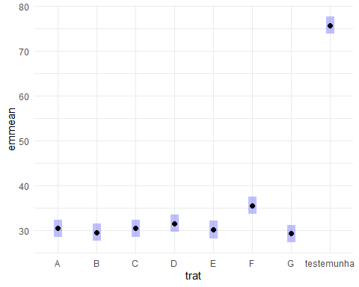

milho <- read_excel("dados-diversos.xlsx", "milho")  
  
#Base R  
#DBC  
#model  
  
#bloco com parcela subdividida precisa de estrutura de erro (bloco, parcela principal, subparcela)(Error)  
aov_milho_bloco <- aov(index ~ factor(block) + hybrid*method +  
Error(factor(block)/hybrid/method), data = milho)  
  
summary(aov_milho_bloco)

Error: factor(block)  
 Df Sum Sq Mean Sq  
factor(block) 3 592.2 197.4  
  
Error: factor(block):hybrid  
 Df Sum Sq Mean Sq F value Pr(>F)   
hybrid 5 974.2 194.84 3.14 0.0389 *  
Residuals 15 930.9 62.06   
---  
Signif. codes: 0 '***' 0.001 '**' 0.01 '*' 0.05 '.' 0.1 ' ' 1  
  
Error: factor(block):hybrid:method  
 Df Sum Sq Mean Sq F value Pr(>F)   
method 1 79.61 79.61 4.726 0.0433 *  
hybrid:method 5 265.28 53.06 3.150 0.0324 *  
Residuals 18 303.18 16.84   
---  
Signif. codes: 0 '***' 0.001 '**' 0.01 '*' 0.05 '.' 0.1 ' ' 1

#usando avo não permitiu checar a normalidade, usar outro modelo (misto)

#lme4 - pacote que permite checar as premissas. O modelo misto é mais moderno que o aov  
library(lme4)  
#usando bloco  
milho$block <- as.factor(milho$block)  
#sqrt para transformar os dados e atender a heterocedasticidade  
mix2 <- lmer(sqrt(index) ~ block + hybrid*method +  
 (1|block/hybrid), data = milho)  
library(car)  
#anova no modelo misto não dá o p-valor, só o F. Então, do pacote car, usar anova com A maiusculo   
Anova(mix2)

Analysis of Deviance Table (Type II Wald chisquare tests)  
  
Response: sqrt(index)  
 Chisq Df Pr(>Chisq)   
block 0.0764 3 0.994506   
hybrid 15.4171 5 0.008721 **  
method 3.9239 1 0.047605 *   
hybrid:method 13.3025 5 0.020703 *   
---  
Signif. codes: 0 '***' 0.001 '**' 0.01 '*' 0.05 '.' 0.1 ' ' 1

check_normality(mix2)

OK: residuals appear as normally distributed (p = 0.422).

check_heteroscedasticity(mix2)

OK: Error variance appears to be homoscedastic (p = 0.970).

#comparação de médias  
#inverter hybrid e method para fazer outra comparação  
means_mix2 <- emmeans(mix2, ~ hybrid|method)  
means_mix2

method = pin:  
 hybrid emmean SE df lower.CL upper.CL  
 30F53 HX 5.00 1.17 5356 2.69 7.30  
 30F53 YH 4.95 1.17 5356 2.65 7.25  
 30K64 4.50 1.17 5356 2.20 6.81  
 30S31H 6.10 1.17 5356 3.79 8.40  
 30S31YH 5.63 1.17 5356 3.33 7.93  
 BG7049H 4.40 1.17 5356 2.10 6.71  
  
method = silk:  
 hybrid emmean SE df lower.CL upper.CL  
 30F53 HX 4.94 1.17 5356 2.64 7.25  
 30F53 YH 5.10 1.17 5356 2.80 7.41  
 30K64 4.61 1.17 5356 2.31 6.91  
 30S31H 5.13 1.17 5356 2.83 7.43  
 30S31YH 5.14 1.17 5356 2.84 7.44  
 BG7049H 4.37 1.17 5356 2.07 6.67  
  
Results are averaged over the levels of: block   
Degrees-of-freedom method: kenward-roger   
Results are given on the sqrt (not the response) scale.   
Confidence level used: 0.95

cld(means_mix2) #na tabela, letras maiúsculas comparam na coluna e minúsculas na linha

method = pin:  
 hybrid emmean SE df lower.CL upper.CL .group  
 BG7049H 4.40 1.17 5356 2.10 6.71 1   
 30K64 4.50 1.17 5356 2.20 6.81 1   
 30F53 YH 4.95 1.17 5356 2.65 7.25 12   
 30F53 HX 5.00 1.17 5356 2.69 7.30 12   
 30S31YH 5.63 1.17 5356 3.33 7.93 12   
 30S31H 6.10 1.17 5356 3.79 8.40 2   
  
method = silk:  
 hybrid emmean SE df lower.CL upper.CL .group  
 BG7049H 4.37 1.17 5356 2.07 6.67 1   
 30K64 4.61 1.17 5356 2.31 6.91 1   
 30F53 HX 4.94 1.17 5356 2.64 7.25 1   
 30F53 YH 5.10 1.17 5356 2.80 7.41 1   
 30S31H 5.13 1.17 5356 2.83 7.43 1   
 30S31YH 5.14 1.17 5356 2.84 7.44 1   
  
Results are averaged over the levels of: block   
Degrees-of-freedom method: kenward-roger   
Results are given on the sqrt (not the response) scale.   
Confidence level used: 0.95   
Note: contrasts are still on the sqrt scale   
P value adjustment: tukey method for comparing a family of 6 estimates   
significance level used: alpha = 0.05   
NOTE: If two or more means share the same grouping symbol,  
 then we cannot show them to be different.  
 But we also did not show them to be the same.