1. Navigate to [www.brightcove.com](http://www.brightcove.com)
2. Login by clicking “Customer Sign In” in the upper right corner

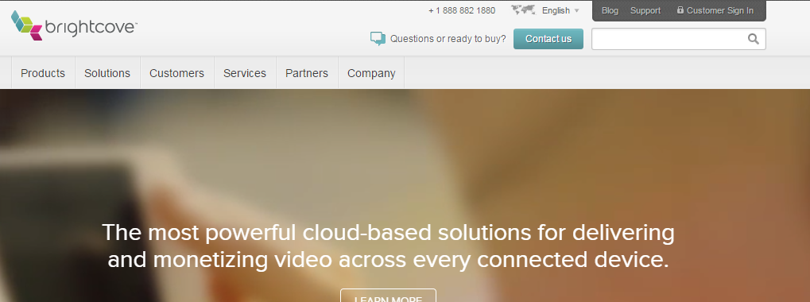

1. When the Home Page loads, click on the “Publishing” tab

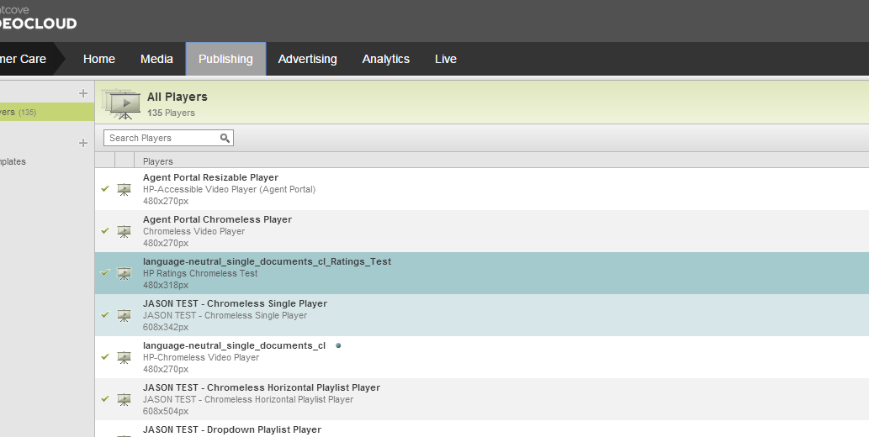

This will give you the listing of the players – the player that we are working on is called:

‘Language-neutral_single_documents_cl_Ratings_Test’