Example of Desktop/Laptop machine experience:

<http://link.brightcove.com/services/player/bcpid2257704014001?bctid=REFIDBC4018166982001>

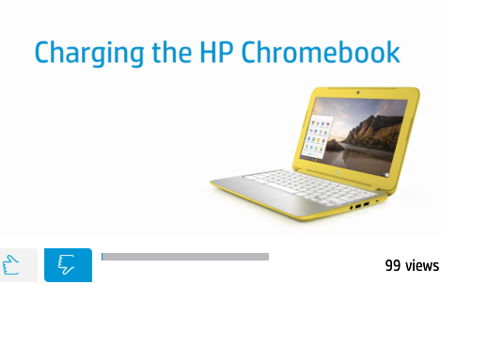

Missing total count for positive and Negative Ratings

**Example of Mobile Experience:**

