S.Y 2022 – 2023



**Inquiries, Investigations and Immersion Quarter 1 - 4**

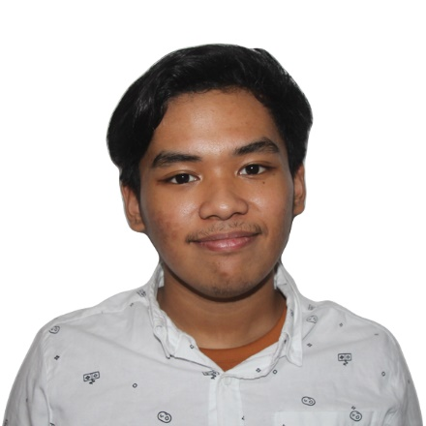

Name: Rei Benedict L. Millano

Grd/Sec: 11 Laplace

Contact No: 09672471227

Email: rbmillano97@gmail.com