PLANAR and SOLID MENSTRATION

Millano, Rei Bendict L.

12 - Laplace

INQUIRIES, INVESTIGATION AND IMMERSION

Millano, Rei Bendict L.

12 – Laplace

09672471227 – rbmillano97@gmail.com

General Chemistry

Millano, Rei Bendict L.

12 - Laplace

UNDERSTANDING CULTURE, SOCIETY AND POLITICS

Millano, Rei Bendict L.

12 - Laplace

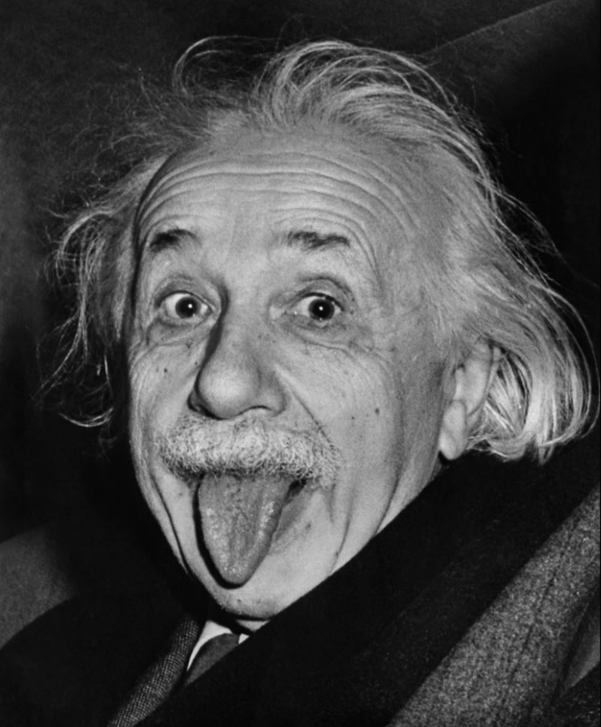

Filipino sa piling larang

Millano, Rei Bendict L.

12 - Laplace

General physics

Millano, Rei Benedict L.

12-Laplace