Psycho Social Subject

Life During

Pandemic

Members (12 - Laplace):

Albert Luis Alvarado

Nathaniel Adrey Colle

Rei Benedict Millano

Rod Rashard Oropesa

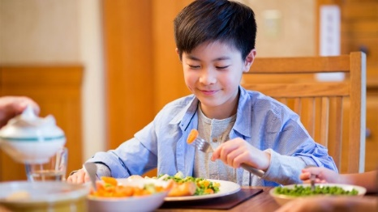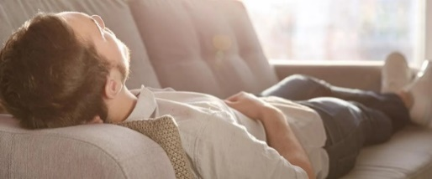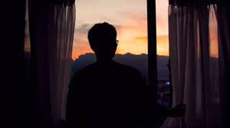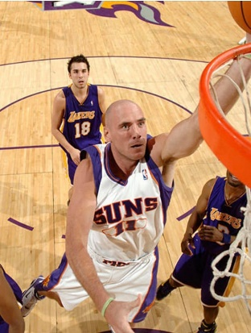

During this pandemic, everything changes, even my perspective on my life. I'm grateful that I didn't have a mental or emotional breakdown. It is because of the care and help of my parents and siblings. I wake up at 5 am and do some exercise and an 8-kilometer jog to ensure my health. At 7 a.m., I eat my breakfast and think about my plans for the rest of the day. At 8 am, I do my house chores for 1–2 hours, and after that, I start doing school homework and eat at 12 noon. I take a 1-hour nap at 1 pm, wake up at 2 pm, and continue doing my homework for 2 hours. And get some rest. At 5 pm, I always wander outside for plants. I usually have my dinner at 7, then resume my homework and sleep at 9 or 10 pm. And so; the cycle repeats. And that's my life during the pandemic.

* A.L.A

Cooking

Work out

Basketball

Lockdown

New things

My life during the pandemic is a bit boring but I've learned and experienced things that's not expected. Every morning, I'm the one cooking our break fast and time goes by, I'm learning new recipes until I'm the one cooking our everyday meal and I realized that I've grown not physically but mentally in the part where I've learned to cook good. During pandemic, I decided to work out and exercise regularly and after a month, I'd look at the mirror and realized that I got muscles, my biceps, triceps and even my chest matured. Basketball is my comfort zone when I'm feeling anxiety, stress during pandemic and it's my favorite sport. I love playing and eager to improve more. Lockdown makes my life boring but I've learned many things, like cooking just I've said, I've got muscles through working out and more.

= NAD

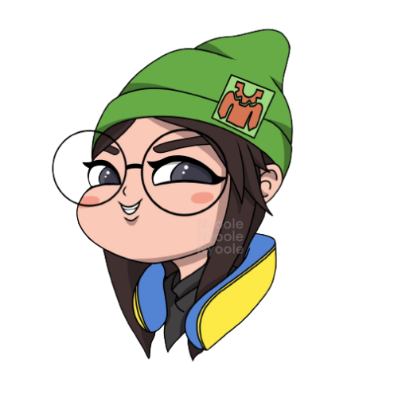

The days I spent during quaratine was quite a hurdle. But I have reached a point where it became stable and even quite enjoyable. Yet now, a new radical change happened and once again my lifestyle requires to change. Having mixed feelings this school year

* RLM

When the pandemic started, a lot of things happened to me. I always think, "Will I ever be able to go outside and see my friends?" I was not thinking right, but I started to become more responsible when it comes to choir while doing these choirs Little by little, I forgot my overthinking and I was very glad that it happened. I always talk to my family when I think of a problem, and they will always help me and guide me to have a better life. I also found a new hobby during the pandemic and it made me more relaxed. When I play online games, I also meet a lot of people, and they also helped me survive the pain. Thanks also to them; they make me a happy person now.

-RRO