**Activity**: PROBLEM SOLVING

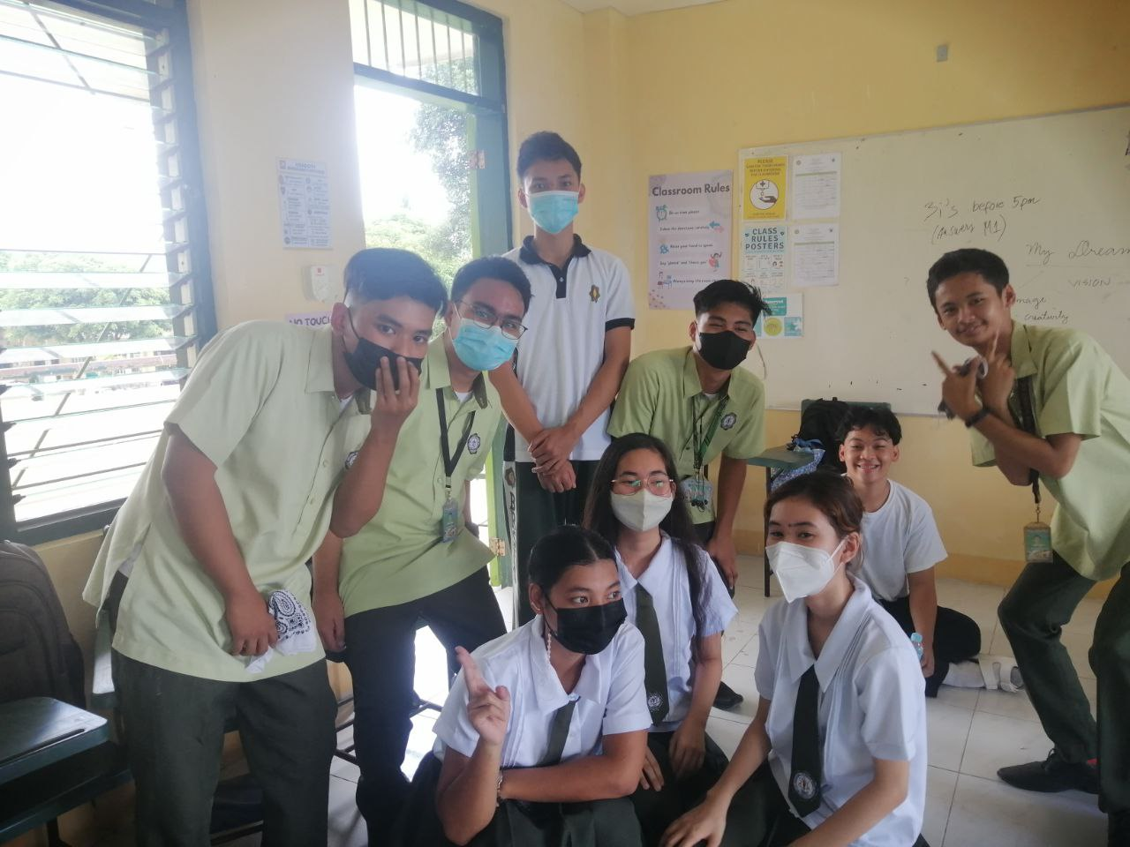

**Situation/Problem**: A group of highschool student is harrassing and bullying a female student

**Solution**: Teachers and Guidance Counselor intervene as they punish and force them to reflect in their ways and apologize to their victim

**Group Number**: 1

**Members**:

Khezra Eecca Sevilla

Ricah Allorde

Louis Brian Buiza

Rei Benedict Millano

Albert Luis Alvarado

Ronald Zamora

Rod Rashard Oropesa

Evan Diom Bobis

Callie Anne Torres