Group Assignment: Data Transformation Data Transformation with Python or R - Clean Your Data

ORES-5160 Data Management

Saint Louis University
November 7th, 2024

Group Members:
Poojitha Sangavi Dunaboina
Ramya Reddy Baapathu
Sharath Kasula
Saisnehanjali Sanike

Introduction
Real-world datasets contain messy information and that is why, when working in the domain of data science, the phrase ‘garbage in, garbage out’ applies. As you rightly mentioned quality issues like errors, outliers, missing values, and format and name variations added up as part and parcel of experimental data. These data quality challenges can become great barriers to obtaining meaningful value from the insights.

It is thus critical that high-quality data is highly overemphasized since quality is the direct determinant of the reliability and validity of the analytical tools used and conclusions made. Findings from research that involves extraneous variables may also incorporate composite, contrary, or mediating factors that obscure or distort real phenomena in the data(Han et al., 2011).

We are taking a narrative path to explain what we did with the screenshots of our code and results, The screenshots are always first followed by the explanation.

About First Dataset
Our first data source covers nursing home facilities that get funding from the Provider Relief Fund Nursing Home Quality Incentive Program. Contemporary, under COVID-19 relief packages, it disburses $2 billion to nursing homes contingent on how effectively they have managed to contain COVID-19 infections and deaths. The funding is then done in proportion to the level that all the concerned facilities performed in September, October, November, and December against the average infection levels in the county and the national mortality standards (Provider Relief Fund COVID-19 Nursing Home Quality Incentive Program | Data | Centers for Disease Control and Prevention, 2021b).

Cleaning First Dataset
This data cleaning was done with the view of making the dataset clean for subsequent analysis by dealing with different problems that may be there with the data. It included activities like dealing with the missing values, data cleaning to eliminate duplication, renaming the columns as well as, adjusting the data types dealing with missing data, removal of dups, renaming columns, and converting the data type so that the dataset is workable and free from inconsistencies
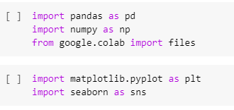
The first step involves importing necessary libraries: The software applied in this work includes pandas for data manipulation, NumPy for the numerical analysis, matplotlib, and seaborn for the visualization of data. In addition to the above, for data visualization and specifically in creating the interactive table recall, we created an import of files from google. colab for the purposes of file manipulation.

Here, we read datasets, and include the necessary package pd.read_csv() to read the CSV format and then save datasets in the format data frame with the name df01. This data set is associated with the nursing home COVID-19 data such as infection rate, etc.
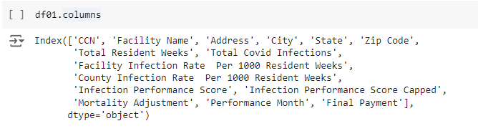
Here, the shape of the data frame can be understood from the columns which are as follows. From the above, we get that the information contains 15 columns expecting identifiers such as ‘CCN’ and ‘Facility Name’, to metrics including ‘Total Covid Infections’ and ‘Infection Performance Score’.
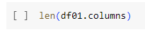
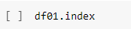
However, before one decides to clean up any data then one needs to look at the general features of the records of the given data set. Looking at the objects it is possible to get the conclusion that the dataset has 15 features, in response to the length function. At the same time, the data set contains 33,440 records that is, a significant number of records in the data set. If we know the number of rows or at least some estimate as to the number of rows, then we can form a rough idea of the size of the data. This is where the index method is used.

Here, the shape of the data frame can be understood from the columns which are as follows. From the above, we get that the information contains 15 columns expecting identifiers such as ‘CCN’ and ‘Facility Name’, to metrics including ‘Total Covid Infections’ and ‘Infection Performance Score’.
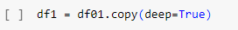
To prevent ourselves from destroying some beneficial data during the cleaning process, we make a copy of the original DataFrame using the copy method. This lets us make changes on df1 apart from the original data hence will allow further changes to be done on the data.
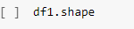
After that, the shape of the df1 DataFrame is verified using df1.shape which still reveals that there are 33,440 records and fifteen features. As we are already at this point, now is the time for cleaning the data.
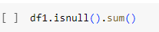
Using isnull().sum() a missing data check is performed and this shows that Infection Performance Score Capped has a missing value of 19621. But, it is also quite evident that there are no missing values in other records like “CCN,” “Facility Name,” or “State.” It is with the help of such perception that one can make necessary determinations with regard to handling the missing values within the given set of indicators.
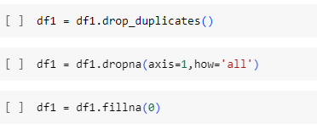
We move to address the gaps in the data and the case of replicated data points. The method used to exclude rows that are duplicated in the dataset is accomplished through a method called drop_duplicates(). Also, the blank data are removed by using the dropna() method as these columns do not offer useful information. The rest of the missing values are taken care of by df1 = df1.fillna(0) since they replace all the missing values with zeros. It is especially valuable when the baseline number is zero which means no data exists, for example in infection rates of a particular institution.
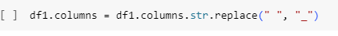
Second, the column names are normalized by removing spaces using the columns = columns.str.replace(“ ”, “_”) format. Thus, it brings more consistent formatting of the column names, which is useful when there is code that defines the procedures with these column names.
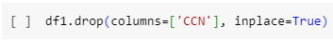
Finally, after cleaning the column names the column ‘CCN’ which stands for ‘CMS Certification Number’ of the facility is dropped by using the command drop(columns=[‘CCN’], inplace=True). This column might not pose much value for the analysis because it appears as a set of numbers that caters to an index number and when deleted simplifies the dataset.
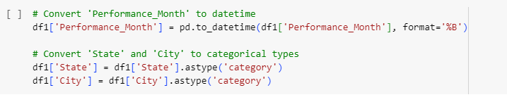
In this dataset, the “Performance Month” field is a string variable, of key importance to the analysis. In order to make use of this column specifically for a time series analysis, the column is then converted to DateTime format using the to_datetime() function. This step also helps in defining the “Performance Month” as a true date type, so that true temporal analyses like trends over the months can be best conducted.

Another important operation is how to avoid memory consumption and are able to change the “State” and “City” into categorical data types. This is done in converting the factor columns, df1[‘State’] = df1[‘State’].astype(‘category’), the same way df1[‘City’] = df1[‘City’].astype(‘category’). Compared to string types, categorical variables take up less space in memory especially when the values are repeated and that makes the conversion a good method of reducing memory usage in a dataset.
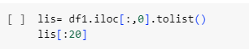
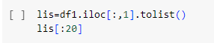
In order to analyze the above data, the first two columns, the name of the facility and its address are selected and cast into lists. These lists give a heads-up on the facility names/addresses making it easy for us to check whether the data is readable or not. The first 20 entries for both columns are shown which are general nursing home naming styles followed by addresses in uppercase for uniformity.
.
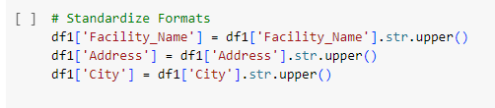
Next, we continue cleaning the text in the “Facility Name,” “Address,” and “City” columns converting all entries to uppercase using.str.upper(). This is done this way to maintain uniformity of text formats this is crucial when aligning or merging data that is in text format for instance; the names of the facility, or the address.
After that, we generate a new column “Infection_Rate” that reflects the infection rate as the total COVID-19 infection count divided by the total weeks of the resident, multiplied by 1,000. This is done under the Total Covid Infections Total Resident Weeks formula divided by 1000. The use of ‘Total Covid Infections’/ ‘Total Resident Weeks’ * 1000 Ratios Summarize Total Covid Infections Into the following; This new feature enables one to have a way better insight of the infection rates relative to various nursing homes this could come in handy in evaluation for instance during performance evaluations or even to establish trends.
As a result of this process, the final form of the dataset is easily suitable for analysis. Data is pre-processed, gauging with missing values, the columns are standardized, and new features were created to enhance infection rate analysis. This cleaned dataset is now good for other kinds of statistical analysis or visualization which is even more complex or enhanced.
About Second Dataset
The second data set is embedded in the determination of vaccine hesitancy percentages at state, county, and sub-state geographical hierarchies. First, based on the HPS and the 2019 ACS, it identifies five types of households and the differences in their living arrangements. For information on COVID-19 vaccine intentions at a national level, one can use HPS data; for sociodemographic and geographic data, ACS data can be used. The dataset consists of predicted vaccine hesitancy with HPS data obtained between May 26, 2021 & June 7, 2021, with adjustments made by cross-walks and population distribution (Vaccine Hesitancy for COVID-19: County and Local Estimates | Data | Centers for Disease Control and Prevention, 2021).

Cleaning Second Dataset
This dataset, which contains data about vaccine hesitancy and the related demographics by county, originally consisted of 21 columns by 3142 rows, which let us have a quite vast picture of the views on the vaccines different regions have. Here is how we clean step by step.
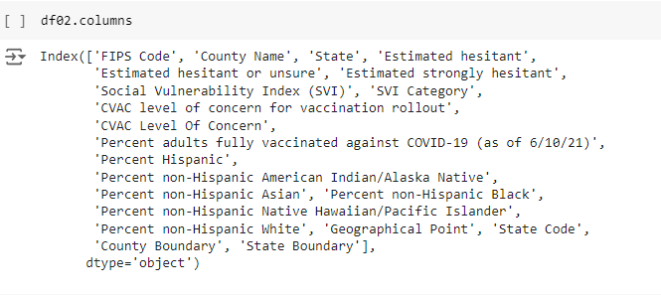
We carried out the first step by importing the data from a CSV file using our standard function, pd.read_csv. This line imports the dataset into a data frame known as df02 for systematic analysis right from this point. Through df02.columns we could type all column names and realized that it contained a wide array of information that included data on vaccination hesitancy, demographic breakdowns, and social vulnerability. This inspection also revealed that the current dataset contains 21 feature columns.

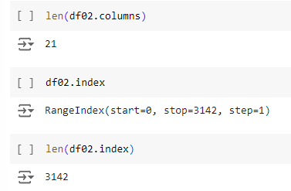
Next, using len(df02.columns), I made another cross-check with the column number and it was 21 as previously. This will at least give a basic idea of what the dataset looks like.
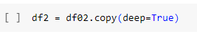
After performing the safe step which will deep copy the dataframe to save originality.
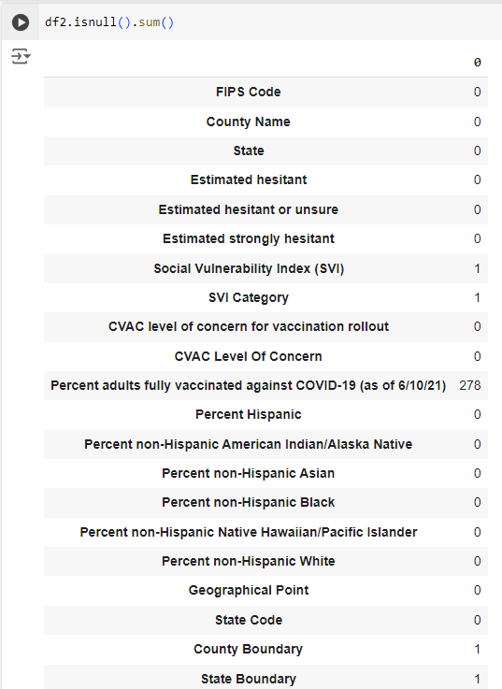
We checked for null values and we found some columns had only one null value these columns are the SVI category, Social Vulnerability Index(SVI), etc, and finally, Percent adults fully vaccinated against COVID-19 (as of 6/10/21) had 278 null places.
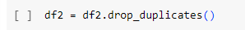
Next up, in order to remove any repeated rows we used the command df2.drop_duplicates(). The same record distortion of rows presents or gives rise to equal or even bigger problems in the context of the county’s analysis; it is where, in order to get the right calculations and, therefore, comparisons at some other stages, conforming to the principle “we do not need multiple copies of records similar under the same county name, ” reigns supreme.
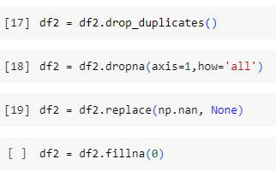
Then, set missing values to None using df2 = df2.replace(np.nan, None) Subsequently, we used df2.dropna(axis=1, how = ‘all’) to filter out any rows with all missing values. Even though running this step did not yield any such columns in our first observation, running this step allows the data set to be lean, with only essential data.
In case there are any more missing values in the data frame then it was filled with zeroes as in df2.fillna(0). This is done deliberately here, because it saves time for further analyses when dealing with gaps in the middle of records, or in the percentage fields, compared to introducing nulls for unclear reasons that would hamper calculations.
To reduce clutter, we dropped three columns that were not directly useful for analysis: These are; ‘Geographical Point,’ ‘County Boundary,’ and ‘State Boundary.’ Similarly, excluding those with df2.drop(columns=['Geographical Point’, ‘County Boundary’, ‘State Boundary’ ], inplace=True) lets us keep only the columns that contain information on how to address vaccine hesitancy.
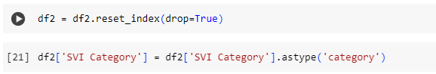
Then, we dropped the ‘SVI Category’ column’s index by using the command: df2 = df2.reset_index(drop=True). As this column only can have a limited set of values, using it as a category is more efficient in terms of memory and faster to perform analysis on, as categorical data is generally easier to filter and analyze.
To enhance convenience more referring to column names programmatically, we decided to substitute spaces and special characters like parentheses, dashes, and slashes with underscores.

Conclusion
In our data preprocessing, we employed the necessary cleaning and transforming of datasets so that they are credible and useful. They tidied up the tables by removing unnecessary column(s) and changing the data types as well as handling the NULL values in the right way. For our data integration and cleaning steps we harmonized the column names, and the parsing of textual formats, created new analytical fields, and removed duplicate values. The data have also been cleansed, normalized, and structured for analysis and these have been saved to a .xlsx format for ease of use.

Appendix
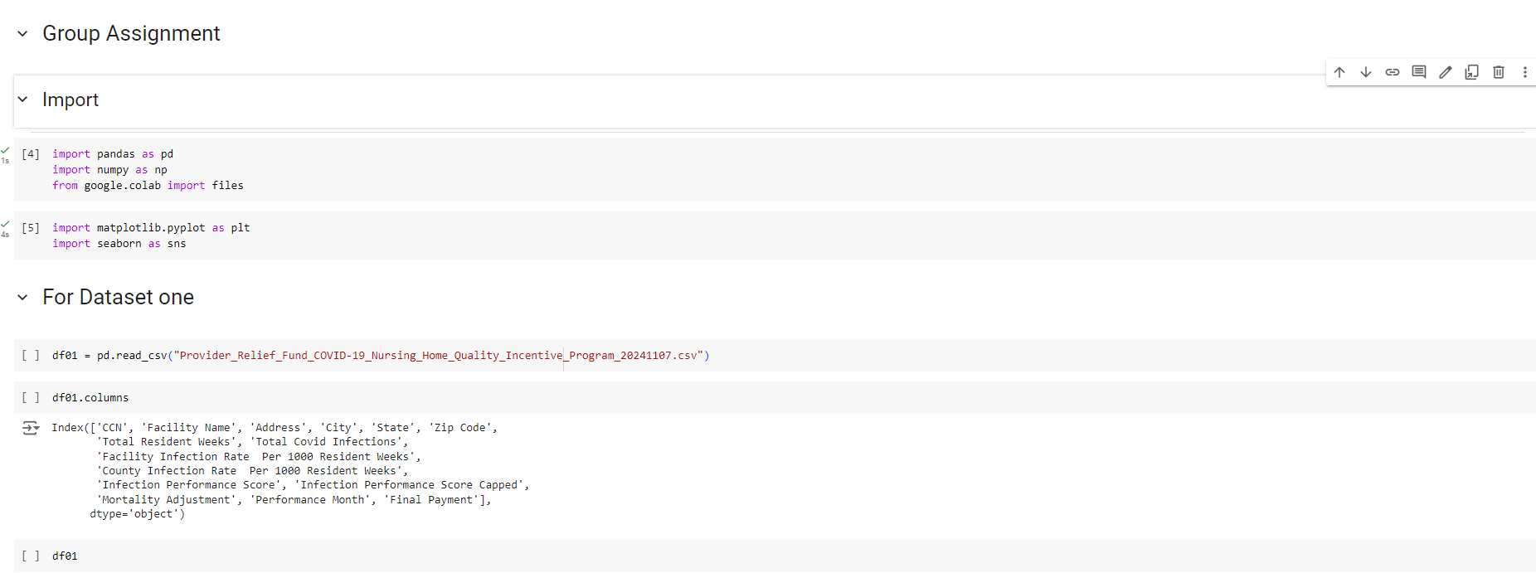
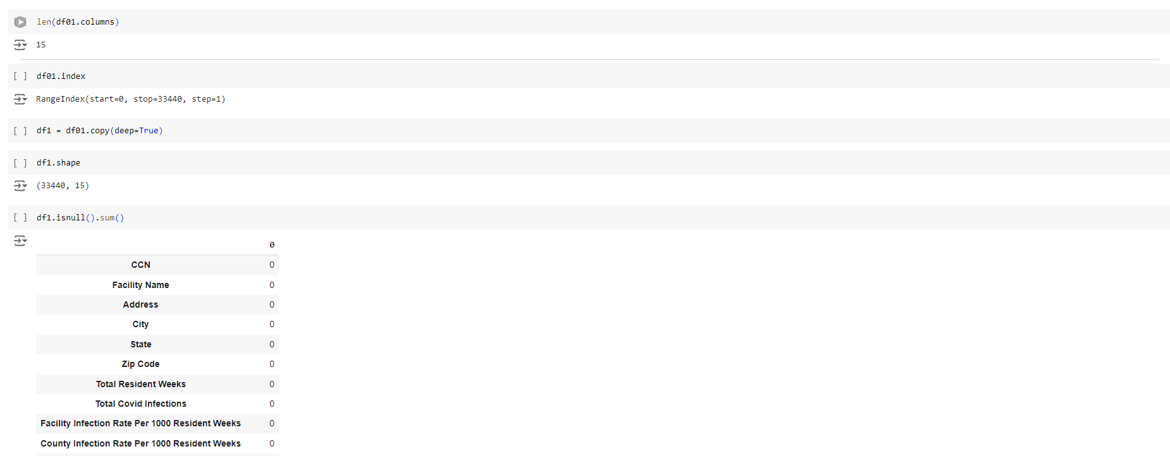
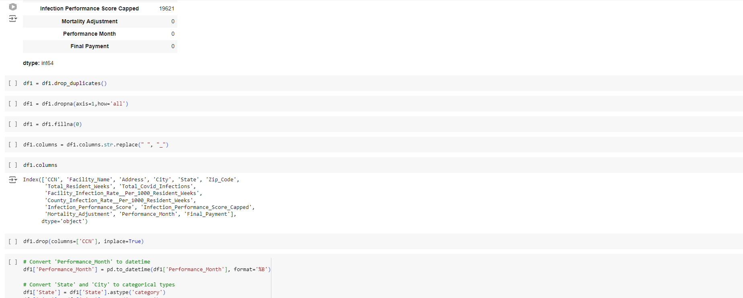
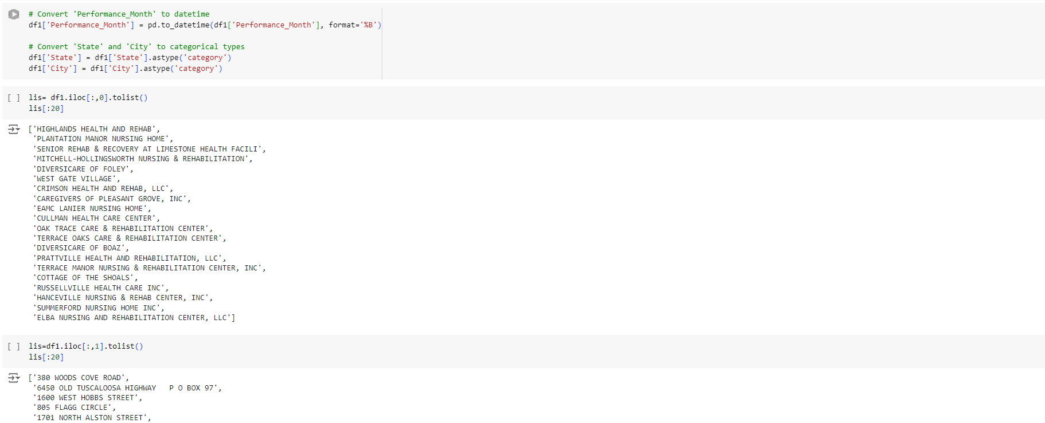

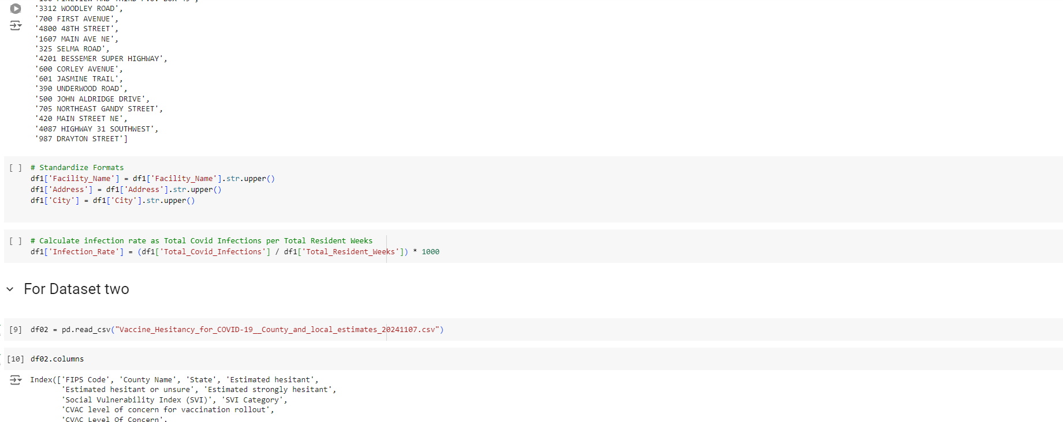
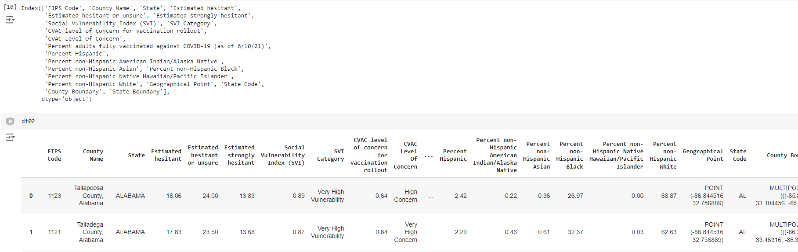
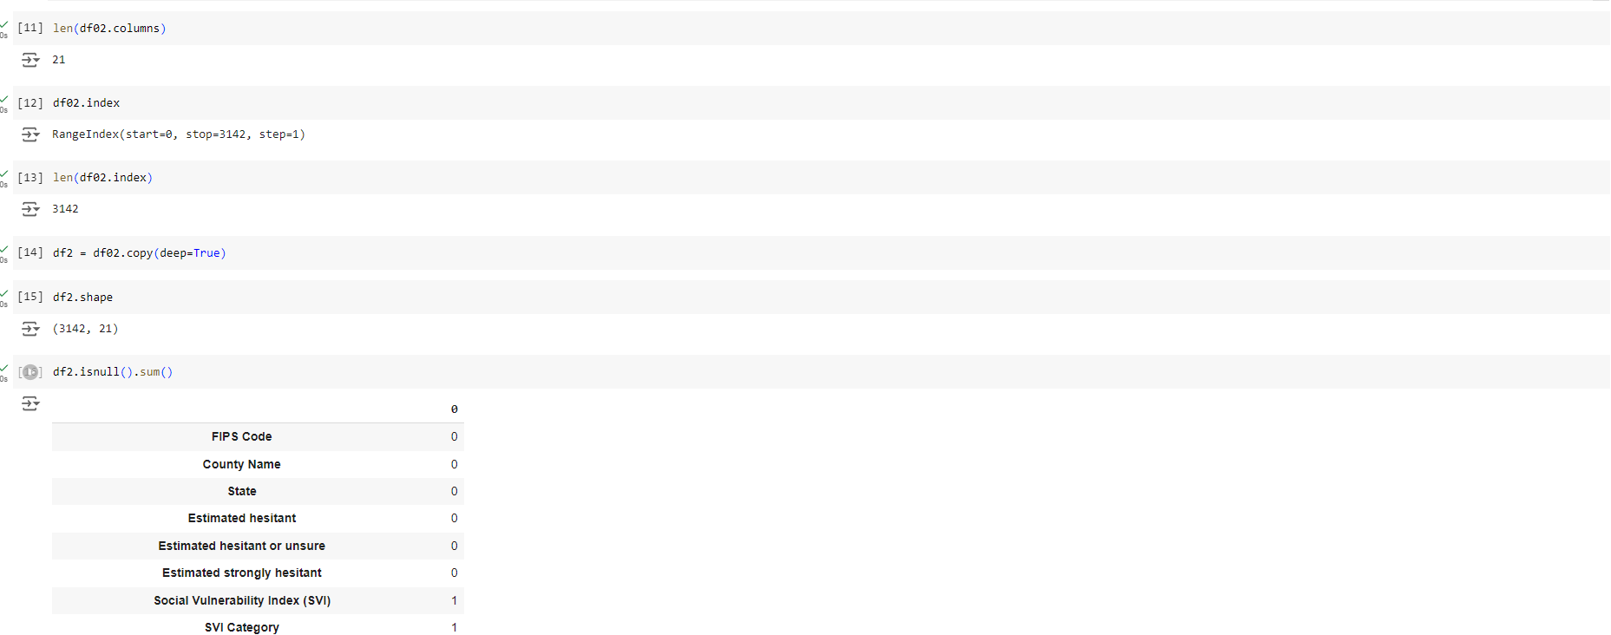
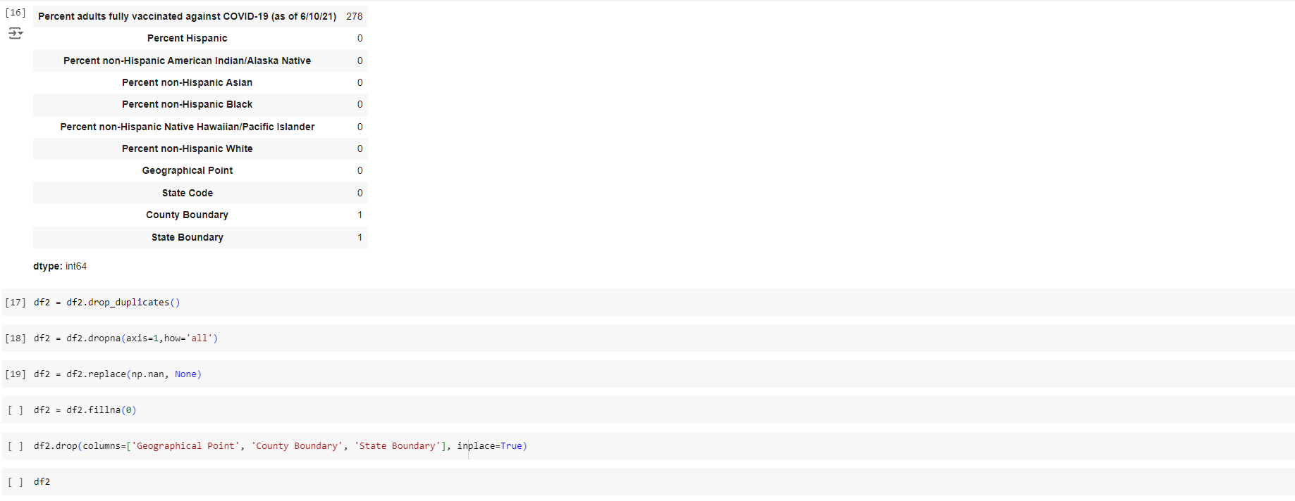
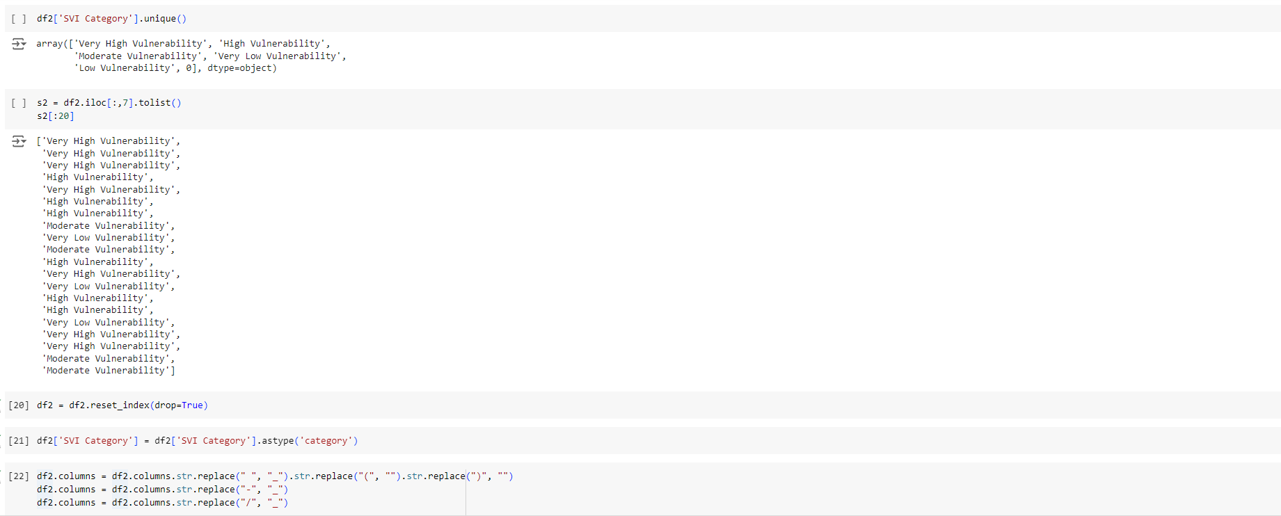
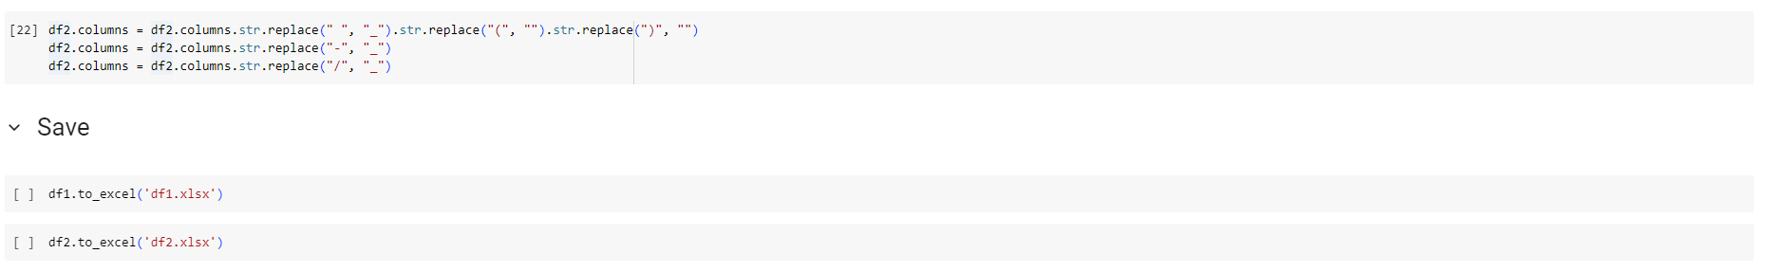

References

- Han, J., J., Kamber, M., Pei, J., University of Illinois at Urbana-Champaign, & Simon Fraser University. (2011). Data Mining: Concepts and Techniques. https://liacs.leidenuniv.nl/~bakkerem2/dbdm2012/03_dbdm2012_Data.pdf
- Provider Relief Fund COVID-19 Nursing Home Quality Incentive Program | Data | Centers for Disease Control and Prevention. (2021b, August 2). https://data.cdc.gov/Administrative/Provider-Relief-Fund-COVID-19-Nursing-Home-Quality/bfqg-cb6d/data_preview
- Vaccine Hesitancy for COVID-19: County and local estimates | Data | Centers for Disease Control and Prevention. (2021, June 17). https://data.cdc.gov/Vaccinations/Vaccine-Hesitancy-for-COVID-19-County-and-local-es/q9mh-h2tw/data_preview

