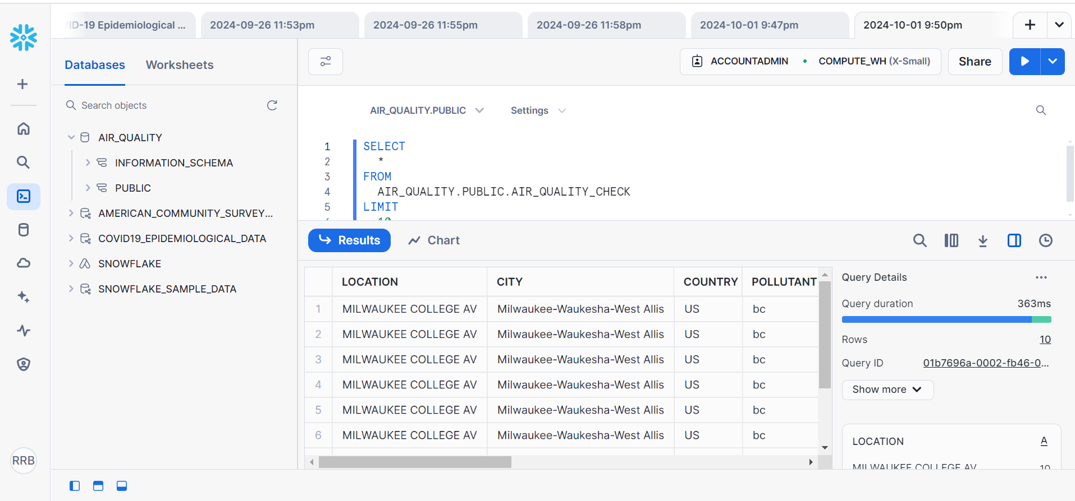

The SQL query run in the Snowflake environment pulls air quality information with query language from the AIR_QUALITY_CHECK table in the PUBLIC schema of the AIR_QUALITY database. The query fetches all the columns of the table and then restricts the result to 10 records only. The findings present data concerning air quality observations for a certain point, namely MILWAUKEE COLLEGE AV in the area of Milwaukee-Waukesha-West Allis, USA. The data includes a column for pollutants, of which “bc” stands for black carbon, which is a measure of air quality. Query execution time in a database was 363 ms, and it provided 10 records of data.

Question 1: How many instances of each pollutant are recorded in the data? Sort the output from highest to lowest number.

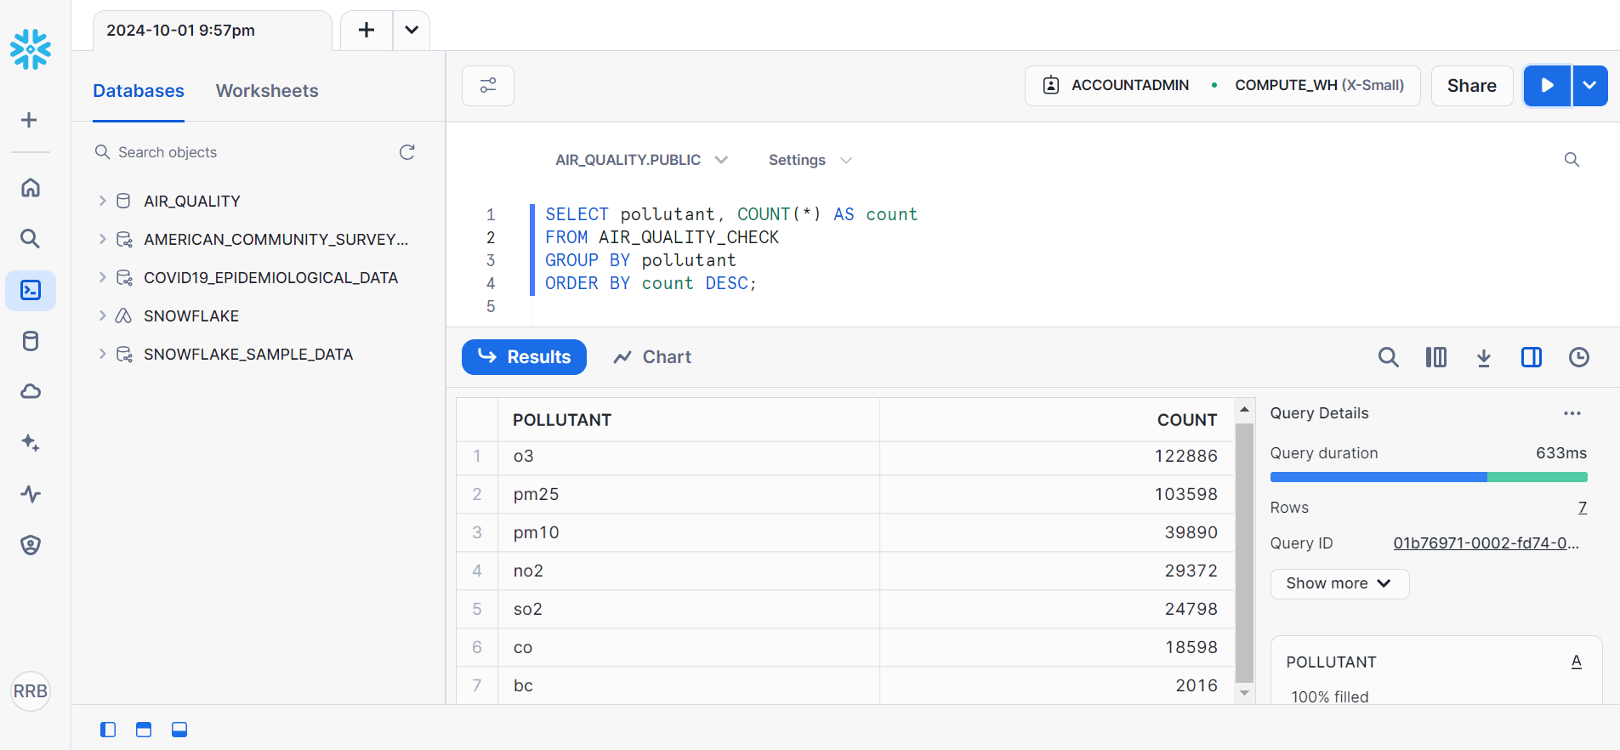

The check done on the air quality shows that O3 is the most recorded pollutant with counts of 122,886. After O3, PM2.5 is mentioned 103,589 times, whereas PM10 is mentioned only 39,932 times. NO2 appeared 38,989 times as well as SO2 at 24,798 occurrences. CO is registered with 18,588 hit counts, while BC had the least number of hit counts out of all the pollutants, with 2016 hit counts. This distribution shows which of the three categories of pollutants the air quality dataset contains the pollutants most frequently, which are O3 and PM2.5.

2) How many unique locations are recorded? How many unique cities? Are there any cities recorded that have multiple locations, and if so, which city has the largest number of locations represented?

unique locations:
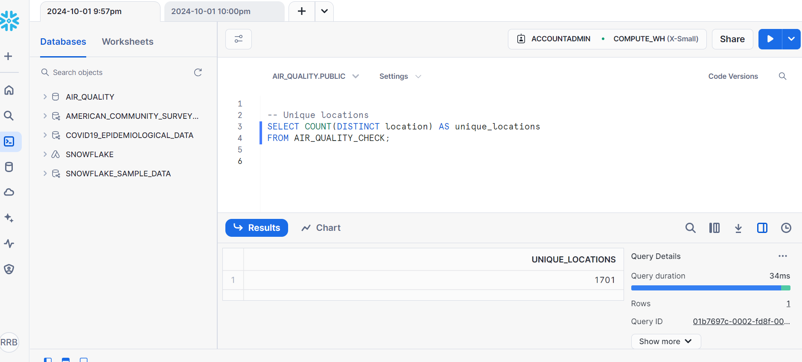
Unique Cities:
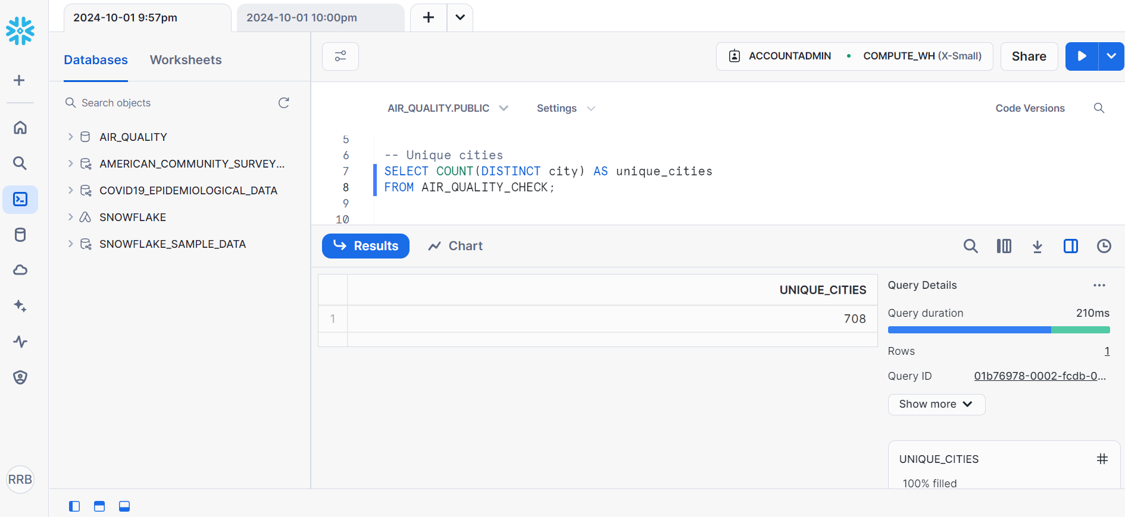

largest number of locations for city:
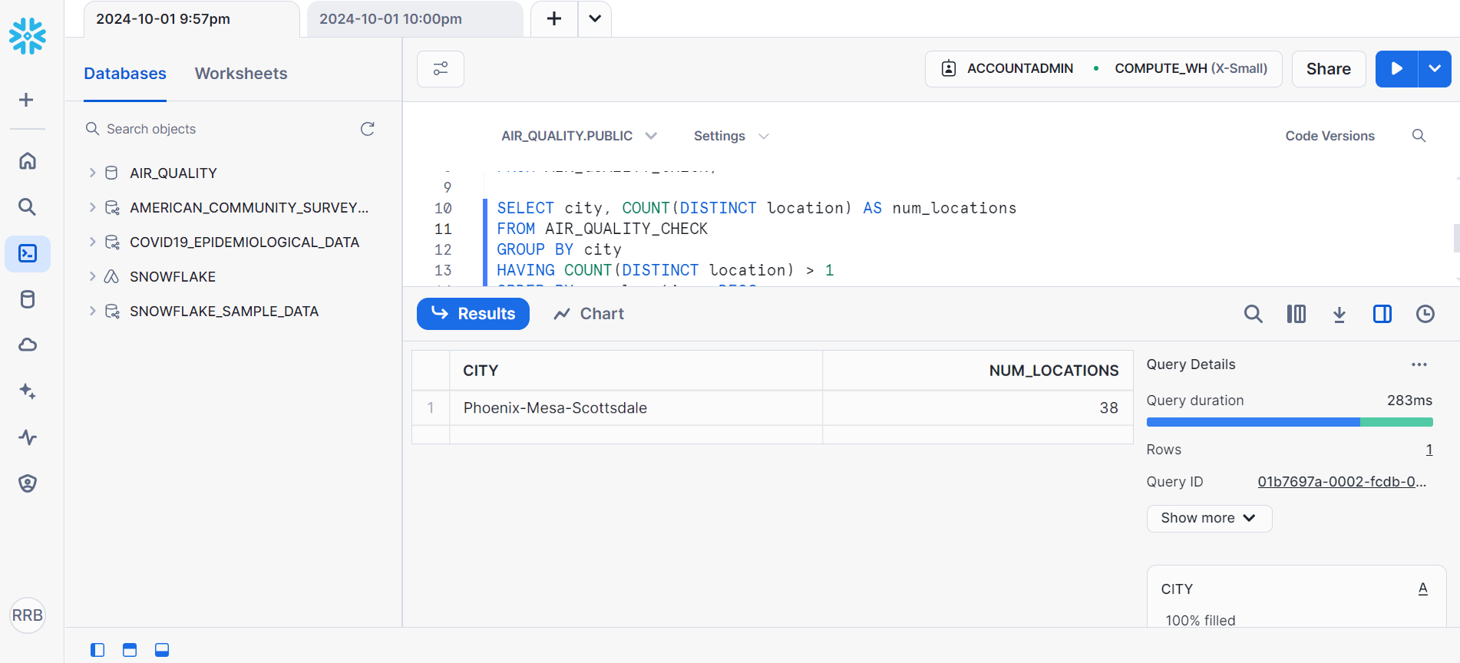
1. Unique locations recorded: Overall, the current dataset includes one thousand seven hundred one unique locations. These are individual geographical points where sampling or checking on air quality has been made or taken.
2. Unique Cities Recorded: In these 1,701 locations, customer service feedback is obtained; out of them, 708 are the distinct cities present. This is the case because the air quality measurements can be obtained from a total of 708 different cities contained in the dataset.
3. Cities with Multiple Locations: To some of these cities, there are two or more stations where the air quality data have been taken. Take, for example, Phoenix-Mesa-Scottsdale; there are 38 various locations detected in the given dataset. represent distinct geographical points where air quality measurements or checks have been recorded.
4. City with the Largest Number of Locations: The most observed points of the air quality are recorded in Phoenix-Mesa-Scottsdale with 38 different spots. Another possibility that is inferred from this is that this city has many monitoring stations or points where air quality is being monitored and thus is the city with the with the most detailed monitoring data among all the cities in the dataset.
In summary, according to the data obtained from the monitoring points, there are 1,701 unique locations in total located in 708 different cities. Different cities have more monitoring points than others; the most points belong to the Phoenix-Mesa-Scottsdale city, containing 38 of them.
3) What is the average value for each pollutant recorded?

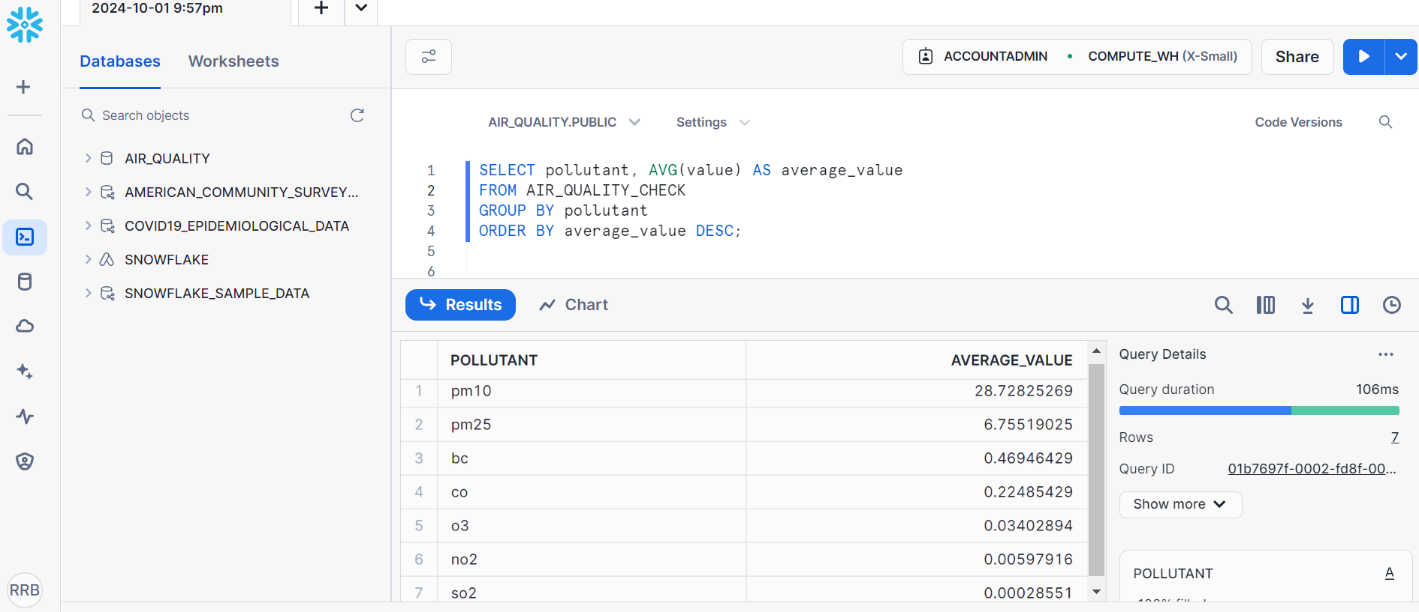

The results listed the average concentration of several pollutants in the air, and PM10 and PM2.5 top the list. They are associated with various urban pollutants, including dust, combustion products, and those arising from industries. The emission of particulate matter in these areas remains high; this puts the health of the citizens at risk since the particles are capable of invading deep into the respiratory system and the blood stream in specific instances.
Looking at the pollutants, the average emissions rates are significantly lower for other pollutants, including black carbon (BC), carbon monoxide (CO), ozone (O3), nitrogen dioxide (NO2), and sulfur dioxide (SO2). While their concentrations are slightly lower, they also remain hazardous for the atmosphere and can pose negative impacts in the long run when regarded to context-specific conditions or long-term exposure.
Since particulate matter appears to be the dominant pollutant, one should address the problem by constantly checking these pollutants and using ways to minimize their emissions. This could include increasing measures of factory effluent discharge and encouraging a shift towards a more environmentally friendly approach to transportation as a method of reducing the prevalence of respiratory diseases.

4) What are the top 5 locations with the highest average value of pm25 recorded?

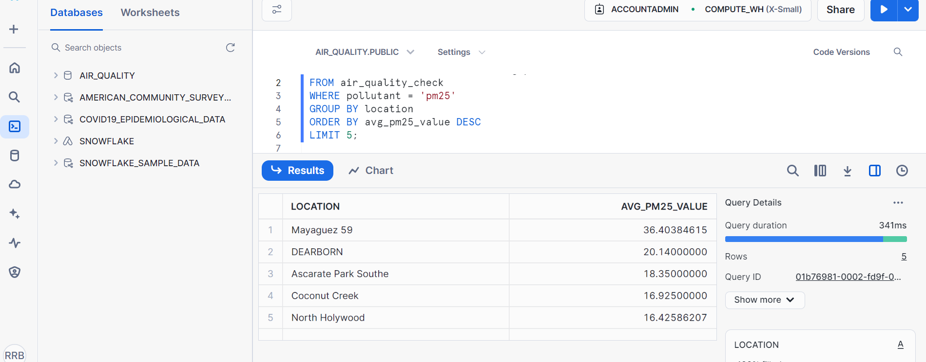

The five areas that were yield the highest average PM2: 5 level include Mayaguez 59, Dearborn, Ascarate Park Southe, Coconut Creek, and North Hollywood. Mayaguez 59 has the highest a PM2.5 concentration of 36.4 while Dearborn has a PM 2.5 concentration of 20.14 on average. Ascarate Park Southe local rank third with an average of 18.35, while Coconut Creek local rank second with an average of 16.93 followed by the North Hollywood local rank with an average of 16.43. These values suggest that these areas have relatively elevated levels of PM2.5 concentrations and proved problematic to air quality and health.

- Return a list of pollutants that have average values greater than 1. How many pollutants are left when you apply this filter?

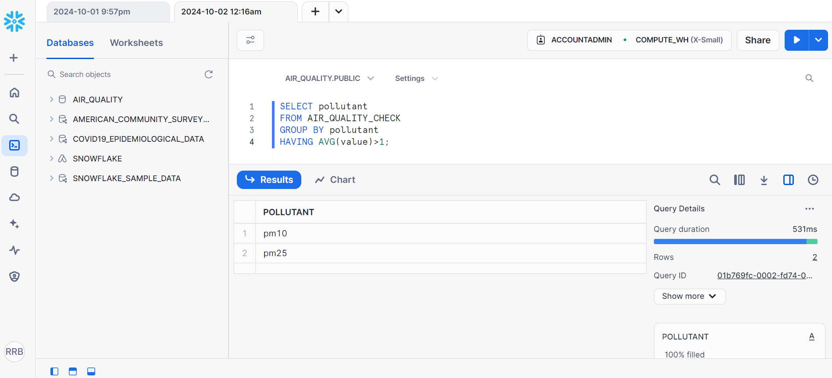

the query selects individual contaminants from the AIR_QUALITY_CHECK database, whose average concentration is greater than 1. The results suggest that of the pollutants studied, there are two that meet this need: PM10 and PM25. Completing the query in 531 milliseconds, two rows of data were returned. This means that the average of the pollutants pm10 and pm25 in the dataset being considered in this analysis are 1.

Pollutants left:

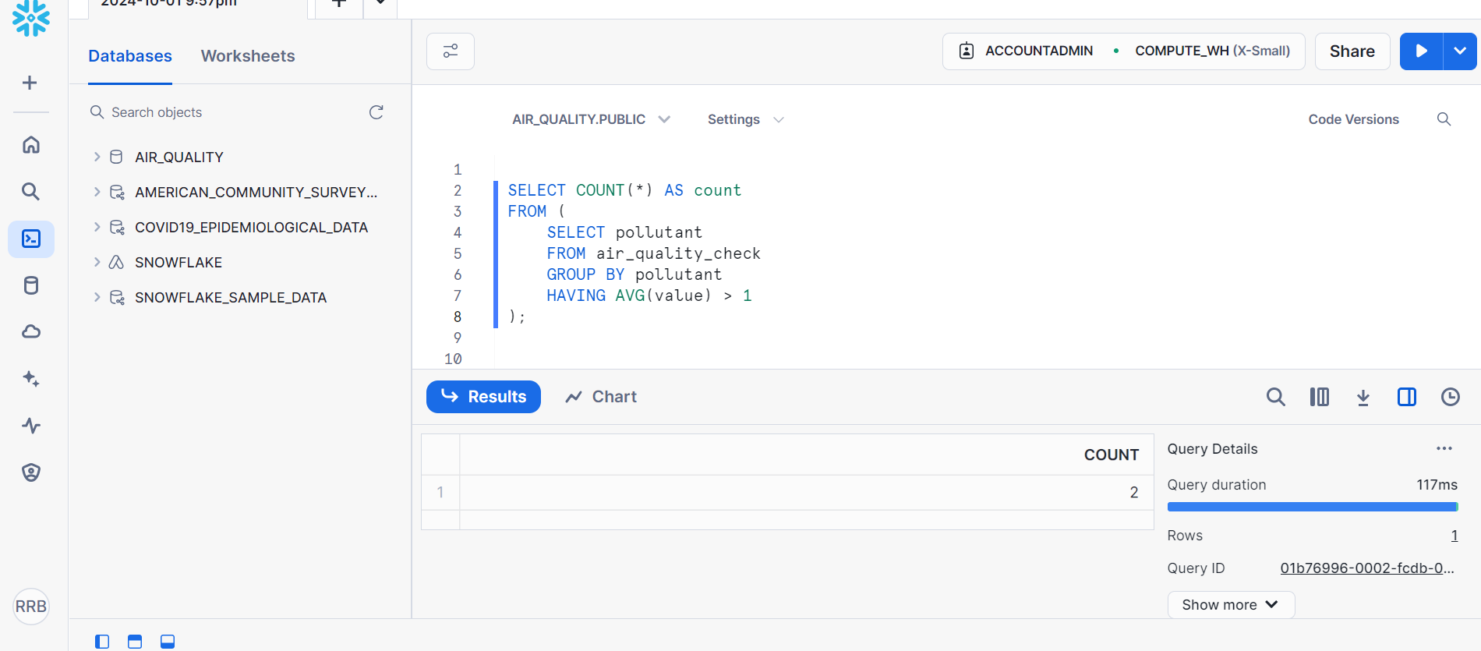
The first of them is to choose the various pollutants to filter by their type in order to obtain one-dimensional arrays of data for each pollutant type, and then the HAVING clause which returns only the average value greater than 1. By developing the query in line 21, we queried for pollutants that satisfy this condition and returned a count of 2 pollutants and the query ran with optimal efficiency, it took only 117ms.

Citations:

File: https://drive.google.com/file/d/1SBD8R6jl5_ycl3X7hulrlHpqR-w3i__a/view?usp=drive_linkLinks to an external site.

