FoodSupply ERP System - Backend Prototype
Source-code screenshots and feature documentation
Generated from the current FoodSupply ASP.NET Core MVC project.

ApplicationDbContext
Entity Framework Core database context and DbSet declarations that connect the FoodSupply models to the database.
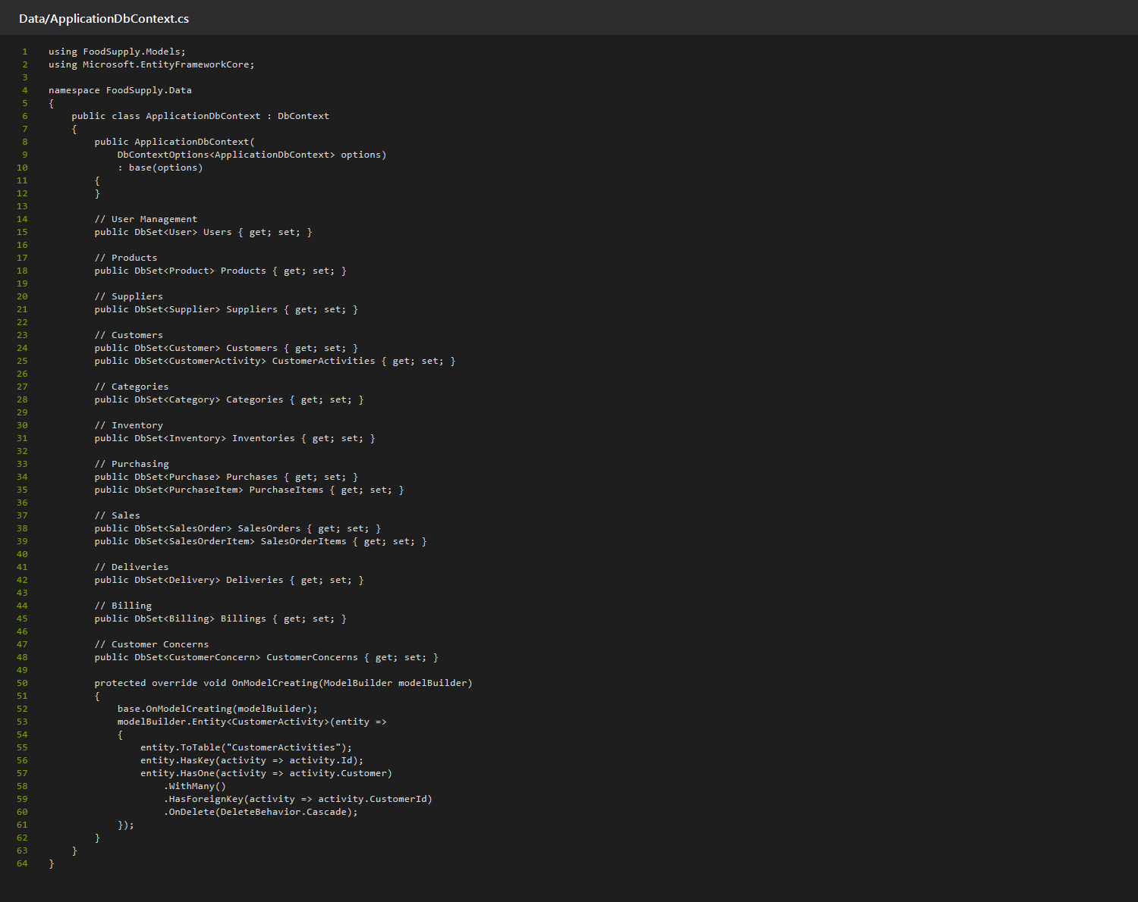

Models
Entity models define validation rules, fields, and relationships used by the system.
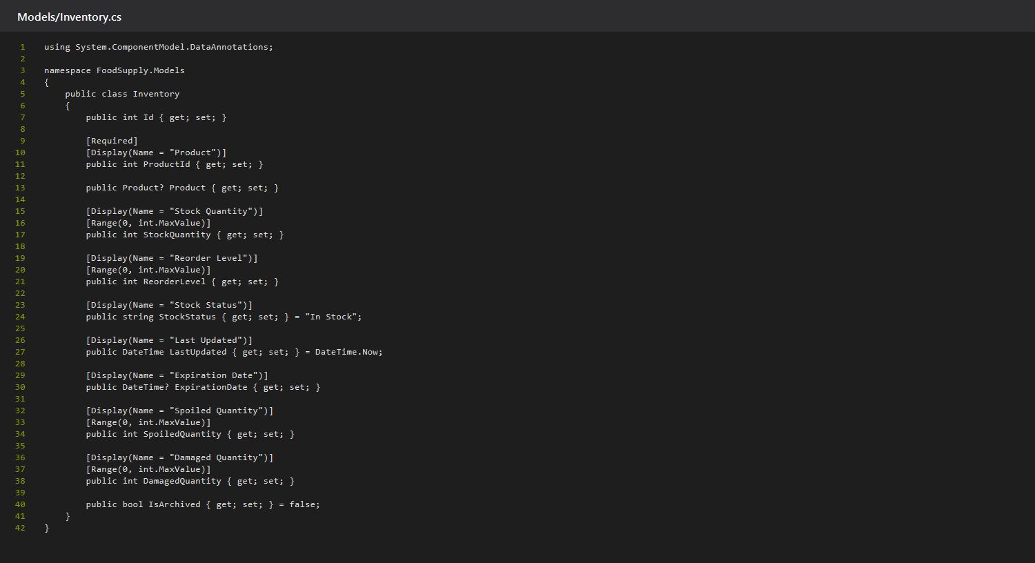

Controllers
Controllers handle CRUD actions, validation, database queries, and business workflows.
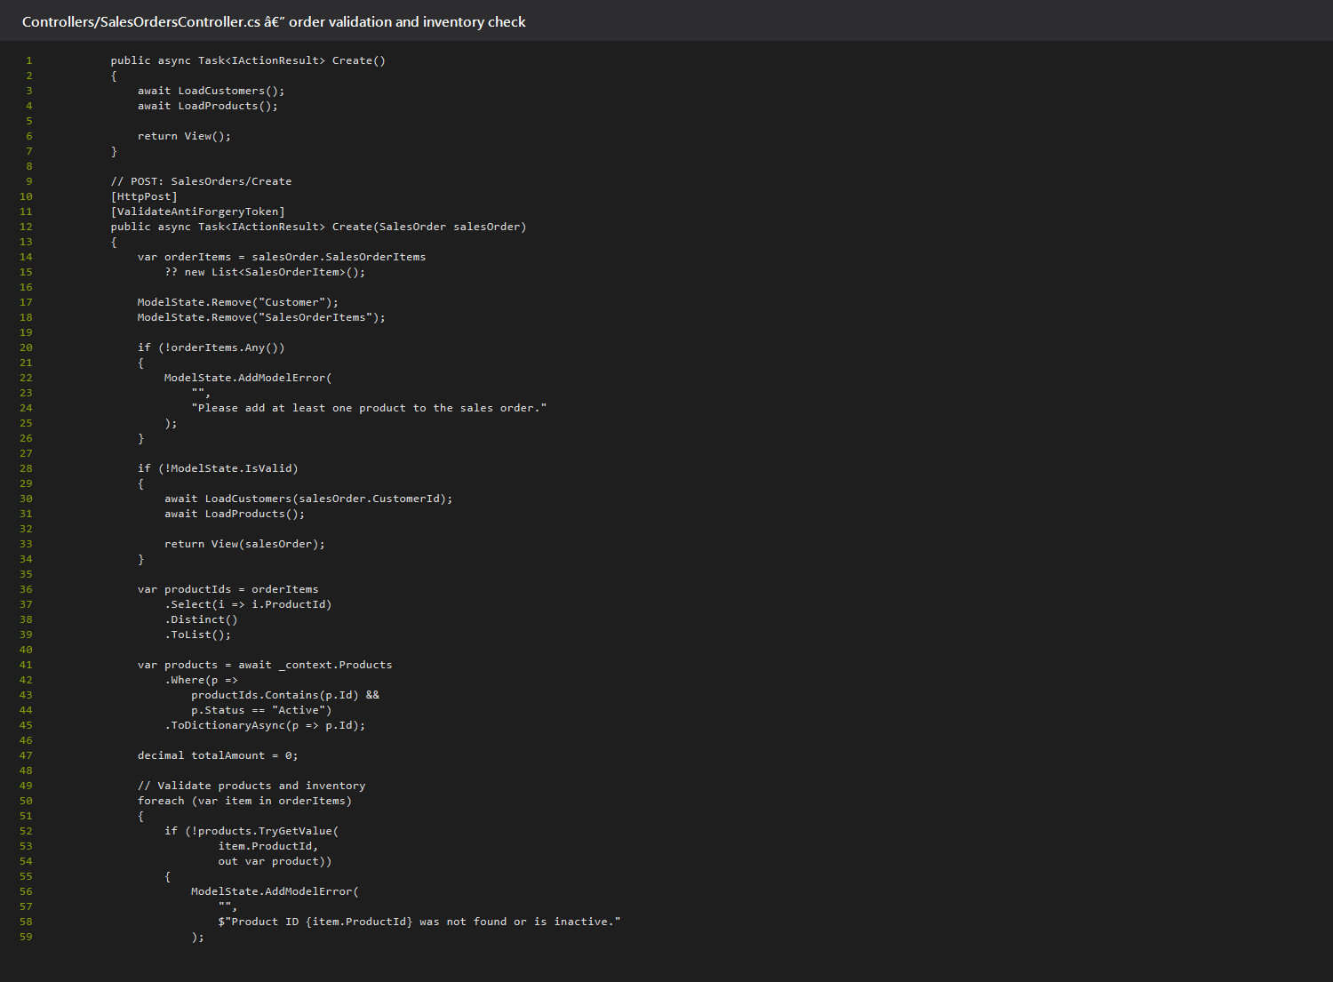

Migrations / Database Integration
EF Core migration code creates database tables and foreign-key relationships. Apply migrations with: dotnet ef database update
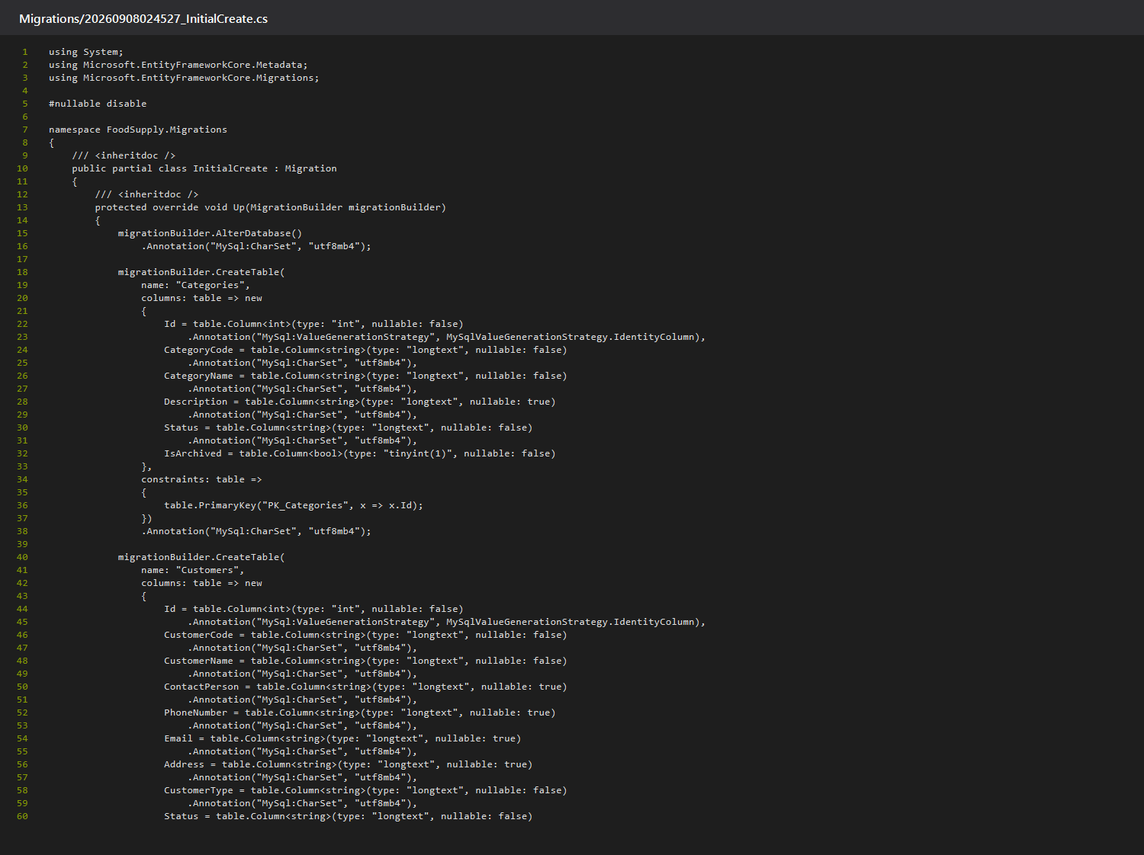

Entity Framework Core Database Operations
Asynchronous EF Core queries retrieve records, update stock levels, and persist the sales order in one workflow.
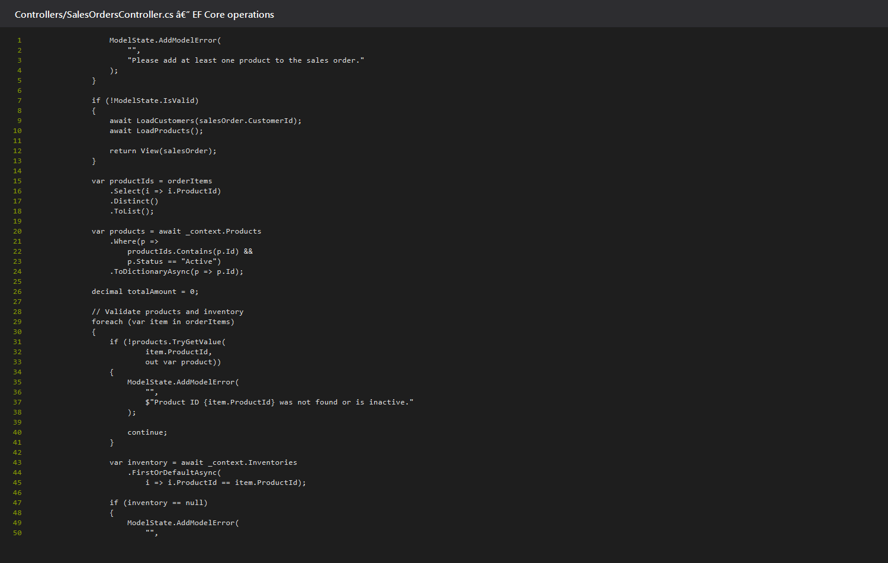

MySQL/MariaDB Integration
Pomelo Entity Framework Core provider is configured in Program.cs to use the DefaultConnection string and auto-detect the server version.
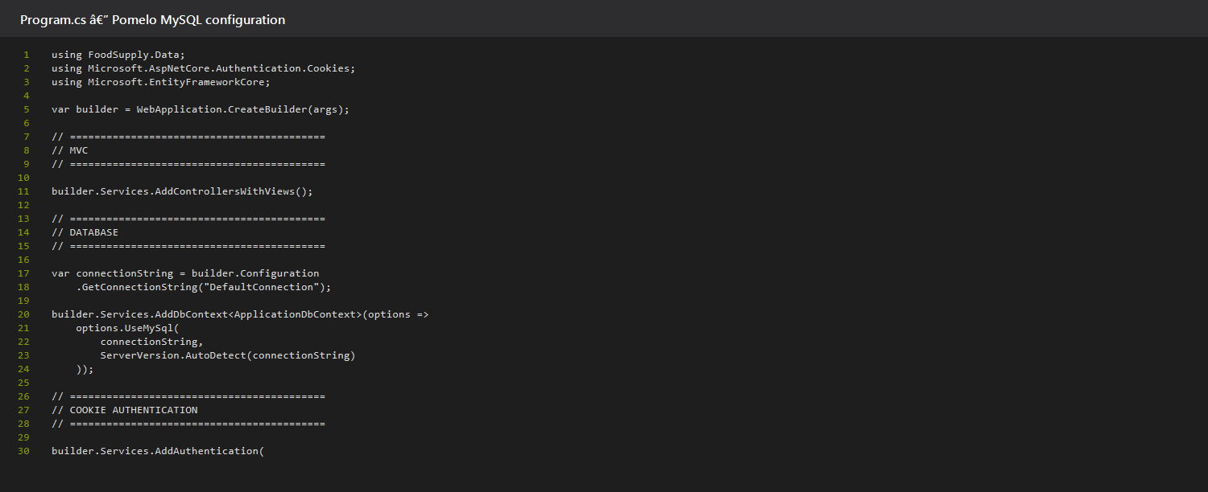

Transaction Workflow
A sales order validates products and stock, records order items, deducts inventory, updates the stock status, then saves the workflow.
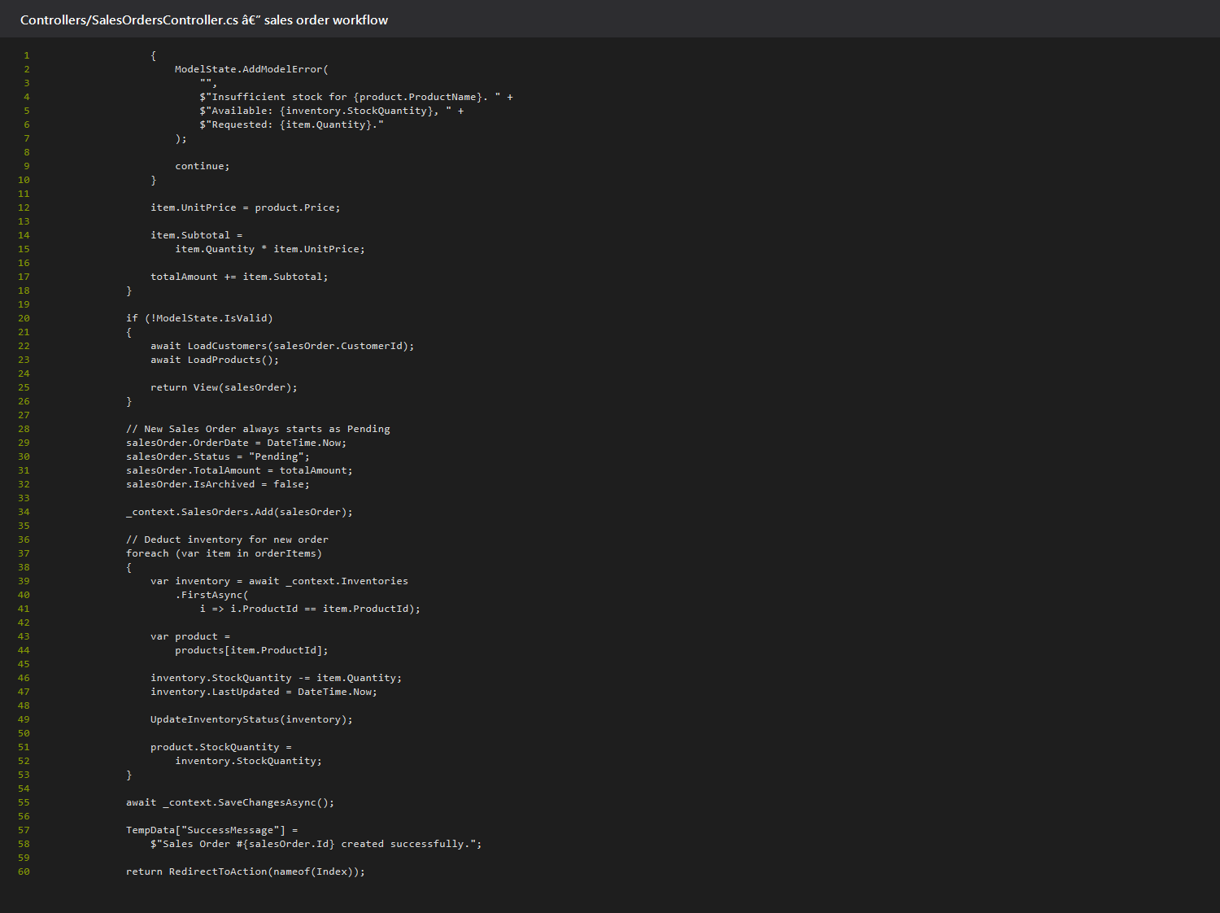

Inventory Monitoring
Inventory tracks quantity, reorder threshold, status, expiry date, spoiled quantity, and damaged quantity.

Authentication
Cookie authentication is configured with login and access-denied paths. The account controller verifies credentials and issues the signed-in principal.


Authorization and Role-Based Access Control
Controller attributes restrict module access to the named roles.
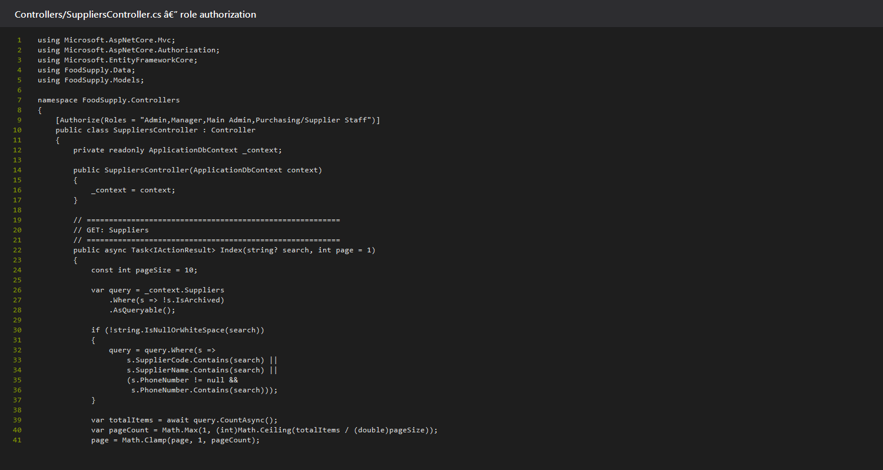

Password Hashing
The login and reset-password workflow uses ASP.NET Core PasswordHasher to verify and create password hashes.
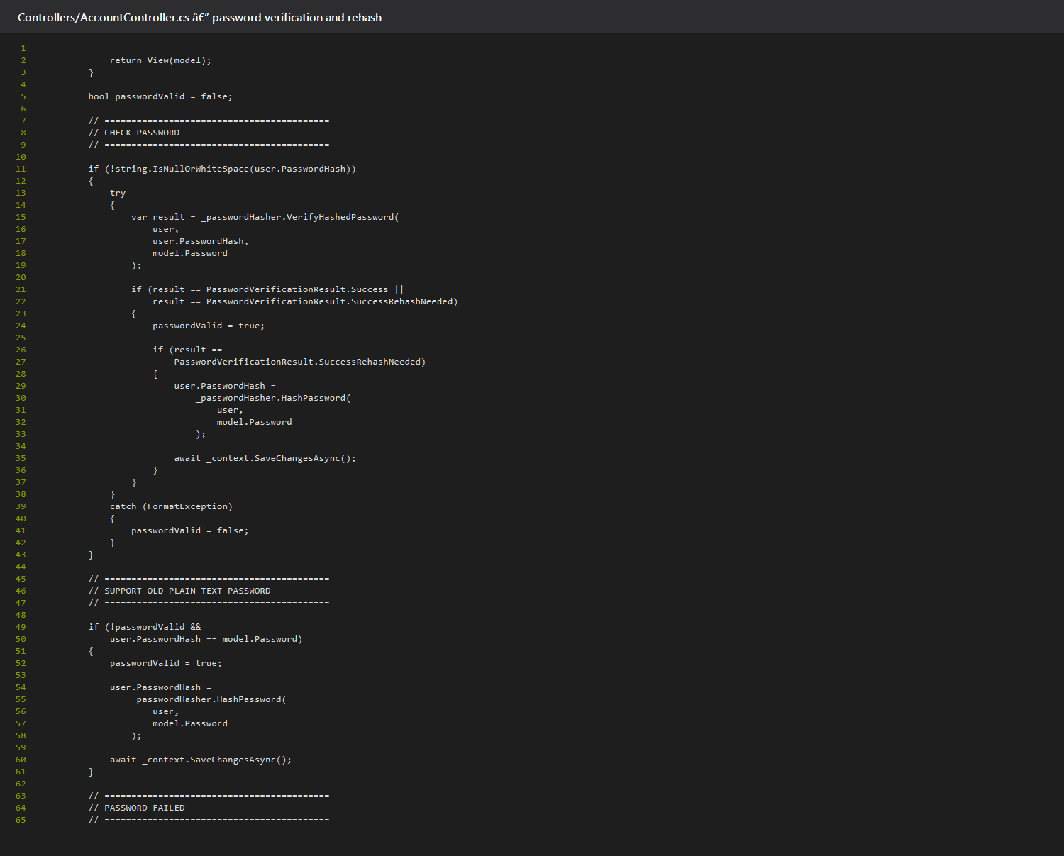

Input Validation
Data annotations define required fields and numeric ranges, while controllers use ModelState before writing records.
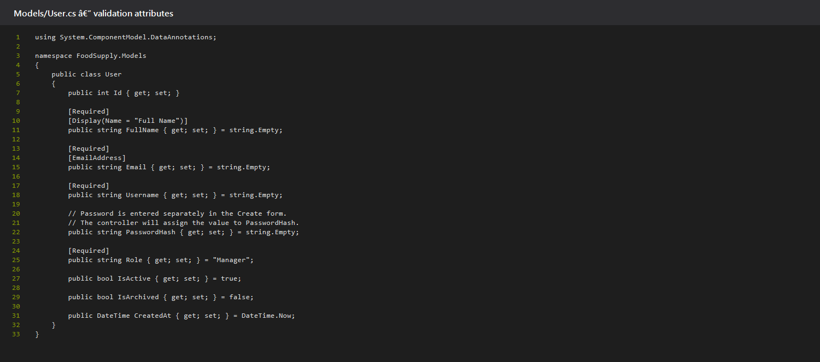

Implementation Note
Password hashing is used by AccountController for login verification and password reset. UsersController currently contains a temporary plain-text assignment when creating a user; replace that assignment with PasswordHasher.HashPassword before treating password hashing as fully enforced for every user-creation path.

