DESIGN DOCUMENT
Exception & Response Handling
Reference Architecture for AI Agent Applications
Starlette/FastAPI + LangGraph + React/Next.js

Version 1.0
May 2026

1. Overview
This document defines a 6-layer reference architecture for handling exceptions, errors, and success responses in AI agent applications. The architecture ensures that every response — whether a successful result or an error at any depth — follows a consistent JSON envelope and is handled gracefully across backend and frontend.
The pattern applies to any stack built on a Python ASGI framework (Starlette or FastAPI), an AI agent orchestration layer (LangGraph or similar), and a React/Next.js frontend.
Design Goals
- Consistent response shape for every endpoint, success or failure
- No unstructured exceptions leaking to the client
- Graceful degradation when deep-layer dependencies fail
- Clear separation between error data models and exception machinery
- Progressive error defense on the frontend (API client → try/catch → error boundary)

2. Architecture Layers
The architecture consists of 6 layers. Layers 1–4 live on the backend, Layer 5 is the wire format contract, and Layer 6 is the frontend.
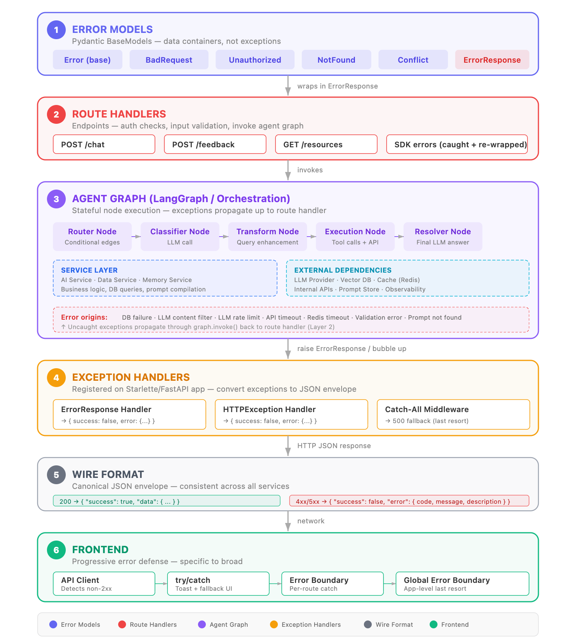

1 | ERROR MODELS  Pydantic BaseModels — data containers, not Python exceptions

Error models are pure data containers that define the shape of every error. Each subclass sets a default HTTP status code and description. The optional message field carries a user-facing string. These live in a shared utils/ package imported by all services.

class Error(BaseModel):
code: int
description: str
message: Optional[str] = None

class BadRequestError(Error): # 400
class UnauthorizedError(Error): # 401
class ForbiddenError(Error): # 403
class NotFoundError(Error): # 404
class EntityConflictError(Error): # 409

2 | ROUTE HANDLERS  Endpoints — auth checks, input validation, invoke agent graph

Route handlers are the entry points for HTTP requests. They validate input, check authentication, and invoke the agent graph. They also contain specific except clauses to catch known SDK errors and re-wrap them as ErrorResponse. The ErrorResponse class is a Python Exception that wraps a Layer 1 Error model — it bridges domain errors into Python’s exception machinery.

class ErrorResponse(Exception):
"""Wraps an Error model. Always raise, never return."""
def __init__(self, error: Error):
super().__init__(error.message)
self.error = error

# In a route handler:
if not request.state.user:
raise ErrorResponse(
error=UnauthorizedError(message="Not logged in")
)

# Invoke the agent graph:
result = await agent_graph.ainvoke(state, config={...})
return SuccessResponse(data=result)

3 | AGENT GRAPH  LangGraph / orchestration — stateful node execution

The agent graph is the core execution engine. It chains together nodes (classifier, transformer, executor, resolver) that call into the service layer and external dependencies. Exceptions originating inside any node propagate uncaught through graph.invoke() back to the route handler.

The graph contains two critical sub-layers:
- Service Layer — business logic, database queries, prompt compilation, AI service calls
- External Dependencies — LLM providers, vector databases, caches, internal APIs, observability

Graph Node Types
Node Type | Purpose | Error Behavior
Router Node | Conditional branching based on state | Returns alternative path (no exception)
Classifier Node | LLM call to categorize input | LLM errors propagate up
Transform Node | Query enhancement, date extraction | LLM errors propagate up
Execution Node | Tool calls, API requests for data | Can handle errors internally (graceful degradation)
Resolver Node | Final LLM call to generate answer | LLM errors propagate up

Error Origins in the Agent Graph
Error Source | Exception Type | Propagation
Database connection failure | OperationalError | Uncaught → bubbles to route handler
LLM content filter | SDK BadRequestError | Uncaught → bubbles to route handler
LLM rate limit / timeout | SDK APIError | Uncaught → bubbles to route handler
Internal API timeout | httpx.TimeoutException | Caught internally → graceful degradation
Cache (Redis) failure | ConnectionError | Uncaught → bubbles to route handler
Prompt store unavailable | HTTP Error | Uncaught → bubbles to route handler
Pydantic validation error | ValidationError | Uncaught → bubbles to route handler

4 | EXCEPTION HANDLERS  Registered on app — convert exceptions to JSON envelope

Every service must register three handlers that convert exceptions into the canonical JSON envelope. These are the last line of defense before a response leaves the backend.

# Handler 1: Domain ErrorResponse exceptions
async def error_response_handler(request, exc: ErrorResponse):
return JSONResponse(
status_code=exc.error.code,
content={"success": False, "error": {
"code": exc.error.code,
"message": exc.error.message,
"description": exc.error.description,
}},
)

# Handler 2: HTTPException handler
async def http_exception_handler(request, exc: HTTPException):
return JSONResponse(status_code=exc.status_code, ...)

# Handler 3: Catch-all ASGI middleware (500 fallback)
class CatchExceptionsMiddleware:
async def __call__(self, scope, receive, send):
try:
await self.app(scope, receive, send)
except Exception as e:
# Return safe JSON 500 in production

Registration in Starlette:
app = Starlette(
exception_handlers={
ErrorResponse: error_response_handler,
HTTPException: http_exception_handler,
},
middleware=[
Middleware(CatchExceptionsMiddleware, debug=DEBUG),
],
)

5 | WIRE FORMAT  Canonical JSON envelope — consistent across all services

Every HTTP response, whether success or error, uses the same top-level envelope. The frontend relies on this contract to handle all responses uniformly.

Success Response Format

HTTP 200 OK
Content-Type: application/json

{
"success": true,
"data": {
"threadId": "abc-123",
"messages": [
{
"id": "msg-001",
"authorRole": "assistant",
"content": {
"parts": [
{ "content_type": "text", "text": "Your milk production..." },
{ "content_type": "chart", "chart": { ... } }
]
},
"createdAt": "2026-05-13T10:30:00Z"
}
],
"continuation_token": null
}
}

Error Response Format

HTTP 400 Bad Request
Content-Type: application/json

{
"success": false,
"error": {
"code": 400,
"message": "Your query was flagged as inappropriate.",
"description": "Bad Request"
}
}

Response Type Reference
HTTP Status | Envelope | When Used
200 OK | { "success": true, "data": T } | Request completed successfully
200 OK (degraded) | { "success": true, "data": T } | Partial success — some data unavailable, AI explains the gap
400 Bad Request | { "success": false, "error": {...} } | Invalid input, content filter, validation failure
401 Unauthorized | { "success": false, "error": {...} } | Missing or invalid authentication
403 Forbidden | { "success": false, "error": {...} } | Authenticated but insufficient permissions
404 Not Found | { "success": false, "error": {...} } | Requested resource does not exist
409 Conflict | { "success": false, "error": {...} } | Entity conflict (duplicate, version mismatch)
500 Internal Server Error | { "success": false, "error": {...} } | Unhandled exception (catch-all middleware)

Key principle: The error.message field is user-facing and safe to display. The error.description field is technical and may be used for logging. In production, the catch-all middleware should not expose internal error details in the description field.

6 | FRONTEND  Progressive error defense — specific to broad

The frontend has three levels of defense, from most specific to broadest catch:

Level A: API Client + try/catch (per-component)
const { data, error } = await apiClient.POST('/chat', { body });

// Check 1: HTTP-level error from openapi-fetch
if (error) throw new Error(`Error: ${JSON.stringify(error)}`);

// Check 2: Verify success envelope
if (data?.success && data?.data) {
// Happy path — render data
setMessages(prev => [...prev, ...data.data.messages]);
} else {
throw new Error('Invalid response format');
}

// Catch block:
toast({ title: 'Error', description: error.message, variant: 'destructive' });
setMessages(prev => [...prev, fallbackErrorMessage]);

Level B: Route-Level Error Boundary (per-page)
// app/(protected)/agents/[feature]/error.tsx
export default function Error({ error, reset }) {
useEffect(() => {
console.error('Page Error:', error);
trackEvent('page.error_boundary', { error_message: error.message });
}, [error]);
return (
// Error UI with 'Try again' (reset()) and navigation buttons
);
}

Level C: Global Error Boundary (app-level, last resort)
// app/global-error.tsx
export default function GlobalError({ error, reset }) {
// Minimal error UI — 'Try again' and 'Return to home'
}

Frontend Defense Summary
Level | Scope | Triggers On | User Experience
API Client | Per-request | Non-2xx HTTP status | { error } object populated
try/catch | Per-component | Any thrown error | Toast notification + fallback UI
Error Boundary | Per-route | Uncaught component error | Full-page error with retry
Global Error | App-wide | Uncaught app error | Minimal error with home link

3. Flow Scenarios
This section traces four representative scenarios through all six layers, showing exactly where each request succeeds or fails and how the response is constructed.

Scenario 1: Happy Path — Chat

Layer | Action | Outcome
2 — Route | POST /chat — auth passes, graph invoked | State constructed, graph.ainvoke() called
3 — Graph: Router | Check data exists in database | has_data = true → continue
3 — Graph: Classifier | LLM classifies message as_QUERY | classification = _QUERY
3 — Graph: Transform | LLM enhances query with date range | date_from, date_to, filters extracted
3 — Graph: Executor | Find metrics via LLM, fetch data via API | Metric data retrieved successfully
3 — Graph: Resolver | LLM generates natural language answer + charts | Text + chart messages produced
2 — Route | Transform graph result to API response | SuccessResponse with messages
5 — Wire | HTTP 200 → { "success": true, "data": {...} } | Consistent envelope
6 — Frontend | data.success is true → render messages | User sees text + charts

Scenario 2: Failure — Database Connection Lost

Layer | Action | Outcome
2 — Route | POST /chat — auth passes, graph invoked | State constructed
3 — Graph: Router | DataService.has_data() → DB connection refused | ⚠️ OperationalError raised
3 — Graph | No try/except in node — exception propagates | Bubbles through graph.invoke()
2 — Route | Generic except catches, wraps as ErrorResponse | raise ErrorResponse(BadRequestError("Something went wrong"))
4 — Handler | ErrorResponse handler converts to JSON | JSONResponse with status 400
5 — Wire | HTTP 400 → { "success": false, "error": {...} } | Consistent envelope
6 — Frontend | error detected → toast + fallback message | User sees error toast

Scenario 3: Failure — LLM Content Filter Triggered

Layer | Action | Outcome
2 — Route | POST /chat — graph invoked, data exists | Proceeds to classification
3 — Graph: Classifier | AIService calls LLM with inappropriate content | LLM SDK raises BadRequestError
3 — Graph | No try/except in node — exception propagates | Bubbles through graph.invoke()
2 — Route | Specific except clause catches SDK BadRequestError | raise ErrorResponse("Query flagged as inappropriate")
4 — Handler | ErrorResponse handler converts to JSON | JSONResponse with status 400
5 — Wire | HTTP 400 → { "success": false, "error": {...} } | User-friendly message
6 — Frontend | error detected → toast notification | User sees content filter message

Scenario 4: Graceful Degradation — API Timeout

Layer | Action | Outcome
2 — Route | POST /chat — graph invoked, passes all checks | Reaches execution node
3 — Graph: Executor | Fetches metric data via internal API | httpx.TimeoutException on one metric
3 — Graph: Executor | APIClient catches timeout, returns error dict | Error collected, loop continues
3 — Graph: Executor | Passes partial data + errors to AI resolver | LLM generates response acknowledging gap
3 — Graph: Resolver | LLM produces text + partial charts + explanation | Graph completes normally
2 — Route | Transform result to API response | SuccessResponse with partial data
5 — Wire | HTTP 200 → { "success": true, "data": {...} } | 200 OK with degraded content
6 — Frontend | data.success is true → render normally | User sees answer + "some data unavailable" note

4. Rules & Anti-Patterns

Critical Rules

Rule | Rationale
Always raise ErrorResponse, never return it | Returning bypasses exception handlers — the response object gets serialized incorrectly
Register all three handlers on every service | Missing one causes inconsistent error shapes (e.g., plain-text 500 or {"detail": ...})
Use logger.error(), not print() | Print bypasses logging configuration, rotation, and observability pipelines
Only re-raise in DEBUG mode | In production, always return a safe JSON 500 — never leak stack traces
No dead code after raise | return JSONResponse() after raise e is unreachable — a silent bug
Middleware must be ASGI class (Starlette) | Starlette does not support @app.middleware("http") — that is FastAPI-only syntax

Common Anti-Patterns

Anti-Pattern 1: return instead of raise
# ❌ WRONG — bypasses exception handler
except OpenAiBadRequestError as e:
return ErrorResponse(error=BadRequestError(message="..."))

# ✅ CORRECT — exception handler catches and serializes
except OpenAiBadRequestError as e:
raise ErrorResponse(error=BadRequestError(message="..."))

Anti-Pattern 2: Dead code after raise
# ❌ WRONG — JSONResponse is unreachable
except Exception as e:
raise e
return JSONResponse(status_code=500, ...)

# ✅ CORRECT — conditional re-raise
except Exception as e:
if DEBUG: raise
return JSONResponse(status_code=500, ...)

Anti-Pattern 3: Infrastructure errors reported as 400
# ❌ WRONG — DB failure is not a client error
except Exception as e:
raise ErrorResponse(
error=BadRequestError(message="Something went wrong")
)

# ✅ BETTER — use Error (500) for infrastructure failures
except OperationalError as e:
raise ErrorResponse(
error=Error(code=500, description="Service unavailable",
message="Please try again later")
)

5. Implementation Checklist

Backend (per service)

# | Check | Status
1 | Error models imported from shared utils/ package | ☐
2 | ErrorResponse and HTTPException handlers registered on app | ☐
3 | Catch-all ASGI middleware registered (proper class, not decorator) | ☐
4 | All domain errors use raise ErrorResponse(...) — never return | ☐
5 | External SDK exceptions caught and re-wrapped as ErrorResponse | ☐
6 | Error logging uses logger.error(), not print() | ☐
7 | No dead code after raise statements | ☐
8 | Catch-all only re-raises in DEBUG mode | ☐
9 | Infrastructure errors use 500, not 400 | ☐

Agent Graph

# | Check | Status
1 | Execution nodes handle API timeouts internally (graceful degradation) | ☐
2 | Error context passed to resolver LLM so it can explain gaps | ☐
3 | Service layer methods document which exceptions they can raise | ☐
4 | No bare except: pass blocks that swallow errors silently | ☐

Frontend (per route)

# | Check | Status
1 | API calls wrapped in try/catch | ☐
2 | Checks both error from API client and data.success from envelope | ☐
3 | Shows toast notification on error | ☐
4 | Route-level error.tsx Error Boundary exists | ☐
5 | Error Boundary tracks events to analytics (PostHog, Sentry) | ☐
6 | global-error.tsx exists at app root | ☐

