Evidence-Gated Medical LLM Alerts for Pharmacogenomic Claims
Detecting overclaiming relative to guideline-supported evidence
Author: Ravi Bajaj | Target venue: ML4H 2026 Findings or Proceedings Track | Course: AI in Healthcare

Abstract
Large language models can draft fluent medication alerts that sound stronger than the evidence they cite. This paper narrows the capstone to one workflow: pharmacogenomic and genomic medication-alert text. I implement a synthetic pre-display evidence gate with three checks: endpoint/actionability, population fit, and citation/guideline support. In 30 synthetic cases spanning CPIC-style medication-gene pairs, variant uncertainty, population transport, and unsupported genetics claims, ungated drafts overclaimed evidence in 20 cases. The gated controller reduced remaining overclaiming to 0/30 while allowing 10/10 aligned bounded alerts and producing no inappropriate denials in this Stage 1 scaffold. These results demonstrate implementation consistency and construct validity against author-designed cases, not independent clinical safety or patient benefit. The planned Stage 2 evaluation compares ungated and gated LLM drafts on independently authored cases with blinded reviewer adjudication of overclaiming, inappropriate denial, calibration, and error categories.

1. Introduction
The prior capstone package showed that a large set of mathematical and assurance ideas could be connected to medical LLM evaluation. The reviewer-facing problem is that breadth weakened the causal chain. This revision makes pruning the method: one workflow, one failure mode, three gates, and a measurable evaluation plan.
The chosen workflow is pharmacogenomic or genomic medication-alert text. It is attractive because guideline resources such as CPIC and ClinPGx already distinguish genotype, phenotype, evidence level, and prescribing recommendation. That creates a concrete setting where an LLM can be audited for a specific error: converting real but limited evidence into a stronger clinical claim.

2. Related Work and Evidence Boundary
The course theme from Byrne, Domenico, and Moore is that patient-outcome claims for healthcare AI require pragmatic clinical evaluation. Stegenga's Medical Nihilism motivates caution when evidentiary pipelines make interventions appear stronger than they are. FDA-NIH BEST materials provide the endpoint vocabulary: biomarkers, surrogate endpoints, validated surrogates, and clinical outcomes are not interchangeable.
Pharmacogenomics adds a useful positive control. CPIC-style resources often support bounded prescribing language, such as avoiding a drug in a specific genotype/phenotype context or reviewing dose because of toxicity risk. Those resources do not automatically support claims that an LLM improves outcomes, that an association is causal, that a finding transports across populations without recalibration, or that a weak genetic association authorizes treatment denial.

3. Methods
The controller is a deterministic pre-display gate. It is not presented as an autonomous clinical agent. It receives a drafted alert claim and structured evidence features, then selects one of five permission levels: allow bounded alert, narrow claim, abstain for population fit, abstain for citation/guideline support, or deny unsupported action.
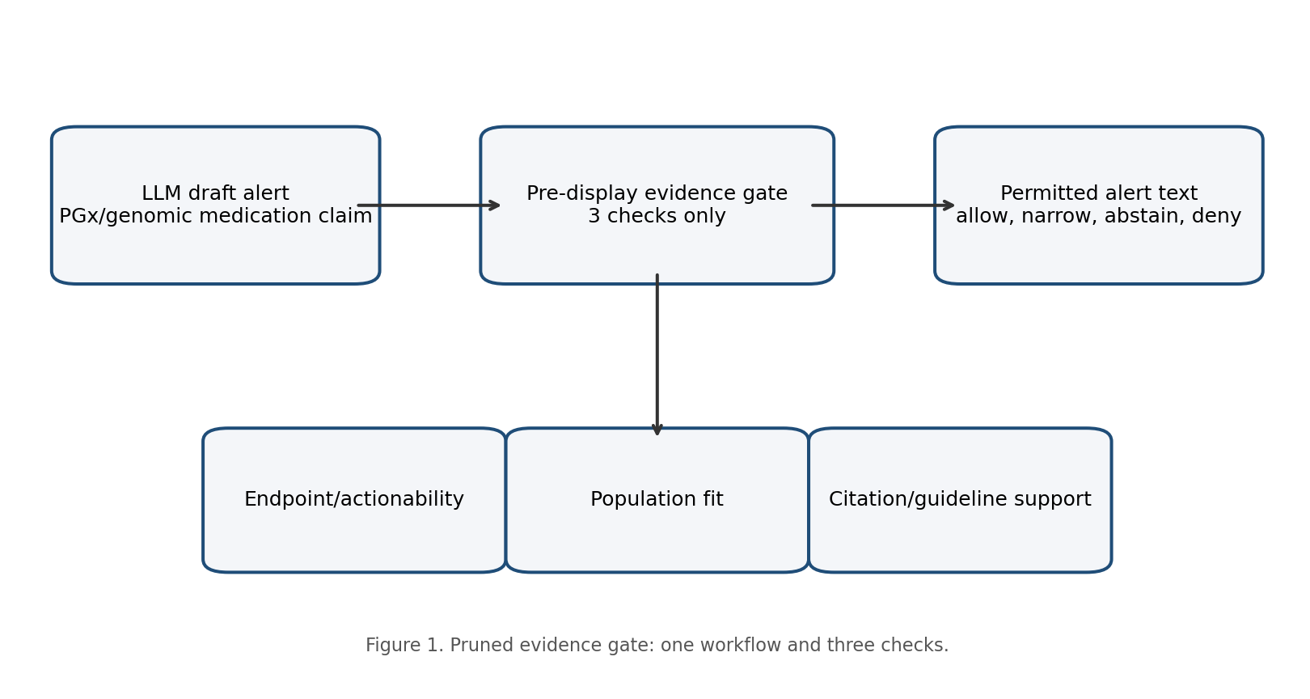
Figure 1. Pruned architecture for the evidence gate.
Gate | Question | Permitted effect
Endpoint/actionability | Does the evidence support medication action, only surrogate/process language, or no action? | Allow bounded alert, narrow wording, or deny unsupported action.
Population fit | Does source evidence plausibly fit the target patient/cohort? | Require source-specific validation or abstain from transport.
Citation/guideline support | Is the cited guideline real, current, relevant, and strong enough for the claim? | Deny fabricated claims; abstain on uncertain/conflicting support.

4. Stage 1 Synthetic Evaluation
The current case bank contains 30 synthetic cases. Ten are bounded aligned alerts; twenty intentionally contain overclaiming through universal action language, unsupported genetics, population mismatch, citation/guideline weakness, variant uncertainty, or obsolete/context-shifted evidence. Each case has an expected action and expected primary gate.
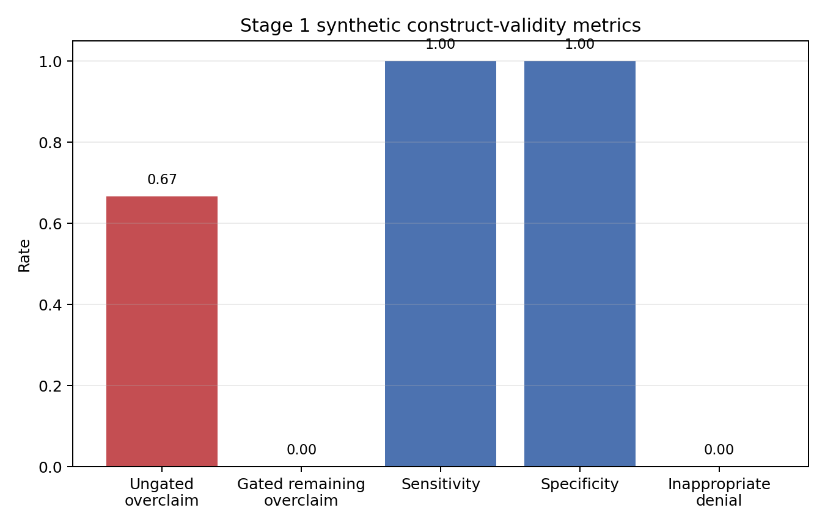
Figure 2. Stage 1 metrics on author-designed synthetic cases.
Result | Value | Claim allowed
Overclaim reduction | 0.67 | Construct-validity signal only.
Sensitivity | 1.00 | Detects intentionally overstrong claims in this synthetic bank.
Specificity | 1.00 | Allows aligned bounded alerts in this synthetic bank.
Brier score | 0.112 | Preliminary risk-score calibration diagnostic.
Inappropriate denial | 0 | No aligned bounded alerts were denied too strongly in Stage 1.

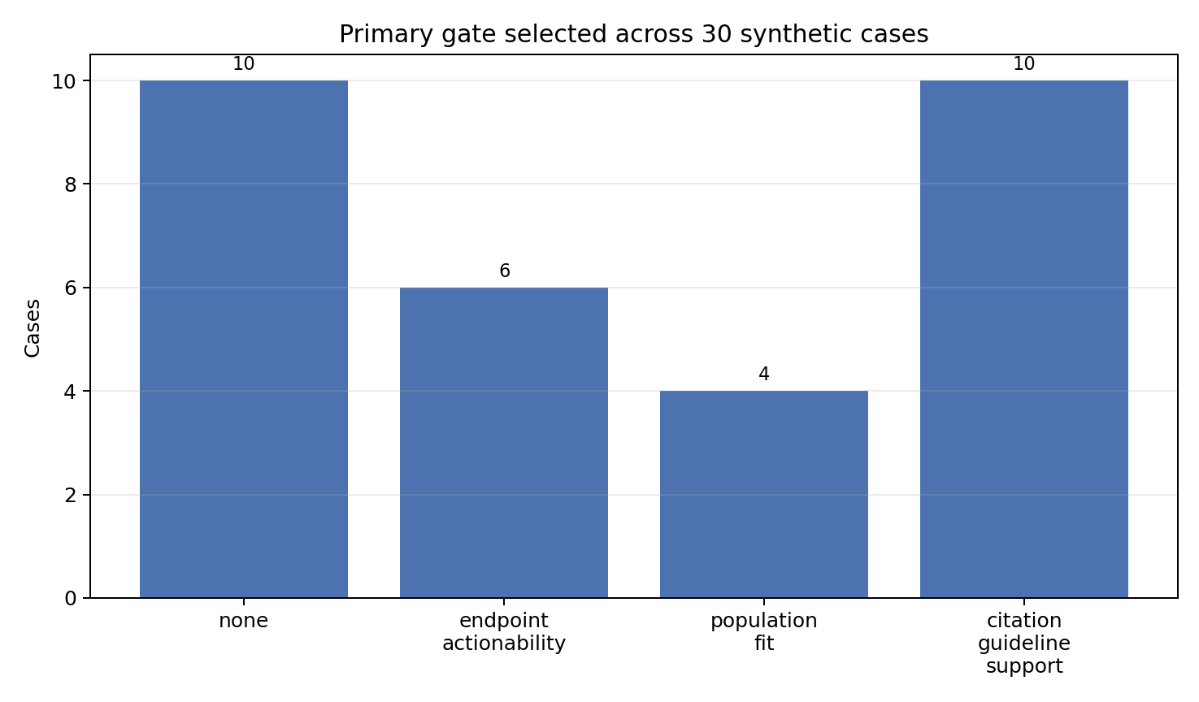
Figure 3. Primary gate selected by the deterministic controller.

5. Planned Stage 2
Stage 2 is the part that would make the paper clinically interpretable. It should compare ungated LLM drafts with gated drafts on independently authored cases. Reviewers should be blinded to arm when feasible and should classify overclaiming, inappropriate denial, preserved clinician authority, population-fit concerns, citation support, and error category.
- Primary outcome: reduction in unsupported evidence overclaiming.
- Safety outcome: inappropriate denial of bounded, guideline-supported alerts.
- Secondary outcomes: calibration of overclaim risk, interrater agreement, and qualitative error taxonomy.
- Boundary: no real patient data are needed for Stage 1; any Stage 2 use of clinical cases requires appropriate governance or synthetic case authoring.

6. Discussion
The key lesson is that an LLM does not need to be proven clinically useful before it can be disciplined. A pre-display gate can enforce a smaller claim grammar: a guideline supports a bounded alert, a population mismatch forces abstention, and an unverifiable citation carries no medical authority. This is not a substitute for pragmatic trials; it is a way to prevent a paper, product, or alert from claiming more than its evidence can bear.
The most important limitation is that the present results are synthetic and author-designed. They demonstrate that the implementation follows the intended rules, not that the system generalizes. The final paper should be honest about that limitation because it is exactly the epistemic discipline the project asks LLMs to follow.

7. Conclusion
A cohesive capstone can be built from the original implementation by pruning. The revised project studies one practical genetics workflow and evaluates whether a three-gate controller prevents LLM alert text from inflating guideline-supported evidence into unsupported clinical authority.

References and Web Sources
- ML4H 2026 home. https://ml4h.ahli.cc/
- ML4H 2026 call for participation. https://ml4h.ahli.cc/submit/call-for-papers/
- Byrne, D. W., Domenico, H. J., & Moore, R. P. (2024). Artificial intelligence for improved patient outcomes: The pragmatic randomized controlled trial is the secret sauce.. https://kjronline.org/DOIx.php?id=10.3348%2Fkjr.2023.1016
- Stegenga, J. (2018). Medical Nihilism. Oxford University Press.. https://global.oup.com/academic/product/medical-nihilism-9780198747048
- FDA-NIH BEST Resource. https://www.ncbi.nlm.nih.gov/books/NBK326791/
- CPIC guidelines overview. https://cpicpgx.org/guidelines/
- ClinPGx CPIC CYP2C19-clopidogrel guideline. https://www.clinpgx.org/guideline/PA166251443
- CPIC CYP2C19-clopidogrel 2022 update. https://pmc.ncbi.nlm.nih.gov/articles/PMC9287492/
- CPIC DPYD-fluoropyrimidines guideline. https://www.clinpgx.org/guideline/PA166251462
- CPIC DPYD-fluoropyrimidines update. https://pmc.ncbi.nlm.nih.gov/articles/PMC5760397/
- CPIC TPMT/NUDT15-thiopurines update. https://pmc.ncbi.nlm.nih.gov/articles/PMC12997511/
- ClinPGx HLA-B-abacavir guideline. https://www.clinpgx.org/guideline/PA166251444
- ClinPGx HLA-A/HLA-B-carbamazepine guideline. https://www.clinpgx.org/guideline/PA166251448
- ClinVar. https://www.ncbi.nlm.nih.gov/clinvar/
- gnomAD. https://gnomad.broadinstitute.org/
- All of Us Research Program. https://allofus.nih.gov/
- Genome India project. https://genomeindia.in/
- Psifas / Mosaic. https://partnership.psifas.org.il/

