Nao Experiments

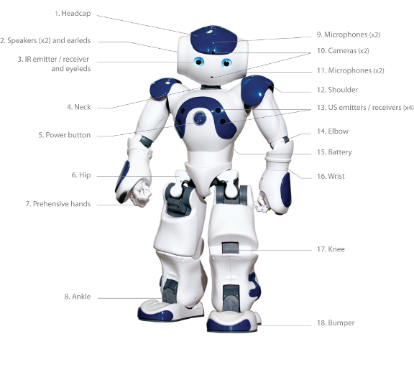

Author: Rene Bakx

Date: December 2015

Contents

1. Introduction 3

2. Ways to work with the Nao 3

1.1. With Choregraphe only 3

1.2. Through SSH connection 4

1.3. Using the SDK 5

1.4. Simulation 5

# Introduction

This document describes the experiments with the Nao robot. Purpose of these experiments is to get to know the Nao robot and its NAOqi framework. The resulting documents (including this one) and code is available at <https://github.com/rbakx/Nao/tree/master/NaoExperiments>.

Summary of the experiments:

* Investigation of the different ways of working with Nao.
* Create a behavior which:
  + Recognizes and greets persons.
  + When a person is not recognized within a certain time the Nao will ask for the name an learns the new face.

This behavior was developed in both in Choregraphe and Python. In Choregraphe it proved to be impossible to complete this behavior because of the complexity.

# Ways to work with the Nao

First read <http://doc.aldebaran.com/2-1/dev/naoqi/index.html> for a good introduction on the NAOqi framework.

Summary: NAOqi is a framework with many modules (shared objects libraries) with functionality like motion, vision, audio, memory etc. They can be accessed by creating a proxy to this module first. The proxy can run on the robot or remote on a laptop. The proxy will connect through TCP/IP with a broker running on the robot. The broker will have the list of available libraries loaded (in ‘autoload.ini’). The libraries contain modules and methods and the broker will pass the call to the prober library. There are two brokers: the main broker (NAOqi broker) for local calls and myBroker (Python broker) for remote calls. When not running in the NAOqi environment but in a standalone Python script, myBroker() is required. This myBroker connects to the main broker.

Many Languages are supported, the top three being C++, Python and .Net languages. For all of these a SDK is available.  
Normally the Nao libraries are developed in C++. This is the only language with real time performance, below 10 ms loops. Python is mostly used when creating behaviors in Python. Python is also used inside Choregraphe boxes.

## With Choregraphe only

This method is the most convenient when creating simple behaviours. However quite soon the boxes and connections in the GUI become very cluttered. Because one has no real control over the behavior of each box and the related events, it gets virtually impossible to get the right behavior. For example creating a timeout when doing speech recognition is not a standard option of the ‘Speech Reco.’ box. Creating this 100% reliable using other boxes like a ‘Delay’ box requires a lot of additional connections and proved to be very difficult.

In Choregraphe a Nao behavior is created by using boxes and connecting them. One can use existing boxes or create new ones. The types are: Diagram, Timeline, Python or Dialog box. A standard box contains MyClass(GeneratedClass), a class derived from ‘GeneratedClass’ with standard methods such as ‘onInput_onStart()’ or ‘’ onInput_onStop(). When the behavior executes the classes are instantiated and the box methods are called when the input is stimulated. There are two ways to let the box react on a event:

* With Python code: One can subscribe to an event and register a callback methods with ‘subscribeToEvent()’, specifying the module name and callback method name. For the module name ‘self.getName()’ is used which is the name of the MyClass class. This class is already registered as a module to the broker by the NAOqi framework. This is done for example in the standard ‘Speech Reco.’ box which subscribes to the ‘WordRecognized’ event. When more events are needed it is convenient to have more classes with callback functions. One can simply add these classes but then these have to be also registered as a module. As this is not done automatically for these new classes this has to be done by calling ’ ALModule.__init__() in the ‘__init__()’ constructor of these classes.. It is important that before ending the exit() function of these modules is called. Otherwise the next time ALModule.__init__(self, name) will fail because the modules are already registered!
* With drawing a connection: Another possibility is to use the event selector in the GUI and make a connection between the event and an input related to a method in MyClass. The underlying event subscription mechanism is configured by Choregraphe when connecting two boxes. This is used for example in the standard box ‘Bumbers’ connected to the ‘Left/RightBumperPressed’ events.

One can write a Python script which makes calls to the Nao API through proxies. Example call to obtain a text to speech proxy: ‘tts = ALProxy("ALTextToSpeech")’. Note that in this case no IP address and port is required as the Python module and the ALTextToSpeech module are both in the main broker. This proxy can then be used to make calls to the text to speech API, for example: ‘tts.say("hello World!")’.  
The behaviors are located in ‘/home/nao/.local/share/PackageManager/apps’. Behaviors are in ‘.xar’ files which are ‘.xml’ files containing Python code within <content> tags.

Debugging the Python script can be done printing to the Choregraphe Log viewer like: ‘self.logger.info("****** This is a info message ******")’.

## Through SSH connection

This method is most convenient when developing in Python. One can develop Python scripts with print statements on the laptop and run it on the Nao. This is possible as the Nao already has Python installed. Compare this with developing in C++; the Nao has no development environment installed for C++, so then using the SDK on a laptop is more convenient. When the Python script runs fine, it is easy to put in in a Choregraphe Python box. In Choregraphe one can combine it with other boxes.

With e.g. ‘ssh nao@192.168.1.137’ and password ‘nao’, one can connect with a laptop to the Nao. Using FileZilla it is possible to transfer files between the laptop and the Nao. The home directory is ‘/home/nao’.

One can write a standalone Python script and execute it from the Nao command terminal. Print statements will show in the terminal. One can make calls to the Nao API through proxies. For example a call to obtain a text to speech proxy: ‘tts = ALProxy("ALTextToSpeech", “localhost", 9559)’. This proxy can then be used to make subsequent calls to the text to speech API, for example: ‘tts.say("hello World!")’. In the standalone Python script the main broker is not available so myBroker has to be created which connects to the main broker.  
When transferring this standalone Python script to a Choregraphe Python script inside a box, please note the following:

* The main function of the standalone script has to be moved to onInput_onStart().
* Put initialization code in __init__(). This function is the constructor and will automatically be called.
* Make sure to put cleanup code in onUnload().
* Print statements will not show but if needed can be replaced with ‘self.logger.info()’.
* In Choregraphe, events can simply be connected to an input in the GUI. To make use of events in a standalone Python file one has to use subscribeToEvent() like described above.

## Using the SDK

This method is most convenient when developing in C++. As the Nao has no C++ development environment installed (as opposed to Python), it is convenient to do the C++ development on a laptop using the SDK. This method can also be used when developing in Python but the benefit compared to developing through a SSH connection is less. An exception is when there is no real Nao available or execution on a simulator before execution on a real Nao is desired.

Installing the SDK on a laptop gives the most freedom in working with the Nao. It is possible to develop behaviors in languages like C++, Java or Python. The behavior can be run from the laptop. This means the Nao is controlled from the laptop which makes calls to the Nao API through proxies. Example call to obtain a text to speech proxy: ‘tts = ALProxy("ALTextToSpeech", “192.168.1.137", 9559)’. The IP address and the port number are of the remote broker ‘myBroker’.

At the moment OS X El Capitan is not supported.

## Simulation

When there is no real Nao available or execution on a simulator before execution on a real Nao is desired, one can use a Nao simulator. Disadvantage with the current Nao simulators is that one cannot simulate realtime vision and speech recognition. There are three types of Nao simulators:Choregraphe local NAOqi

* Choregraphe local NAOqi. Inside Choregraphe you can connect to a virtual robot. It is a limited simulation environment with no gravity, vision, audio or sensors.
* Using Webots for Nao. Webots for NAO is a lite version of Webots of Cyberbotics. Webots for Nao is a complete simulation environment and can connect to Choregraphe. It has a simulated camera view but no audio.
* Creating your own simulation environment using the simulator-sdk. The simulator-sdk contains the robot models. The SDK can connect to a simulator-sdk through a HAL. One has to write plugins which use the simulator-sdk libraries to find out the state of the robot and visualize it in the own simulation environment.