***Experiment No. 7***

***Title:*** Scheduling and tracking of the project

***Name of Student:***

***Roll No. :***

***Date : ____ / ____ / ________***

***Subject In-charge Sign: ……………………….***

**Experiment No. 7**

**Aim:** Scheduling and tracking of the project

**Theory:**

Project Scheduling in a project refers to roadmap of all activities to be done with specified order and within time slot allotted to each activity.

Software project scheduling is an action that distributes estimated effort across the planned project duration by allocating the effort to specific software engineering tasks. The schedule evolves over time. During early stages of project planning, a macroscopic schedule is developed. This type of schedule identifies all major process framework activities and the product functions to which they are applied. As the project gets under way, each entry on the macroscopic schedule is refined into a detailed schedule. Here, specific software actions and tasks are identified and scheduled.

##### Scheduling for software engineering projects can be viewed from two different perspectives. In the first, an end date for release of a computer-based system has been established. The software organization is constrained to distribute effort within the prescribed time frame. The second view of software scheduling assumes that rough chronological bounds have been discussed but that the end date is set by the software engineering organization. Effort is distributed to make best use of resources, and an end date is defined after careful analysis of the software. But the first situation is encountered far more frequently than the second.

Scheduling projects involves managing timelines and dates. Using the Scheduler, you can create projects and tasks, quickly determine the risk of schedule slips, overlaps, and dependencies, and visualize project obligations as you plan.

##### **Project Scheduling Process:**

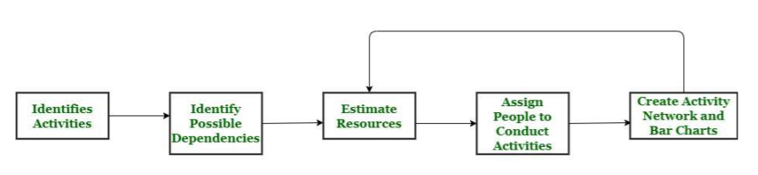

While scheduling project, the manager needs to estimate time and resources of project. All activities in project must be arranged in a sequence that means activities should be organized in such a manner that it is easy to understand.

The total work is separated or divided into various small activities or tasks during project schedule. Then, Project manager will decide time required for each activity or task to get completed. Even some activities are conducted and performed in parallel for effective performance. The project manager should be aware of fact that each stage of project is not problem-free.

**Advantages of Project Scheduling:**

There are several advantages provided by project scheduling in Project management are

* It ensures that everyone remains on same page as far as tasks get completed, dependencies, and deadlines.
* It helps in identifying issues early and concerns such as lack or unavailability of resources.
* It also helps to identify relationships and to monitor process.
* It provides effective budget management and risk mitigation.

**Basic Principles:**

The following are the basic principles of software project scheduling.

* **Compartmentalization:** The project must be compartmentalized into a number of manageable activities and tasks. To accomplish compartmentalization, both the product and the process are refined.
* **Interdependency:** The interdependency of each compartmentalized activity or task must be determined. Some tasks must occur in sequence, while others can occur in parallel. Some activities cannot commence until the work product produced by another is available. Other activities can occur independently.
* **Time allocation:** Each task to be scheduled must be allocated some number of work units such as person-days of effort. Each task must be assigned a start date and a completion date that are a function of the interdependencies and whether work will be conducted on a fulltime or part-time basis.
* **Effort validation**: Every project has a defined number of people in the software team. As time allocation occurs, you must ensure that no more than the allocated number of people has been scheduled at any given time.
* **Defined responsibilities**: Every task that is scheduled should be assigned to a specific team member.
* **Defined outcomes:** Every task that is scheduled should have a defined outcome. For software projects, the outcome is normally a work product such as the design of a component or a part of a work product. Work products are often combined in deliverables.
* **Defined milestones**: Every task or group of tasks should be associated with a project milestone. A milestone is accomplished when one or more work products has been reviewed for quality and has been approved.
* Each of these principles is applied as the project schedule evolves.

**Task set of the project:**

A task set is a collection of software engineering work tasks, milestones, work products, and quality assurance filters that must be accomplished to complete a particular project. The task set must provide enough discipline to achieve high software quality. But, at the same time, it must not burden the project team with unnecessary work.

In order to develop a project schedule, a task set must be distributed on the project time line. The task set will vary depending upon the project type.

**Gantt Chart:**

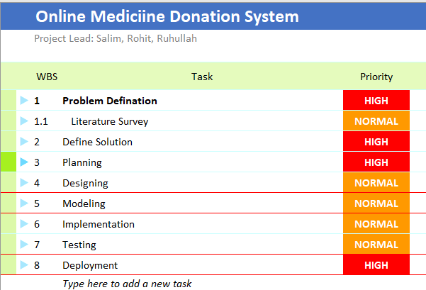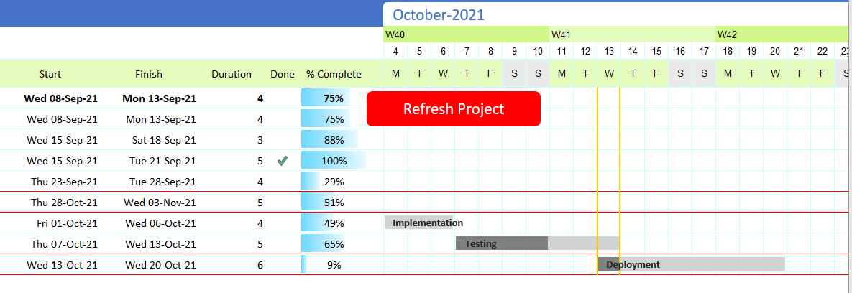

**Conclusion:** After successful completion of this lab, the students will be able to Schedule and track progress of their project with the help of Gantt chart.