Winconv version 3 user guide
This application converts measurements
The next generation of converting tool
Ralf Ballis
IT-Service & Softwareentwicklung
Ralf Ballis
Grafstrasse 6
82008 Unterhaching
Germany
Phone: +49 (0)089 / 611 00 137
Fax: +49 (0)089 / 611 00 138
E-Mail: Ralf.Ballis@mnet-mail.de
Introduction:

This application converts measurements. Ok, in this world exists a lot of tolls this kind but the special thing on this kind is that the user can make a configuration what and how to convert it. This can be done by modifying the XML file located at the application folder. It is also possible to set a XML equation file by start parameters of this application located local or remote.

Installation:

For a proper installation you get two files, the setup.exe and the winconv.msi for installation. Execute the file setup.exe with system permissions to install, now follow the instructions.

After a proper installation you get on your desktop a linked icon to the “Windows Converter” application and a new “Windows Converter” group at your Windows Start menu with a linkage to this user guide and another to the “Windows Converter” application.

Now execute this program and you will see what you get:
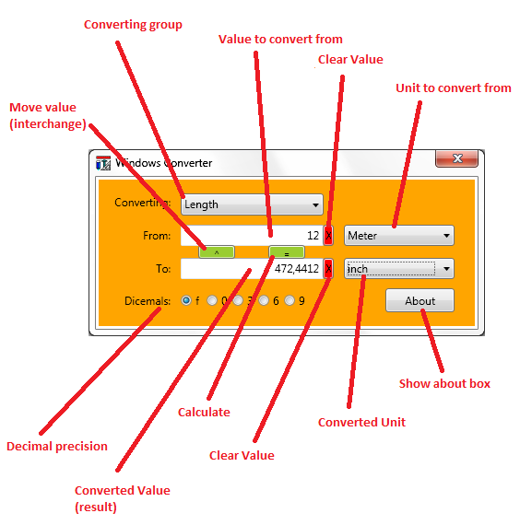
About box:
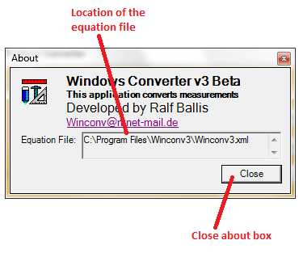
Start application:

Winconv3.exe

or:

Winconv3.exe –equationfile [equation file]

Application parameters:

The application could execute with an argument parameter:

-equationfile a location from where the equation file should readed.

Without pasing this argument, the equation file is readed from the programm folder where the applcation is installed and located.

Examples:

Equation file shuld read from the default application folder where this application is installed:

Winconv3.exe

The equation file should read from the named “Users” folder:

Winconv3.exe –equationfile C:\Users\Winconv3.xml

The equation file should read remotely from a specified URL:

Winconv3.exe –equationfile http://rballis.dyndns.org/dl2mrb/Winconv3.xml
Equation file:

Check by using the “About” box where your equation file is located at your computer.
With this Program comes a default equation file, which has included the most common measurements (units) to convert like:

- Length
- Area
- Volume
- Speed
- Mass
- Pressure
- Strength
- Performance
- Temperature

The equation file is a structured XML file. Open this file by using an edit or the notepad application:
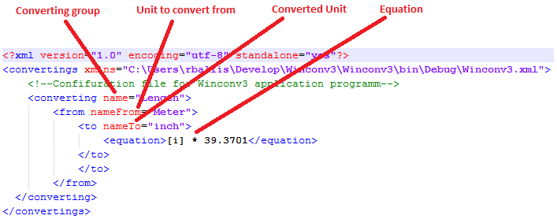
All elements with a value have a starting and end tag. There is no need to explain the Converting group, Unit to convert from and the Converted Unit tag,

The Equation tag is more complex. It could contain variables, numbers, functions and complex open and close brackets.

Variables:

Variables stands between an open and close bracket like [].

Variable: | Explication:
i | Reference to the “value to convert from” in the input field at the application GUI.

Example:

[i]
Mathematic Functions:

Function: | Explication:
+ | Addition
- | Subtraction
* | Multiplication
/ | Division
^ | Projected result
acos | Angel Co sinus
asin | Angel Sinus
atan | Angel Tangential
atan2 | Angel Tangential (Quotient)
cos | Co sinus
cosh | Hyperbolic Co sinus
exp | Exponential
flor | Human number
log | Logarithmic
log10 | Logarithmic basic to 10
sin | Sinus
sinh | Hyperbolic sinus
sqrt | Square
tan | Tangential
tanh | Hyperbolic tangential

Examples of equation tags:

This converts meter to inch:

<equation>[i] * 39.3701</equation>

This one converts inch² to meter²:

<equation>[i] * ( 0.6452 / 1000 )</equation>

And this converts Watt to dBm:

<equation>10 * ( Log10 ( [i] / 0,001 ) )</equation>

Note: It is very important to make a space between the tokens!
Using the Winconv3 application:

Start this program from the desktop icon or the start menu group.
Now chose a converting group element.
Type a value to convert in the “value to convert from” field.
Select or chose the proper unit from the “unit to convert from” field.
By select or chose a unit from the “converted unit” the application starts to convert and displays the value at the “converted value (result)” field.
It is possible to move a result to the “value to convert from” field by depress the “move value (interchange)” button.
A proper decimal precision can be selected by depressing a radio button in the “decimal precision” button field.
Calculation cam by triggered by depressing the “calculate” button at any time.

