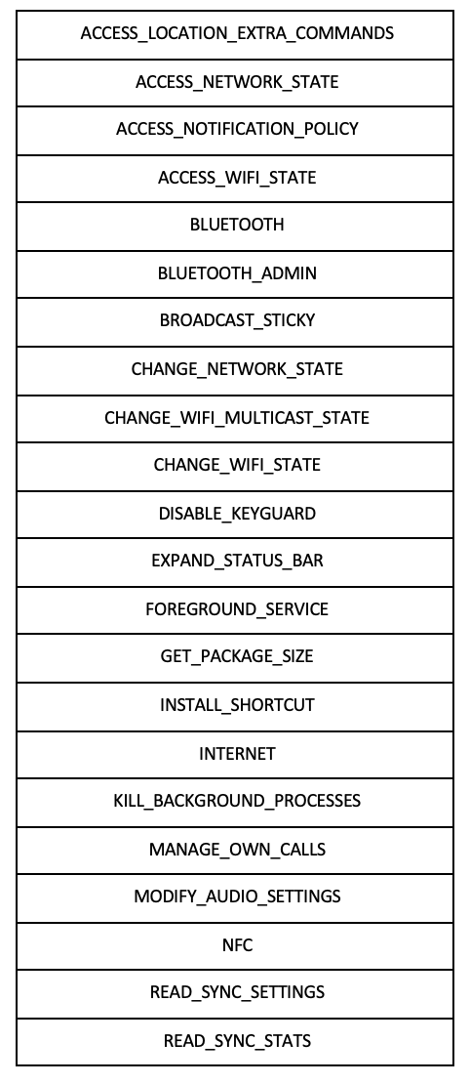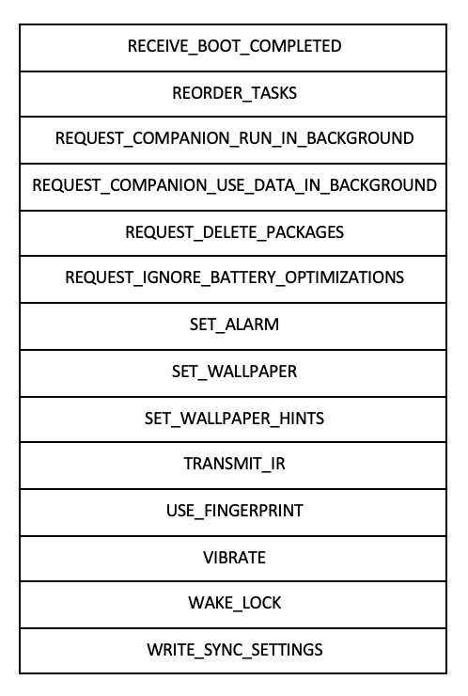



|  |  |
| --- | --- |
| **PERMISSION GROUP** | **PERMISSIONS** |
| [CALENDAR](https://developer.android.com/reference/android/Manifest.permission_group.html#CALENDAR) | [READ_CALENDAR](https://developer.android.com/reference/android/Manifest.permission.html#READ_CALENDAR) |
| [WRITE_CALENDAR](https://developer.android.com/reference/android/Manifest.permission.html#WRITE_CALENDAR) |
| [CALL_LOG](https://developer.android.com/reference/android/Manifest.permission_group#CALL_LOG) | [READ_CALL_LOG](https://developer.android.com/reference/android/Manifest.permission#READ_CALL_LOG) |
| [WRITE_CALL_LOG](https://developer.android.com/reference/android/Manifest.permission#WRITE_CALL_LOG) |
| [PROCESS_OUTGOING_CALLS](https://developer.android.com/reference/android/Manifest.permission#PROCESS_OUTGOING_CALLS) |
| [CAMERA](https://developer.android.com/reference/android/Manifest.permission_group.html#CAMERA) | [CAMERA](https://developer.android.com/reference/android/Manifest.permission.html#CAMERA) |
| [CONTACTS](https://developer.android.com/reference/android/Manifest.permission_group.html#CONTACTS) | [READ_CONTACTS](https://developer.android.com/reference/android/Manifest.permission.html#READ_CONTACTS) |
| [WRITE_CONTACTS](https://developer.android.com/reference/android/Manifest.permission.html#WRITE_CONTACTS) |
| [GET_ACCOUNTS](https://developer.android.com/reference/android/Manifest.permission.html#GET_ACCOUNTS) |
| [LOCATION](https://developer.android.com/reference/android/Manifest.permission_group.html#LOCATION) | [ACCESS_FINE_LOCATION](https://developer.android.com/reference/android/Manifest.permission.html#ACCESS_FINE_LOCATION) |
| [ACCESS_COARSE_LOCATION](https://developer.android.com/reference/android/Manifest.permission.html#ACCESS_COARSE_LOCATION) |
| [MICROPHONE](https://developer.android.com/reference/android/Manifest.permission_group.html#MICROPHONE) | [RECORD_AUDIO](https://developer.android.com/reference/android/Manifest.permission.html#RECORD_AUDIO) |
| [PHONE](https://developer.android.com/reference/android/Manifest.permission_group.html#PHONE) | [READ_PHONE_STATE](https://developer.android.com/reference/android/Manifest.permission.html#READ_PHONE_STATE) |
| [READ_PHONE_NUMBERS](https://developer.android.com/reference/android/Manifest.permission.html#READ_PHONE_NUMBERS) |
| [CALL_PHONE](https://developer.android.com/reference/android/Manifest.permission.html#CALL_PHONE) |
| [ANSWER_PHONE_CALLS](https://developer.android.com/reference/android/Manifest.permission.html#ANSWER_PHONE_CALLS) |
| [ADD_VOICEMAIL](https://developer.android.com/reference/android/Manifest.permission.html#ADD_VOICEMAIL) |
| [USE_SIP](https://developer.android.com/reference/android/Manifest.permission.html#USE_SIP) |
| [SENSORS](https://developer.android.com/reference/android/Manifest.permission_group.html#SENSORS) | [BODY_SENSORS](https://developer.android.com/reference/android/Manifest.permission.html#BODY_SENSORS) |
| [SMS](https://developer.android.com/reference/android/Manifest.permission_group.html#SMS) | [SEND_SMS](https://developer.android.com/reference/android/Manifest.permission.html#SEND_SMS) |
| [RECEIVE_SMS](https://developer.android.com/reference/android/Manifest.permission.html#RECEIVE_SMS) |
| [READ_SMS](https://developer.android.com/reference/android/Manifest.permission.html#READ_SMS) |
| [RECEIVE_WAP_PUSH](https://developer.android.com/reference/android/Manifest.permission.html#RECEIVE_WAP_PUSH) |
| [RECEIVE_MMS](https://developer.android.com/reference/android/Manifest.permission.html#RECEIVE_MMS) |
| [STORAGE](https://developer.android.com/reference/android/Manifest.permission_group.html#STORAGE) | [READ_EXTERNAL_STORAGE](https://developer.android.com/reference/android/Manifest.permission.html#READ_EXTERNAL_STORAGE) |
| [WRITE_EXTERNAL_STORAGE](https://developer.android.com/reference/android/Manifest.permission.html#WRITE_EXTERNAL_STORAGE) |