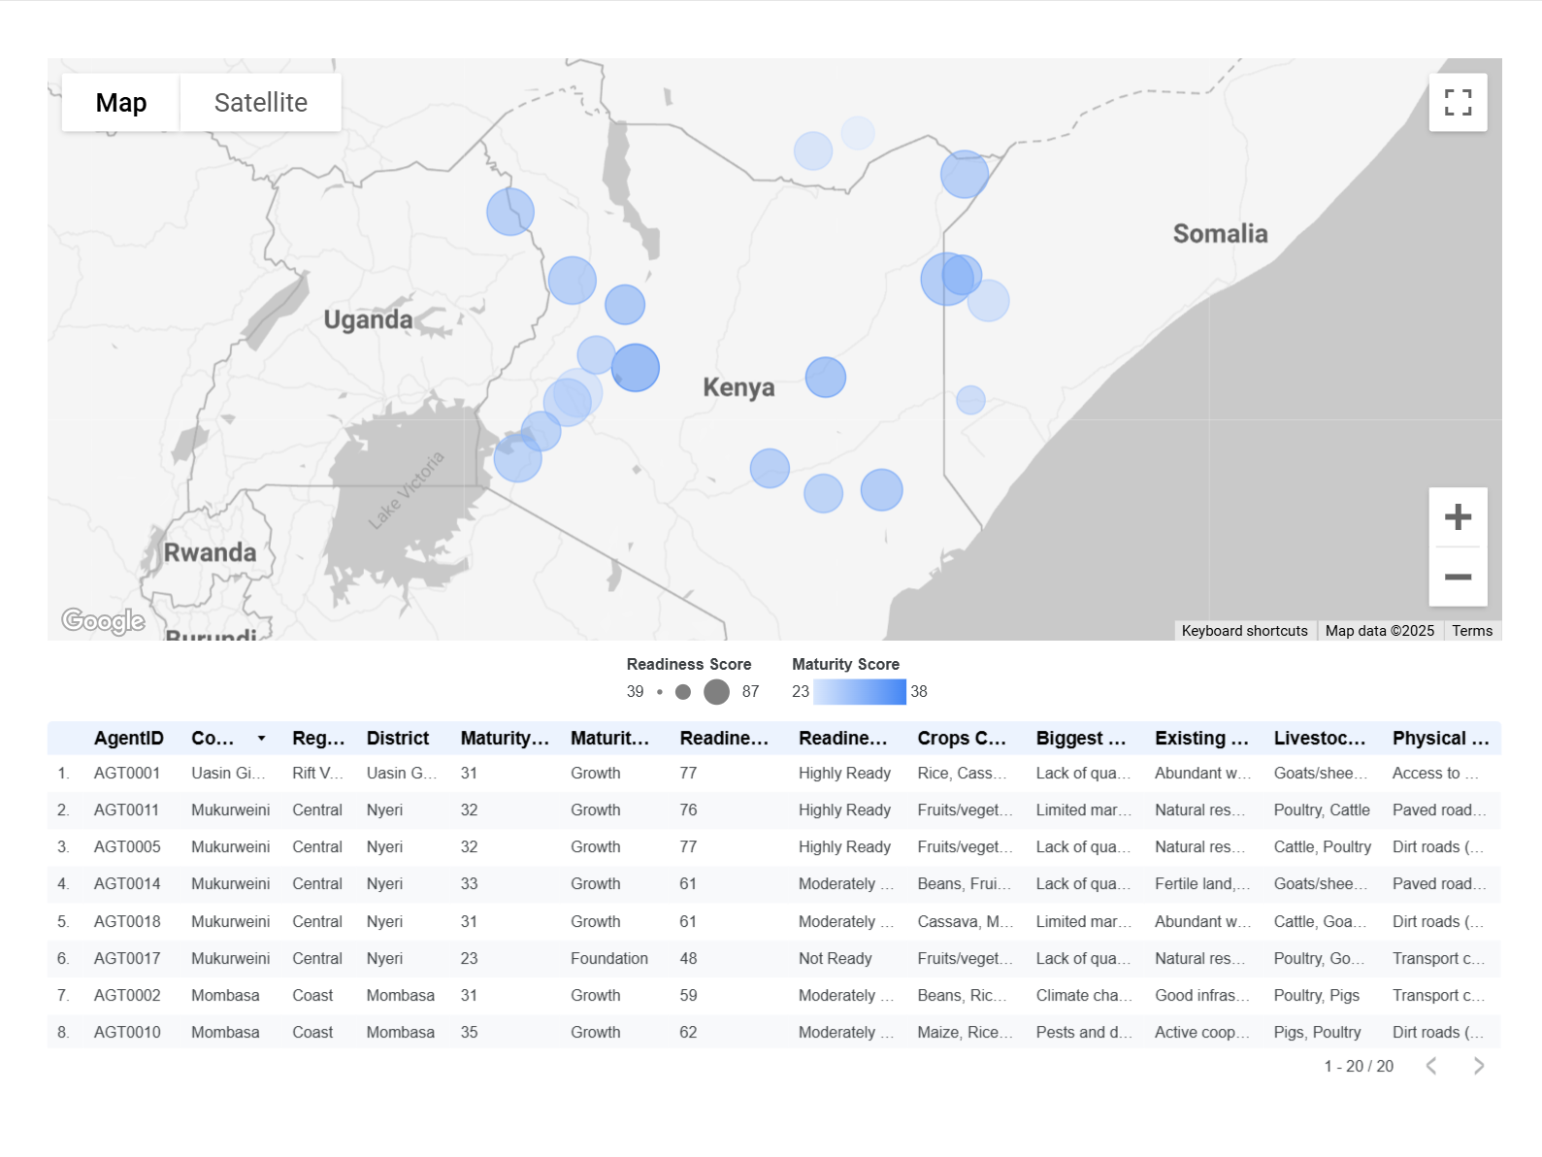

<https://lookerstudio.google.com/u/0/reporting/8ca44803-9157-475f-9132-665546ccf4c3/page/o52HF>