Riley Barrow

Blackwell Electronics – Course 2 / Task 4

**Market Basket Analysis – A Study of Electronindex Item Association and Potential Acquisition**

I performed a study on a list of 9835 transactions from Electronindex to identify item associations and determine if an acquisition would be beneficial for Blackwell.

In my study, I analyzed the transactions using the Apriori algorithm which helps identify patterns between items and their associated transactions. After much testing and changing specific parameters within the model, I identified 40 associations rules with the most statistically interesting insights. The basic parameters I used were support = 0.0015 and confidence of 0.85. This means that the items within the 40 rules all appear roughly 150 times within the entire transaction data set and the rules have at least an 85% probability of correctly determining the resulting item (RHS) based on the items in the transaction (LHS). Below are the rules plotted by support and confidence. Lift is also a parameter illustrated showing how often the rule under question would happen, then if it did simply happen by chance. The higher the lift generally means the stronger the rule. 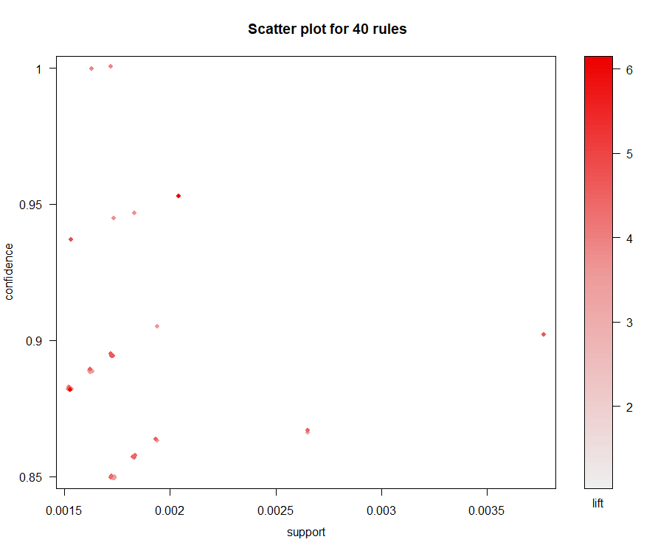

The 40 rules yielded insights into 4 products: HP Laptop, iMac, Apple MacBook Air, Lenovo Desktop Computer. Of these 40 rules either the HP Laptop or the iMac was the result 38 times, leaving just the Apple MacBook Air and Lenovo Desktop Computer to appear just once each.

Below is a more inclusive illustration of the items in the transaction (LHS) and the item that was discovered using the algorithm (RHS). Where the arrow ends, shows the resulting item (RHS), notice how there is just one arrow for Lenovo Desktop Computer and Apple MacBook Air. At each point of the arrow on the position (x-value) shows which items where included in the LHS of the itemset. 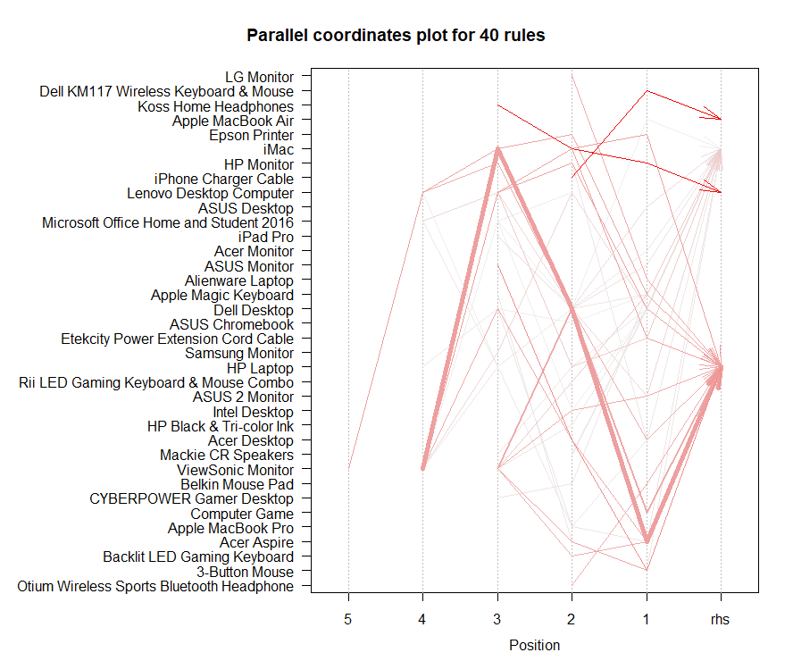

Below are the 10 rules sorted by the highest lift. One interesting thing to note is that the two outliers, Apple MacBook Air and Lenovo Desktop Computer, have the highest lift followed by the HP Laptop. The iMac item actually has the lowest 23 rules in terms of lift of the 40 total rules.



A few things I have considered based on these insights. It appears that a lot of these transactions seem business related. The expensive machines and accessories sold accompanying them make it seem like these transactions were made for a business setting rather than for a personal consumer. These results had me wondering, what are the percentage of transactions at Blackwell that are business related? Below is a grouped-rules visual to further help identify grouped item sets and the product insights they reveal. 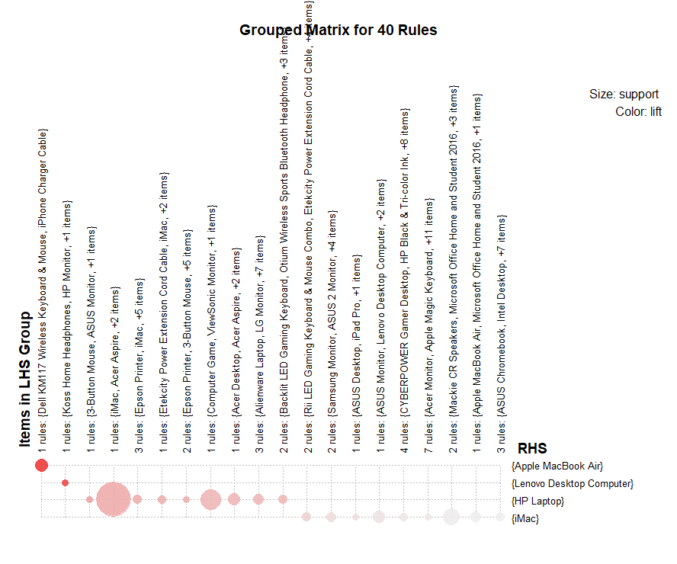

One other thing to consider when analyzing the Electronindex item portfolio is that they do not carry Sony products. In a previous report I successfully concluded that Blackwell customers prefer Sony over Acer products when compared side by side. Electronindex carries many Acer products. It is hard to determine what the Blackwell consumer brand preference would have been if we were able to compare more brands, but, knowing that Blackwell customers prefer Sony over Acer does not particularly reflect well on the current item offerings the Electronindex portfolio presents.

One recommendation I would have would be to perform a more complete brand preference study both on Blackwell and Electronindex customers and compare. I think this would help alleviate some uncertainties around the available items and help document how the customers would react to the potential merger. Furthermore, I would strongly advise Blackwell to gain insights into whether the majority of the transactions are going to businesses or individual consumers. This is an important step in evaluating the merger in my opinion. If Electronindex is primarily a business retailer like I suspect, it would take some new marketing efforts to effectively transition over to Blackwell. This would include re-branding efforts to more corporate clients.