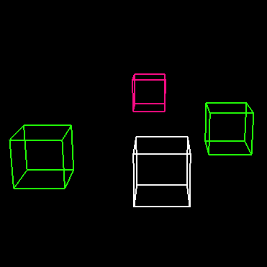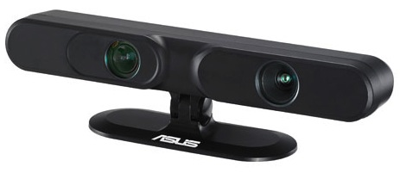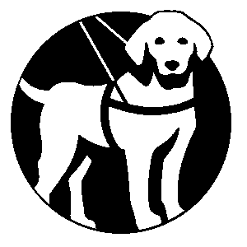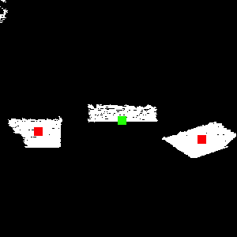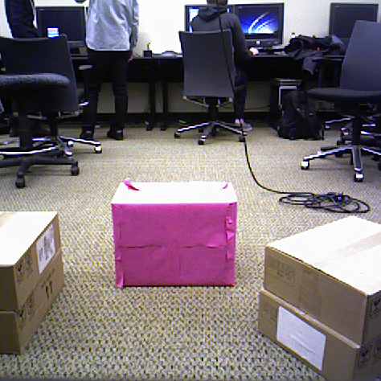

**Destination Detection**

Guide Dog is able to detect and determine the location of bright-colored destination objects. It does so by looking for large contiguous regions that share the color of the destination object. We take advantage of OpenCV blob detection in order to more reliably detect contiguous regions of color, which allows the system to tolerate a wider range of lighting conditions.

**Obstacle Detection**

To detect obstacles, Guide Dog first figures out what part of the image is the floor. It then removes the floor from the image leaving only the obstacles. An OpenCV blob detection algorithm is run on the remaining image to group each obstacle together. Guide Dog then detects the closest obstacles and passes them off to the audio interface.

**Audio Interface**

The audio interface uses the OpenAL library to communicate the relative direction of objects. The wrapper plays a sound for each object to convey whether the object is in front, to the left, or to the right of the user. The destination is communicated using a beacon played at a constant interval. Obstacles are alerted to the user when the user gets too close. As the user gets closer to a tracked object, the pitch of the sound increases. A virtual simulator (shown above) was created to test these features.

## Technical

Department of Computer Science  
CSE 481 O, Autumn 2012

http://rbart.github.com/guide-dog/

University of Washington

Rob Bart, Minh Nguyen, Eric Spishak

Guide Dog

Images: three different perspectives of the same view.

*Left top*: The color view.

*Left bottom*: Destination detection view.

*Right*: Top down view. Destination is marked by green dot, obstacles by red dots.

### Details

Guide Dog is built using an ASUS Xtion camera. This is an RGB-D camera, the same type of camera that the Microsoft Kinect uses. It allows the system to not only use color, but also depth information to see the surroundings and detect objects.

Guide Dog takes advantage of the open source libraries such as OpenNI, Point Cloud Library (PCL), and OpenCV to process the data it receiver from the camera. The system runs on any computer with Ubuntu Linux.

Guide Dog is split into three parts:

* **Destination detection**: locates the destination in the image and communicates this location to the audio interface
* **Obstacle detection**: locates all of the obstacles in view and communicates the locations to the audio interface
* **Audio interface**: takes the locations it receives and communicates them via audio to the user.

**Guide Dog** is an application to provide indoor guidance for the visually impaired. The goal is to use audio to guide a user to a destination, while keeping them away from obstacles. Guide Dog could be used to guide a visually impaired person through a room to the door. Or it could be used to guide someone through a dark room.

# Overview