BREAKFAST SPECIALTIES

**The Strawboss** – $6.99

Fried Potatoes or Hash Browns Cooked with Grilled Onions & Peppers, Mixed with Cheese & Ham with Sausage Gravy on the side and choice of Toast

**Hired Hand** – $3.35

One Egg, Cheese, and Choice of Bacon, Ham, or Sausage Patty served on an English Muffin

**Shirley’s Breaded Western Steak** – $7.65

Breaded Steak, Eggs, Gravy, Choice of Potato & Toast

\***Steak & Eggs** – $9.65

6 oz. Steak, 2 Eggs, Choice of Potato & Toast

**The Drover** – $5.55

Hash Browns or American Fries covered with Sausage Gravy

**Breakfast Burrito** – $4.35

Egg, Sausage, Onion, Green Peppers, & Cheese served in Tortilla Shell smothered in Gravy

**3 Glazed Cinnamon Roll Pancakes** – $6.35

Choice of ½ meat

**Bananza** – $6.45

3 Slices of Banana Bread French Toast w/Bananas, Strawberries covered in Whipped Cream

**The Chuckwagon Omelet** - $6.95

4 Eggs, Ham, Cheese, Onion, Green Peppers & Hash Browns Topped with Sausage Gravy

**3 Apple Pie Pancakes** - $6.35  
Choice of ½ Meat

**BREAKFAST SERVED ALL DAY**

C:\Users\owner\AppData\Local\Microsoft\Windows\Temporary Internet Files\Content.IE5\SNP73IJM\MC900151213[1].wmf

**FROM THE GRIDDLE FLAP JACKS**

1 Flap Jack $2.65  
2 Flap Jacks $3.95  
Blueberry/Sausage - add $0.55 each

**WOW Waffle** $3.95

½ Order - $2.95 Add Fruit for - $1.50

**French Toast**

1 French Toast $2.45  
2 French Toast $3.95  
 Prairie Toast - Add $0.75  
(Made With Homemade Cinnamon Bread)

BREAKFAST ON THE LITE SIDE   
 (Served from 6am-11am only)   
1 Egg & 1 Slice Toast & ½ Meat $3.35  
2-Silver Dollar Flap Jack½ Meat $3.35  
 (Served Monday through Friday only)

SHIRLEY’S BREAKFAST PIZZA  
Sausage Gravy, 1 Scrambled Egg and Cheese Served on a 6” Tortilla Shell $4.95  
 (Additional items each - $0.50)

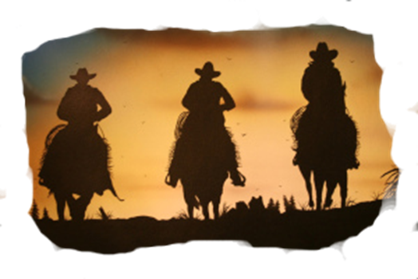

*EGGS ANY STYLE  
 Served with Choice of Toast  
 1Egg $1.99  
 1 Egg & Meat $3.95  
 2 Eggs $2.99  
 2 Eggs & Meat $4.55  
 2 Eggs & Corned Beef Hash $5.65  
  
BUILD YOUR OWN OMELET’S  
 Served with Choice of Toast  
Omelets 2 Eggs 3 Eggs

Cheese $3.25 $4.55  
Meat Additions - $0.65

(Ham, Sausage, Bacon)   
Vegetables Additions - $0.35  
 (Tomato, Green Peppers, Onions, Mushrooms)   
  
OUR FAMOUS BISCUITS AND GRAVY  
Biscuits & Gravy $4.95  
 ½ order $3.95

Beverages  
Coffee, Hot Tea, or Iced Tea $1.25  
Specialty Teas Available $1.45  
Soda Pop $1.50  
Juice Sm $0.95 / Lg $1.45  
 (Orange, Apple or Tomato)  
Hot Cocoa $1.25  
Milk Sm.$0.95 / Lg $1.45  
 (White / Chocolate)  
Lemonade $1.50

SIDE ORDERS  
**Biscuits** $1.25  
**Toast** $1.35  
White, Wheat, Texas, Rye

Homemade

White, Wheat, (Cinnamon), Raisin, English Muffin  
**Bagel**  
 Plain Toasted $1.55  
 Cream Cheese add $0.75  
**Meat**  
Bacon, Ham, Sausage Patties or Links $2.65  
Corned Beef Hash only $3.99  
 ½ order $3.29  
Cup of Sausage Gravy $2.75  
Oatmeal   
 Served w/ Milk & Brown Sugar $2.95  
 ½ order $2.50  
Grits $2.95  
 ½ order $2.50  
 (Pecans, Walnuts or Raisins) add 0.75

* Choice of Potato *1.95 Baked When Available

Hash Browns,

American Fries

Mashed / French Fries.  
(Brew Fries additional $.50)

*NOTICE we will cook your eggs or meat to order, although consuming raw or undercooked eggs or meat may increase your risk of foodborne illness.