PTP Architecture Time Synchronization Test

Test Objective and Expected Results
Using two AX88279 devices to execute the PTP time-synchronization function:
Device_1 Use the AX88279 as the PTP master.
Device_2 Configure the AX88279 as a PTP slave and follow the grandmaster’s time corrections.

Test Equipment
Linux Platform * 2
AX88279 *2
Oscilloscope *1
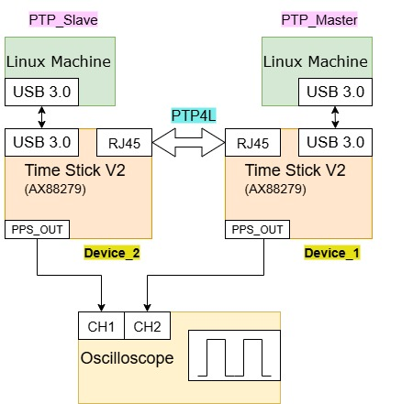

Environment Configuration

3.1 PTP Master setting
Build The Driver
- Open the asix_usb_nic_linux_driver_v3.5.16.
- Extract the source code from the compressed file.
$ tar -xf asix_usb_nic_linux_driver_v3.5.16.zip
- Edit the Makefile and enable PTP
ENABLE_PTP_FUNC = y // The PTP_FUNC flag must be enabled.
- In a terminal, navigate to the driver source code folder.
- From within the driver source code folder, build the driver
$ make

Running the Driver
- Install the driver if you’d like to use the modprobe command to mount the driver.
$ sudo make install
- To load the driver by modprobe command
$ sudo modprobe ax_usb_nic
- To unload the driver by modprobe command
$ sudo modprobe -r ax_usb_nic
- To check driver information
$ modinfo ax_usb_nic

Remove the driver and cdc_ncm
$ sudo modprobe -r ax_usb_nic
$ sudo rmmod cdc_mbim
$ sudo rmmod cdc_ncm
$ sudo rmmod ax88179_178a
Run the driver
$ sudo modprobe ax_usb_nic

// After the parameters are configured, connect the network cable and verify the network connectivity.
The DUT runs PTP4L and configured as the PTP master.
$ sudo ip addr add 192.168.200.2/24 dev [interface name]
$ sudo ip link set [interface name] up
$ ip addr show [interface name]
// Add an option to specify the interface!
$ ping 192.168.200.1
$ sudo ptp4l -i [interface name] -m -H --masterOnly 1 --priority1 100

3.3 PTP slave
The driver configuration is the same as in Section 3.1.

// After the parameters are configured, connect the network cable and verify the network connectivity.
The DUT runs PTP4L and configured as the PTP Salve.
$ sudo ip addr add 192.168.200.1/24 dev [interface name]
$ sudo ip link set [interface name]up
$ ip addr show [interface name]
// Add an option to specify the interface!
$ ping 192.168.200.2
$ sudo ptp4l -i [interface name]-m -H --slaveOnly 1

Check whether the PPS out of Device_1 and the PPS out of Device_2 are synchronized.