Jlaja Pandora Podier

Robert Bathmann

COSC 603: Software Testing and Maintenance

Spring 2016

Project 1 Task 3 Using Eclipse and Git / GitHub Desktop for Configuration Management

**Jlaja Pandora Podier’s Experience:**

This was my first time being introduced to the GitHub tool so completing the LearnGit Course in the CodeAcademy was very helpful. Some of the units were very simple whereas others were complex and trivial to complete due to the instructions not being clear or being able to properly navigate the code window or the terminal window. As I learned the various git commands and what it takes to add source code changes to a repository the exercise began to remind me of the execution of various LINUX/UNIX OS commands and command line commands. I was able to complete the course in code academy.

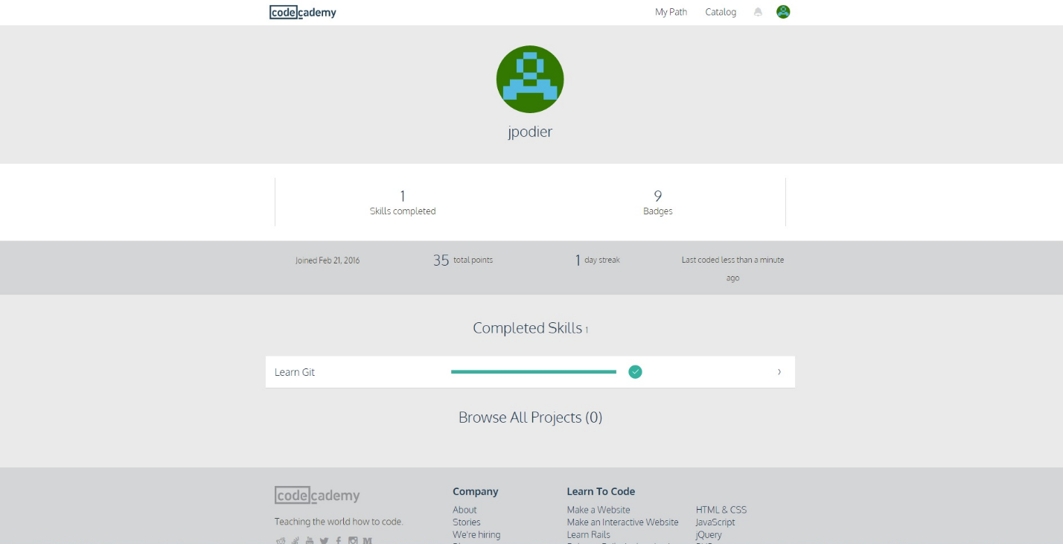

As I began trying to develop a structure to reengineer the program, I faced many challenges with syncing the GitHub repository to my Eclipse Jave EE IDE as every time I would set the workspace the Project Explorer would come up empty. I turned to YouTube videos and other peers in the class to troubleshoot my issues after the alternative workarounds did not work. After some frustration, I decided to uninstall and try reinstalling. It did not resolve all my issues but it alleviated some. It will take some time and practice to become familiar with utilizing GitHub and all its commands with the Eclipse as these tools are new to me.

**Robert Bathmann’s Experience:**

I have familiarity with using configuration management tools including CVS and Subversion. I read the Git Book a while back, but I hadn’t actually used Git in a project so I was unfamiliar with the names of commands. The CodeAcademy Git course was helpful, but a reference card with the most common commands would have worked well too. Since I have a lot of experience with Subversion, it would have also been helpful to see an explanation of key differences.

