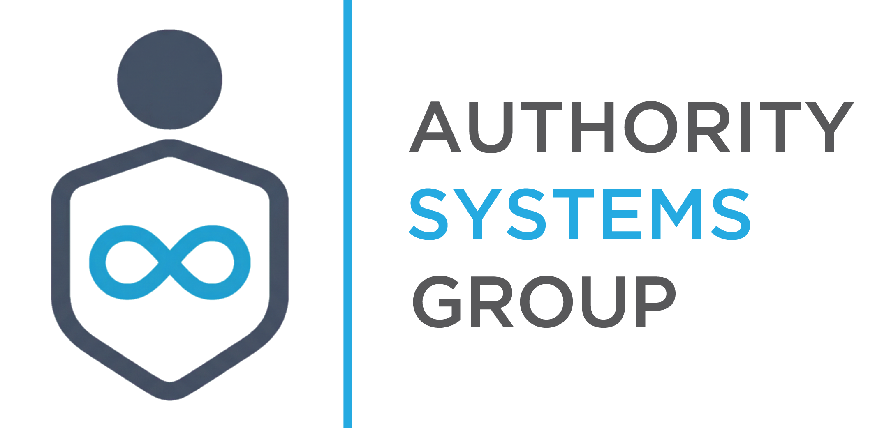
Positioning You As The Authority

Target Niche Analysis
Top 20 Recommended Markets for ASG Expansion

Internal Reference | Authority Systems Group™ | March 2026
DIRECTOR USE ONLY — Roger Bauer / Authority Systems Group™

Overview & Strategic Context
This document is a permanent internal reference for Authority Systems Group™. It captures the 20 highest-priority target niches drawn from a database of 1,077 evaluated markets, filtered and ranked against ASG's acquisition model: composite score, LTV, retainer structure, serviceability, cashflow risk, and channel alignment.
All 20 niches meet the following minimum criteria:
- Composite score ≥ 9.2 / 10.0
- Lifetime value (LTV) ≥ $126,000
- Retainer payment structure
- Serviceability rating 2/5 (easy to deliver at scale)
- LOW cashflow risk under all four stress scenarios
- Primary acquisition channels: LinkedIn / Cold Email / Content (or PPC/SEO/Content for vertical marketing)

Niches already in active client engagements (law / attorney practices, business / executive coaching) are excluded from this analysis. The 20 niches below represent ASG's highest-confidence expansion targets as of March 2026.
Selection criteria prioritize professional service practitioners where the owner IS the product, trust precedes every purchasing decision, and authority content creates an asymmetric competitive advantage. These are the exact conditions where the Belief-to-Buy Framework™ dominates.

Summary Scorecard by Cluster
Cluster | Avg Composite | Avg LTV | Primary Channels | Avg Sales Cycle
Financial & Accounting | 9.51 | $136K | LinkedIn / Cold Email / Content | 45–90 days
HR & People Strategy | 9.40 | $130K | LinkedIn / Cold Email / Content | 60–75 days
Compliance & Risk | 9.42 | $132K | LinkedIn / Cold Email / Content | 60–75 days
Specialty Consulting | 9.53 | $141K | LinkedIn / Cold Email / Content | 75–90 days
Vertical Marketing | 9.60 | $149K | PPC / SEO / Content | 75–90 days

Cluster 1 — Financial & Accounting Advisory
High-trust practitioners. The buyer's certainty about the person IS the sale.
These practitioners ARE the product. Trust precedes every transaction. Authority content is the dominant acquisition lever — and almost none of these consultants have one.
Niche | Composite | LTV | Deal Size | Payment | Srvc
Controller Services (Fractional) | 9.60 | $144K | $48K | Retainer | 2/5
ERISA Compliance Services | 9.60 | $144K | $48K | Retainer | 2/5
Pension Plan Administration | 9.54 | $144K | $48K | Retainer | 2/5
401(k) Plan Advisory | 9.20 | $128K | $32K | Retainer | 2/5
Retirement Planning Services | 9.20 | $128K | $32K | Retainer | 2/5

Strategic Rationale
CFOs, fractional controllers, and retirement advisors sell expertise packaged as a person. The buyer's belief about the practitioner's credibility is the entire sale. LinkedIn authority content combined with a structured belief sequence is the highest-leverage acquisition system in these markets. Most competitors are invisible on content. The gap is wide open. The Belief-to-Buy Framework maps perfectly: 'My current advisor is reactive' is the enemy belief, and a well-positioned fractional CFO with consistent authority content rewrites that belief before the first conversation happens.

Cluster 2 — HR & People Strategy Consulting
High LTV, short-to-medium sales cycles, LinkedIn-native buyers, underserved by quality marketing.
HR consultants are fighting for the same CHROs and business owners on LinkedIn with generic content. The Belief-to-Buy Framework maps directly — and the enemy belief is begging to be disrupted.
Niche | Composite | LTV | Deal Size | Payment | Srvc
Talent Management Consulting | 9.55 | $135K | $45K | Retainer | 2/5
Performance Management Consulting | 9.60 | $135K | $45K | Retainer | 2/5
HR Consulting Services | 9.19 | $126K | $42K | Retainer | 2/5
Labor Relations Consulting | 9.33 | $126K | $42K | Retainer | 2/5
Employee Relations Consulting | 9.33 | $126K | $42K | Retainer | 2/5

Strategic Rationale
HR consultants are fighting for the same CHROs and business owners on LinkedIn with nearly identical positioning. The enemy belief — 'HR consulting is reactive, compliance-focused, not strategic' — is universal and almost never challenged in their marketing. A well-positioned HR consultant with a strong content engine rewrites that belief before any competitor gets the meeting. These clients also become long-term retainers because HR challenges don't resolve — they evolve. Churn is low, LTV compounds.

Cluster 3 — Compliance & Risk Consulting
Regulatory complexity creates a credibility crisis for buyers — authority is the only safe harbor.
When the stakes are regulatory — fines, shutdowns, liability — buyers don't shop on price. They buy certainty. That's the deepest convergence point on the Belief Track.
Niche | Composite | LTV | Deal Size | Payment | Srvc
Healthcare Compliance Consulting | 9.33 | $126K | $42K | Retainer | 2/5
Food Safety Consulting | 9.33 | $126K | $42K | Retainer | 2/5
Energy Procurement Consulting | 9.60 | $144K | $48K | Retainer | 2/5

Strategic Rationale
When regulatory consequences are on the table — OCR audits, FDA violations, energy contract penalties — buyers make decisions based on perceived safety, not price comparison. A compliance consultant with a visible, expert content presence is the obvious safe choice. A consultant with no content presence is invisible and indistinguishable from the next firm. These markets respond exceptionally well to the Belief-to-Buy Framework because the emotional track — Dissatisfaction → Contrast → Desire → Urgency → Relief — is already primed. We just have to show up as the relief.

Cluster 4 — Specialty Consulting
Niche expertise commanding premium retainers. Authority is the only meaningful differentiator.
Buyers in these markets have almost no framework for evaluating providers — they default to whoever looks most credible. The practitioner who owns the content space owns the category.
Niche | Composite | LTV | Deal Size | Payment | Srvc
Hotel Revenue Management | 9.60 | $144K | $48K | Retainer | 2/5
Emergency Management Consulting | 9.60 | $144K | $48K | Retainer | 2/5
Rights Management Services | 9.60 | $135K | $45K | Retainer | 2/5
Supply Chain Financing | 9.32 | $144K | $48K | Retainer | 2/5

Strategic Rationale
These are hyper-specialized fields where buyers have almost no framework for evaluating providers. The hotel GM evaluating a revenue management consultant doesn't know what great looks like. The municipal director considering emergency management consulting is equally unsure. They default to whoever appears most authoritative, most credible, most certain. Almost none of these consultants have a functioning content or authority system. First-mover advantage in these niches is significant — the practitioner who builds the content presence first owns the category perception for years.

Cluster 5 — High-Trust Vertical Marketing
These businesses hire external marketing firms. ASG IS the firm they need.
These verticals spend heavily on marketing but are flooded with generalist agencies. Niche specificity IS credibility — and the highest deal sizes on this list reflect that.
Niche | Composite | LTV | Deal Size | Payment | Srvc
Fertility Clinic Marketing | 9.60 | $135K | $45K | Retainer | 2/5
Custom Home Builder Marketing | 9.60 | $156K | $52K | Retainer | 2/5
Luxury Auto Dealership Marketing | 9.60 | $156K | $52K | Retainer | 2/5

Strategic Rationale
Fertility clinics, custom home builders, and luxury auto dealerships all share a common challenge: they spend heavily on marketing but rarely find an agency that speaks their specific language. A generalist digital agency pitching a fertility clinic sounds exactly like every other agency. An ASG engagement that leads with deep niche knowledge, patient acquisition expertise, and authority positioning wins the room immediately. These also carry the highest deal sizes and LTVs in this entire analysis. Cluster 5 should be treated as a dedicated prospecting lane with tailored positioning for each vertical.

Roger's Read — Priority & Next Steps
The highest-confidence immediate targets are Clusters 1 and 2 — Financial & Accounting Advisory and HR & People Strategy Consulting. Both are LinkedIn-native, authority-starved, and the full ASG deliverable stack maps directly to how they acquire clients. Prospecting campaigns can launch with existing infrastructure.
The compliance cluster (Cluster 3) is slightly longer cycle but commands premium retainers and near-zero churn once embedded. Healthcare Compliance and Energy Procurement are the two strongest entries in this group — both have clear enemy beliefs and regulatory urgency that accelerates the emotional track.
Cluster 5 (Vertical Marketing) deserves a dedicated prospecting lane. Deal sizes are the highest across all 20 niches, buyers are active marketing spenders, and the niche-specialization story writes itself. Custom Home Builder Marketing and Luxury Auto Dealership Marketing both carry $156K LTV with 9.60 composite scores.
Recommended first move: Activate a Cold Email + LinkedIn outreach sequence targeting Fractional Controller and Performance Management Consulting prospects. Both have 60-day sales cycles, $135K–$144K LTV, and retainer structures that feed ASG's recurring revenue base immediately.

This document should be consulted whenever:
- Evaluating a new prospecting campaign target
- Assessing whether an inbound inquiry fits the ASG expansion model
- Selecting the next vertical for a Dopamine Ladder or Dream 100 build-out
- Briefing Daniel Frost or Tanya Blackwood on new market opportunities
- Comparing ROI potential across expansion options

Reviewed and approved for use as an ongoing reference document.
Roger Bauer, Director — Authority Systems Group™

