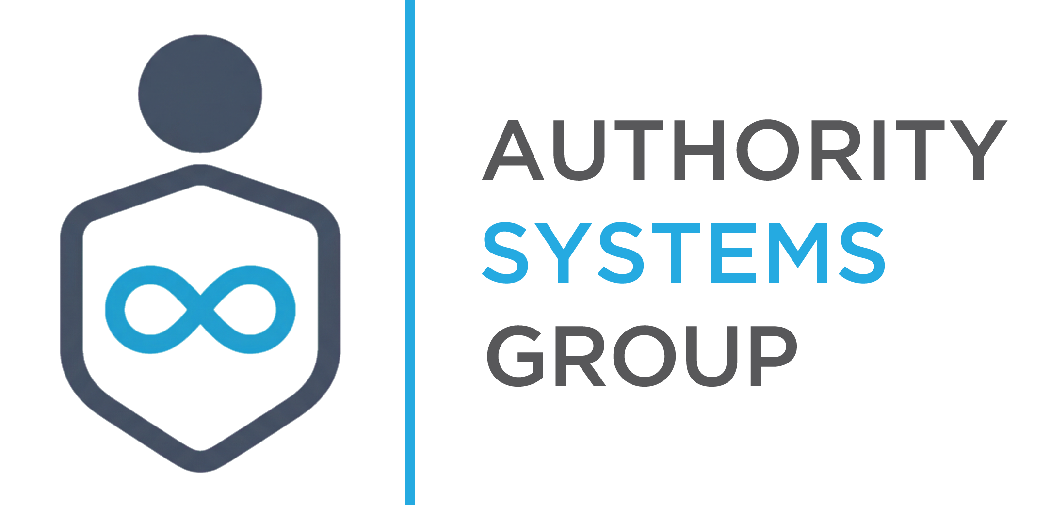
Positioning You As The Authority

ColdOutreachEngine.com
Internal Strategic Assessment

Directed by Roger Bauer | Authority Systems Group™
March 8, 2026

INTERNAL USE ONLY — NOT FOR CLIENT DISTRIBUTION

Background & Context
ColdOutreachEngine.com is an internal ASG business concept under evaluation by Roger Bauer. The following assessment was produced by the ASG leadership team following a review of the domain, the service model, and the existing one-page website built by Manus.

The Service Model
ColdOutreachEngine.com is a done-for-you cold email infrastructure and managed outreach service for B2B consultants, agencies, and service businesses. The model operates as follows:
- ASG builds dedicated sending infrastructure for each client (15+ domains, 30+ inboxes, private SMTP server)
- ASG manages ongoing campaign operations — outreach, response handling, meeting booking — on the client's behalf
- Approximately 80% of the process is automated through n8n or Make; human oversight handles the remaining 20%
- AI voice agents and outbound calling represent a Phase 2 automation layer — not in scope for the initial launch
- Affiliate revenue from platform tools (Instantly, Smartlead, etc.) provides a secondary passive income stream on top of client retainers

The Website
A one-page site was produced at predeploy-9b557dfd-coldoutreach-vn9kqlg8-jqsdyamlhrxq2ts8nbapu4.manus.space. The site positions Cold Outreach Engine as a premium done-for-you client acquisition system with a "5 qualified sales meetings in 90 days" pipeline guarantee. Pricing is not disclosed on the page; all traffic is routed to a free strategy call CTA.

STATUS: Backburner — Project is on hold pending development of case studies from LGD and DMA engagements. No active client acquisition for this service until proof-of-concept is established.

Leadership Team Assessment
Daniel Frost — Chief Strategy Officer
Strategic Positioning
This is a strong complementary play, not a standalone business. The strategic value is not in the service itself — it is in what cold email funds and feeds. ASG is creating a client acquisition engine, then offering it as a productized service. That is a defensible position.
The positioning risk: "cold email infrastructure" sounds commodity. Every freelancer on Upwork does setup. The differentiation must be that ASG clients receive a revenue-producing system, not a configured inbox. The current website copy is closer to the commodity frame.
The real moat is the affiliate stack and the proprietary sending infrastructure. If ASG goes deep on 2-3 tool relationships rather than remaining platform-agnostic, this creates a technical moat most competitors cannot replicate. The infrastructure story — private SMTP server, dedicated domain pools, warmup protocols — is the differentiator. Lean into it.
Strategic priority: Rename "cold email infrastructure" in all positioning. The offer is a revenue-producing client acquisition system. The infrastructure is proof, not the product.
— Daniel Frost, CSO | Authority Systems Group™

Vivienne Carr — Chief Marketing Officer
Copy & Messaging Review
The headline lands: "Double Your Qualified Sales Meetings in 90 Days Without Wasting a Single Minute on Prospecting" is outcome-first, time-bound, and specific. The problem section is well-written — the "trapped in the prospecting grind" frame resonates with the B2B consultant avatar.
Where the copy loses traction: by the middle of the page it defaults to generic agency language. "Battle-tested process." "B2B growth architects." "Value-driven email sequences designed to start conversations, not just send messages." These phrases appear on a thousand competitor pages. There is no proprietary language, no distinctive point of view, nothing that makes Cold Outreach Engine sound built by people with a specific philosophy.
"Trusted by B2B Growth Leaders" with no testimonials, names, or logos underneath is a credibility hole, not a credibility builder. The animated stat counters displaying "0+" in the live site are a technical bug that must be resolved before any marketing drives traffic to the page.
- Name the frameworks — give the process proprietary language
- Replace generic phrases with position-taking statements
- Fix the broken counter animations immediately
- Remove or replace social proof claims until real client results exist
— Vivienne Carr, CMO | Authority Systems Group™

Tanya Blackwood — Chief Revenue Officer
Revenue Model & Offer Structure
The model architecture is sound. The setup fee converts the initial sale. Affiliate commissions build a passive income layer that compounds as the client base grows. The value stack on the pricing page is well-constructed — breaking out component values totaling $11,000/month is a classic anchoring move, and the pipeline guarantee is strong.
The missing piece is a retention mechanism. Currently, once setup is complete, client continuity depends on the retainer relationship holding. A light-touch managed service tier — monthly deliverability monitoring, domain rotation, list hygiene consulting — creates a reason to remain engaged and an insurance policy on the affiliate trail.
The CTA is weak. "Book Your Free Strategy Call" is generic. Given the scarcity angle referenced in the FAQ ("limited new clients per month"), the CTA should reinforce that constraint: "Claim Your Spot — We Only Take 8 New Clients Per Month" converts urgency into action.
Fast Cash Opportunity: If Roger has 5 existing ASG clients not currently running cold outreach, that is a $5,000–$15,000 setup week with minimal overhead and zero new marketing required.
— Tanya Blackwood, CRO | Authority Systems Group™

Iris Nolan — Chief Technology Officer
Automation Architecture
80% automation is achievable and realistic for this service model. The split between automated and human-handled tasks is well-defined once the client intake SOP is standardized.
Automatable via n8n or Make:
- Infrastructure provisioning triggers (domain purchase workflow, DNS config, mailbox setup notifications)
- Contact list processing and verification
- Campaign launch sequencing and scheduling
- Response classification: interested / not interested / out of office / unsubscribe
- Meeting booking handoff once a positive reply is detected
- Monthly reporting compilation and client Slack notifications
Requires human review (the 20%):
- Initial ICP definition and strategy per client
- Email sequence writing (AI drafts, human approves)
- Positive replies that do not fit the standard booking flow
- Edge cases: angry responses, legal threats, domain blacklisting incidents
The AI voice agent and outbound calling layer is correctly parked for Phase 2. Get the email automation running cleanly first — that is a complete build on its own. n8n is the preferred platform for self-hosted control; Make is faster if the goal is getting something live within a week.
Critical dependency: a client portal or structured Airtable tracker is required to maintain affiliate attribution per client. That audit trail is the revenue record.
Architecture note: Standardize the client intake form tightly before building automation. The quality of automation output is directly proportional to the quality of intake data.
— Iris Nolan, CTO | Authority Systems Group™

James Whitfield III — Board, Revenue Architecture
Pricing Strategy & Unit Economics
With 80% automation, cost-to-serve drops significantly. The unit economics at standard pricing are attractive:
- Setup fee: $1,500–$2,500 (one-time, covers infrastructure build and initial sequence writing)
- Monthly retainer: $1,500–$2,500/month (sending infrastructure, list procurement, automated management, human oversight)
- Hard costs per client: ~$300–$500/month (tools, SMTP, list data, contractor time for the 20%)
- Gross margin per active client: 70–80%
At 20 active clients: $30,000–$50,000/month in retainer revenue with $24,000–$40,000 gross margin. At 50 clients on a light managed plan, this becomes a mid-five-figure annual passive revenue stream requiring almost no new selling.
Pricing guidance: Do not undercharge the setup fee to drive volume. The affiliate tail is only valuable if the client is well-configured and succeeds — which requires margin in the setup to execute correctly. Below $1,500 and corners get cut or money gets lost on labor.
The affiliate passive income stream is now secondary. The retainer is the primary revenue engine. Build pricing around the retainer and treat affiliate commissions as found money.
— James Whitfield III, Board — Revenue Architecture | Authority Systems Group™

Sofia Vega — Board, Operational Feasibility
Operational Readiness
The model is feasible at scale. The primary concern is the transition period: the first 3–5 clients before automation is fully operational will be onboarded manually or semi-manually. Roger is the system during that window. That is not a disqualifier — it is the standard path for this type of build — but it should be planned for explicitly.
Recommended sequencing:
- Sell 2–3 clients manually — use the process to document every step in granular detail
- Iris builds the automation from that SOP — not from a theoretical process
- Client 4+ onboards through the automated system
- Do not sell beyond manual handling capacity until automation is live and proven
Three questions must be answered in writing before the first client is signed: (1) What does the client receive? (2) What is the delivery timeline? (3) Where does ASG's scope end — setup only, or ongoing management? Answered clearly in the contract, these prevent the first five clients from becoming support nightmares.
The website copy is correct for the managed model. "Done-for-you" is accurate whether the process is automated or manual. The client does not need to know the delivery mechanism — only the outcome.
— Sofia Vega, Board — Operational Feasibility | Authority Systems Group™

Leadership Consensus
The Cold Outreach Engine concept is strategically sound. The managed + heavily automated model is the optimal configuration: it commands premium pricing while maintaining commodity-level labor cost, and the pipeline guarantee becomes a sales tool rather than a genuine liability once the automation is refined.
What Works
- The business model architecture — setup fee + monthly retainer + affiliate passive income
- The pipeline guarantee as a conversion mechanism
- The technical differentiation of proprietary sending infrastructure
- 80% automation target reducing cost-to-serve to 70–80% gross margin
- The one-page website structure — bones are right, copy needs sharpening
What Needs Work Before Launch
- Fix broken animated stat counters on the website immediately
- Rewrite copy to eliminate generic agency language and introduce proprietary framework names
- Replace or remove unsubstantiated social proof claims
- Strengthen the CTA with scarcity-anchored language
- Define "qualified meeting" in writing before the first client contract is signed
- Document the full manual onboarding SOP across 2–3 initial clients before building automation
- Build Airtable or equivalent tracker for affiliate attribution per client
Project Status
BACKBURNER — No active sales or marketing for ColdOutreachEngine.com until case studies are developed from LGD and DMA engagements. Case study availability is the trigger for re-activating this project. At that point, Tanya's fast cash sprint angle (closing existing ASG clients on setup service first) is the recommended Day 1 move.

Authority Systems Group™ — Confidential. Internal Use Only.

