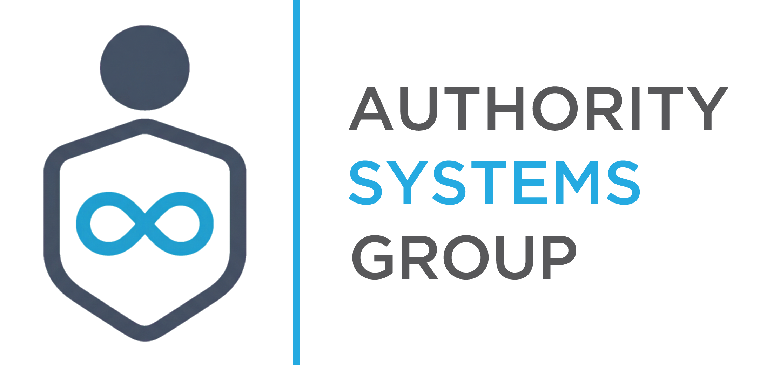
Positioning You As The Authority

LinkedIn Post — Ready to Publish
Melissa Doss Law | March 9, 2026 | Get Over It Day

Copy and paste this post directly into LinkedIn. Post today — March 9 is Get Over It Day. Use the headline as your first line. No hashtags required, but #NorthernKentucky #FamilyLaw #CollaborativeDivorce may be added at your discretion. LinkedIn profile must include your firm name and Florence, KY office address before publishing (see compliance note at end).

RECOMMENDED HEADLINE (FIRST LINE OF POST)
If someone is telling you to fight for everything in your divorce,
read this before you listen.

POST COPY — COPY FROM HERE

Today is Get Over It Day.
The irony is not lost on me.

Get Over It Day exists on one premise: holding on costs more than letting go.

I've practiced family law in Northern Kentucky for 11 years.

And I can tell you — the adversarial divorce process was not built to help you get over it.

Here's what I've watched happen, more times than I can count:

A woman enters the process being told she needs to "protect herself."
She's advised to document everything, disclose nothing, and outlast.

Eighteen months later, she's still in it.

Financially drained. Emotionally exhausted. And in a worse co-parenting relationship with the other parent of her children than when she started.

She didn't end up here because she had a bad attorney.

She ended up here because she was given a strategy designed for conflict — when what she actually needed was a path through it.

Extended proceedings benefit a lot of people in the legal system.

The person paying for them is not usually one of them.

This is not an accusation. It's an observation.

Some cases require aggressive advocacy. Some situations genuinely leave you no other choice.

But many women I've spoken with over the years were never told that another option existed — one designed to resolve, rather than outlast.

One that measures success by how quickly and cleanly you can get to the other side — with your finances, your children's stability, and your ability to co-parent still intact.

Today is Get Over It Day.

If you're somewhere in the middle of this process, or still deciding how to begin — the most important question you can ask isn't "how do I win?"

It's "what process gives me the best chance of actually moving forward?"

Those are very different questions.

And they lead to very different outcomes.

Save this for someone who needs to hear it. Or follow along — I share what I've learned over 11 years of family law every week.

—

This content is for informational purposes only and does not constitute legal advice. Every situation is different — consult a licensed attorney in your state before making legal decisions.

COMPLIANCE NOTE — ACTION REQUIRED BEFORE PUBLISHING
Kentucky SCR 3.130 requires all attorney advertising to include at least one attorney name and Kentucky office address. Your name is displayed on your LinkedIn profile automatically. Before publishing, confirm your LinkedIn profile bio or contact section displays: Melissa Doss Law | 7289 Burlington Pike, Florence, KY 41042. This is a one-time setup item.

ABA Compliance Review completed by Diana Voss, Legal Compliance Analyst — Authority Systems Group™. Status: PASS WITH NOTES. No violations found in copy.

