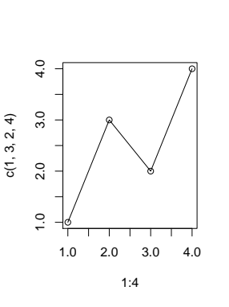

Made this in Rstudio and saved as pdf and then inserted here into this document.

