Ryan Avery

Final

1a) We start with the limit

Then evaluating the numerator and denominator as x goes to infinity we get

The result is 2/3.

1b) MATLAB Plot verifying 1a. Expression approaches .666666666~ which equals 2/3rds.
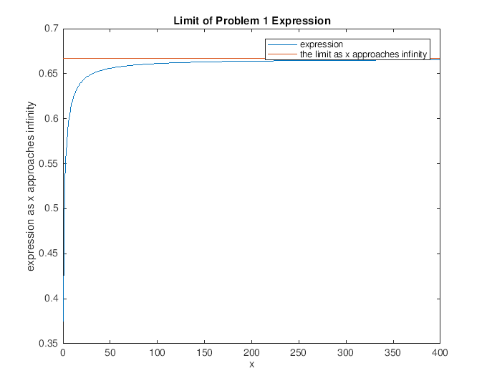

2a)

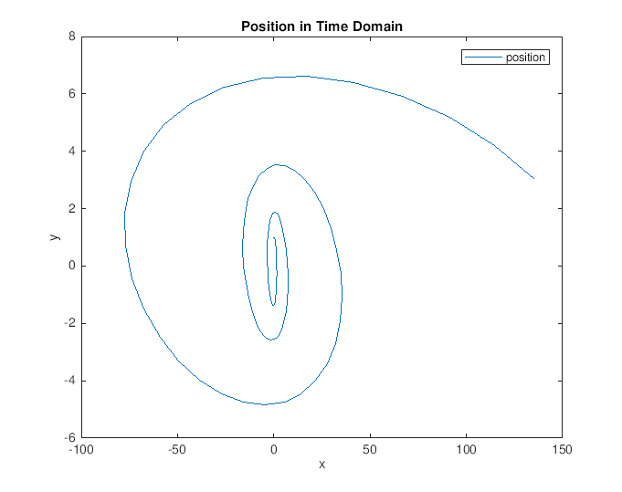
2b) Analytical calculation of the derivatives u and v of x and y, respectivley.

2c) See full MATLAB code at end of document
unum = (x(2:end)-x(1:end-1))./dt;
vnum = (y(2:end)-y(1:end-1))./dt;

2d)
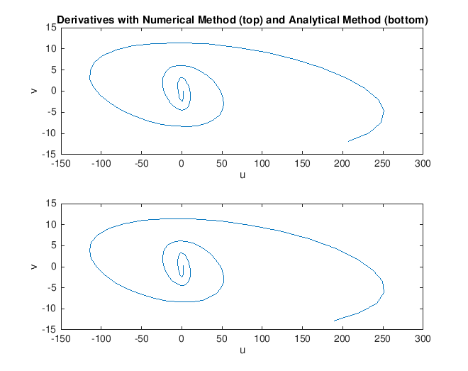
3a) A_nought of my exponential decay model is 6.3393 and k is -.0042.

This is the fitted function (also shown in MATLAB Code)

Where A_nought is the initial amount in grams, k is a decay constant, t is time, and A is amount at time t.

3b) The half life of this element is 164.1954 years

There will be .1220 grams remaining at 2000 years.

3c)
Derivative of exponential model

Integral of exponential model

With u substitution, we can have:

so that the integral becomes much easier to solve

The integral of e to an exponent is itself plus a constant. Subbing the expression back in for u we get

At t =0 we can find the value of C

Solving for C and simplifying, we find that C = 6.3127. Our final equation is

3d)

3e)

