Find_closest_Mary.ipynb
I filter my orthologs based on most similar sequence.
Using aligner = Align.PairwiseAligner(scoring="blastp")
from Bio import SeqIO, Align

AAAS.fasta
│
▼
Read all sequences
│
▼
┌────────────────────┐
│ For every sequence │
└────────────────────┘
│
▼
Identify species
│
▼
Align to human reference
│
▼
Calculate normalized
score
│
▼
┌──────────────────────┐
│ Is this the highest │
│ scoring sequence for │
│ this species? │
└──────────────────────┘
│ │
YES NO
│ │
▼ ▼
Save Ignore
│
└──────┬───┘
▼
One best sequence
per species
│
▼
Write to FASTA
Summary of code;
For one gene, read all protein sequences → compare every sequence to the human reference → calculate a normalized similarity score → keep only the highest-scoring sequence for each species → write those best sequences to a FASTA file.

Python version
(py312) adesinamary@Azevedo-Pro

Ancestral State building using … MEGA

Ouput storage location;

/Users/adesinamary/Documents/MEGA_12/Examples/Mary_08_2026/HBB_Ancestral-states-details.txt

Ancestral states Reconstruction (ASR)

ACADM:29 R-L position 117 in alignment
Aotus nancymaae

Callithrix jacchus
Saimiri boliviensis
Sapajus apella

N10,117,2.3873e-07,0.999864,9.04934e-09,9.6196e-10,3.57006e-08,5.16954e-06,4.83535e-09,1.28524e-07,2.08455e-06,2.60127e-08,3.46532e-05,3.01914e-06,8.33412e-08,1.2486e-09,8.89868e-05,1.2883e-06,1.35582e-07,5.0013e-08,1.71412e-09,1.85239e-08

marginal probabilities at position: 117
of node: N10: p(R)=0.999864
of node: Piliocolobus tephrosceles: p(R)=1
of node: Rhinopithecus bieti: p(R)= 1
of node: Rhinopithecus roxellana: p(R)=1

N10 MRPLPRSQRRRTQGSRSMRWLPGAGDRSHPAWRSAPSFRSPTASSRPAPPHPAHGLQWAG
N10 PEESRVRGVCQGRDPCIIVRVAGTGANMAAGFRRCCRAVLRSISRFHWRSQHTKANRQRE
N10 PGLGFSFEFTEQQKEFQATARKFAREEIIPVAAEYDKTGEYPVPLIRRAWELGLMNTHIP
N10 ENCGGLGLGTFDACLITEELAYGCTGVQTAIEGNSLGQMPIIIAGNDQQKKKYLGRMTEE
N10 PLMCAYCVTEPGAGSDVAGIKTKAEKKGDEYIINGQKMWITNGGKANWYFLLARSDPDPK
N10 APANKAFTGFIVEADTPGIQIGRKELNMGQRCSDTRGIVFEDVKVPKENVLIGDGAGFKI
N10 AMGAFDKTRPAVAAGAVGLAQRALDEATKYALERKTFGKLLVEHQAISFMLAEMAMKVEL
N10 ARMSYQRAAWEVDSGRRNTYYASIAKAFAGDIANQLATDAVQIFGGNGFNTEYPVEKLMR
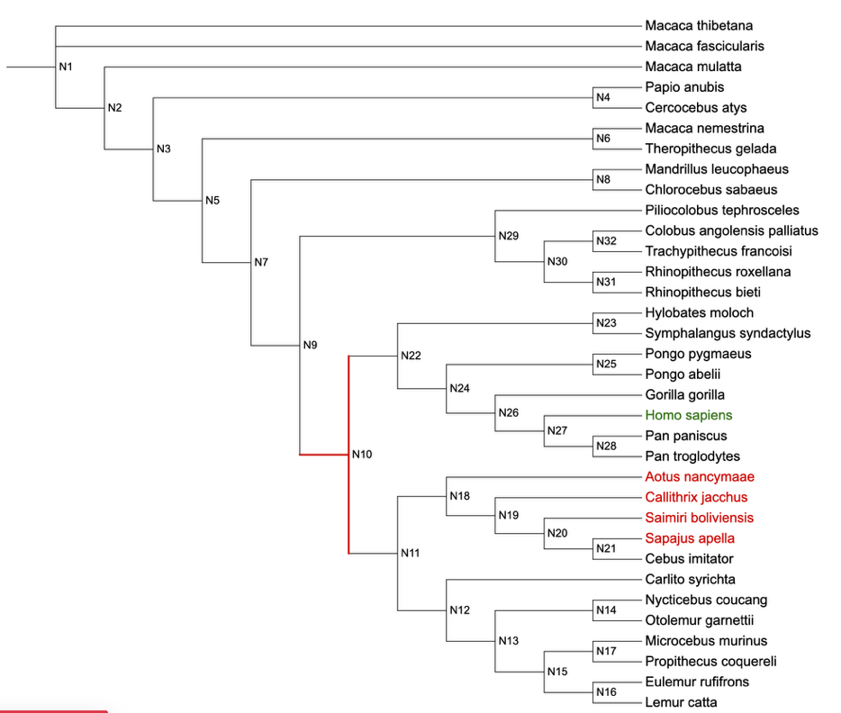
N10 DAKIYQIYEGTSQIQRLIIAREHIGKSYKNDRVNF
ACADM:31 R-H position 119 in alignment
Nycticebus coucang
Otolemur garnettii

N10,119,-23.5935,-7.36156e-08,-24.8766,-27.7919,-22.8853,-19.1931,-25.8309,-20.9402,-18.6702,-26.8513,-24.6838,-16.6345,-25.5942,-31.4989,-23.274,-22.0494,-23.5671,-22.9601,-27.5683,-27.399

marginal probabilities at position: 119
of node: N10: p(R)=1
of node: Piliocolobus tephrosceles: p(R)=1
of node: Rhinopithecus bieti: p(R)=1
of node: Rhinopithecus roxellana: p(R)=1

N10 MRPLPRSQRRRTQGSRSMRWLPGAGDRSHPAWRSAPSFRSPTASSRPAPPHPAHGLQWAG
N10 PEESRVRGVCQGRDPCIIVRVAGTGANMAAGFRRCCRAVLRSISRFHWRSQHTKANRQRE
N10 PGLGFSFEFTEQQKEFQATARKFAREEIIPVAAEYDKTGEYPVPLIRRAWELGLMNTHIP
N10 ENCGGLGLGTFDACLITEELAYGCTGVQTAIEGNSLGQMPIIIAGNDQQKKKYLGRMTEE
N10 PLMCAYCVTEPGAGSDVAGIKTKAEKKGDEYIINGQKMWITNGGKANWYFLLARSDPDPK
N10 APANKAFTGFIVEADTPGIQIGRKELNMGQRCSDTRGIVFEDVKVPKENVLIGDGAGFKI
N10 AMGAFDKTRPAVAAGAVGLAQRALDEATKYALERKTFGKLLVEHQAISFMLAEMAMKVEL
N10 ARMSYQRAAWEVDSGRRNTYYASIAKAFAGDIANQLATDAVQIFGGNGFNTEYPVEKLMR
N10 DAKIYQIYEGTSQIQRLIIAREHIGKSYKNDRVNF
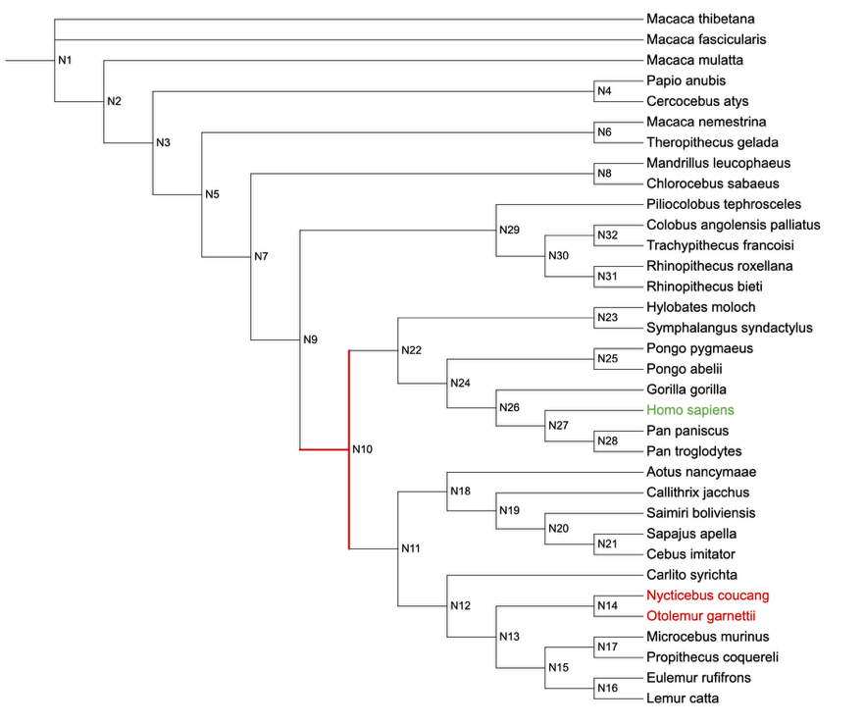
ACADM:103 F-L position in alignment 191
Lemur catta

N10,191,-28.1363,-31.7811,-29.9038,-32.461,-24.5808,-32.6388,-31.6611,-31.4534,-26.4081,-23.1913,-19.5852,-32.3598,-26.1544,-1.44632e-08,-28.1751,-22.8608,-29.0448,-26.0683,-18.3191,-24.0633

marginal probabilities at position: 191
of node: N10: p(F)=1
of node: Piliocolobus tephrosceles: p(F)=1
of node: Rhinopithecus bieti: p(F)=1
of node: Rhinopithecus roxellana: p(F)=1

N10 MRPLPRSQRRRTQGSRSMRWLPGAGDRSHPAWRSAPSFRSPTASSRPAPPHPAHGLQWAG
N10 PEESRVRGVCQGRDPCIIVRVAGTGANMAAGFRRCCRAVLRSISRFHWRSQHTKANRQRE
N10 PGLGFSFEFTEQQKEFQATARKFAREEIIPVAAEYDKTGEYPVPLIRRAWELGLMNTHIP
N10 ENCGGLGLGTFDACLITEELAYGCTGVQTAIEGNSLGQMPIIIAGNDQQKKKYLGRMTEE
N10 PLMCAYCVTEPGAGSDVAGIKTKAEKKGDEYIINGQKMWITNGGKANWYFLLARSDPDPK
N10 APANKAFTGFIVEADTPGIQIGRKELNMGQRCSDTRGIVFEDVKVPKENVLIGDGAGFKI
N10 AMGAFDKTRPAVAAGAVGLAQRALDEATKYALERKTFGKLLVEHQAISFMLAEMAMKVEL
N10 ARMSYQRAAWEVDSGRRNTYYASIAKAFAGDIANQLATDAVQIFGGNGFNTEYPVEKLMR
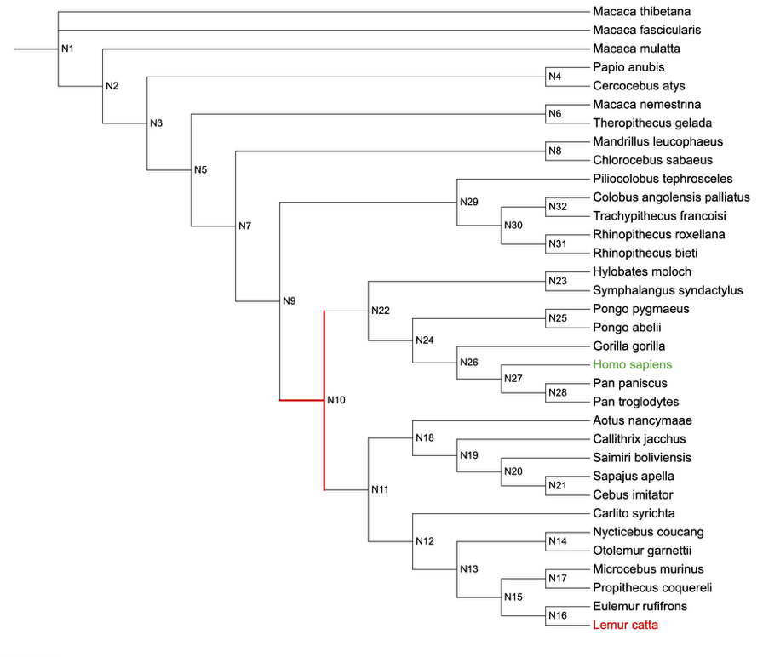
N10 DAKIYQIYEGTSQIQRLIIAREHIGKSYKNDRVNF

IQTREE - was used to generate the Phylogenetic tree per protein
Based on Maximun-likehood

https://iqtree.github.io/doc/Quickstart

For MUTYH protein

command line;

../bin/iqtree3 -s MUTYH_NP_001121897.1_match_renamed.fasta -B 1000 -alrt 1000

This command generates this set of output files;

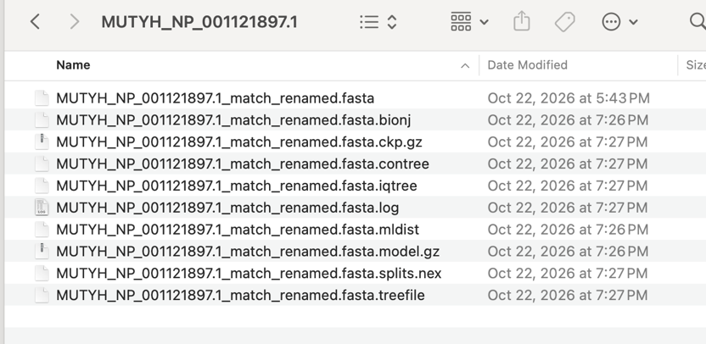

Analysis results written to:
IQ-TREE report: MUTYH_NP_001121897.1_match_renamed.fasta.iqtree
Maximum-likelihood tree: MUTYH_NP_001121897.1_match_renamed.fasta.treefile
Likelihood distances: MUTYH_NP_001121897.1_match_renamed.fasta.mldist

Ultrafast bootstrap approximation results written to:
Split support values: MUTYH_NP_001121897.1_match_renamed.fasta.splits.nex
Consensus tree: MUTYH_NP_001121897.1_match_renamed.fasta.contree
Screen log file: MUTYH_NP_001121897.1_match_renamed.fasta.log

FastML is used to generate the ancestral sequence state

Command line;

fastml -s ACADM_NP_000007.1_match_copy.fasta -t ACADM_NP_000007.1_match.Newick -mj

Correct Analysis Pipeline
Tool | Role | Output file | platform | More details
MEGA | Generate protein model | Excel sheet | Web interface | N/A  ‘find best DNA/protein models’
IQ-Tree | Generate phylogenetic tree | .treefile | Command line | ..\..\..\..\bin\iqtree3.exe -s .\AGXT_NP_000021.1_match_renamed.fasta -m JTT+G+I+F
FastML | Generate ancestral state sequence |  |  | fastml -s ACADM_NP_000007.1_match_copy.fasta -t ACADM_NP_000007.1_match_copy.Newick
iTOL | Tree annotation |  | Web interface

