- Log in to your Canvas course shell.
- If Panorama appears in the course menu, skip to step 6
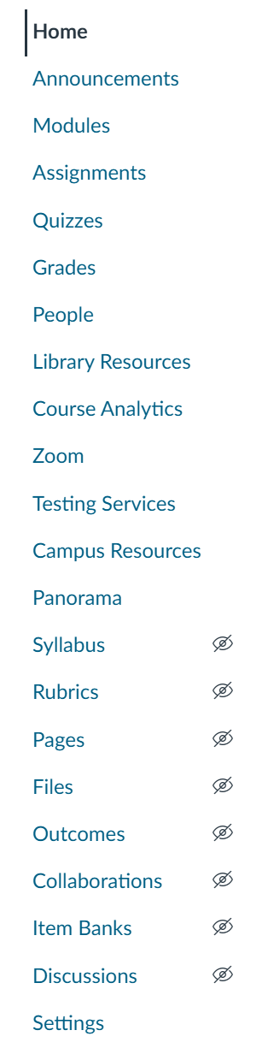
- If Panorama does not appear in the course menu, click on Settings
- Within Settings, click on the Navigation Tab.
- Find Panorama in the list of hidden items and drag it up to the course navigation list.
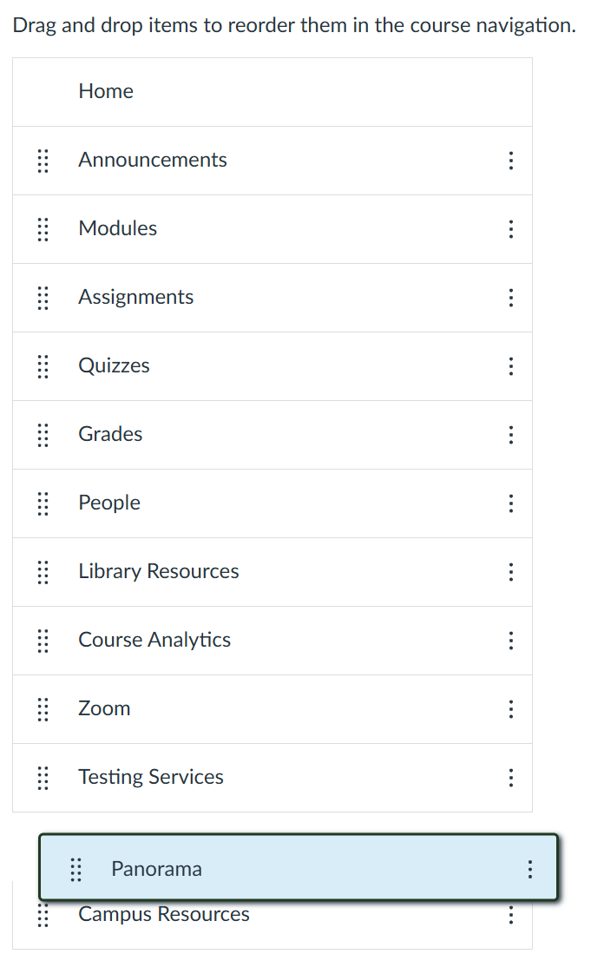
- Return the main menu or refresh the page. Panorama should appear in the course menu
- Click on Panorama within the course menu.
- Select the Export Report button within Course Report

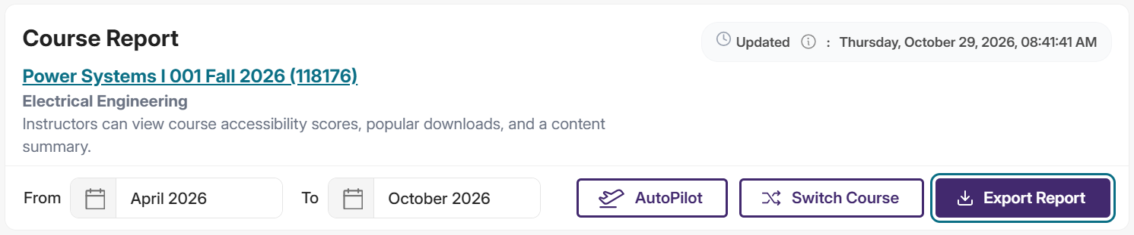

- Click on the Export Report box.
- Select Email Link, JSON, and enter “maseehservices@pdx.edu”
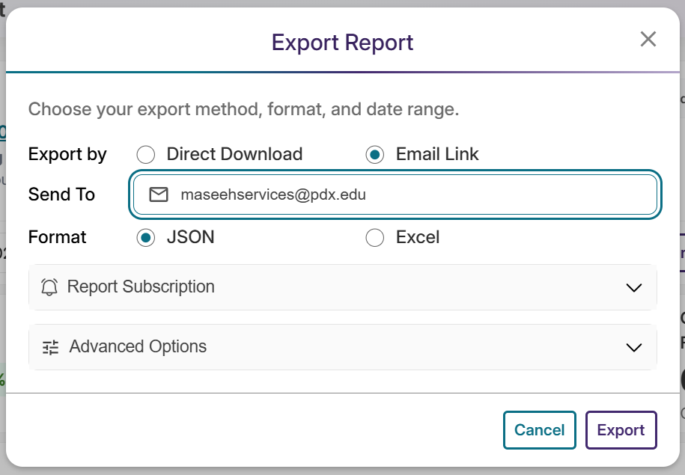
- Click Export to send the Panorama report.

