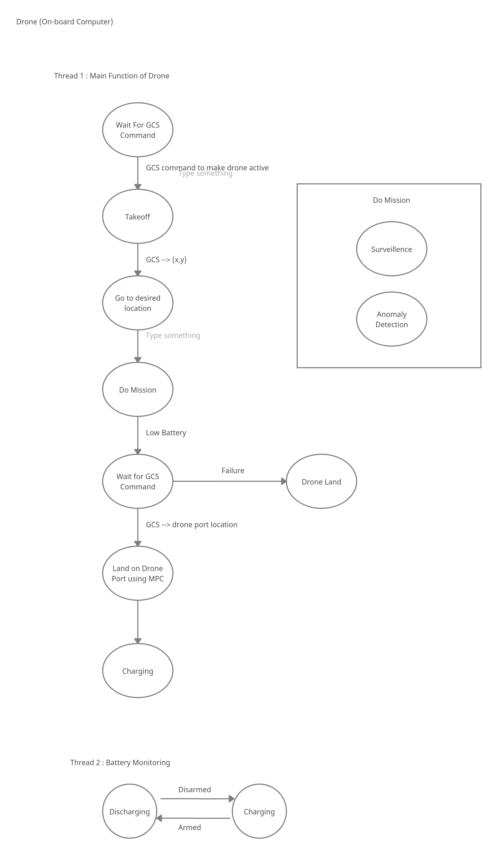

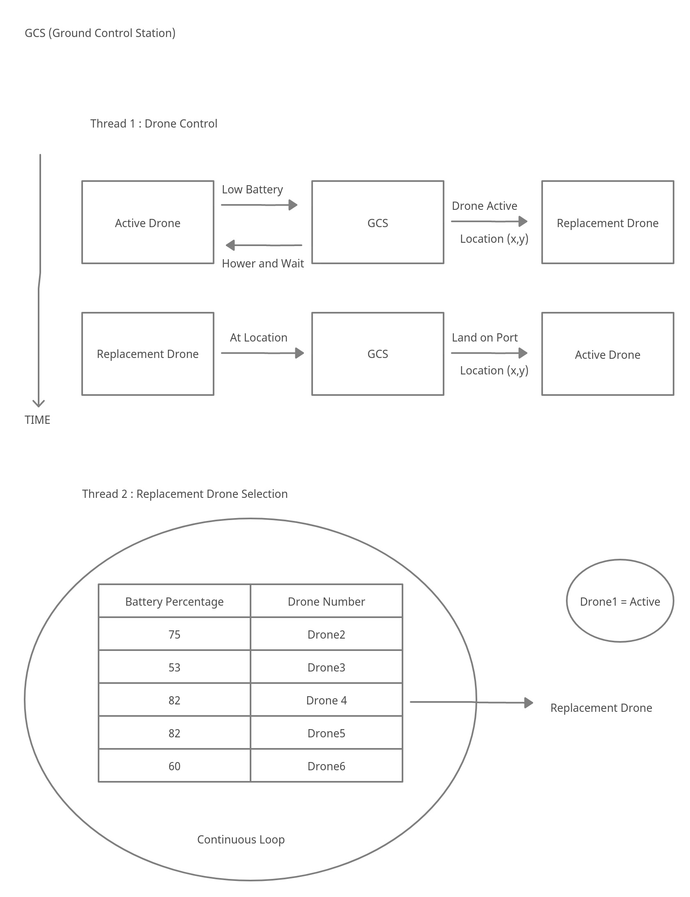

MPC ALGORITHM

Case 1 : No Wind

Drone

Aruco

10m

Error due to GPS (Δx , Δy)

Go to location (x_aruco , y_aruco)

MPC Correction

LAND Command

1.5m

Case 2: With Wind

Drone

Aruco

10m

Error due to GPS (Δx , Δy)

Go to location (x_aruco , y_aruco)

MPC Correction

DRIFT due to wind

Error due to GPS (Δx’ , Δy’)

Go to location (x_aruco , y_aruco)

LAND Command

1.5m