CSCI6525 Project Proposal
Randy Schur
2/21/15

Overview: For the Robotics: Manipulation class project, I would like to design a simulation and controller for a 3 degree of freedom robotic arm. The simulation will be done in Gazebo with the result being to have the robot 'write' a message using it's end-effector. The model of the robot will be based on a physical prototype, for which a kinematic model will need to be developed. The inspiration for the prototype is the uArm, which is a mostly-open source robotic arm that can be found here: http://blog.ufactory.cc/category/robot-arms/. The CAD files for the model being used can be found here, although they have been modified slightly: http://www.thingiverse.com/thing:480446.

Methods: The primary goal of the project will be to develop a model and a contoller for the robotic arm, and I will attempt this in two ways. The first is to use system identification methods on the physical robot to identify the necessary parameters for forward and inverse kinematics. Once this is accomplished, I should be able to build a model of the robot in Gazebo. A set of letters will be constructed using splines as discussed in class. RMRC, or another inverse kinematic algorithm, can be used to control the motion of the robot. A secondary method of building a lookup table of grid points on a plane around the arm will also be explored. This would alleviate the need to build a precise kinematic model of the robot, and splines would be used to generate the paths between waypoints.

Risks and Limitations: Determining a kinematic model of a robotic arm is a difficult task, and it may be even harder because the prototype of the arm is not a precise model. I will not be able to achieve a high level of precision with the physical model, and a probabilistic model of robotics is not something we have discussed in class. If characterizing the model becomes too difficult, I will move to the secondary approach of building a lookup table and minimize the effect of the inaccurate robot model. In addition, there is a good chance that the simulated model will not match the physical model, or that the control strategy in a simulated environment is not robust enough on the physical robot. For this reason, the final product will be the simulated model only.

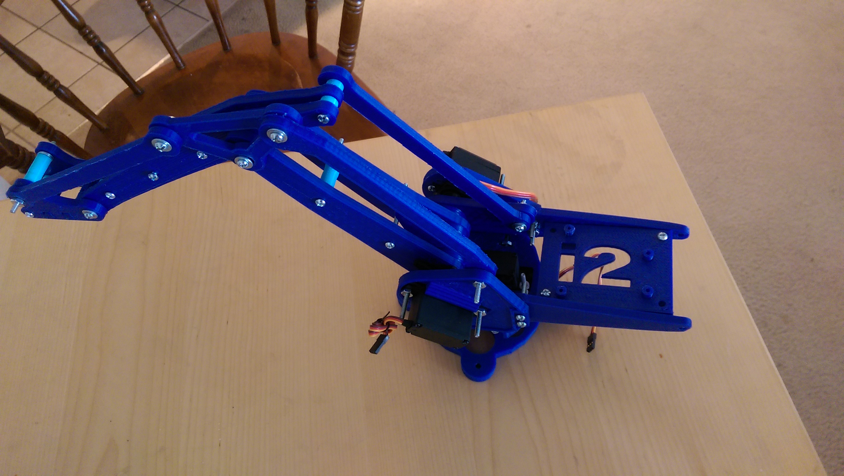Illustration 1: The physical prototype of the robotic arm for this project.

